Supplementary Material

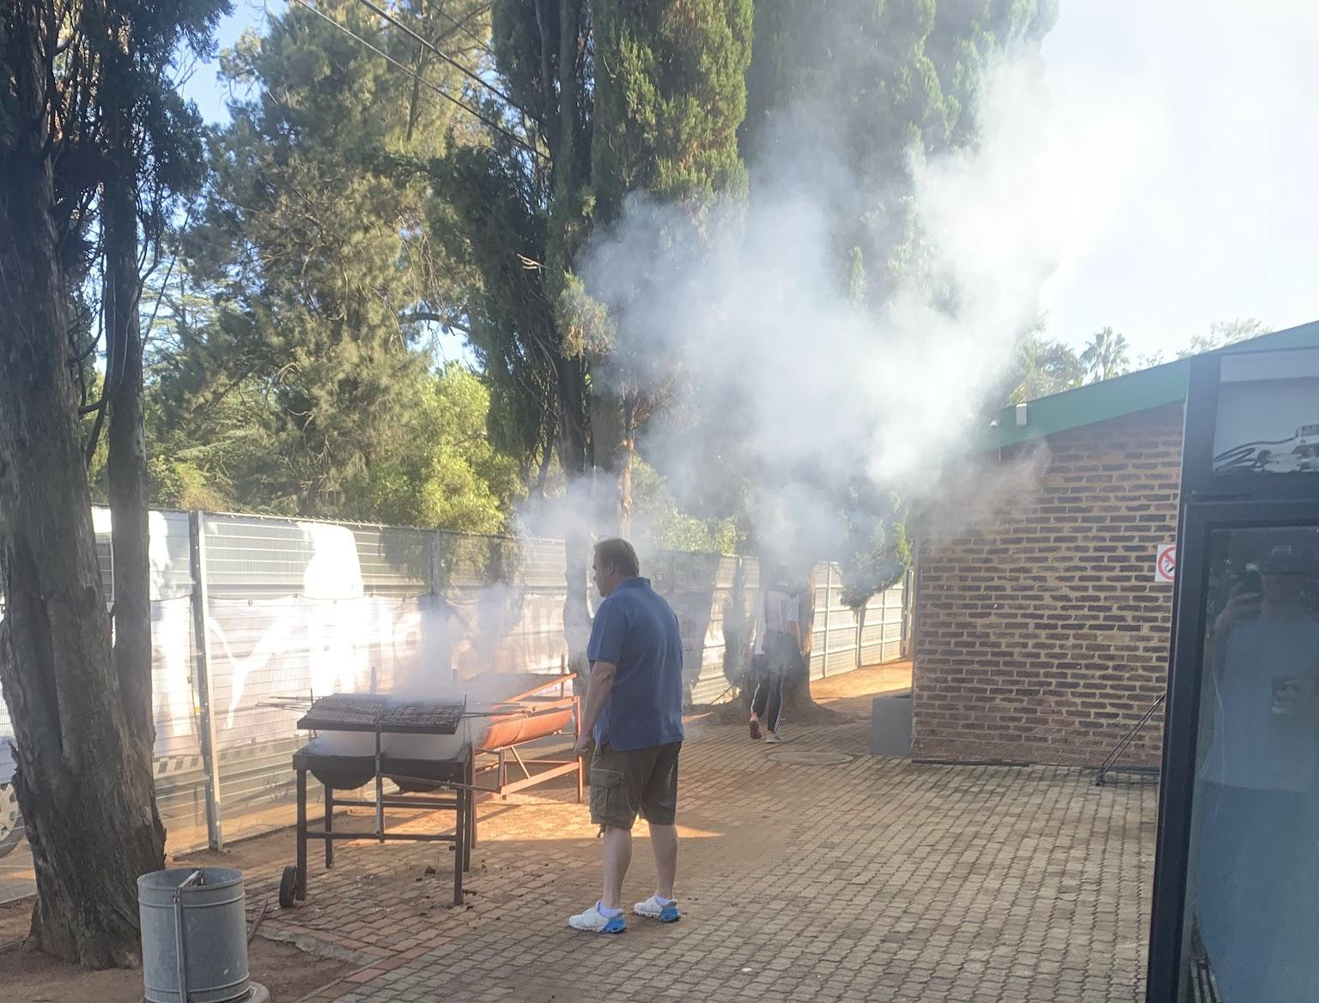
Supplementary Figure 1: Open fire cooking that resulted in peak PM2.5 concentration during the national championships

