How is climate science used to inform national level adaptation planning in southern Africa?
Authors: Ailish Craig, Rachel A. James, Emma Archer, Joseph Daron, Christopher D. Jack Richard G. Jones, Alan T. Kennedy-Asser, Jessica Lee, Alice McClure, Christopher Shaw, Anna Steynor , Andrea Taylor, Katharine Vincent

SM Table 1. Participant information. *= local government. INGO=international non-government organisation, IGO=intergovernmental organisation, MDB=multilateral development bank.
Participant Group
 | Department/Ministry
Government Official | Disaster risk reduction
Government Official | Climate Change/Environment
Government Official | Climate Change/Environment
Government Official | Climate Change/Environment
Government Official | Sustainability/Resilience*
Government Official | Climate Change/Environment
 | Organisation Type
Climate Scientist | University
Climate Scientist | University
Climate Scientist | University
Climate Scientist | Research organisation
Boundary Agent | Government research organisation
Boundary Agent | INGO
Boundary Agent | University
Boundary Agent | Consultancy
Boundary Agent | Government research organisation
Boundary Agent | Consultancy
Technical Expert | IGO
Technical Expert | IGO/MDB

Further details of methodology
For the KII, ethical approval was granted from the University of Bristol (CRAIG-2023-1) and The University of Cape Town (FSREC 081-2023) and all participants provided informed consent. Interviews were conducted from September 2023 to April 2024 and ranged from 22-75 minutes in duration. Participants were contacted via email and interviews were conducted online or in person. The interview guide was developed based on the research questions and key themes included: how participants expect climate change to affect their country in the future, what future climate information they use or produce in their work, the adaptation planning process and the role of climate information in this, the interpretation of climate information and barriers that may exists in using climate science for adaptation.
Thematic analysis of the KII was undertaken in NVivo using both an inductive and deductive approach (Terry et al., 2017). The deductive thematic analysis used pre-existing knowledge to generate themes and was guided by the research questions, themes identified in the document analysis and existing literature. The wider research team developed the inductive codes after reading transcripts to ensure key codes were identified based on repetition, similarities and differences between participants and the literature. Once the initial analysis was undertaken, codes were grouped into larger themes. Participants were provided with this research manuscript prior to submission to ensure they were anonymous.
The most recent NCs were obtained and downloaded from the UNFCCC website on the 6th July 2023. The document analysis used deductive thematic analysis, whereby codes were developed a priori and are based on literature and theory. The coding framework was an iterative process based on the research team’s feedback. Once codes were finalised, they were tested on Uganda’s NC by three researchers to ensure the coding strategy was clear and coding was consistent. Any differences in the coding of this test exercise were discussed and, where needed, altered.
The coding framework included: details of future climate information (characteristics of future change, climate models used, variables, scenarios, downscaling methods, communication of information), adaptation (main sectors, inclusion of future climate information, impact studies) and barriers to climate information and adaptation (technology, observations, human resources). The analysis was conducted in NVivo (2018). Alongside the thematic analysis, content analysis was also conducted for a list of 34 key weather hazards, such as heatwave, drought and cyclone, to identify the most frequently mentioned hazards in each document.
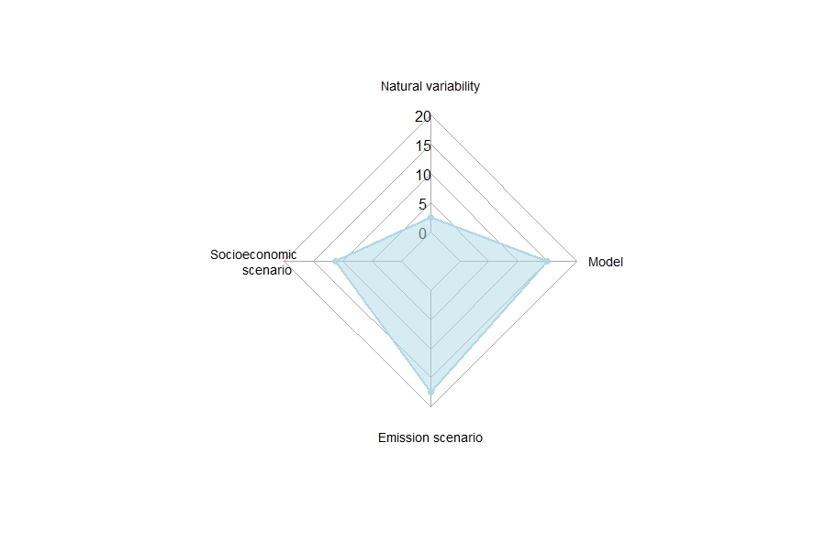
SM Figure 1. The number of NCs (n=16) that mention each type of uncertainty related to climate projections

