Figure S1. How the introduction status of a species might change through time (specifically between status reports).

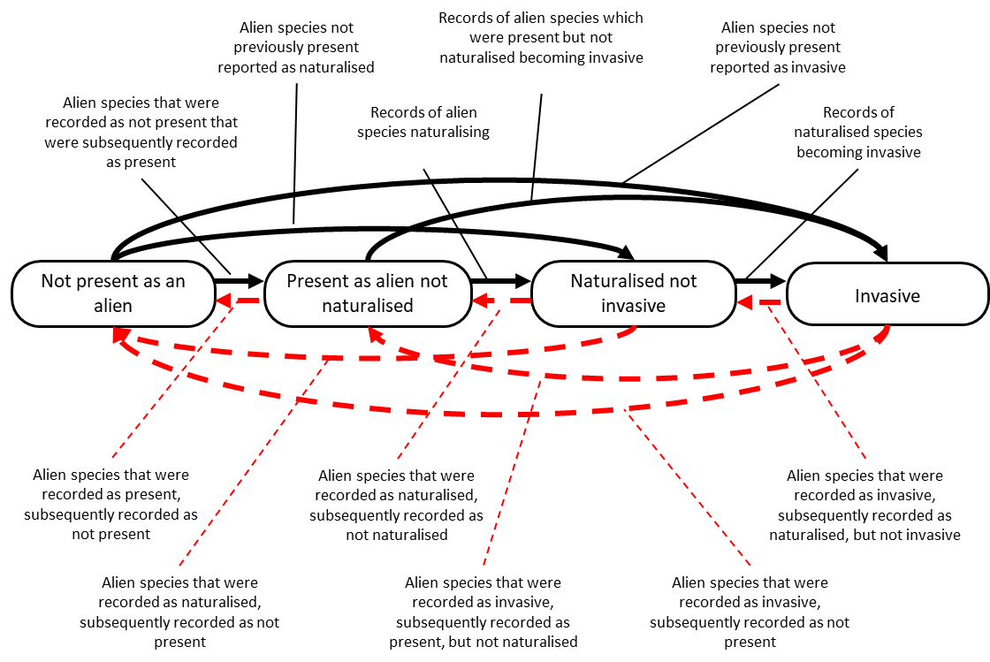
Figure S1. How the introduction status of a species might change through time. The diagram is shown here for ease of interpretation, but the information can be presented in the form of a matrix to ensure it is machine readable and more easily analysed. Importantly, the risk that a species poses can be more about how quickly it moves through these stages rather than which stage it is at (Brock and Daehler 2020).

