Insights on agricultural greenhouse gas research and collaboration in Southern Africa.
Regional Environmental Change
Pamela Pophiwa^{1*} , Ackim Mwape² , Abubeker Hassen³, Cornelius J.L. du Toit; Este van Marle-Koster³ and Lindiwe M. Sibanda³
¹ARUA Centre of Excellence in Sustainable Food Systems, University of Pretoria, South Africa
²The Global Research Alliance on Agricultural Greenhouse Gases, New Zealand
³Department of Animal Science, Faculty of Natural & Agricultural Science, University of Pretoria, South Africa

* Correspondence author (pamela.pophiwa@up.ac.za)

Table S1 Search terms used for the scoping review
Category | Search words
Agriculture | “Agricultur*” OR “livestock” OR “ruminant*” OR “cattle” OR “beef” OR “dairy” OR “sheep” OR “goat*” OR “poultry” OR “pig” OR “manure” OR “soil” OR “crop*” “maize” OR “rangeland” OR “pasture” OR “grassland”
Greenhouse gas emissions | “carbon” OR “greenhouse gas” OR “greenhouse gas” OR “GHG” OR “CO2” OR “emission*” OR “global warming” OR “methane” OR “nitrous oxide” OR “CH4” OR “NO2”
Countries | “Botswana” OR “Zambia” OR “Zimbabwe” OR “South Africa” OR “Namibia” OR “Lesotho” OR “Swaziland” OR “Malawi” OR “Mozambique” OR “Eswatini”
Table S2 Inclusion and exclusion criteria
Criteria | Inclusion | Exclusion
Article type | Full articles | Articles that have abstracts only
Geographical focus | Studies conducted in southern Africa | Studies conducted outside southern Africa
Publication date | Published between 2010 and 2023 | Articles published before 2010
Research Focus | Articles focusing on agricultural greenhouse gas (GHG) measurements and mitigation | Articles focused on broader climate change topics unrelated to agricultural GHGs
Methodology | Empirical studies with detailed methodologies, analysis, and results | Articles lacking empirical data or detailed methodologies
Data type | Primary data | Secondary data or articles that do not contribute new experimental insights

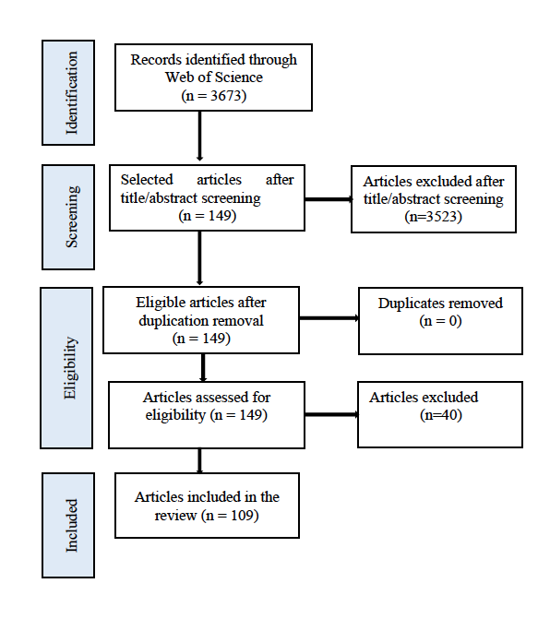
Fig. S1 Flowchart showing the process used to identify relevant studies for the scoping review

