Unveiling the role of aeration systems in the bioaerosol emission rate, particle size and microbial composition from wastewater treatment plants

Puseletso C Kumaloª, Isaac D Amoah^{a,b}, Rian E Pierneef ^{c,d}, Arshad Ismail^{e}, Faizal Buxª, Sheena Kumari^{a*}
ª Institute for Water and Wastewater Technology, Durban University of Technology, KwaZulu-Natal, South Africa
^{b} Department of Environmental Science, The University of Arizona, Shantz Building Rm 4291177 E 4th St, Tucson, AZ 85721, USA
^{c} Department of Biochemistry, Genetics and Microbiology, University of Pretoria, Pretoria, South Africa
^{d} Centre for Bioinformatics and Computational Biology, University of Pretoria, Pretoria, South Africa
^{e} NICD Sequencing Core Facility, National Institute for Communicable Diseases, Sandringham 2192, Pretoria, South Africa

Corresponding author: SheenaK1@dut.ac.za

1 Description of the Wastewater Treatment Plants

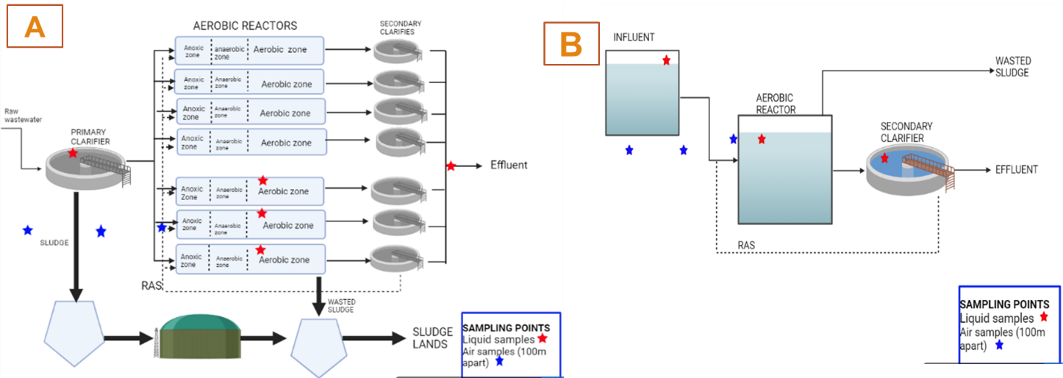
Fig. S1: A) Diffused aerated WWTP and B) Surface aerated WWTP

2. Bioaerosol Emission level and particle size distribution across different aeration systems

Fig. S2: Seasonal particle size distribution of bioaerosol concentrations at 0 m from surface (SA) and diffused aeration (DA) systems across spring, summer, and autumn.

3 Dominant Microbial Composition of Bioaerosols

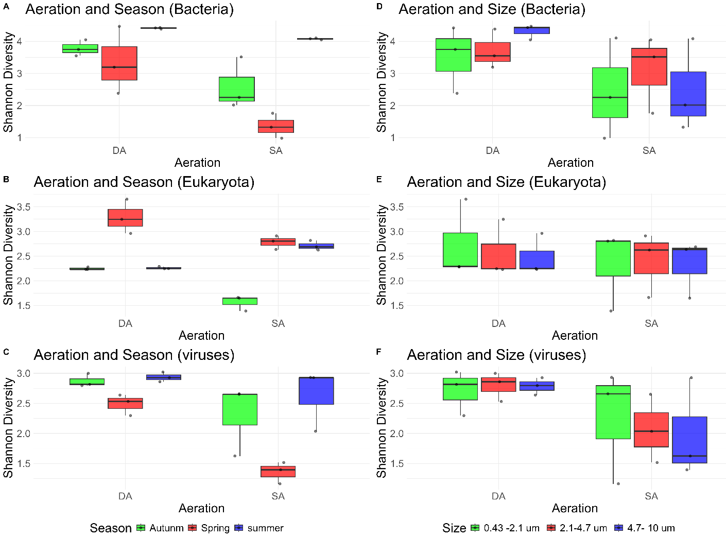
Fig. S3. Shannon diversity indices for bacteria, eukaryotes, and viruses under different aeration conditions, seasons, and particle sizes. (A–C) Diversity by aeration (DA: Diffused Aeration, SA: Surface Aeration) and season. (D–F) Diversity by aeration and particle size. Boxes show interquartile ranges, medians, and whiskers, with points as outlines.

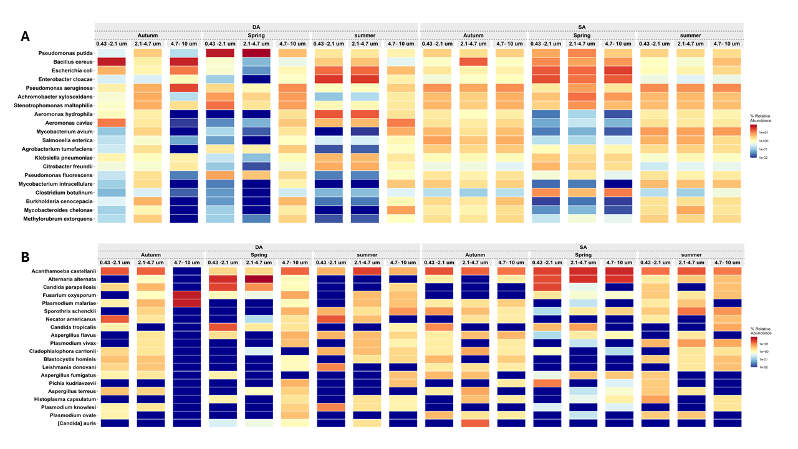
Fig. S3: Potential opportunistic airborne bacterial and eukaryotic pathogens present in bioaerosols in DA and SA aeration systems across particle sizes and seasons

4 Factors Influencing bioaerosol generation and microbial composition

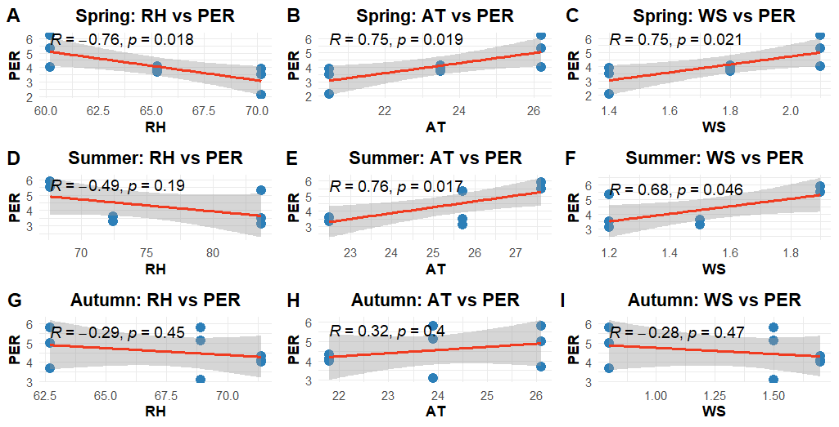
Fig. S4: Correlation between abiotic factors: relative humidity (RH), ambient temperature (AT), and wind speed (WS) and particle emission rate (PER) across different seasons measured at 0 m in the DA system. A–C present the correlation matrices for the SA system, and D–F spring, D–F: summer and G-I: autumn.

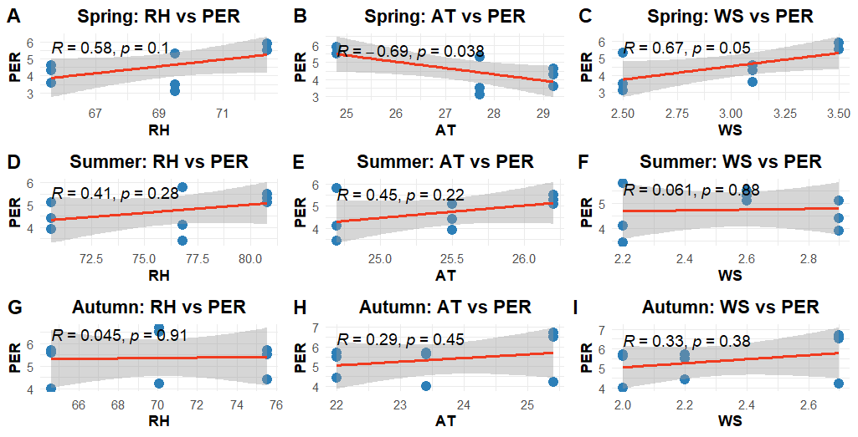
Fig. S5: Correlation between abiotic factors: RH, AT, and WS and PER across different seasons measured at 0 m in the SA system. A–C present the correlation matrices for the spring, D–F: summer and G-I: autumn.

A

Fig. S6: Seasonal particle size distribution of bioaerosol concentrations (A) and corresponding emission rates (B) at 0 m and 100 m distances from surface (SA) and diffused aeration (DA) systems across spring, summer, and autumn.

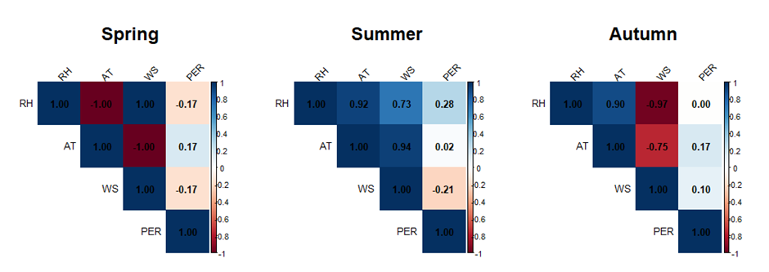
B
C
A

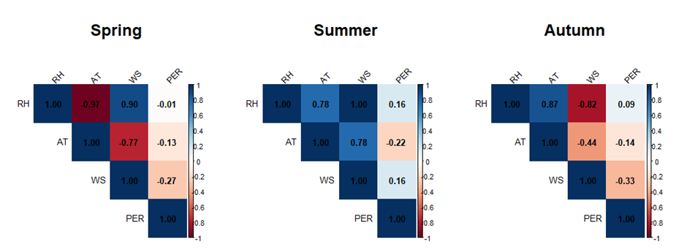
D
E
F
A
B
Fig. S7: Correlation matrix between particle emission rates and abiotic factors (e.g., temperature, relative humidity, wind speed) at 100 m from DA and SA systems. Figure A–B represent spring, C–D summer, and E–F autumn. DA system results are shown in A, C, and E, while SA system results are shown in B, D, and F.

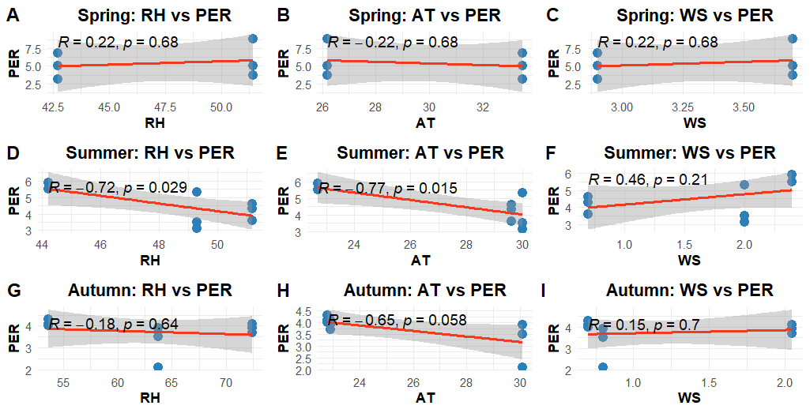
Fig. S8: Correlation between abiotic factors: RH, AT, and WS and PER across different seasons measured at 100 m in the DA system. A–C present the correlation matrices for the spring, D–F: summer and G-I: autumn.

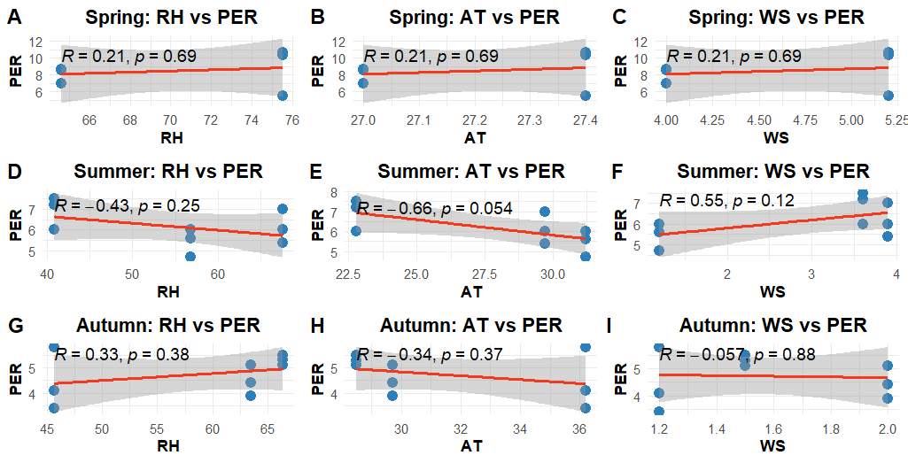
Fig. S9: Correlation between abiotic factors: RH, AT, and WS and PER across different seasons measured at 100 m in the SA system. A–C present the correlation matrices for the spring, D–F: summer and G-I: autumn.

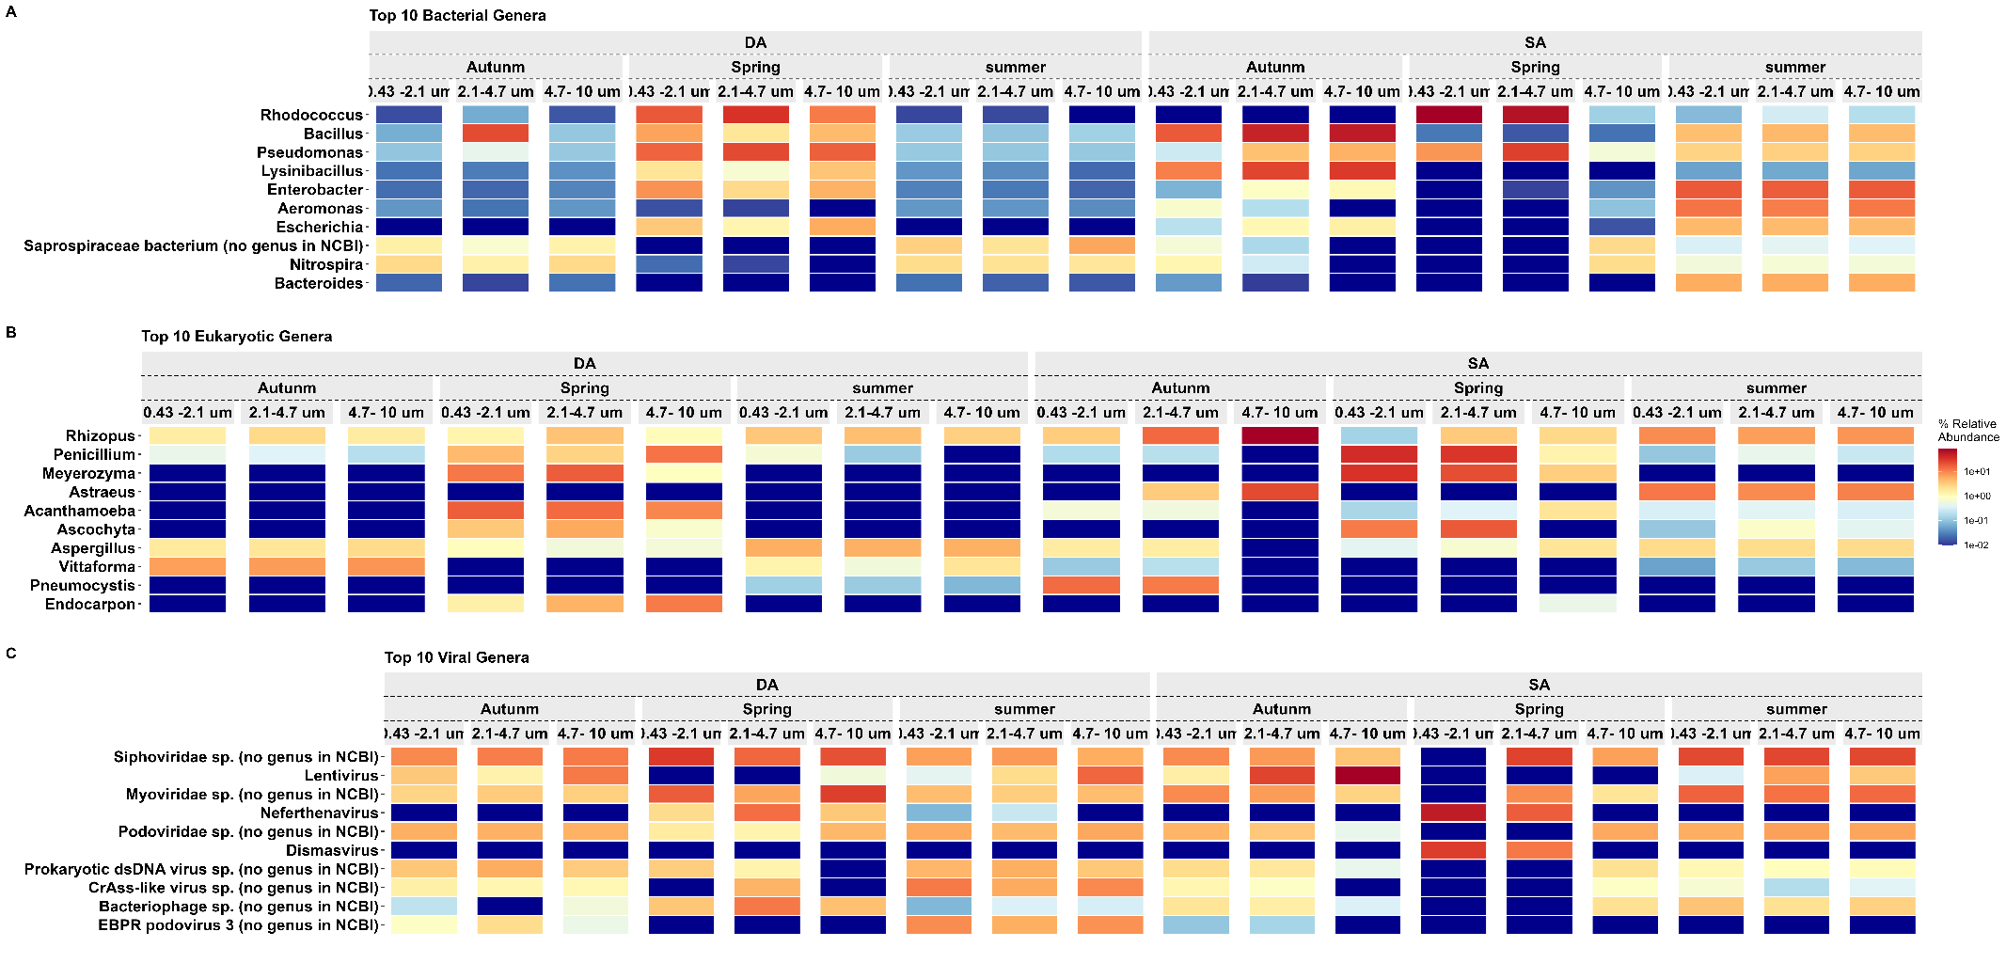
Fig. S10: Relative abundances of (A) bacterial, (B) eukaryotic, and (C) viral genera across particle size fractions and seasons at 100m away from the DA and SA system.

Table S1: Abiotics facors

Aeration | Season | Size | Distance | RH % | AT ºC | WS m/s
DA | Spring | 4.7- 10 um | 0m | 67.8 | 22 | 1.6
DA | Spring | 2.1-4.7 um | 0m | 67.8 | 22 | 1.6
DA | Spring | 0.43 -2.1 um | 0m | 67.8 | 22 | 1.6
DA | summer | 4.7- 10 um | 0m | 74.6 | 25.3 | 1.5
DA | summer | 2.1-4.7 um | 0m | 74.6 | 25.3 | 1.5
DA | summer | 0.43 -2.1 um | 0m | 74.6 | 25.3 | 1.5
DA | Autunm | 4.7- 10 um | 0m | 67.7 | 23.9 | 1.3
DA | Autunm | 2.1-4.7 um | 0m | 67.7 | 23.9 | 1.3
DA | Autunm | 0.43 -2.1 um | 0m | 6.7.7 | 23.9 | 1.3
DA | Spring | 4.7- 10 um | 100m | 66.3 | 24.5 | 1.4
DA | Spring | 2.1-4.7 um | 100m | 66.3 | 24.5 | 1.4
DA | Spring | 0.43 -2.1 um | 100m | 66.3 | 24.5 | 1.4
DA | summer | 4.7- 10 um | 100m | 69.7 | 28.0 | 1.9
DA | summer | 2.1-4.7 um | 100m | 69.7 | 28.0 | 1.9
DA | summer | 0.43 -2.1 um | 100m | 69.7 | 28.0 | 1.9
DA | Autunm | 4.7- 10 um | 100m | 65.0 | 27.0 | 1.2
DA | Autunm | 2.1-4.7 um | 100m | 65.0 | 27.0 | 1.2
DA | Autunm | 0.43 -2.1 um | 100m | 65.0 | 27.0 | 1.2
SA | Spring | 4.7- 10 um | 0m | 70.1 | 26.3 | 3.0
SA | Spring | 2.1-4.7 um | 0m | 70.1 | 26.3 | 3.0
SA | Spring | 0.43 -2.1 um | 0m | 70.1 | 26.3 | 3.0
SA | summer | 4.7- 10 um | 0m | 76.1 | 26.5 | 2.6
SA | summer | 2.1-4.7 um | 0m | 76.1 | 26.5 | 2.6
SA | summer | 0.43 -2.1 um | 0m | 76.1 | 26.5 | 2.6
SA | Autunm | 4.7- 10 um | 0m | 70.1 | 25.3 | 2.3
SA | Autunm | 2.1-4.7 um | 0m | 70.1 | 25.3 | 2.3
SA | Autunm | 0.43 -2.1 um | 0m | 70.1 | 25.3 | 2.3
SA | Spring | 4.7- 10 um | 100m | 68.9 | 28.3 | 2.5
SA | Spring | 2.1-4.7 um | 100m | 68.9 | 28.3 | 2.5
SA | Spring | 0.43 -2.1 um | 100m | 68.9 | 28.3 | 2.5
SA | summer | 4.7- 10 um | 100m | 68.4 | 28.3 | 1.5
SA | summer | 2.1-4.7 um | 100m | 68.4 | 28.3 | 1.5
SA | summer | 0.43 -2.1 um | 100m | 68.4 | 28.3 | 1.5
SA | Autunm | 4.7- 10 um | 100m | 61.8 | 25.2 | 1.2
SA | Autunm | 2.1-4.7 um | 100m | 61.8 | 25.2 | 1.2
SA | Autunm | 0.43 -2.1 um | 100m | 61.8 | 25.2 | 1.2

Table S2: Shannon diversity indices
Size | Season | Bacteria |  | Eukaryota |  | Viruses
Size | Season | DA | SA | DA | SA | DA | SA
4.7- 10 µm | Spring | 4.47 | 1.32 | 2.96 | 2.63 | 2.64 | 1.39
2.1-4.7 µm | Spring | 3.2 | 1.76 | 3.25 | 2.91 | 2.53 | 1.52
0.43 -2.1 µm | Spring | 2.38 | 0.98 | 3.66 | 2.81 | 2.3 | 1.16
4.7- 10 µm | summer | 4.43 | 4.08 | 2.25 | 2.69 | 2.93 | 2.93
2.1-4.7 µm | summer | 4.38 | 4.05 | 2.25 | 2.62 | 2.86 | 2.04
0.43 -2.1 µm | summer | 4.42 | 4.1 | 2.29 | 2.82 | 3.02 | 2.93
4.7- 10 µm | Autunm | 4.05 | 2.02 | 2.23 | 1.65 | 2.8 | 1.62
2.1-4.7 µm | Autunm | 3.55 | 3.51 | 2.23 | 1.66 | 3 | 2.65
0.43 -2.1 µm | Autunm | 3.75 | 2.25 | 2.28 | 1.39 | 2.82 | 2.66
Average |  | 3.85 | 2.67 | 2.60 | 2.35 | 2.77 | 2.10
STDEV |  | 0.67 | 1.19 | 0.49 | 0.54 | 0.22 | 0.66

Table S3: Microbial population detected in activated sludge (AS), bioaerosols (BA), and shared between AS and BA in the surface and diffused aeration system.

Bacterial population: Surface aeration
AS | BA | AS|BA
Evtepia | Halanaerobiaceae bacterium no genus in NCBI | Actinobacillus
Croceimicrobium | Stenotrophobium | Woeseiaceae bacterium no genus in NCBI
Streptobacillus | Litchfieldia | Unclassified Pectobacteriaceae
Lihuaxuella | Pseudochrobactrum | Candidatus Krumholzibacteria bacterium no genus in NCBI
Rhodoluna | Candidatus Spechtbacteria bacterium no genus in NCBI | Nitrospiraceae bacterium no genus in NCBI
Oceanicella | Nigerium | Candidatus Harrisonbacteria bacterium no genus in NCBI
Mesoaciditoga | Marinifilum | Unclassified Thermoflexaceae
Unclassified Euzebyales | Lottiidibacillus | Zavarzinella
Desertihabitans | Thermanaeromonas | Candidatus Taylorbacteria bacterium no genus in NCBI
Agaricicola | Sinanaerobacter | Candidatus Protochlamydia
Aliiruegeria | Elstera | Parachlamydiales bacterium no genus in NCBI
Luteimicrobium | Vallicoccus | Unclassified Isosphaeraceae
Luteibaculum | Chroogloeocystis | Unclassified Chromatiaceae
Galbibacter | Gorillibacterium | Ottowia
Flexistipes | Entomomonas | Xanthobacteraceae bacterium no genus in NCBI
bacterium 1xD42 87 no genus in NCBI | Salinicoccus | Unclassified Streptomycetaceae
Entomohabitans | Finegoldia | Unclassified Flavobacteriia
Candidatus Nucleicultrix | Nitratiruptor | Collinsella
Unclassified Pseudanabaenaceae | Unclassified Abditibacteriota | Leptotrichiaceae bacterium no genus in NCBI
Chrysiogenales bacterium no genus in NCBI | Christensenellaceae bacterium no genus in NCBI | Myxococcota bacterium no genus in NCBI
Desulfonauticus | Unclassified Aerococcaceae | Unclassified Flavobacteriaceae
Humibacter | Tomitella | Rhodobacteraceae bacterium no genus in NCBI
Pseudemcibacter | Candidatus Merdivicinus | Unclassified Ignavibacteriales
Rhodospira | Unclassified Ancalomicrobiaceae | Unclassified Saprospiraceae
Unclassified Aquificales | Salinimonas | Baekduia
Acidisarcina | bacterium BMS3Abin15 no genus in NCBI | Herbaspirillum
bacterium HR10 no genus in NCBI | Mesobacterium | Thermoflexales bacterium no genus in NCBI
Salsipaludibacter | Calidifontibacillus | Rhodospirillaceae bacterium no genus in NCBI
Thalassolituus | Holosporaceae bacterium no genus in NCBI | Candidatus Pacebacteria bacterium no genus in NCBI
Pontivivens | Rarobacter | Paracoccus
Desulfofarcimen | Pacificibacter | Unclassified Blastocatellia
Aestuariivivens | Thorsellia | Streptomyces
Xanthovirga | Caedimonadaceae bacterium no genus in NCBI | Hyphomicrobiales bacterium no genus in NCBI
Weizmannia | Metakosakonia | Actinobacteria bacterium no genus in NCBI
bacterium AH 315 P07 no genus in NCBI | Buchananella | Unclassified Propionibacteriales
Candidatus Thermochlorobacteriaceae bacterium no genus in NCBI | Kribbia | Gemmataceae bacterium no genus in NCBI
Desulfotalea | Spirochaeta | Ignavibacteriae bacterium no genus in NCBI
Unclassified Desulfuromonadaceae | Caldibacillus | Methylosarcina
Falseniella | bacterium HR12 no genus in NCBI | Cyclobacteriaceae bacterium no genus in NCBI
Halanaerobacter | Unclassified Methylothermaceae | Planctomycetales bacterium no genus in NCBI
Thiorhodovibrio | Phascolarctobacterium | Opitutaceae bacterium no genus in NCBI
Salinibacillus | Caproicibacter | Oscillibacter
Oleibacter | Nioella | Pirellulales bacterium no genus in NCBI
Thermovirga | Unclassified Aeromonadales | Tetrasphaera
Unclassified Syntrophorhabdales | Weissella | Ignavibacteria bacterium no genus in NCBI
Bombella | Crenalkalicoccus | Unclassified Anaerolineales
Chania | Endobacter | Phnomibacter
Lentilactobacillus | Unclassified Elusimicrobiaceae | Falsibacillus
Saccharobesus | Owenweeksia | Ureibacillus
Tibeticola | Falsirhodobacter | Tepidimonas
bacterium HR28 no genus in NCBI | Enterobacterales bacterium no genus in NCBI | Shigella flexneri no genus in NCBI
Unclassified Acidiferrobacteraceae | Franconibacter | Metabacillus
Gloeomargarita | Lederbergia | Rhizorhabdus
Pyruvatibacter | Lonsdalea | Unclassified Thermaceae
endosymbiont GvMRE of Glomus versiforme no genus in NCBI | Vermiphilus | Pandoraea
Formosa | Nissabacter | Mesobacillus
Croceitalea | Cellulosilyticum | Hoeflea
Unclassified Candidatus Sumerlaeaceae | Saliterribacillus | Unclassified Cellvibrionales
Parerythrobacter | Serinibacter | Cellvibrio
Pseudopuniceibacterium | Melghirimyces | Xanthomonas
Anaerobacterium | Desulfobacter | Ignavibacteriales bacterium no genus in NCBI
Candidatus Merdousia | Estrella | Ruminococcus
Simiduia | Wenxinia | Propionibacteriaceae bacterium no genus in NCBI
Anaerosphaera | Thermacetogenium | Unclassified Yersiniaceae
Trichlorobacter | Daejeonella | Unclassified Xanthobacteraceae
Abyssisolibacter | Hyella | Reyranella
Unclassified Caldisericia | Geoalkalibacter | Geminicoccaceae bacterium no genus in NCBI
Unclassified Thiobacillaceae | Unclassified Microcystaceae | Candidatus Daviesbacteria bacterium no genus in NCBI
Unclassified Sulfuricellaceae | Unclassified Candidatus Wolfebacteria | Methylobacterium
Ezakiella | Enorma | Unclassified Geminicoccaceae
Phosphitispora | Cognaticolwellia | Tessaracoccus
Ferrimicrobium | Aestuariirhabdus | Acetobacteraceae bacterium no genus in NCBI
bacterium HR35 no genus in NCBI | Roseicitreum | Sphingobacteriaceae bacterium no genus in NCBI
 | Kordiimonadaceae bacterium no genus in NCBI | Unclassified Aeromonadaceae
 | bacterium ADurb Bin236 no genus in NCBI | Polynucleobacter
 | Novispirillum | Unclassified Nitrosomonadaceae
 | Microterricola | Brucella
 | Sutterellaceae bacterium no genus in NCBI | Rhodoblastus
 | Sandaracinobacter | Unclassified Acidobacteriia
 | Phytobacter | Sediminibacterium
 | Unclassified Chroococcaceae | Lewinellaceae bacterium no genus in NCBI
 | Agreia | Candidatus Hydrogenedentes bacterium no genus in NCBI
 | Mobilicoccus | Sterolibacteriaceae bacterium no genus in NCBI
 | Piscicoccus | Unclassified Verrucomicrobiales
 | Rosenbergiella | Ideonella
 | Spirabiliibacterium | Rhodanobacteraceae bacterium no genus in NCBI
 | Desulfuromusa | Unclassified Neisseriales
 | Kerstersia | Ramlibacter
 | Aureibaculum | Hyphomonadaceae bacterium no genus in NCBI
 | Granulicatella | Rhodocyclaceae bacterium no genus in NCBI
 | Candidatus Tagabacteria bacterium no genus in NCBI | Unclassified Rhodobacterales
 | Desulfobacterium | Unclassified Intrasporangiaceae
 | Unclassified Eubacteriales Family XIII Incertae Sedis | Unclassified Ignavibacteriae
 | Candidatus Chrysopegis | Solirubrobacterales bacterium no genus in NCBI
 | Ehrlichia | Labilithrix
 | Unclassified Gemmatales | Planctomycetia bacterium no genus in NCBI
 | Fretibacterium | Vicinamibacteria bacterium no genus in NCBI
 | Pannonibacter | Blastocatellia bacterium no genus in NCBI
 | Oceanimonas | Dechloromonas
 | Thiolapillus | Unclassified Gemmatimonadetes
 | Pleurocapsales cyanobacterium no genus in NCBI | Pseudorhodoplanes
 | Rubrivirga | Candidatus Melainabacteria bacterium no genus in NCBI
 | Klenkia | Caldilinea
 | Ruania | Unclassified Methylococcaceae
 | Pilimelia | Unclassified Ignavibacteria
 | Anaerovibrio | Micropruina
 | Faecalibacter | Unclassified Peptostreptococcaceae
 | Puia | Unclassified Microbacteriaceae
 | Hydrogenobacter | Leptospirales bacterium no genus in NCBI
 | Solihabitans | Tabrizicola
 | Caldimonas | Agrobacterium
 | Mumia | Diaphorobacter
 | Helicobacteraceae bacterium no genus in NCBI | Bacteroidia bacterium no genus in NCBI
 | Lachnospira | Unclassified Actinomycetaceae
 | Ruaniaceae bacterium no genus in NCBI | Acidimicrobiia bacterium no genus in NCBI
 | Candidatus Hamiltonella | Nocardioidaceae bacterium no genus in NCBI
 | Unclassified Maricaulales | Chitinophagales bacterium no genus in NCBI
 | Unclassified Helicobacteraceae | Holophagales bacterium no genus in NCBI
 | Marinicauda | Limnohabitans
 | Arsenophonus | Brevundimonas
 | Candidatus Regiella | Chitinophagaceae bacterium no genus in NCBI
 | Eggerthellaceae bacterium no genus in NCBI | Nocardioides
 | Thermaurantiacus | Bradyrhizobiaceae bacterium no genus in NCBI
 | Notoacmeibacter | Kosakonia
 | Spirilliplanes | Shigella
 | Bergeyella | Unclassified Carnobacteriaceae
 | Robinsoniella | Unclassified Candidatus Nanopelagicales
 | Wocania | Unclassified Chrysiogenales
 | Stackebrandtia | Cnuibacter
 | Oceaniglobus | Mangrovibacterium
 | Fervidicella | Unclassified Enterococcaceae
 | Aestuariimicrobium | Erysipelatoclostridium
 | Terrisporobacter | Niallia
 | Wielerella | Roseiarcus
 | Pseudaestuariivita | Melaminivora
 | Litoribacter | Dulcicalothrix
 | Gellertiella | Holdemanella
 | Leptothermofonsia | Thermobifida
 | Sporosalibacterium | Mizugakiibacter
 | Candidatus Stahlbacteria | Tannerellaceae bacterium no genus in NCBI
 | Candidatus Blochmannia | Pseudobutyrivibrio
 | Pararhodospirillum | Unclassified Candidatus Brocadiia
 | Thermodesulforhabdus | Thermosporothrix
 | Candidatus Chaera | Alkalispirochaeta
 | Pseudohoeflea | Zymobacter
 | Scrofimicrobium | Candidatus Babeliaceae bacterium no genus in NCBI
 | Maricaulaceae bacterium no genus in NCBI | Desulfatirhabdium
 | Acetonema | bacterium ADurb Bin478 no genus in NCBI
 | Tepidimicrobium | Senegalia
 | Chromatocurvus | Herbihabitans
 | Catenulisporales bacterium no genus in NCBI | Fibromonadales bacterium no genus in NCBI
 | Maledivibacter | Ilyomonas
 | Faecalicatena | Desmospora
 | Facklamia | Hydrogenophilus
 | Tidjanibacter | Unclassified Candidatus Collierbacteria
 | Unclassified Halanaerobiaceae | Sulfidibacter
 | Aquimixticola | bacterium HR27 no genus in NCBI
 | Roseibaca | Rhodobium
 | SR1 bacterium no genus in NCBI | Microseira
 | Thermosyntropha | Undibacter
 | Lutibaculum | Candidatus Moanabacter
 | Sediminitomix | Christensenella
 | endosymbiont of Riftia pachyptila no genus in NCBI | Paucimonas
 | Unclassified Zetaproteobacteria | Metallibacterium
 | Modicisalibacter | Agarivorans
 | bacterium AH 315 F03 no genus in NCBI | Aeriscardovia
 | Pseudospirillum | Promicromonospora
 | Cedecea | Sabulicella
 | Terrihabitans | Unclassified Chthonomonadales
 | Unclassified Candidatus Saccharimonadaceae | Consotaella
 | Candidatus Pullichristensenella | Kineosphaera
 | Poseidonocella | Acetatifactor
 | Tissierellia bacterium no genus in NCBI | Avibacterium
 | methanotrophic bacterial endosymbiont of Bathymodiolus sp no genus in NCBI | Candidatus Paracaedibacteraceae bacterium no genus in NCBI
 | Pasteuria | Methyloterricola
 | Amazonocrinis | bacterium MnTg02 no genus in NCBI
 | blood disease no genus in NCBI | Aliiglaciecola
 | Pseudoclostridium | Agrococcus
 | Oceanobacillus | Unclassified Thermoanaerobaculaceae
 | Halalkalibacter | Hapalosiphon
 | X Eubacterium rectale no genus in NCBI | Amphiplicatus
 | Unclassified Thermotogae | Rhodopila
 | Chenggangzhangella | Cecembia
 | bacterium M00 F Ca ET 221 01 1 1 no genus in NCBI | Nostocales cyanobacterium no genus in NCBI
 | Arcobacteraceae bacterium no genus in NCBI | Lapillicoccus
 | Xylanimonas | Polymorphum
 | Hydrogenibacillus | Arachnia
 | Zhouia | Actinosynnema
 | Mangrovibacter | Thiococcus
 | Scandinavium | Desulfosporosinus
 | Inmirania | Branchiibius
 | Gynurincola | Unclassified Ornithinimicrobiaceae
 | Thermodesulfatator | Arachidicoccus
 | Thermobispora | Fulvimarina
 | Desulfosediminicola | bacterium BMS3Abin03 no genus in NCBI
 | Intestinimonas | Subtercola
 | Thermosynechococcus | Salinihabitans
 | Olivibacter | Demequinaceae bacterium no genus in NCBI
 | Desulforegula | bacterium ADurb BinA028 no genus in NCBI
 | Terrimicrobiaceae bacterium no genus in NCBI | Tissierella
 | Algibacter | Pluralibacter
 | Macromonas | Anaerosporobacter
 | Caldisericaceae bacterium no genus in NCBI | Calycomorphotria
 | Curvivirga | Unclassified Holosporales
 | Candidatus Paracaedibacter | Desmonostoc
 | Tepidibacter | Unclassified Synergistaceae
 | Polycladomyces | Sedimenticola
 | Waddliaceae bacterium no genus in NCBI | Dissulfurispira
 | Francisellaceae bacterium no genus in NCBI | Flintibacter
 | Larsenimonas | Roseitranquillus
 | Salinarimonadaceae bacterium no genus in NCBI | Unclassified Anaplasmataceae
 | Coraliihabitans | Aeribacillus
 | Unclassified Candidatus Poribacteria | bacterium JGI no genus in NCBI
 | Butyricimonas | Candidatus Thermochlorobacter
 | Thermotoga | Eggerthella
 | Zymomonas | Cellvibrionaceae bacterium no genus in NCBI
 | Izhakiella | Congregibacter
 | Unclassified Candidatus Manganitrophaceae | Psychromicrobium
 | Candidatus Protoclostridium | Ornithinibacillus
 | Methyloferula | Leptothoe
 | Mixta | Oenococcus
 | Sinosporangium | Sessilibacter
 | Antarcticimicrobium | Thaumasiovibrio
 | Elusimicrobium | Hydrocarboniclastica
 | Bifidobacteriaceae bacterium no genus in NCBI | Actinocrispum
 | Orrella | Seonamhaeicola
 | Methylococcales symbiont of Hymedesmia sp n MRB 2018 no genus in NCBI | bacterium ADurb Bin363 no genus in NCBI
 | Weeksellaceae bacterium no genus in NCBI | Desnuesiella
 | Microtetraspora | Phototrophicales bacterium no genus in NCBI
 | Oceanococcus | Alishewanella
 | Legionellaceae bacterium no genus in NCBI | Gilliamella
 | Lusitaniella | Unclassified Candidatus Thermofonsia
 | Bowdeniella | Fluviispira
 | Senegalimassilia | Actinophytocola
 | Tangfeifania | Unclassified Candidatus Liptonbacteria
 | Lachnotalea | Acidiferrimicrobium
 | Caldalkalibacillus | Piscirickettsia
 | Epulopiscium | Rhodovastum
 | Thiovulum | Sinirhodobacter
 | Solemya pervernicosa gill symbiont no genus in NCBI | Eikenella
 | Xaviernesmea | Unclassified Candidatus Vogelbacteria
 | Natronosporangium | Paludibacterium
 | Microcoleaceae bacterium no genus in NCBI | Desulfovibrionales bacterium no genus in NCBI
 | Pinibacter | Citrifermentans
 | Spongiactinospora | Geovibrio
 | Denitrovibrio | Mediterraneibacter
 | Desertifilum | Tepidicaulis
 | Unclassified Candidatus Buchananbacteria | Perlucidibaca
 | Aliterella | Chroococcidiopsidales cyanobacterium no genus in NCBI
 | Unclassified Candidatus Magasanikbacteria | Moheibacter
 | Agathobacter | Rikenellaceae bacterium no genus in NCBI
 | Falsochrobactrum | Parasulfuritortus
 | Unclassified Microscillaceae | Unclassified Candidatus Peribacterales
 | Deinococcales bacterium no genus in NCBI | Alsobacter
 | Haloechinothrix | Unclassified Deinococcus Thermus
 | Hathewaya | Reticulibacter
 | Dictyoglomus | bacterium M00 F Ca ET 230 01 1 1 no genus in NCBI
 | Unclassified Demequinaceae | Candidatus Nanopelagicaceae bacterium no genus in NCBI
 | Lamprobacter | Unclassified Planococcaceae
 | Mongoliibacter | Muribaculum
 | Mariprofundaceae bacterium no genus in NCBI | Olavius algarvensis Gamma 3 endosymbiont no genus in NCBI
 | Malaciobacter | Microvenator
 | Anaerococcus | Tepidamorphus
 | Zobellella | Unclassified Candidatus Binatia
 | Pontibacillus | Balneolales bacterium no genus in NCBI
 | Candidatus Anoxymicrobium | Frondihabitans
 | Unclassified Candidatus Andersenbacteria | bacterium HR33 no genus in NCBI
 | Pseudoglutamicibacter | Bradymonas
 | Sulfobacillus | Unclassified Vicinamibacteraceae
 | Flavivirga | Halanaerobium
 | Amantichitinum | Sodalis
 | Symbiobacteriaceae bacterium no genus in NCBI | Microcella
 | Unclassified Candidatus Gastranaerophilales | Poriferisphaera
 | Allostreptomyces | Oceanisphaera
 | Imtechella | Castellaniella
 | Ewingella | Geothermobacter
 | Numidum | bacterium HR16 no genus in NCBI
 | bacterium HR32 no genus in NCBI | Williamwhitmania
 | Goodfellowiella | Alicyclobacillaceae bacterium no genus in NCBI
 | Ruminococcaceae bacterium no genus in NCBI | Candidatus Veblenbacteria bacterium no genus in NCBI
 | bacterium BMS3Bbin10 no genus in NCBI | Saccharospirillaceae bacterium no genus in NCBI
 | Sansalvadorimonas | Planctomonas
 | Desulfofalx | Profundibacter
 | Roseofilum | Spiroplasma
 | Thermoanaerobacteraceae bacterium no genus in NCBI | Sedimentisphaera
 | Tianweitania | Dethiosulfatarculus
 | Cumulibacter | Desulfohalovibrio
 | bacterium ADurb Bin429 no genus in NCBI | Flaviflexus
 | Sphaerochaetaceae bacterium no genus in NCBI | Dermabacter
 | Pseudonocardiaceae bacterium no genus in NCBI | Chlorogloeopsis
 | Unclassified Pleomorphomonadaceae | Phototrophicus
 | Candidatus Absconditabacterales bacterium no genus in NCBI | Rivibacter
 | Lentisphaerales bacterium no genus in NCBI | Rahnella
 | Actinoalloteichus | Hassalia
 | Thiolinea | Paraprevotella
 | Mastigocladopsis | Thiohalophilus
 | Cyanothece | Lucifera
 | Trueperella | Candidatus Polarisedimenticolaceae bacterium no genus in NCBI
 | Pygmaiobacter | Paeniglutamicibacter
 | Candidatus Syntrophocurvum | Syntrophotalea
 | Unclassified Candidatus Beckwithbacteria | Candidatus Avidesulfovibrio
 | Sulfuriroseicoccus | Luteococcus
 | Limoniibacter | Candidatus Magnetominusculus
 | Chloroherpeton | Candidatus Phaeomarinobacter
 | Caryophanon | Unclassified Candidatus Gracilibacteria
 | Faecalicoccus | Tistrella
 | Labedaea | Sinimarinibacterium
 | Marinilabilia | Rossellomorea
 | Croceivirga | Fredinandcohnia
 | Subdoligranulum | Lelliottia
 | Marinoscillum | Anatilimnocola
 | Sulfurovaceae bacterium no genus in NCBI | Comamonadaceae bacterium no genus in NCBI
 | Haematobacter | Ancrocorticia
 | Proteiniphilum | Methylophilus
 | Acholeplasma | Haliangium
 | Gloeocapsopsis | Myxococcaceae bacterium no genus in NCBI
 | Intestinibacter | X Flavobacterium sp no genus in NCBI
 | Litoreibacter | Devosia
 | Silvanigrella | Unclassified Verrucomicrobiaceae
 | Qiania | Unclassified Neisseriaceae
 | Pelomicrobium | Unclassified Bacteroidaceae
 | bacterium YEK0313 no genus in NCBI | Unclassified Micrococcales
 | Tyzzerella | Bdellovibrionales bacterium no genus in NCBI
 | Veronia | Sphaerotilus
 | Unclassified Tissierellaceae | Xanthomonadales bacterium no genus in NCBI
 | Oxynema | Unclassified Rhodospirillales
 | Phytomonospora | Unclassified Xanthomonadales
 | Acutalibacter | Unclassified Corynebacteriales
 | Mucinivorans | candidate division no genus in NCBI
 | Oceanirhabdus | Actinomycetales bacterium no genus in NCBI
 | Nostocaceae cyanobacterium no genus in NCBI | Anaerolineales bacterium no genus in NCBI
 | Candidatus Neptunochlamydia | Candidatus Promineofilum
 | Candidatus Margulisbacteria bacterium no genus in NCBI | Planomicrobium
 | Rickettsiella | Cupriavidus
 | Herbiconiux | Variovorax
 | Candidatus Contubernalis | Cellulosimicrobium
 | Unclassified Tissierellales | Unclassified Alcaligenaceae
 | Cardiobacteriaceae bacterium no genus in NCBI | Roseobacter
 | Unclassified Dermabacteraceae | Unclassified Chitinophagia
 | Enteractinococcus | Unclassified Burkholderiaceae
 | Candidatus Deianiraea | Solimonas
 | Anaerosolibacter | Zoogloea
 | Stenoxybacter | Microthrixaceae bacterium no genus in NCBI
 | Cricetibacter | Rhodoferax
 | Mariniflexile | Verrucomicrobia bacterium no genus in NCBI
 | Dichelobacter | Gemmatimonadetes bacterium no genus in NCBI
 | Gulbenkiania | Moraxella
 | Croceibacter | Gordonia
 | Ruminiclostridium | Photorhabdus
 | Catalinimonas | Anaerobacillus
 | Catonella | Clostridioides
 | Leminorella | Janthinobacterium
 | Raineyella | Unclassified Sphingobacteriaceae
 | Unclassified Hyellaceae | Azospirillum
 | Sandaracinomonas | Sphingomonas
 | Gaiellaceae bacterium no genus in NCBI | Romboutsia
 | Buttiauxella | Methylorubrum
 | Chlorogloea | Unclassified Halieaceae
 | Globicatella | Bifidobacterium
 | Corticibacter | Candidatus Competibacteraceae bacterium no genus in NCBI
 | Agathobaculum | Cellvibrionales bacterium no genus in NCBI
 | Asaccharospora | Planctomycetaceae bacterium no genus in NCBI
 | Cupidesulfovibrio | Elusimicrobia bacterium no genus in NCBI
 | Fulvimonas | Unclassified Acidimicrobiia
 | Unclassified Defluviitaleaceae | Starkeya
 | Candidatus Absconditicoccus | Unclassified Hyphomicrobiaceae
 | Candidatus Puniceispirillum | Unclassified Sphingomonadales
 | Aliidiomarina | Unclassified Anaerolineae
 | Mageeibacillus | Unclassified Armatimonadetes
 | Soonwooa | Steroidobacteraceae bacterium no genus in NCBI
 | Desulfovirgula | Empedobacter
 | Salirhabdus | Unclassified Acetobacteraceae
 | Candidatus Scatomorpha | Candidatus Odyssella
 | Rubneribacter | Rivicola
 | Slackia | Thermoanaerobaculia bacterium no genus in NCBI
 | Seinonella | Burkholderiales bacterium no genus in NCBI
 | Rhabdaerophilum | Hyphomicrobium
 | Candidatus Avigastranaerophilus | Unclassified Rhodocyclales
 | Coriobacteriaceae bacterium no genus in NCBI | Candidatus Competibacter
 | Calidifontibacter | Stigonema
 | Tepidiforma | Unclassified Candidatus Staskawiczbacteria
 | Vallitalea | Marinifilaceae bacterium no genus in NCBI
 | Symbiopectobacterium | Bathymodiolus heckerae thiotrophic gill symbiont no genus in NCBI
 | Brevinematales bacterium no genus in NCBI | Haloflavibacter
 | Acaryochloridaceae cyanobacterium no genus in NCBI | marine gamma no genus in NCBI
 | Salipaludibacillus | Hwanghaeicola
 | Flavimobilis | Mannheimia
 | Siculibacillus | Pseudescherichia
 | Propionimicrobium | Paraflavitalea
 | Idiomarinaceae bacterium no genus in NCBI | Spirulinaceae cyanobacterium no genus in NCBI
 | Unclassified Chloroflexaceae | Aquitalea
 | Candidatus Fischerbacteria bacterium no genus in NCBI | Maricaulis
 | Thermoflavimicrobium | Thalassomonas
 | Edwardsiella | Unclassified Tannerellaceae
 | Edaphobacillus | Oryzihumus
 | Colibacter | Unclassified Sporomusaceae
 | Caldicoprobacter | Aliihoeflea
 | Endomicrobia bacterium no genus in NCBI | Enterocloster
 | bacterium 1XD21 13 no genus in NCBI | Sporichthyaceae bacterium no genus in NCBI
 | Gallibacterium | Dongshaea
 | Tildeniella | Chroococcus
 | Candidatus Manganitrophaceae bacterium no genus in NCBI | Caldora
 | Granulicoccus | Cardiobacterium
 | Pigmentibacter | Enemella
 | Gracilibacillus | Thermoactinomyces
 | Allokutzneria | Unclassified Candidatus Kerfeldbacteria
 | Nitrosophilus | bacterium G20 no genus in NCBI
 | Anaerotignum | Leuconostoc
 | Limnochordaceae bacterium no genus in NCBI | Hydromonas
 | Anseongella | Oxalobacter
 | Lysinibacter | Algihabitans
 | Albibacillus | Stagnimonas
 | Pseudosulfitobacter | Unclassified Marinifilaceae
 | Succinivibrio | Halovulum
 | Dethiosulfatibacter | Candidatus Faecousia
 | Puniceicoccus | Terracidiphilus
 | Pragia | Marichromatium
 | Sideroxyarcus | Tetragenococcus
 | Unclassified Tissierellia | Corticibacterium
 | unidentified bacterial endosymbiont no genus in NCBI | Ferruginivarius
 | Desulfocarbo | Aminivibrio
 | Chryseoglobus | Geomicrobium
 | Mangrovivirga | Desulfuromonadaceae bacterium no genus in NCBI
 | Bergeriella | Anaerotruncus
 | Unclassified Shewanellaceae | Galbitalea
 | Unclassified Succinivibrionaceae | Sinobacterium
 | Unclassified Candidatus Absconditabacteria | Candidatus Thioglobus
 | Natronincola | bacterium MnTg04 no genus in NCBI
 | Hydrococcus | Atlanticothrix
 | Aegicerativicinus | Olsenella
 | Latilactobacillus | Calditrichales bacterium no genus in NCBI
 | Cucumibacter | Neosynechococcus
 | Unclassified Candidatus Sungbacteria | Edaphocola
 | Caldicellulosiruptor | Parasphingorhabdus
 | Marinibacterium | Litoricolaceae bacterium no genus in NCBI
 | Auraticoccus | Anaeroarcus
 | Succinivibrionaceae bacterium no genus in NCBI | Fusibacter
 | Desulfocucumis | Phaeovulum
 | Jejubacter | Motilimonas
 | Oceanobacter | Thermincola
 | bacterium HR37 no genus in NCBI | Candidatus Termititenax
 | Tepidicella | Thermithiobacillus
 | Microscilla | Aquifex
 | Candidatus Nitronauta | Marinosulfonomonas
 | Szabonella | Pelistega
 | Robertmurraya | Rugosimonospora
 | Arcticiflavibacter | Silicimonas
 | Paraperlucidibaca | Caldiserica bacterium no genus in NCBI
 | Unclassified Candidatus Veblenbacteria | Adlercreutzia
 | Fluoribacter | bacterium AH 315 P15 no genus in NCBI
 | bacterium 210820 DFI 6 52 no genus in NCBI | Unclassified Candidatus Brennerbacteria
 | Candidatus Galacturonibacter | Hyphobacterium
 | Hydrogenivirga | Agarilytica
 | Agriterribacter | Anderseniella
 | Sutcliffiella | Cetobacterium
 | Candidatus Faecicola | Unclassified Thermoguttaceae
 | bacterium TMED198 no genus in NCBI | Maridesulfovibrio
 | Unclassified Candidatus Dormibacteraeota | Timaviella
 | Commensalibacter | Mameliella
 | Petrotoga | Acetivibrio
 | Desulfotignum | Imperialibacter
 | Luteipulveratus | Candidatus Ruthia
 | Rickettsiales endosymbiont of Trichoplax sp H2 no genus in NCBI | Thermomicrobium
 | Methylothermaceae bacterium no genus in NCBI | Unclassified Gallionellaceae
 | Unclassified Candidatus Midichloriaceae | Aquipluma
 | bacterium HR24 no genus in NCBI | Methylocucumis
 | Gelria | Telluribacter
 | Saezia | Ketobacter
 | Colwelliaceae bacterium no genus in NCBI | Parenemella
 | Thermomonospora | Mucisphaera
 | Algicola | Jiulongibacter
 | Acidimangrovimonas | Portibacter
 | Pseudocitrobacter | Candidatus Sulfotelmatobacter
 | Persicirhabdus | Unclassified Candidatus Fermentibacteria
 | Unclassified Candidatus Dadabacteria | Unclassified Solibacteraceae
 | Sporotomaculum | Muriiphilus
 | Natronocella | Frigoriflavimonas
 | Candidatus Caldipriscus | Pseudohongiella
 | Pelorhabdus | Caldisericia bacterium no genus in NCBI
 | Sciscionella | Sunxiuqinia
 | Mycoplasmopsis | Tropicibacter
 | Pasteurellaceae bacterium no genus in NCBI | Pseudoflavitalea
 | Variimorphobacter | Jiella
 | Unclassified Dysgonomonadaceae | Thermotogaceae bacterium no genus in NCBI
 | Unclassified Criblamydiaceae | Cognatazoarcus
 | Thioalbus | Microbacter
 | Chitinolyticbacter | Candidatus Cardinium
 | Anaeromicrobium | Anaeromassilibacillus
 | Neorickettsia | bacterium BMS3Abin12 no genus in NCBI
 | Candidatus Kinetoplastibacterium | Leptospirillum
 | Unclassified Francisellaceae | Deferrisoma
 | Candidatus Amoebophilus | Prochlorothrix
 | Unclassified Campylobacteraceae | Candidatus Brennerbacteria bacterium no genus in NCBI
 | Kingella | Atlantibacter
 | Myceligenerans | Candidatus Jacksonbacteria bacterium no genus in NCBI
 | Mycoplasma | Gordonibacter
 | Thermocatellispora | Luminiphilus
 | Hymenobacteraceae bacterium no genus in NCBI | Limibacillus
 | Raineya | Trichococcus
 | Gracilibacter | Eubacteriales bacterium no genus in NCBI
 | bacterium HR34 no genus in NCBI | Fodinicola
 | Nafulsella | Thermosulfuriphilus
 | Effusibacillus | Saccharomonospora
 | Yokenella | Unclassified Syntrophorhabdaceae
 | Candidatus Macondimonas | Cycloclasticus
 | Sulfurirhabdus | Flexithrix
 | Erysipelothrix | Methylobrevis
 | Kroppenstedtia | Bradymonadaceae bacterium no genus in NCBI
 | Unclassified Isosphaerales | Rhodovarius
 | Unclassified Candidatus Komeilibacteria | bacterium ADurb Bin374 no genus in NCBI
 | Desulfurella | Candidatus Nitromaritima
 | Rubritalea | Unclassified Oligoflexales
 | Massilibacteroides | Gallaecimonas
 | Caminibacter | Unclassified Chitinispirillaceae
 | Unclassified Candidatus Tectomicrobia | Neisseriales bacterium no genus in NCBI
 | Glaciecola | Lichenibacterium
 | Sporomusaceae bacterium no genus in NCBI | Marinovum
 | Unclassified Synergistetes | Unclassified Sphaerobacteraceae
 | Pseudacidobacterium | Psychrosphaera
 | Unclassified Candidatus Babeliales | Schleiferia
 | Pinisolibacter | Pengzhenrongella
 | Candidatus Endolissoclinum | bacterium BMS3Bbin07 no genus in NCBI
 | Candidatus Nitrosacidococcus | Deefgea
 | Thalassobium | Beutenbergia
 | Candidatus Marithrix | Unclassified Acidaminococcaceae
 | Geitlerinema | Martelella
 | Oceanospirillales bacterium no genus in NCBI | Glaciihabitans
 | Verrucosispora | Mastigocoleus
 | Dysgonamonadaceae bacterium no genus in NCBI | Crenobacter
 | Victivallis | Aestuariivita
 | Atopobium | Candidatus Galligastranaerophilus
 | Enterobacteriaceae bacterium no genus in NCBI | Thermogemmatispora
 | Unclassified Rhodothermales | Catenovulum
 | Unclassified Candidatus Microgenomates | Umezawaea
 | Unclassified Candidatus Kryptonia | Bradymonadales bacterium no genus in NCBI
 | Olleya | Weeksella
 | Fusicatenibacter | Solirhodobacter
 | Candidatus Chazhemtobacterium | Nonlabens
 | Aggregicoccus | Occallatibacter
 | Unclassified Fibrobacteria | Unclassified Thermoanaerobacteraceae
 | Anaerofustis | Ephemeroptericola
 | Unclassified Sulfurospirillaceae | Angulomicrobium
 | Tatumella | Desulfatitalea
 | Candidatus Caldatribacterium | Coriobacteriales bacterium no genus in NCBI
 | Albidovulum | Thermorudis
 | Candidatus Phycorickettsia | Acidihalobacter
 | Lactiplantibacillus | Thermocrinis
 | Desertibacillus | Actinotignum
 | Alysiella | Prolixibacter
 | Acholeplasmatales bacterium no genus in NCBI | Maribellus
 | Breznakiella | Azomonas
 | Unclassified Candidatus Rokubacteria | Komarekiella
 | Unclassified Catenulisporales | Lichenihabitans
 | Unclassified Candidatus Adlerbacteria | Candidatus Laterigemmans
 | Lentibacillus | Trinickia
 | Lactobacillaceae bacterium no genus in NCBI | Pleomorphomonas
 | Arhodomonas | Methylomarinum
 | Rickettsiales endosymbiont of Peranema trichophorum no genus in NCBI | Ktedonospora
 | Unclassified Rubrobacteria | Tagaea
 | Lentisphaera | Unclassified Aquificae
 | Unclassified Atribacterota | Kiloniellales bacterium no genus in NCBI
 | Saccharibacter | Synechococcaceae bacterium no genus in NCBI
 | Arenibaculum | Actinoallomurus
 | Listeriaceae bacterium no genus in NCBI | bacterium ADurb Bin157 no genus in NCBI
 | Unclassified Candidatus Margulisbacteria | Thermodesulfobacteria bacterium no genus in NCBI
 | Inediibacterium | Unclassified Sedimentisphaerales
 | Maritalea | Palleronia
 | Mobiluncus | Salinimicrobium
 | Acidiluteibacter | Actinospica
 | Mucispirillum | Vampirovibrio
 | Citreimonas | Cnuella
 | Catenuloplanes | Muribaculaceae bacterium no genus in NCBI
 | Candidatus Bandiella | Xenorhabdus
 | Parvimonas | Anoxybacillus
 | Geofilum | Unclassified Prevotellaceae
 | Anaerobium | Candidatus Wildermuthbacteria bacterium no genus in NCBI
 | bacterium HR21 no genus in NCBI | Acidithrix
 | Jongsikchunia | Pimelobacter
 | Unclassified Candidatus Blackburnbacteria | Fimbriimonadales bacterium no genus in NCBI
 | Paenactinomyces | Candidatus Chisholmbacteria bacterium no genus in NCBI
 | Unclassified Vampirovibrionales | Thalassobaculum
 | Anaerohalosphaeraceae bacterium no genus in NCBI | Salmonella
 | Candidatus Anadelfobacter | Candidatus Brocadiales bacterium no genus in NCBI
 | Unclassified Coleofasciculaceae | Fluviibacter
 | Allofrancisella | Candidatus Azoamicus
 | Unclassified Candidatus Giovannonibacteria | Euzebya
 | Dinoroseobacter | Prosthecochloris
 | Sellimonas | Candidatus Rhabdochlamydia
 | Pseudokineococcus | Breznakibacter
 | Unclassified Heliobacteriaceae | Acrocarpospora
 | Unclassified Longimicrobiales | Dolichospermum
 | Unclassified Candidatus Kaiserbacteria | Fictibacillus
 | Simonsiella | Unclassified Erysipelotrichales
 | Conchiformibius | Chlamydia
 | Erysipelotrichales bacterium no genus in NCBI | Stakelama
 | Hellea | Alkaliflexus
 | endosymbiont of Galathealinum brachiosum no genus in NCBI | Planctobacterium
 | Unclassified Candidatus Curtissbacteria | Gomphosphaeria
 | Unclassified Acholeplasmataceae | Peptoniphilaceae bacterium no genus in NCBI
 | Unclassified Candidatus Harrisonbacteria | Millisia
 | Anaerocolumna | Unclassified Parvularculaceae
 | Casaltella | Aetherobacter
 | Hoyosella | Acidibacter
 | Mangrovicella | Bogoriella
 | Haloimpatiens | Canibacter
 |  | Candidatus Limicola
 |  | Aestuariibaculum
 |  | Unclassified Armatimonadia
 |  | Aureivirga
 |  | Thermohalobacter
 |  | Racemicystis
 |  | Mariniplasma
 |  | bacterium HR08 no genus in NCBI
 |  | Flexilinea
 |  | Methylonatrum
 |  | Alkalicoccus
 |  | Millionella
 |  | Nitratifractor
 |  | Jonquetella
 |  | Alcanivoracaceae bacterium no genus in NCBI
 |  | Microaerobacter
 |  | Eudoraea
 |  | Candidatus Magnetaquicoccus
 |  | Candidatus Xiphinematincola
 |  | Candidatus Methylospira
 |  | Unclassified Brevibacteriaceae
 |  | Rubritepida
 |  | Indioceanicola
 |  | Unclassified Syntrophobacteraceae
 |  | Salidesulfovibrio
 |  | Cryomorpha
 |  | Lishizhenia
 |  | Geosporobacter
 |  | Tengunoibacter
 |  | Tamaricihabitans
 |  | Geopsychrobacter
 |  | Acidiferrobacterales bacterium no genus in NCBI
 |  | Abditibacterium
 |  | Oceanicoccus
 |  | Candidatus Wirthbacteria bacterium no genus in NCBI
 |  | Woodsholea
 |  | Sulfurifustis
 |  | Unclassified Candidatus Sericytochromatia
 |  | Halomonadaceae bacterium no genus in NCBI
 |  | Thiohalomonas
 |  | Natranaerofaba
 |  | Allosphingosinicella
 |  | Lacimicrobium
 |  | Desulfoprunum
 |  | Unclassified Candidatus Falkowbacteria
 |  | Flavicella
 |  | Oceanipulchritudo
 |  | Borreliella
 |  | Tamilnaduibacter
 |  | Unclassified Pontiellaceae
 |  | Unclassified Peptoniphilaceae
 |  | Unclassified Aestuariivirgaceae
 |  | Unclassified Syntrophomonadaceae
 |  | Robertkochia
 |  | Eisenibacter
 |  | Antarcticibacterium
 |  | Celeribacter
 |  | Superficieibacter
 |  | Alkalibacterium
 |  | Dokdonia
 |  | Unclassified Rhodothermia
 |  | Arcanobacterium
 |  | Unclassified Coprobacillaceae
 |  | Simkaniaceae bacterium no genus in NCBI
 |  | Unclassified Boseaceae
 |  | Malikia
 |  | Iningainema
 |  | Actinobaculum
 |  | Unclassified Thermoactinomycetaceae
 |  | Membranicola
 |  | Silvanigrellaceae bacterium no genus in NCBI
 |  | Unclassified Veillonellaceae
 |  | Unclassified Fastidiosibacteraceae
 |  | Shimwellia
 |  | Ardenticatena
 |  | Jannaschia
 |  | Desulfofustis
 |  | Oleispira
 |  | Unclassified Gordoniaceae
 |  | Lentimicrobiaceae bacterium no genus in NCBI
 |  | Tumebacillus
 |  | bacterium LRH843 no genus in NCBI
 |  | Unclassified Hafniaceae
 |  | Conexibacteraceae bacterium no genus in NCBI
 |  | Qipengyuania
 |  | Campylobacteraceae bacterium no genus in NCBI
 |  | Planotetraspora
 |  | Erysipelotrichaceae bacterium no genus in NCBI
 |  | Porphyrobacter
 |  | Desulfamplus
 |  | Trebonia
 |  | Unclassified Eubacteriaceae
 |  | Unclassified Pleurocapsales
 |  | Unclassified Chlamydiales
 |  | Vulcanococcus
 |  | Silvibacterium
 |  | Holosporales bacterium no genus in NCBI
 |  | Hungatella
 |  | Actinopolymorpha
 |  | Zoogloeaceae bacterium no genus in NCBI
 |  | Alkalihalobacillus
 |  | Wolbachia
 |  | Aquabacter
 |  | Aurantimonas
 |  | Solibacillus
 |  | Kamptonema
 |  | Couchioplanes
 |  | Prauserella
 |  | Terracoccus
 |  | Segnochrobactrum
 |  | Chachezhania
 |  | Salinivibrio
 |  | Candidatus Muproteobacteria bacterium no genus in NCBI
 |  | Vulgatibacter
 |  | Candidatus Cerribacteria bacterium no genus in NCBI
 |  | Hartmannibacter
 |  | Stappia
 |  | Candidatus Edwardsbacteria bacterium no genus in NCBI
 |  | Domibacillus
 |  | Methylovorus
 |  | Serpentinimonas
 |  | Candidimonas
 |  | Serinicoccus
 |  | Idiomarina
 |  | Unclassified Magnetococcales
 |  | Yimella
 |  | Plantactinospora
 |  | Unclassified Coriobacteriales
 |  | Euzebyaceae bacterium no genus in NCBI
 |  | Fibrisoma
 |  | Sinomonas
 |  | Nitriliruptor
 |  | Thermaceae bacterium no genus in NCBI
 |  | Peptostreptococcaceae bacterium no genus in NCBI
 |  | Unclassified Ilumatobacteraceae
 |  | Unclassified Silvanigrellaceae
 |  | Candidatus Choladousia
 |  | Desulforamulus
 |  | Deferribacteres bacterium no genus in NCBI
 |  | Unclassified Lentisphaeraceae
 |  | Desulfotruncus
 |  | Chitiniphilus
 |  | Actinocrinis
 |  | Fuscibacter
 |  | Pseudohalocynthiibacter
 |  | Longimicrobium
 |  | Paralcaligenes
 |  | Acidothermus
 |  | Phormidium
 |  | Ferriphaselus
 |  | Thiomicrorhabdus
 |  | Unclassified Candidatus Taylorbacteria

Bacterial Population: Diffused aeration
AS | BA | AS|BA
bacterium 1xD42 67 no genus in NCBI | Robertmurraya | Unclassified Chroococcidiopsidales
Maribius | Rummeliibacillus | Cyanomargarita
Croceimicrobium | Novacetimonas | Pseudaquidulcibacter
Vescimonas | Senegalimassilia | Candidatus Contubernalis
Salirhabdus | Candidatus Nanopelagicaceae bacterium no genus in NCBI | Goodfellowiella
Nocardiopsaceae bacterium no genus in NCBI | Galbibacter | Chitinispirillaceae bacterium no genus in NCBI
Lutimaribacter | Seongchinamella | Hydrocarboniphaga
Sulfidibacter | Flaviaesturariibacter | Psychroserpens
Christensenellaceae bacterium no genus in NCBI | blood disease no genus in NCBI | Sinomicrobium
Desulfolutivibrio | Unclassified Saccharospirillaceae | Thermoanaerobaculum
Hydrocoleum | Terribacillus | Pseudoarcobacter
Trabulsiella | Prevotellaceae bacterium no genus in NCBI | Gallicola
Pseudosporangium | Pluralibacter | Plantibacter
Hapalosiphonaceae cyanobacterium no genus in NCBI | Thiomicrorhabdus | bacterium 336 3 no genus in NCBI
Arcticiflavibacter | Sabulibacter | Amphritea
bacterium HR24 no genus in NCBI | Alkalibacterium | Actinobaculum
endosymbiont GvMRE of Glomus versiforme no genus in NCBI | Hathewaya | Thiohalophilus
Unclassified Candidatus Komeilibacteria | Francisellaceae bacterium no genus in NCBI | Acidaminobacter
Candidatus Onthenecus | Coprobacillus | Eisenbergiella
Candidatus Nitrosacidococcus | Candidatus Synoicihabitans | Acutalibacter
bacterium BMS3Bbin10 no genus in NCBI | Unclassified Candidatus Veblenbacteria | Limnochordia bacterium no genus in NCBI
Moheibacter | Kiritimatiellaeota bacterium no genus in NCBI | Oceanobacter
Unclassified Candidatus Nanopelagicaceae | Lactonifactor | Soonwooa
Breznakibacter | Halovulum | Ornithinicoccus
Allofrancisella | Pseudohalioglobus | Candidatus Chaera
Unclassified Hydrogenothermaceae | Egicoccus | Acetomicrobium
Tamilnaduibacter | Tepidimicrobium | Primorskyibacter
Parashewanella | Frederiksenia | Desulfurellaceae bacterium no genus in NCBI
Cetobacterium | Casaltella | Unclassified Chthonomonadetes
bacterium AH 315 C07 no genus in NCBI | Niallia | Caldimonas
Saliterribacillus | Desulfoglaeba | Paramesorhizobium
Unclassified Candidatus Buchananbacteria | Flectobacillus | Bilophila
Desulfuromusa | Planococcus | bacterium BMS3Abin12 no genus in NCBI
bacterium JGI no genus in NCBI | Spirirestis | Atlantibacter
Anaerosalibacter | Pseudarcicella | Roseitranquillus
Penaeicola | Unclassified Aeromonadales | Pontivivens
Gelria | Alkalibacillus | Saccharospirillum
Bathymodiolus brooksi thiotrophic gill symbiont no genus in NCBI | bacterium HR17 no genus in NCBI | Oceanobacillus
Zymobacter | Saezia | Ferrimonas
Reinekea | Parerythrobacter | Unclassified Phototrophicales
Sutcliffiella | Canibacter | Unclassified Chthonomonadaceae
Unclassified Rubrobacteria | Unclassified Candidatus Microgenomates | Candidatus Spechtbacteria bacterium no genus in NCBI
Rubritepida | Microaerobacter | Lentisphaeraceae bacterium no genus in NCBI
Salidesulfovibrio | Entomohabitans | Klenkia
Weizmannia | Unclassified Shewanellaceae | Cyanobacterium
Candidatus Endolissoclinum | Pelagerythrobacter | Lihuaxuella
Gomphosphaeria | Unclassified Candidatus Kryptonia | Thermomicrobium
Facklamia | Globicatella | Halobacillus
Unclassified Synergistetes | Unclassified Candidatus Doudnabacteria | Labedella
Calidifontibacillus | Candidatus Jidaibacter | Unclassified Chelatococcaceae
Weeksella | Rhodothermales bacterium no genus in NCBI | Tissierellia bacterium no genus in NCBI
Coralloluteibacterium | Fluoribacter | Sanguibacter
Formosimonas | Hymenobacteraceae bacterium no genus in NCBI | Unclassified Candidatus Peribacterales
Rubneribacter | Edwardsiella | Shimwellia
Thalassococcus | Haloechinothrix | Streptosporangiaceae bacterium no genus in NCBI
Ghiorsea | Argonema | Acidaminococcaceae bacterium no genus in NCBI
Gilvibacter | Sandaracinomonas | Psychroflexus
bacterium HR35 no genus in NCBI | Unclassified Syntrophorhabdaceae | Unclassified Desulfurobacteriaceae
Unclassified Candidatus Colwellbacteria | Unclassified Candidatus Taylorbacteria | Unclassified Euzebyales
Lucifera | Trueperella | Aureibaculum
Hugenholtzia | bacterium M00 F Ca ET 230 01 1 1 no genus in NCBI | Salinicoccus
Terracidiphilus | Tenuifilum | Unclassified Candidatus Gastranaerophilales
bacterium 1XD21 13 no genus in NCBI | Pseudospirillum | Enterobacteriaceae bacterium no genus in NCBI
Unclassified Armatimonadia | Leptobacterium | Candidatus Puniceispirillum
Eggerthella | Dictyoglomi bacterium no genus in NCBI | Fodinicola
Jonquetella | Candidatus Marinamargulisbacteria bacterium no genus in NCBI | Haematospirillum
Beutenbergia | bacterium BMS3Bbin12 no genus in NCBI | Exilibacterium
Paraphotobacterium | Sulfuricaulis | Marinicaulis
Unclassified Candidatus Poribacteria | Lactiplantibacillus | Mesonia
Jeotgalicoccus | Auraticoccus | Unclassified Spongiibacteraceae
Lachnotalea | Bizionia | Asanoa
Cucumibacter | Crenotrichaceae bacterium no genus in NCBI | Bradymonadales bacterium no genus in NCBI
Diaminobutyricibacter | Friedmanniella | Arsenicitalea
Candidatus Nitronauta | Unclassified Candidatus Wildermuthbacteria | Oceanipulchritudo
Unclassified Acholeplasmataceae | Paenibacillaceae bacterium no genus in NCBI | Rubritalea
Pelomicrobium | Neotabrizicola | Lacisediminimonas
Lentisphaera | Shigella flexneri no genus in NCBI | Zhouia
Unclassified Nitriliruptoraceae | Actinotignum | Melghirimyces
bacterium 1xD42 87 no genus in NCBI | bacterium AH 315 N03 no genus in NCBI | Advenella
Anaerobacterium | Falsibacillus | Flexibacter
Spirobacillus | Rhodoluna | Chroococcales cyanobacterium no genus in NCBI
Colwelliaceae bacterium no genus in NCBI | Avibacterium | Helicobacteraceae bacterium no genus in NCBI
Acholeplasma | Wangella | Unclassified Solibacteraceae
Puia | Cumulibacter | Planktothricoides
Scrofimicrobium | Unclassified Abditibacteriota | Pseudoflavitalea
Epulopiscium | Actinocatenispora | Thermotogaceae bacterium no genus in NCBI
Altibacter | Rhodothalassium | Candidatus Moanabacter
Unclassified Holophagae | Okibacterium | Terrisporobacter
Anaerocolumna | Roseibaca | Osedax symbiont Rs2 no genus in NCBI
Halothece | Pelagicola | Desulfurella
Candidatus Syntrophocurvum | Poseidonibacter | Marinibacterium
Salibacter | Longimicrobiales bacterium no genus in NCBI | Sulfuriroseicoccus
bacterium HR08 no genus in NCBI | Wielerella | Mangrovivirga
Candidatus Xiphinematincola | Pannonibacter | Serinibacter
Anditalea | Ruminiclostridium | Desertihabitans
Candidatus Amoebophilus | Leminorella | Tamaricihabitans
Leptothoe | Agreia | Allosphingosinicella
Unclassified Ancalomicrobiaceae | Abditibacterium | Unclassified Peptoniphilaceae
Dissulfurirhabdus | Kamptonema | Pseudoprimorskyibacter
Candidatus Nitrohelix | Asaia | Pseudoglutamicibacter
Sediminibacillus | Zhihengliuella | Celeribacter
Gloeomargarita | Sandaracinobacter | Gynuella
Herbihabitans | Angustibacter | Orenia
Fluviispira | bacterium ADurb Bin132 no genus in NCBI | Litoribacter
Unclassified Candidatus Manganitrophaceae | Pragia | Algihabitans
Aestuariispira | Amnibacterium | Hanstruepera
Candidatus Brennerbacteria bacterium no genus in NCBI | Rarobacter | Spirochaeta
Methylacidiphilum | Gaetbulibacter | Chthonomonadetes bacterium no genus in NCBI
Buchnera | Actinocrispum | Marinospirillum
Edaphocola | Phytobacter | Schumannella
 | Pajaroellobacter | Olsenella
 | Oceanicella | Anaeroarcus
 | Motilimonas | Unclassified Maricaulales
 | Candidatus Hamiltonella | Ectobacillus
 | Pelistega | Candidatus Lindowbacteria bacterium no genus in NCBI
 | Shimia | Flexistipes
 | Unclassified Candidatus Jacksonbacteria | Senegalia
 | Lacinutrix | Unclassified Defluviitaleaceae
 | Pseudopedobacter | Spirulina
 | Mastigocoleus | Methylocucumis
 | Succinivibrio | Caloramator
 | Conchiformibius | Telluribacter
 | Trebonia | Tritonibacter
 | Spelaeicoccus | Pseudobacteroides
 | Pseudokineococcus | Thermostaphylospora
 | Musicola | Cysteiniphilum
 | Tengunoibacter | Trichococcus
 | Syntrophotalea | Candidatus Magnetoglobus
 | Anoxybacter | Propylenella
 | Roseicitreum | Unclassified Chthonomonadales
 | Candidatus Caccocola | Phormidium
 | Parvimonas | Unclassified Coriobacteriaceae
 | Pseudorhizobium | Tepidamorphus
 | Unclassified Carnobacteriaceae | Marivivens
 | Mesoaciditoga | Oculatella
 | Denitrovibrio | Flaviflexus
 | Kangiellaceae bacterium no genus in NCBI | Crenalkalicoccus
 | Aestuariivivens | Desulforhabdus
 | Desulfohalovibrio | Desulforhopalus
 | Chlorogloea | Acidothermales bacterium no genus in NCBI
 | Siphonobacter | Terracoccus
 | Aegicerativicinus | Unclassified Flammeovirgaceae
 | Anaerotruncus | Citrifermentans
 | bacterium HR25 no genus in NCBI | Candidatus Kryptonium
 | Pseudobutyrivibrio | Frateuria
 | Drouetiella | Candidatus Buchananbacteria bacterium no genus in NCBI
 | Candidatus Manganitrophaceae bacterium no genus in NCBI | Pseudochelatococcus
 | Suttonella | Rhodocytophaga
 | Candidatus Scatomorpha | Unclassified Fastidiosibacteraceae
 | bacterium HR29 no genus in NCBI | Holospora
 | Sediminicola | Allochromatium
 | Carideicomes | Tenericutes bacterium no genus in NCBI
 | Unclassified Eubacteriales Family XIII Incertae Sedis | Unclassified Synergistaceae
 | Candidatus Desulfobacillus | Verticiella
 | Zeaxanthinibacter | Rothia
 | Desulfurobacterium | Roseococcus
 | Kandeliimicrobium | Arsenicicoccus
 | Aestuariibacter | Terrabacter
 | Alteribacter | Unclassified Haliscomenobacteraceae
 | Succinivibrionaceae bacterium no genus in NCBI | Actinobacillus
 | Chromatocurvus | Saccharophagus
 | Planktotalea | Yokenella
 | Qiania | Unclassified Selenomonadaceae
 | sulfur oxidizing endosymbiont of Gigantopelta aegis no genus in NCBI | Brasilonema
 | Lacrimispora | Unclassified Planococcaceae
 | Unclassified Fulvivirgaceae | Unclassified Candidatus Kerfeldbacteria
 | Hellea | Leuconostoc
 | bacterium MnTg04 no genus in NCBI | Mannheimia
 | Eoetvoesia | Kaistella
 | Maricaulaceae bacterium no genus in NCBI | Aggregatibacter
 | Rhabdaerophilum | Alkalihalobacillus
 | Candidatus Chrysopegis | Caldora
 | Miniimonas | Muricauda
 | Calidifontibacter | Sporosarcina
 | Candidatus Choladousia | Unclassified Pectobacteriaceae
 | Candidatus Thermofonsia bacterium no genus in NCBI | Aneurinibacillus
 | Halanaerobacter | Anaerobacillus
 | Salsipaludibacter | Unclassified Sphingobacteriia
 | Mesobacterium | Metabacillus
 | Unclassified Nitriliruptorales | Vannielia
 | Caldicellulosiruptor | Poritiphilus
 | Anaplasma | Tissierellaceae bacterium no genus in NCBI
 | Halodesulfovibrio | Bermanella
 | Unclassified Listeriaceae | Parasporobacterium
 | Sulfurirhabdus | bacterium endosymbiont of Mortierella elongata FMR23 6 no genus in NCBI
 | Deinococcales bacterium no genus in NCBI | Unclassified Reichenbachiellaceae
 | Actinopolyspora | Maledivibacter
 | Mycetohabitans | Aidingimonas
 | Halothiobacillus | Thalassobium
 | Unclassified Robiginitomaculaceae | Unclassified Muribaculaceae
 | Candidatus Anoxymicrobium | Lelliottia
 | Unclassified Rhodovibrionaceae | Chitinilyticum
 | Rudaeicoccus | Dendronalium
 | Kiritimatiella | Unclassified Candidatus Vogelbacteria
 | Unclassified Petrotogaceae | Thermodesulfovibrio
 | Glycocaulis | Candidatus Denitrolinea
 | Unclassified Hydrogenophilaceae | Candidatus Kuenenbacteria bacterium no genus in NCBI
 | Mitsuokella | Flagellatimonas
 | Falsigemmobacter | Haloferula
 | Frigoriflavimonas | Candidatus Vecturithrix
 | Desulfonatronovibrio | Unclassified Maricaulaceae
 | Mixta | Domibacillus
 | Gallaecimonas | Candidatus Peribacter
 | Tranquillimonas | Serpentinimonas
 | Unclassified Candidatus Yanofskybacteria | Mediterraneibacter
 | Companilactobacillus | Candidimonas
 | Unclassified Syntrophales | Methylomarinum
 | Paucidesulfovibrio | Cecembia
 | Marisediminicola | Ornithobacterium
 | Atlanticothrix | Acanthopleuribacter
 | Kastovskya | Foetidibacter
 | Gloeotrichia | Craterilacuibacter
 | Persicitalea | Unclassified Fusobacteriaceae
 | Pseudanabaenaceae cyanobacterium no genus in NCBI | Caenibius
 | Chania | Lichenicoccus
 | Ketogulonicigenium | Melittangium
 | Solemya pervernicosa gill symbiont no genus in NCBI | Luteibacter
 | Unclassified Atopobiaceae | Unclassified Rikenellaceae
 | Macromonas | Hansschlegelia
 | Mobilicoccus | Butyrivibrio
 | Peptoniphilaceae bacterium no genus in NCBI | Unclassified Acidiferrobacterales
 | Propionicimonas | Pseudolysinimonas
 | Paraperlucidibaca | X Eubacterium rectale no genus in NCBI
 | Sediminitomix | Herminiimonas
 | Unclassified Prochlorococcaceae | Anoxybacillus
 | Candidatus Magnetaquicoccus | Cylindrospermopsis
 | Jhaorihella | Unclassified Veillonellaceae
 | Canicola | Agathobacter
 | Unclassified Candidatus Kaiserbacteria | Hanamia
 | Candidatus Wirthbacteria bacterium no genus in NCBI | Unclassified Sporichthyaceae
 | Unclassified Tissierellia | Sutterella
 | Unclassified Peptococcaceae | Unclassified Prevotellaceae
 | Unclassified Desulfitobacteriaceae | Lentimicrobium
 | Agriterribacter | Intrasporangiaceae bacterium no genus in NCBI
 | Caldibacillus | Colwellia
 | Unclassified Bernardetiaceae | Aphanizomenon
 | Unclassified Candidatus Fermentibacteria | Dethiosulfatibacter
 | Pelolinea | Polycladomyces
 | Hartmannibacter | Unclassified Synechococcaceae
 | Enorma | Oscillatoriaceae cyanobacterium no genus in NCBI
 | Caldalkalibacillus | Arenibacter
 | Vulcanococcus | Hydrogenophilaceae bacterium no genus in NCBI
 | Faecalibacter | Lentimicrobiaceae bacterium no genus in NCBI
 | Gloeocapsopsis | Niveispirillum
 | Marortus | Campylobacteraceae bacterium no genus in NCBI
 | Corticimicrobacter | Loigolactobacillus
 | X Bacillus atrophaeus no genus in NCBI | Candidatus Jettenia
 | Finegoldia | Unclassified Pleurocapsales
 | Viridibacillus | Dinghuibacter
 | Spiroplasma | Cytophaga
 | Candidatus Fermentibacter | Intrasporangium
 | Unclassified Deferribacteres | Ponticaulis
 | Tyzzerella | Chitinivorax
 | Unclassified Aquificaceae | Actinocorallia
 | Bailinhaonella | Halopseudomonas
 | Cocleimonas | Carboxylicivirga
 | Desulfuromonadaceae bacterium no genus in NCBI | Oleiphilus
 | Actibacterium | Unclassified Coprobacillaceae
 | Marinifilum | Hafnia
 | Limnospira | Aldersonia
 | Unclassified Candidatus Beckwithbacteria | Unclassified Selenomonadales
 | Salinibacillus | Unclassified Sporomusaceae
 | bacterium AH 315 O15 no genus in NCBI | Enterocloster
 | Unclassified Caedimonadaceae | Unclassified Candidatus Margulisbacteria
 | Thermales bacterium no genus in NCBI | Owenweeksia
 | Epibacterium | Desulfotignum
 | Coprobacter | Microscilla
 | Mageeibacillus | Arthrospira
 | Salana | Commensalibacter
 | Candidatus Cardinium | Chondrocystis
 | Ruaniaceae bacterium no genus in NCBI | Sandaracinobacteroides
 | Fontibacillus | Oceaniglobus
 | marine actinobacterium no genus in NCBI | Dictyoglomus
 | Endobacter | Waterburya
 | Flavimobilis | Phytomonospora
 | Candidatus Avidesulfovibrio | Glaciecola
 | Ilyobacter | Unclassified Thermoflexia
 | Caldanaerobacter | Youngimonas
 | Candidatus Pullichristensenella | Salinarimonadaceae bacterium no genus in NCBI
 | bacterium M00 F Ca ET 221 01 1 1 no genus in NCBI | Geopsychrobacter
 | Unclassified Caldisericia | Lonsdalea
 | Salinicola | Mongoliibacter
 | Krasilnikoviella | Pararheinheimera
 | Shackletoniella | Hydrogenimonas
 | Homoserinimonas | Oenococcus
 | Pinibacter | Zymomonas
 | Candidatus Magnetoovum | Unclassified Candidatus Falkowbacteria
 | Tangfeifania | Arhodomonas
 | Tildeniella | Siculibacillus
 | Aphanocapsa | Sediminicoccus
 | bacterium HR10 no genus in NCBI | Flavicella
 | Ferrimicrobium | Unclassified Atribacterota
 | Castellaniella | Paenimaribius
 | Agilicoccus | Oscillatoriophycideae cyanobacterium no genus in NCBI
 | Streptosporangiales bacterium no genus in NCBI | Novispirillum
 | Desulforapulum | Seonamhaeicola
 | Heyndrickxia | Robertkochia
 | Scandinavium | Allokutzneria
 | Rickettsiales endosymbiont of Peranema trichophorum no genus in NCBI | Thorsellia
 | Atopobiaceae bacterium no genus in NCBI | Eisenibacter
 | Thiopseudomonas | Unclassified Candidatus Tectomicrobia
 | Lunatimonas | Candidatus Acetothermum
 | Candidatus Avipropionibacterium | Unclassified Candidatus Saccharimonadaceae
 | Pleomorphovibrio | Wenxinia
 | Coriobacteriaceae bacterium no genus in NCBI | Poseidonocella
 | Abyssibacter | Unclassified Candidatus Babeliales
 | Marinitoga | Alkalilimnicola
 | Seinonella | Stakelama
 | Numidum | Bathymodiolus thermophilus thioautotrophic gill symbiont no genus in NCBI
 | Candidatus Thermochlorobacteriaceae bacterium no genus in NCBI | Pseudaestuariivita
 | Unclassified Hyellaceae | Thermobifida
 | Azomonas | Spartinivicinus
 | Abyssisolibacter | Rubricoccus
 | Salinimonas | Stagnimonas
 | Spiractinospora | Ferruginivarius
 | Saonia | Pararhodospirillum
 | Oxynema | Bifidobacteriaceae bacterium no genus in NCBI
 | Thermotoga | Gulosibacter
 | Minwuia | Thiohalobacter
 | Lishizhenia | Caldichromatium
 | Geosporobacter | Desulfonauticus
 | Arcticibacter | Paenalcaligenes
 | Tannerella | Synechococcales bacterium no genus in NCBI
 | Erysipelatoclostridium | Rhodophyticola
 | Bergeyella | Unclassified Catenulisporales
 | Thalassobacillus | Thermoflexibacter
 | Galbitalea | Hydrogenobacter
 | Mastigocladus | Carbonactinospora
 | Metasolibacillus | Heliobacterium
 | Unclassified Halanaerobiales | Oxalobacteraceae sp no genus in NCBI
 | Acidisarcina | Thermincola
 | Xenococcus | Unclassified Helicobacteraceae
 | Coraliomargarita | Nitrincola
 | Malonomonas | Desulfosediminicola
 | Volucribacter | Marinosulfonomonas
 | bacterium YEK0313 no genus in NCBI | Silicimonas
 | bacterium LRH843 no genus in NCBI | bacterium AH 315 P15 no genus in NCBI
 | Candidatus Spyradomonas | Solihabitans
 | Proteiniclasticum | Anderseniella
 | Aquidulcibacter | Krasilnikovia
 | Sphingomicrobium | Unclassified Methylothermaceae
 | Roseivivax | Oligella
 | Halanaerobiaceae bacterium no genus in NCBI | Heliomicrobium
 | Lichenicola | Acetivibrio
 | Candidatus Raymondbacteria bacterium no genus in NCBI | Ichthyenterobacterium
 | Allonocardiopsis | Silvanigrellales bacterium no genus in NCBI
 | Anabaenopsis | Unclassified Criblamydiaceae
 | Candidatus Merdivicinus | Thalassospiraceae bacterium no genus in NCBI
 | Bryocella | Oceanospirillales bacterium no genus in NCBI
 | Arsenophonus | Maritalea
 | Fibromonadales bacterium no genus in NCBI | Mucisphaera
 | Westiellopsis | Methylicorpusculum
 | Ureibacillus | Portibacter
 | Candidatus Nucleicultrix | Hydrobacter
 | Romeria | Pseudochrobactrum
 | Enterovibrio | Candidatus Sulfotelmatobacter
 | Desulfovirgula | Pseudemcibacter
 | Sansalvadorimonas | Rubidibacter
 | Fortiea | Rhodoflexus
 | Halalkalibacter | Rhodobium
 | Goleter | Flagellimonas
 | Paeniglutamicibacter | Lederbergia
 | Myxosarcina | bacterium HR26 no genus in NCBI
 | Homoserinibacter | Phascolarctobacterium
 | Gloeothece | Sunxiuqinia
 | Plectonema | Microseira
 | Chroogloeocystis | Ancylomarina
 | Komarekiella | Aliiroseovarius
 | Desmonostoc | Thermobaculum
 | Chroococcidiopsidales cyanobacterium no genus in NCBI | Aliivibrio
 | Candidatus Paracaedibacter | bacterium candidate no genus in NCBI
 | Dulcicalothrix | endosymbiont of Riftia pachyptila no genus in NCBI
 | Unclassified Chroococcaceae | Aeribacillus
 | Sutterellaceae bacterium no genus in NCBI | Unclassified Zetaproteobacteria
 | Chroococcus | Unclassified Budviciaceae
 | Unclassified Chroococcidiopsidaceae | Oleiagrimonas
 | Hassalia | Bathymodiolus platifrons methanotrophic gill symbiont no genus in NCBI
 |  | Denitrificimonas
 |  | Modicisalibacter
 |  | Acaryochloridaceae cyanobacterium no genus in NCBI
 |  | Limnochordales bacterium no genus in NCBI
 |  | Congregibacter
 |  | Vulcaniibacterium
 |  | Weissella
 |  | Motiliproteus
 |  | Pelodictyon
 |  | Actinobacillus pleuropneumoniae no genus in NCBI
 |  | Rhabdonatronobacter
 |  | Petrotoga
 |  | Crocosphaera
 |  | Methylopila
 |  | Crossiella
 |  | Erwiniaceae bacterium no genus in NCBI
 |  | Magnetovibrio
 |  | bacterium endosymbiont of Escarpia laminata no genus in NCBI
 |  | Cyanosarcina
 |  | Unclassified Rhodobiaceae
 |  | Spongiibacter
 |  | Candidatus Paracaedibacteraceae bacterium no genus in NCBI
 |  | Rudanella
 |  | Unclassified Candidatus Binataceae
 |  | Piscicoccus
 |  | Mariprofundus
 |  | Pseudonocardiaceae bacterium no genus in NCBI
 |  | Unclassified Frankiaceae
 |  | bacterium MnTg02 no genus in NCBI
 |  | Raineyella
 |  | Alteraurantiacibacter
 |  | Geitlerinema
 |  | bacterium ADurb Bin236 no genus in NCBI
 |  | Terrimicrobiaceae bacterium no genus in NCBI
 |  | Cognatishimia
 |  | Paucimonas
 |  | Agarivorans
 |  | Unclassified Candidatus Ryanbacteria
 |  | Butyricicoccus
 |  | Thermoleophilales bacterium no genus in NCBI
 |  | Unclassified Chitinispirillaceae
 |  | Pacificimonas
 |  | Balneolales bacterium no genus in NCBI
 |  | Prochlorococcus
 |  | Pseudolysobacter
 |  | Liberibacter
 |  | Eubacteriales bacterium no genus in NCBI
 |  | Xanthomarina
 |  | Ekhidna
 |  | Dehalobacter
 |  | Endomicrobium
 |  | Candidatus Protoclostridium
 |  | Pseudobacter
 |  | Pseudodonghicola
 |  | Oryzicola
 |  | Catenulisporales bacterium no genus in NCBI
 |  | Alloacidobacterium
 |  | Bombilactobacillus
 |  | Unclassified Aerococcaceae
 |  | Victivallaceae bacterium no genus in NCBI
 |  | Aquifex
 |  | bacterium HR16 no genus in NCBI
 |  | Marivibrio
 |  | Mycoplasma
 |  | Alkalispirochaeta
 |  | Granulosicoccus
 |  | Candidatus Azobacteroides
 |  | Levilactobacillus
 |  | Timaviella
 |  | Candidatus Udaeobacter
 |  | Unclassified Microcystaceae
 |  | Allorhizocola
 |  | Euzebyales bacterium no genus in NCBI
 |  | Fulvivirgaceae bacterium no genus in NCBI
 |  | Flavobacteria bacterium no genus in NCBI
 |  | Syntrophorhabdus
 |  | Porticoccus
 |  | Alishewanella
 |  | Franconibacter
 |  | Aetokthonos
 |  | Serinicoccus
 |  | Terriglobus
 |  | Candidatus Magnetomorum
 |  | Rikenellaceae bacterium no genus in NCBI
 |  | Gelidibacter
 |  | Psychrobacillus
 |  | Xenorhabdus
 |  | Candidatus Uabimicrobium
 |  | Brevilactibacter
 |  | Dehalococcoides
 |  | Unclassified Rhodothermaceae
 |  | Actinophytocola
 |  | Henriciella
 |  | Leptolinea
 |  | Algisphaera
 |  | Tepidimonas
 |  | Salmonella
 |  | Leeuwenhoekiella
 |  | Halpernia
 |  | Frankiaceae bacterium no genus in NCBI
 |  | Fictibacillus
 |  | Piscirickettsiaceae bacterium no genus in NCBI
 |  | Tersicoccus
 |  | Roseofilum
 |  | Pseudopuniceibacterium
 |  | Thiorhodovibrio
 |  | Nitratifractor
 |  | Caldisericum
 |  | Sagittula
 |  | Franklinella
 |  | Fangia
 |  | Unclassified Lentisphaerales
 |  | Mesotoga
 |  | Desulfocucumis
 |  | Mongoliitalea
 |  | Unclassified Bacteroidetes Order II Incertae sedis
 |  | Xanthovirga
 |  | Effusibacillus
 |  | Unclassified Rhodothermia
 |  | Waddliaceae bacterium no genus in NCBI
 |  | Wocania
 |  | Desulfobacterium
 |  | Desulfuribacillus
 |  | Croceitalea
 |  | bacterium D16 36 no genus in NCBI
 |  | Falsirhodobacter
 |  | Candidatus Phytoplasma
 |  | Desulfospira
 |  | Fervidicella
 |  | Agaricicola
 |  | Methylohalobius
 |  | Candidatus Muirbacterium
 |  | Paralysiella
 |  | Stigonema
 |  | Shigella
 |  | Xaviernesmea
 |  | Marinirhabdus
 |  | Persephonella
 |  | Unclassified Francisellaceae
 |  | Anaerosphaera
 |  | Candidatus Ozemobacter
 |  | Mesoflavibacter
 |  | Chitiniphilus
 |  | Actinocrinis
 |  | Metallibacterium
 |  | Unclassified Alteromonadaceae
 |  | Unclassified Thermoanaerobacterales
 |  | Sabulicella
 |  | Methylobrevis
 |  | Candidatus Kryptobacter
 |  | Desulfofundulus
 |  | Candidatus Nitromaritima
 |  | Neisseriales bacterium no genus in NCBI
 |  | Histidinibacterium
 |  | Consotaella
 |  | Marinovum
 |  | Sulfuritortus
 |  | Crinalium
 |  | Iodidimonas
 |  | Unclassified Acidaminococcaceae
 |  | Desulfacinum
 |  | Vallitaleaceae bacterium no genus in NCBI
 |  | Crenobacter
 |  | Pseudofulvimonas
 |  | Ruania
 |  | Chlorogloeopsis
 |  | Aestuariivita
 |  | Paraglaciecola
 |  | Catenovulum
 |  | Syntrophales bacterium no genus in NCBI
 |  | bacterium HR11 no genus in NCBI
 |  | Pigmentibacter
 |  | Unclassified Thermoanaerobacteraceae
 |  | Desulfocapsa
 |  | Saccharibacillus
 |  | Rivibacter
 |  | Unclassified Bradymonadaceae
 |  | Puteibacter
 |  | Mangrovicella
 |  | Thiohalomonas
 |  | Natranaerofaba
 |  | Aliiruegeria
 |  | bacterium HR28 no genus in NCBI
 |  | Inmirania
 |  | Luteococcus
 |  | Pacificibacter
 |  | bacterium AH 315 M05 no genus in NCBI
 |  | Ammoniphilus
 |  | Gracilibacillus
 |  | Acidomonas
 |  | Microterricola
 |  | Thermosipho
 |  | Candidatus Phycosocius
 |  | Unclassified Desulfocapsaceae
 |  | Unclassified Candidatus Aminicenantes
 |  | bacterium ADurb Bin363 no genus in NCBI
 |  | Unclassified Candidatus Giovannonibacteria
 |  | Luteimicrobium
 |  | Borrelia
 |  | Parageobacillus
 |  | bacterium HR33 no genus in NCBI

Eukaryotic population: surface Aeration
AS | BA | AS|BA
Neohortaea | Microbotryum | Jaapia
Babjeviella | Phlegmacium | Agaricus
Agrocybe | Opisthorchis | Euglypha
Imleria | Debaryomyces | Chrysochromulina
Gigantopelta | Coniosporium | Letrouitia
Nemania | Elysia | Nitzschia
Blyttiomyces | Hydnomerulius | Dissophora
Hirsutella | Trematosphaeria | Trametes
Hymenoscyphus | Xylaria | Exidia
 | Irpex | Thyridium
 | Fonsecaea | Paramoeba
 | Sistotremastrum | Spraguea
 | Vermamoeba | Leptogium
 | Saprolegnia | Calocera
 | Dendrothele | Cryptococcus
 | Kipferlia | Porphyra
 | Gigaspora | Kazachstania
 | Microthyrium | Mycena
 | Hyaloscypha | Spathaspora
 | Zopfia | Auriculariopsis
 | Talaromyces | Byssothecium
 | Sepia | Leishmania
 | Protopolystoma | Ustilago
 | Ogataea | Amoebophrya
 | Angomonas | Botrytis
 | Tuber | Aureococcus
 | Hydrococcus | Entamoeba
 | Paxillus | Sphaeroforma
 | Ectocarpus | Rhizoctonia
 | Brettanomyces | Zancudomyces
 | Lobosporangium | Pisolithus
 | Zymoseptoria | Ambispora
 | Pseudotulostoma | Cavenderia
 | Diplodia | Globisporangium
 | Synchytrium | Salpingoeca
 | Polyplosphaeria | Podospora
 | Trichoderma | Spizellomyces
 | Neocallimastix | Linnemannia
 | Fragilaria | Funneliformis
 | Encephalitozoon | Tremella
 | Biomphalaria | Mortierella
 | Pneumocystis | Mercenaria
 | Elsinoe | Glutinoglossum
 | Thraustotheca | Schistosoma
 | Aduncisulcus | Syncephalis
 | Tirmania | Suillus
 | Annulohypoxylon | Plasmodium
 | Leptodontidium | Aphanomyces
 | Plicaturopsis | Epicoccum
 | Enterospora | Tribonema
 | Monocercomonoides | Yarrowia
 | Dactylellina | Endocarpon
 | Portieria | Bulinus
 | Stemphylium | Leucosporidium
 | Toensbergia | Polyporus
 | Cutaneotrichosporon | Dentiscutata
 | Gonapodya | Erysiphe
 | Schizosaccharomyces | Paraphoma
 | Crassisporium | Actinomortierella
 | Tubulinosema | Gracilaria
 | Lichtheimia | Termitomyces
 | Hamiltosporidium | Rhizoclosmatium
 | Nosema | Fistulifera
 | Rozella | Dreissena
 | Pyrenophora | Dictyostelium
 | Monilinia | Phytomonas
 | Glonium | Saccharomyces
 | Venturia | Macrostomum
 | Tilletia | Planoprotostelium
 | Tritrichomonas | Emiliania
 | Candidula | Geotrichum
 | Trichoglossum | Rhizophagus
 | Heterococcus | Anncaliia
 | Clonostachys | Pancytospora
 | Puccinia | Acytostelium
 | Lomentospora | Blastomyces
 | Pelagomonas | Endogone
 | Mollisia | Monosporascus
 | Perkinsela | Lactarius
 | Haliotis | Choiromyces
 | Leucogyrophana | Anaeromyces
 | Geosiphon | Hypsibius
 | Galerina | Batrachochytrium
 | Ceratobasidium | Cladosporium
 | Toxoplasma | Pichia
 | Ilyonectria | Rhodotorula
 | Rutstroemia | Purpureocillium
 | Piromyces | Colletotrichum
 | Dentipellis | Thelotrema
 | Saprochaete | Reclinomonas
 | Enterocytozoon | Scleroderma
 | Apophysomyces | Pythium
 | Sticta | Drepanopeziza
 | Thozetella | Trichomonas
 | Triparma | Rostrohypoxylon
 | Diversispora | Thecamonas
 | Theileria | Vitrella
 | Trachipleistophora | Heterostelium
 | Reticulomyxa | Allomyces
 | Ascochyta | Cryptosporidium
 | Semimytilus | Albugo
 | Aplysia | Pseudocercospora
 | Astraeus | Atractiella
 | Plasmopara | Lottia
 |  | Alternaria
 |  | Vittaforma
 |  | Crassostrea
 |  | Hanseniaspora
 |  | Hondaea
 |  | Phanerochaete
 |  | Aureobasidium
 |  | Candida
 |  | Fibularhizoctonia
 |  | Austropuccinia
 |  | Amphimedon
 |  | Conus
 |  | Plakobranchus
 |  | Clohesyomyces
 |  | Akanthomyces
 |  | Smittium
 |  | Bodo
 |  | Beauveria
 |  | Hypoxylon
 |  | Plasmodiophora
 |  | Polarella
 |  | Perkinsus
 |  | Pseudogymnoascus
 |  | Mytilus
 |  | Thalassiosira
 |  | Guillardia
 |  | Entomortierella
 |  | Absidia
 |  | Paravannella
 |  | Coleophoma
 |  | Verticillium
 |  | Pelomyxa
 |  | Hepatospora
 |  | Jimgerdemannia
 |  | Umbelopsis
 |  | Paramicrosporidium
 |  | Lodderomyces
 |  | Histiona
 |  | Meyerozyma
 |  | Ramazzottius
 |  | Vannella
 |  | Streblomastix
 |  | Aspergillus
 |  | Penicillium
 |  | Tulasnella
 |  | Trypanosoma
 |  | Fusarium
 |  | Acanthamoeba
 |  | Naegleria
 |  | Phytophthora
 |  | Rhizopus
 |  | Symbiodinium

Eukaryotic population: Diffused Aeration
AS | BA | AS|BA
Gracilariopsis | Sepia | Unclassified Nosematidae
Exidia | Unclassified Tremellomycetes | Dictyocoela
Blastocystis | Albugo | Gloeopeniophorella
Microbotryum | Astraeus | Toxoplasma
Unclassified Cordycipitaceae | Monilinia | Cafileria
Unclassified Dinophyceae | Rachicladosporium | Ogataea
Unclassified Tremellales | Acremonium | Linnemannia
Heterococcus | Peltula | Paravannella
Unclassified Aconoidasida | Trichophyton | Unclassified Sarcocystidae
Hydrococcus | Unclassified Dothideales | Unclassified Enterocytozoonidae
Unclassified Teloschistaceae | Xylographa | Zancudomyces
Unclassified Glomeromycetes | Ophidiomyces | Unclassified Bacillariophyta
Conidiobolus | Trichoderma | Funneliformis
Semimytilus | Unclassified Lecanorales | Vannella
Opisthorchis | Wilcoxina | Crassostrea
Cryptococcus | Gyalolechia | Unclassified Microbotryomycetes
Unclassified Haemosporida | Flammula | Leptogium
 | Lophiostoma | Lineolata
 | Unclassified Ophiocordycipitaceae | Ceratobasidium
 | Paecilomyces | Podila
 | Galerina | Unclassified Gracilariales
 | Plasmodium | Xylaria
 | Pseudomassariella | Irpex
 | Unclassified Trematoda | Unclassified Erysiphaceae
 | Polyporus | Xylariaceae sp no genus in NCBI
 | Gryganskiella | Dictyostelium
 | Ambispora | Letrouitia
 | Salpingoeca | Lodderomyces
 | Tremella | Epicoccum
 | Unclassified Opisthorchiidae | Nosema
 | Unclassified Hypoxylaceae | Anncaliia
 | Unclassified Mycosphaerellales | Cladosporium
 | Clathrospora | Reclinomonas
 | Sistotremastrum | Suillus
 | Plasmopara | Unclassified Mucorales
 | Pisolithus | Pelomyxa
 | Saprolegnia | Unclassified Agaricales
 | Unclassified Histionidae | Aureobasidium
 | Microsporidium | Unclassified Pleosporaceae
 | Wolfiporia | Rhodotorula
 | Endogone | Unclassified Debaryomycetaceae
 | Acytostelium | Trematosphaeria
 | Botrytis | Unclassified Euglenida
 | Unclassified Heterolobosea | Diplodia
 | Unclassified Chaetothyriales | Pleurotus
 | Globisporangium | Haliotis
 | Gonapodya | Dactylellina
 | Porphyridium | Puccinia
 | Babesia | Unclassified Ustilaginales
 | Toensbergia | Synchytrium
 | Chlorociboria | Phaeosphaeriaceae sp no genus in NCBI
 | Ptychographa | Rhizoctonia
 | Tulosesus | Clonostachys
 | Lomentospora | Unclassified Pythiaceae
 | Venturia | Cavenderia
 | Metarhizium | Chrysochromulina
 | Coniosporium | Unclassified Teratosphaeriaceae
 | Pseudocyphellaria | Podospora
 | Annulohypoxylon | Hondaea
 | Lottia | Unclassified Onygenales
 | Drechslerella | Mortierella
 | Unclassified Dictyotaceae | Guillardia
 | Puttea | Enterospora
 | Lignoscripta | Leucogyrophana
 | Balamuthia | Echinostoma
 | Unclassified Serendipitaceae | Fonsecaea
 | Mitosporidium | Amanita
 | Entamoeba | Kipferlia
 | Unclassified Sclerotiniaceae | Nemania
 | Unclassified Saccharomycetaceae | Akanthomyces
 | Ophiocordyceps | Saccharomyces
 | Unclassified Xylariaceae | Mycena
 | Epichloe | Phlegmacium
 | Lachnellula | Serendipita sp no genus in NCBI
 | Unclassified Sordariales | Ganoderma
 | Unclassified Glomerellales | Acarospora
 | Thozetella | Flagelloscypha
 | Plasmodiophora | Lichtheimia
 | Imleria | Rhizaria sp no genus in NCBI
 | Choiromyces | Mollisia
 | Encephalitozoon | Russula
 | Astathelohania | Dissophora
 | Amphimedon | Thalassiosira
 | Thelephora | Tritrichomonas
 | Tubulinosema | Unclassified Kinetoplastea
 | Vermamoeba | Nitzschia
 | Dendrothele | Unclassified Lecanoromycetes
 | Streblomastix | Yarrowia
 | Didymella | Beauveria
 | Gigaspora | Unclassified Dipodascaceae
 | Pecten | Endocarpon
 | Hirsutella | Unclassified Saccharomycetales
 | Leishmania | Unclassified Peronosporaceae
 | Cryptosporidium | Trypanosoma
 | Vitrella | Sticta
 | Bacidia | Glonium
 | Unclassified Botryosphaeriales | Smittium
 | Unclassified Geoglossaceae | Unclassified Eumycetozoa
 | Golovinomyces | Spizellomyces
 | Ordospora | Microthyrium
 | Podosphaera | Unclassified Pleosporales
 | Histoplasma | Achlya
 | Unclassified Jakobida | Clavispora
 | Brettanomyces | Psilocybe
 | Spraguea | Actinomortierella
 | Pyricularia | Rozella
 | Unclassified Ajellomycetaceae | Claroideoglomus
 | Agyrium | Unclassified Phaeophyceae
 | Pyrenophora | Unclassified Eurotiales
 | Pneumocystis | Aduncisulcus
 | Pestalotiopsis | Unclassified Mollusca
 | Curvularia | Gracilaria
 | Unclassified Herpotrichiellaceae | Enterocytozoon
 | Wardomyces | Syncephalis
 | Peltigera | Coleophoma
 | Unclassified Evosea | Alternaria
 | Unclassified Helotiales | Tribonema
 | Pithomyces | Rhizophagus
 | Unclassified Didymellaceae | Geotrichum
 | Lasallia | Mytilus
 | Coniothyrium | Penicillium
 | Ascochyta | Unclassified Saprolegniaceae
 | Unclassified Eurotiomycetes | Glutinoglossum
 | Exophiala | Verticillium
 |  | Candida
 |  | Crassisporium
 |  | Unclassified Cochliopodiidae
 |  | Perkinsela
 |  | Trichosporon
 |  | Hymenoscyphus
 |  | Bulinus
 |  | Polyplosphaeria
 |  | Unclassified Bacillariophyceae
 |  | Pelagomonas
 |  | Macrostomum
 |  | Phanerochaete
 |  | Elsinoe
 |  | Lizonia
 |  | Unclassified Leotiomycetes
 |  | Unclassified Haptophyta
 |  | Thyridium
 |  | Fistulifera
 |  | Trichomonas
 |  | Elysia
 |  | Termitomyces
 |  | Zopfia
 |  | Polarella
 |  | Perkinsus
 |  | Pachysolen
 |  | Coprinopsis
 |  | Unclassified Exobasidiomycetes
 |  | Paraphoma
 |  | Planoprotostelium
 |  | Tilletia
 |  | Bodo
 |  | Pichia
 |  | Colletotrichum
 |  | Aphanomyces
 |  | Unclassified Aspergillaceae
 |  | Unclassified Pichiaceae
 |  | Paragonimus
 |  | Sphaeroforma
 |  | Hyaloscypha
 |  | Reticulomyxa
 |  | Paramoeba
 |  | Unclassified Nectriaceae
 |  | Unclassified Trypanosomatidae
 |  | Jimgerdemannia
 |  | Unclassified Hypocreales
 |  | Aplysia
 |  | Pseudo nitzschia
 |  | Unclassified Gigasporaceae
 |  | Porphyra
 |  | Unclassified Gastropoda
 |  | Trichoglossum
 |  | Drepanopeziza
 |  | Unclassified Basidiomycota
 |  | Unclassified Rhodophyta
 |  | Unclassified Boletales
 |  | Unclassified Venturiales
 |  | Hericium
 |  | Heterostelium
 |  | Lobosporangium
 |  | Fragilaria
 |  | Purpureocillium
 |  | Acanthamoeba
 |  | Fusarium
 |  | Naegleria
 |  | Unclassified Chytridiomycetes
 |  | Unclassified Florideophyceae
 |  | Hydnomerulius
 |  | Protopolystoma
 |  | Atractiella
 |  | Talaromyces
 |  | Pythium
 |  | Paxillus
 |  | Athelia
 |  | Unclassified Irpicaceae
 |  | Eremomyces
 |  | Pseudocercospora
 |  | Unclassified Polyporaceae
 |  | Unclassified Mortierellaceae
 |  | Unclassified Neocallimastigaceae
 |  | Unclassified Xylariales
 |  | Hypsibius
 |  | Hamiltosporidium
 |  | Paramicrosporidium
 |  | Hepatospora
 |  | Unclassified Dothideomycetes
 |  | Vittaforma
 |  | Meyerozyma
 |  | Biomphalaria
 |  | Unclassified Mucoromycota
 |  | Diversispora
 |  | Schistosoma
 |  | Monocercomonoides
 |  | Mercenaria
 |  | Tuber
 |  | Plakobranchus
 |  | Unclassified Parachela
 |  | Hortaea
 |  | Unclassified Oomycota
 |  | Pancytospora
 |  | Unclassified Sordariomycetes
 |  | Unclassified Suessiales
 |  | Conus
 |  | Unclassified Bivalvia
 |  | Caulacanthus
 |  | Phytomonas
 |  | Cladophialophora
 |  | Coniochaeta
 |  | Pseudogymnoascus
 |  | Phytophthora
 |  | Gigantopelta
 |  | Ramazzottius
 |  | Unclassified Agaricomycetes
 |  | Unclassified Ectocarpales
 |  | Emiliania
 |  | Unclassified Microsporidia
 |  | Rhizopus
 |  | Aspergillus
 |  | Unclassified Ascomycota
 |  | Symbiodinium
 |  | Unclassified Eukaryota

Viral population: Surface aeration
AS | BA |  |  | AS|BA
Obolenskvirus | Pakpunavirus |  |  | Flumine myo like phage 1 no genus in NCBI
Ralstonia phage RP13 no genus in NCBI | Bronvirus |  |  | Aeromonas phage phiA047 no genus in NCBI
Pseudomonas phage phiK7A1 no genus in NCBI | Kostyavirus |  |  | Glutamicibacter phage Montesquieu no genus in NCBI
Pegunavirus | Unclassified Cressdnaviricota |  |  | Orpheovirus IHUMI LCC2 no genus in NCBI
Lymphocystivirus | Synechococcus phage S SRM01 no genus in NCBI |  |  | Faustovirus mariensis no genus in NCBI
Vibrio phage LP 1 no genus in NCBI | Unclassified Pimascovirales |  |  | Pseudanabaena phage PA SR01 no genus in NCBI
Synechococcus phage S LBS1 no genus in NCBI | Cuernavacavirus |  |  | Erwinia phage Pavtok no genus in NCBI
 | Hiyaavirus |  |  | Pithovirus LCPAC102 no genus in NCBI
 | Cedratvirus Zaza IHUMI no genus in NCBI |  |  | Vibrio phage PWH3a P1 no genus in NCBI
 | Vibrio phage pVa 21 no genus in NCBI |  |  | Catovirus
 | Methylophilaceae phage P19250A no genus in NCBI |  |  | Marseillevirus
 | CrAssphage ZA no genus in NCBI |  |  | Homavirus sp no genus in NCBI
 | Pokkenvirus |  |  | Rhodothermus phage RM378 no genus in NCBI
 | Marseillevirus LCMAC103 no genus in NCBI |  |  | Gilsonvirus
 | Aeromonas phage P5 no genus in NCBI |  |  | Konstantinevirus
 | Acinetobacter phage BS46 no genus in NCBI |  |  | Pithovirus LCDPAC01 no genus in NCBI
 | Libanvirus |  |  | Sourvirus
 | Bacillus phage Silence no genus in NCBI |  |  | Aeromonas phage 62AhydR11PP no genus in NCBI
 | Vividuovirus |  |  | Chloriridovirus
 | Nankokuvirus |  |  | CRESS virus sp no genus in NCBI
 | Pithovirus |  |  | EBPR podovirus 3 no genus in NCBI
 | Kenoshavirus |  |  | Bixzunavirus
 | Pantoea phage AH01 no genus in NCBI |  |  | Pithovirus LCPAC104 no genus in NCBI
 | Lillamyvirus |  |  | Mycobacterium phage ScoobyDoobyDoo no genus in NCBI
 | Megavirus baoshan no genus in NCBI |  |  | Bradyrhizobium phage BDU MI 1 no genus in NCBI
 | Mardecavirus |  |  | Yuavirus
 | Marseillevirus LCMAC201 no genus in NCBI |  |  | Patiencevirus
 | Aeromonas phage phiA008 no genus in NCBI |  |  | Pseudomonas phage PHB09 no genus in NCBI
 | Muminvirus |  |  | Harvfovirus sp no genus in NCBI
 | Acinetobacter phage TaPaz no genus in NCBI |  |  | Xanthomonas phage Xoo sp13 no genus in NCBI
 | Titanvirus |  |  | Pithovirus LCPAC404 no genus in NCBI
 | Soupsvirus |  |  | Nipunavirus
 | Inoviridae sp no genus in NCBI |  |  | Lazarusvirus
 | Pithovirus LCPAC001 no genus in NCBI |  |  | Pithovirus LCPAC304 no genus in NCBI
 | Microvirus sp no genus in NCBI |  |  | Unclassified Herelleviridae
 | Pelagibacter phage HTVC115P no genus in NCBI |  |  | Unclassified Microviridae
 | Moineauvirus |  |  | Hokovirus
 | Odonata associated circular virus 15 no genus in NCBI |  |  | Acinetobacter phage YMC13 03 R2096 no genus in NCBI
 | Abalone asfa like virus no genus in NCBI |  |  | Kafunavirus
 | Schizotequatrovirus |  |  | Phapecoctavirus
 | Alteromonas phage JH01 no genus in NCBI |  |  | Flumine podo like phage 1 no genus in NCBI
 | Privateervirus |  |  | Fletchervirus
 | Phoenicurus auroreus CRESS DNA virus sp no genus in NCBI |  |  | Tetraselmis virus 1 no genus in NCBI
 | Mosigvirus |  |  | Mimiviridae sp no genus in NCBI
 | Klebsiella virus KpV2811 no genus in NCBI |  |  | Aeromonas phage phiA005 no genus in NCBI
 | Microbacterium phage Shocker no genus in NCBI |  |  | Ficleduovirus
 | Barrevirus sp no genus in NCBI |  |  | Burrovirus
 | Certrevirus |  |  | Pithovirus LCPAC201 no genus in NCBI
 | Litunavirus |  |  | Saclayvirus
 | Eracentumvirus |  |  | Friunavirus
 | Arthrobacter phage DanielleIgnace no genus in NCBI |  |  | Fadolivirus 1 no genus in NCBI
 | Herelleviridae sp no genus in NCBI |  |  | Microbacterium phage IAmGroot no genus in NCBI
 | Neptunevirus |  |  | Arthrobacter phage Sarge no genus in NCBI
 | Plotvirus |  |  | Edafosvirus sp no genus in NCBI
 | Halovirus HCTV 5 no genus in NCBI |  |  | Solivirus sp no genus in NCBI
 | Unclassified Iridoviridae |  |  | Pelagibacter phage HTVC034P no genus in NCBI
 | Acinetobacter phage SH Ab 15599 no genus in NCBI |  |  | Caulobacter phage Cr30 no genus in NCBI
 | Phage AS32 no genus in NCBI |  |  | Hyperionvirus sp no genus in NCBI
 | Bacillus phage SP 10 no genus in NCBI |  |  | Lambovirus
 | Alcyoneusvirus |  |  | Betterkatzvirus
 | Unclassified Zobellviridae |  |  | Unclassified Marseilleviridae
 | Erwinia phage AH03 no genus in NCBI |  |  | Caudovirales GX15bay no genus in NCBI
 | EBPR siphovirus 1 no genus in NCBI |  |  | Rhodococcus phage E3 no genus in NCBI
 | Shewanella sp phage 1 44 no genus in NCBI |  |  | Fromanvirus
 | Terrestrivirus sp no genus in NCBI |  |  | Iridovirus LCIVAC01 no genus in NCBI
 | Burkholderia phage BCSR129 no genus in NCBI |  |  | Cheoctovirus
 | Tequatrovirus |  |  | Ralstonia phage RsoM2USA no genus in NCBI
 | Clostridium phage phiCTP1 no genus in NCBI |  |  | Unclassified Megaviricetes
 | Cyanophage KBS S 2A no genus in NCBI |  |  | Grus japonensis CRESS DNA virus sp no genus in NCBI
 | Pandoravirus |  |  | Virus Rctr71 no genus in NCBI
 | Omegavirus |  |  | Caudovirales sp no genus in NCBI
 | Scapunavirus |  |  | Marseillevirus LCMAC202 no genus in NCBI
 | Bastillevirus |  |  | Acinetobacter phage MD 2021a no genus in NCBI
 | Kleczkowskavirus |  |  | Burkholderia phage BCSR5 no genus in NCBI
 | Unclassified Schitoviridae |  |  | Caeruleovirus
 | Hot spring virus BHS1 no genus in NCBI |  |  | Acinetobacter phage Phab24 no genus in NCBI
 | Bdellovibrio phage phi1422 no genus in NCBI |  |  | Pyramimonas orientalis virus no genus in NCBI
 | Chlorovirus |  |  | Satyrvirus sp no genus in NCBI
 | Iridovirus |  |  | Cylindrospermopsis phage Cr LKS3 no genus in NCBI
 | Solumvirus sp no genus in NCBI |  |  | Curvibacter phage P26059A no genus in NCBI
 | Acinetobacter phage Ac42 no genus in NCBI |  |  | Tupanvirus
 | Marseillevirus LCMAC101 no genus in NCBI |  |  | Asfivirus
 | Unclassified Ackermannviridae |  |  | Xanthomonas phage BUDD no genus in NCBI
 | Pelagibacter phage HTVC010P no genus in NCBI |  |  | Grus japonensis parvo like hybrid virus no genus in NCBI
 | Squashvirus |  |  | Unclassified Lavidaviridae
 | Streptomyces phage Coruscant no genus in NCBI |  |  | Menderavirus
 | Indivirus |  |  | Dasosvirus sp no genus in NCBI
 | Bellamyvirus |  |  | Dickeya phage Sucellus no genus in NCBI
 | Montyvirus |  |  | Unclassified Drexlerviridae
 | Burkholderia phage FLC9 no genus in NCBI |  |  | Synechococcus phage S SCSM1 no genus in NCBI
 | Marseillevirus LCMAC102 no genus in NCBI |  |  | Klosneuvirus
 | Xanthomonas phage XacN1 no genus in NCBI |  |  | Flavobacterium phage 11b no genus in NCBI
 | Sicyoidochytrium minutum DNA virus no genus in NCBI |  |  | CrAss like virus sp no genus in NCBI
 | Bacillus phage pW4 no genus in NCBI |  |  | Unclassified Demerecviridae
 | Delepquintavirus |  |  | Arthrobacter phage BruhMoment no genus in NCBI
 | CrAssphage LMMB no genus in NCBI |  |  | Pacmanvirus S19 no genus in NCBI
 | Klebsiella phage ST405 OXA48phi1 1 no genus in NCBI |  |  | Gaeavirus sp no genus in NCBI
 | Microcystis phage MinS1 no genus in NCBI |  |  | Otagovirus
 | Virus NIOZ UU157 no genus in NCBI |  |  | Xanthomonas phage DES1 no genus in NCBI
 | Eurybiavirus |  |  | Mimivirus
 | Mu like cryoconite phage AB09 no genus in NCBI |  |  | Cotonvirus japonicus no genus in NCBI
 | Nocardia phage P3 1 no genus in NCBI |  |  | Septimatrevirus
 | Skermania phage SPI1 no genus in NCBI |  |  | Fipvunavirus
 | Tsarbombavirus |  |  | Yersinia phage YerA41 no genus in NCBI
 | Woodruffvirus |  |  | Protoparvovirus
 | Yellowstone Lake virophage 5 no genus in NCBI |  |  | Unclassified Crassvirales
 | Unclassified Autographiviridae |  |  | Aveparvovirus
 | Cyanophage S RIM98 no genus in NCBI |  |  | Virus Rctr197k no genus in NCBI
 | Pectobacterium phage Arno18 no genus in NCBI |  |  | Bacteriophage sp no genus in NCBI
 | Pseudomonas phage YMC11 02 R656 no genus in NCBI |  |  | Yasminevirus sp GU 2018 no genus in NCBI
 | Alphabaculovirus |  |  | Arthrobacter phage Odyssey395 no genus in NCBI
 | Pamexvirus |  |  | Unclassified Pithoviridae
 | Klebsiella phage ST974 OXA48phi18 2 no genus in NCBI |  |  | Prokaryotic dsDNA virus sp no genus in NCBI
 | EBPR siphovirus 6 no genus in NCBI |  |  | Unclassified Caudoviricetes
 | virus sp ctkyY8 no genus in NCBI |  |  | Unclassified Parvoviridae
 | Klebsiella phage ST846 OXA48phi9 2 no genus in NCBI |  |  | Unclassified Podoviridae
 | Bacteriophage sp 438212 no genus in NCBI |  |  | Unclassified Mimiviridae
 | Neferthenavirus |  |  | Podoviridae sp no genus in NCBI
 | Caulobacter phage RW no genus in NCBI |  |  | Unclassified Caudovirales
 | Dismasvirus |  |  | Myoviridae sp no genus in NCBI
 | Gordonia phage EpicDab no genus in NCBI |  |  | Unclassified Viruses
 |  |  |  | Unclassified Myoviridae
 |  |  |  | Siphoviridae sp no genus in NCBI
 |  |  |  | Unclassified Siphoviridae
 |  |  |  | Lentivirus
Viral population: Diffused Aeration
AS |  | BA | AS|BA
Pantoea phage AH01 no genus in NCBI |  | Aeromonas phage P5 no genus in NCBI | Laroyevirus
Eracentumvirus |  | Pithovirus LCPAC201 no genus in NCBI | Halovirus HCTV 5 no genus in NCBI
Gilsonvirus |  | Flumine myo like phage 1 no genus in NCBI | Unclassified Pimascovirales
Unclassified Lavidaviridae |  | Marseillevirus | Lymphocystivirus
Satyrvirus sp no genus in NCBI |  | Phoenicurus auroreus CRESS DNA virus sp no genus in NCBI | Ackermannviridae sp no genus in NCBI
virus sp ctE0n6 no genus in NCBI |  | Microbacterium phage Shocker no genus in NCBI | Terrestrivirus sp no genus in NCBI
Thermobifida phage P1312 no genus in NCBI |  | Aeromonas phage phiA047 no genus in NCBI | Burkholderia phage FLC9 no genus in NCBI
Klebsiella phage ST405 OXA48phi1 1 no genus in NCBI |  | Pithovirus LCPAC404 no genus in NCBI | Microbacterium phage IAmGroot no genus in NCBI
Odonata associated circular virus 15 no genus in NCBI |  | Mementomorivirus | Mimiviridae sp no genus in NCBI
Certrevirus |  | Pokkenvirus | Pseudanabaena phage PA SR01 no genus in NCBI
Unclassified Zobellviridae |  | Unclassified Phycodnaviridae | Unclassified Cressdnaviricota
Cyanophage KBS S 2A no genus in NCBI |  | Otagovirus | Klosneuvirus
Kostyavirus |  | Wilnyevirus | Alteromonas phage JH01 no genus in NCBI
Abalone asfa like virus no genus in NCBI |  | Patiencevirus | Vibrio phage PWH3a P1 no genus in NCBI
Megavirus baoshan no genus in NCBI |  | CRESS virus sp no genus in NCBI | Xanthomonas phage Xoo sp13 no genus in NCBI
Squashvirus |  | Xanthomonas phage DES1 no genus in NCBI | Arthrobacter phage DanielleIgnace no genus in NCBI
Hot spring virus BHS1 no genus in NCBI |  | Yellowstone Lake virophage 5 no genus in NCBI | Herelleviridae sp no genus in NCBI
Ralstonia phage RP13 no genus in NCBI |  | Pithovirus LCPAC104 no genus in NCBI | Abidjanvirus
Iridovirus LCIVAC01 no genus in NCBI |  | Friunavirus | Acinetobacter phage YMC13 03 R2096 no genus in NCBI
Burkholderia phage BCSR129 no genus in NCBI |  | Pithovirus LCDPAC01 no genus in NCBI | Cuernavacavirus
Shapirovirus |  | Marseillevirus LCMAC103 no genus in NCBI | Acinetobacter phage TaPaz no genus in NCBI
Virus NIOZ UU157 no genus in NCBI |  | Catovirus | Pamexvirus
Phapecoctavirus |  | Chloriridovirus | virus sp ctoYX9 no genus in NCBI
Coopervirus |  | Harvfovirus sp no genus in NCBI | Marseillevirus LCMAC202 no genus in NCBI
Godonkavirus |  | Woodruffvirus | Flumine podo like phage 1 no genus in NCBI
Fadolivirus 2 no genus in NCBI |  | Solivirus sp no genus in NCBI | Rhodococcus phage Mbo2 no genus in NCBI
Skermania phage SPI1 no genus in NCBI |  | Microviridae sp no genus in NCBI | Septimatrevirus
Cedratvirus Zaza IHUMI no genus in NCBI |  | Mardecavirus | Bronvirus
Homavirus sp no genus in NCBI |  | Chlorella virus XW01 no genus in NCBI | virus sp ctkyY8 no genus in NCBI
Pandoravirus |  | Libanvirus | Caulobacter phage Cr30 no genus in NCBI
EBPR siphovirus 6 no genus in NCBI |  | Lentivirus | Ralstonia phage RsoM2USA no genus in NCBI
 |  | Phormidium phage MIS PhV1A no genus in NCBI | Pseudomonas phage PHB09 no genus in NCBI
 |  | Hyperionvirus sp no genus in NCBI | Aeromonas phage phiA005 no genus in NCBI
 |  | Neferthenavirus | Alcyoneusvirus
 |  | Microcystis phage Mic1 no genus in NCBI | Aeromonas phage 62AhydR11PP no genus in NCBI
 |  |  | Grus japonensis parvo like hybrid virus no genus in NCBI
 |  |  | Pelagibacter phage HTVC010P no genus in NCBI
 |  |  | Unclassified Iridoviridae
 |  |  | Acinetobacter phage MD 2021a no genus in NCBI
 |  |  | Curvibacter phage P26059A no genus in NCBI
 |  |  | Montyvirus
 |  |  | Synechococcus phage S SRM01 no genus in NCBI
 |  |  | Gaeavirus sp no genus in NCBI
 |  |  | Virus Rctr197k no genus in NCBI
 |  |  | Plotvirus
 |  |  | Hiyaavirus
 |  |  | Marseillevirus LCMAC201 no genus in NCBI
 |  |  | Klebsiella virus KpV2811 no genus in NCBI
 |  |  | Bdellovibrio phage phi1402 no genus in NCBI
 |  |  | Nickievirus
 |  |  | Wphvirus
 |  |  | Circoviridae sp no genus in NCBI
 |  |  | Marseillevirus LCMAC101 no genus in NCBI
 |  |  | Cylindrospermopsis phage Cr LKS3 no genus in NCBI
 |  |  | Nocardia phage P3 1 no genus in NCBI
 |  |  | Cheoctovirus
 |  |  | EBPR podovirus 3 no genus in NCBI
 |  |  | Tupanvirus
 |  |  | Litunavirus
 |  |  | Soupsvirus
 |  |  | Indivirus
 |  |  | Saclayvirus
 |  |  | Mimivirus
 |  |  | Unclassified Megaviricetes
 |  |  | Yuavirus
 |  |  | Pakpunavirus
 |  |  | Mycobacterium phage ScoobyDoobyDoo no genus in NCBI
 |  |  | Omegavirus
 |  |  | Ficleduovirus
 |  |  | Mu like cryoconite phage AB09 no genus in NCBI
 |  |  | Mosigvirus

