Supplementary Material

Supplementary Figures and Tables

Supplementary Figures
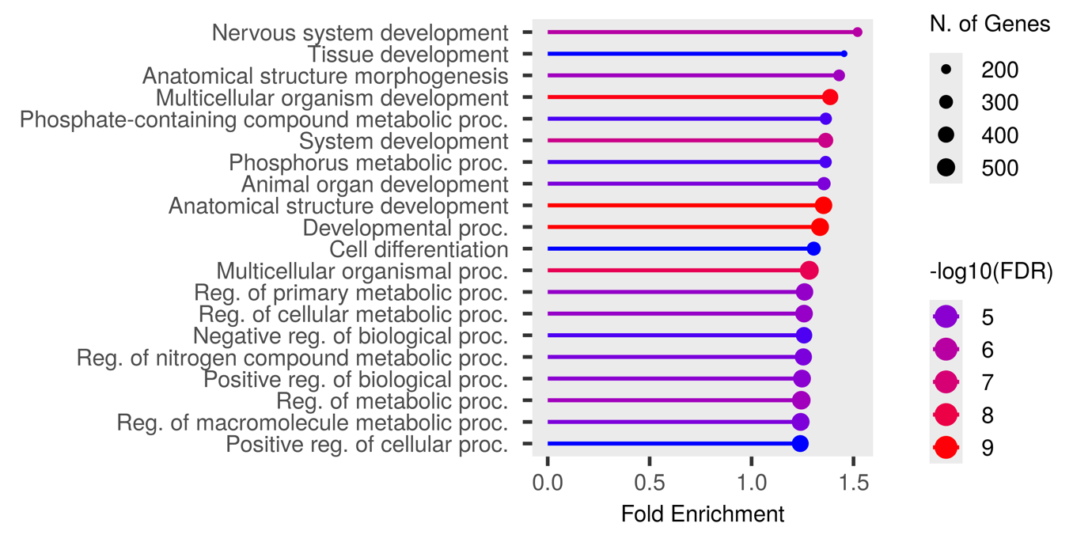
Supplementary Figure 1. Significant GO enrichment terms for the Afrikaner population

Supplementary Figure 2. Significant GO enrichment terms for the Bonsmara population

Supplementary Tables

Supplementary Table 1. Candidate genes relating to adaptation obtained from the FST analysis between the Afrikaner and Bonsmara populations and filtered by biological relevance
BTA | Gene start ª | Gene name | Role | References
1 | 50258772 | CBLB | Inflammatory response; hoof and leg disorders | Han et al., 2020; Kosińska-Selbi et al., 2020
5 | 103631360 | CD4 | Upregulated in bovine virus infected mammary tissues | Çomakli & Özdemir, 2019
17 | 35062902 | IL21 | Host-liver fluke interaction; inflammatory bowel disease | May et al., 2025; Walsh et al., 2009; Zwane et al., 2021
5 | 103493143 | PHB2 | Parkin- mediated mitophagy | De Falco et al., 2020
5 | 103502500 | PTPN6 | Resistance to vector-borne diseases; trypanotolerance | Kambal et al., 2023; Tijjani, 2019
7 | 51762895 | CD14 | Innate immunity and SCS | Gupta et al., 2018; Xue et al., 2018
9 | 59679876 | MAP3K7 | Immune response | Boschiero et al., 2025
7 | 40663606 | NLRP3 | Immune regulation; inflammasome | Bauernfeind & Hornung, 2013; Harte et al., 2017
7 | 50736654 | STING1 | Thermogenesis; immune response; resistance to vector-borne diseases | Kim et al., 2020; Huang et al., 2023; Terefe et al., 2023
8 | 104084879 | TNFSF8 | Immune response | Wang et al., 2020
11 | 92474734 | DAB2IP | QTLs associated with stillbirth | Sanchez et al., 2024
10 | 34100135 | RASGRP1 | Mastitis resistance/susceptibility | Essa et al., 2023
7 | 50680729 | DNAJC18 | Heat tolerance | Bahbahani et al., 2017
7 | 50593615 | MATR3 | Local pathogen adaptation | Kim et al., 2020

ª Gene positions measured in base pairs (bp); BTA – Bos taurus autosome

References
Bahbahani, H., Tijjani, A., Mukasa, C., Wragg, D., Almathen, F., Nash, O., et al. (2017). Signatures of selection for environmental adaptation and zebu x taurine hybrid ztness in East African shorthorn Zebu. Front. Genet. 8, 68. doi:10.3389/fgene.2017.00068
Bauernfeind, F., and Hornung, V. (2013). Of inpammasome and pathogens – sensing of microbes by the inpammasome. EMBO Mol. Med. 5, 814–826. doi:10.1002/emmm. 201201771
Boschiero, C., Beshah, E., Zhu, X., Tuo, W., and Liu, G. E. (2025). Prozling genome- wide methylation patterns in cattle infected with ostertagia osstertagi. Int. J. Mol. Sci. 26, 89. doi:10.3390/ijms26010089
Çomakli, S., and Özdemir, S. (2019). Comparative evaluation of the immune responses in cattle mammary tissues naturally infected with bovine parainpuenza virus type 3 and bovine Alphaherpesvirus-1. Pathogens 8, 26. doi:10.3380/ pathogens8010026
De Falco, F., Gentile, I., Cerino, P., Cutarelli, A., Catoi, C., and Roperto, S. (2020). Prohibitin 2 is involved in Parkin-mediated mitophagy in urothelial cells of cattle infected with bovine papillomavirus. Pathogens 9, 621. doi:10.3390/pathogens9080621
Essa, B., Al-Sharif, M., Abdo, M., Fericean, L., and Ateya, A. (2023). New insights on nucleotide sequence variants and mRNA levels of candidate genes assessing resistance/ susceptibility to mastitis in Holstein and Montbéliarde dairy cows. Vet. Sci. 10, 35. doi:10.3390/vetsci10010035
Gupta, J. P., Bhushan, B., Asaf, V. N. M., Kumar, A., Ranjan, S., Panigrahi, M., et al. (2018). Association and expression analysis of single nucleotide polymorphisms of CD14 gene with somatic cell score in crossbred cattle. Gene Rep. 12, 255–260. doi:10. 1016/j.genrep.2018.07.011
Han, S., Li, X., Liu, J., Zou, Z., Luo, L., Wu, R., et al. (2020). Bta-miR-223 targeting CBLB contributes to resistance to Staphylococcus aureus mastitis through the PI3K/ AKT/NF-kB pathway. Front. Vet. Sci. 7, 00529. doi:10.3389/fvets.2020.00529
Harte, C., Gorman, A. L., McCluskey, S., Carty, M., Bowie, A. G., Scott, C. J., et al. (2017). Alum activated the bovine NLRP3 inpammasome. Front. Immunol. 8, 01494. doi:10.3389/zmmu.2017.01494
Huang, N., Zhao, L., Wang, J., Jiang, Q., Ju, Z., Wang, X., et al. (2023). Signatures of selection in indigenous Chinese cattle genomes reveal adaptive genes and genetic variations to cold climate. J. Anim. Sci. 101, skad006. doi:10.1093/jas/skad006
Kambal, S., Tijjani, A., Ibrahim, S. A. E., Ahmed, M.-K. A., Mwacharo, J. M., and Hanotte, O. (2023). Candidate signatures of positive selection for environmental adaptation in indigenous African cattle: a review. Anim. Genet. 54, 689–709. doi:10. 1111/age.13353
Kim, K., Kwon, T., Dessie, T., Yoo, D. A., Mwai, O. A., Jang, J., et al. (2020). The mosaic genome of indigenous African cattle as a unique genetic resource for African pastoralism. Nat. Genet. 52, 1099–1110. doi:10.1038/s41588-020-0694-2
Kosiqska-Selbi, B., Suchocki, T., Egger-Danner, C., Schwarzenbacher, H., Fraszczak, M., and Szyda, J. (2020). Exploring the potential genetic heterogeneity in the incidence of hoof disorders in Austrian Fleckvieh and Braunvieh cattle. Front. Genet. 11, 577116. doi:10.3389/fgene.2020.577116
May, K., Hecker, A. S., Strube, C., Yin, T., and König, S. (2025). Genetic parameters and single-step genome-wide association analysis for trematode (Fasciola hepatica and Calicophoron/Paramphistotum spp.) infections in German dairy cows. Infect. Genet. Evol. 128, 105712. doi:10.1016/j.meegid.2025.105712
Sanchez, L., Campos-Chillon, F., Sargolzaei, M., Peterson, D. G., Sprayberry, K. A., McArthur, G., et al. (2024). Molecular mechanisms associated with the development of the metritis complex in dairy cattle, Genes (Basel). 15: 439. doi:10.3390/genes15040439
Terefe, E., Belay, G., Tijjani, A., Han, J., and Hanotte, O. (2023). Whole genome resequencing reveals genetic diversity and selection signatures of Ethiopian indigenous cattle adapted to local environments. Diversity 15, 540. doi:10.3390/d15040540
Tijjani, A. (2019). Genome diversity and adaptation of African Taurine and Zebu cattle. University of Nottingham, Nottingham. PhD thesis.
Walsh, K. P., Brady, M. T., Finlay, C. M., Boon, L., and Mills, K. H. G. (2009). Infection with a helminth parasite attenuates autoimmunity through TGF-beta-mediated suppression of Th17 and Th1 responses. J. Immunol. 183, 1577–1586. doi:10.4049/ jimmunol.0803803
Wang, M., Liang, Y., Ibeagha-Awemu, E. M., Li, M., Zhang, H., Chen, Z., et al. (2020). Genome-wide DNA methylation analysis of mammary gland tissues from Chinese Holstein cows with Staphylococcus aureus induced mastitis. Front. Genet. 11, 550515. doi:10.3389/fgene.2020.550515
Xue, Y., Gao, W. N., Chen, F., Ma, B. B., Zhou, F., Hu, Z. G., et al. (2018). CD14 gene polymorphisms associated with increased risk of bovine tuberculosis in Chinese Holstein cows. Vet. J. 232, 1–5. doi:10.1016/j.tvjl.2017.11.015
Zwane, A. A., Nxumalo, K. S., Makgahlela, M. L., van Marle-Köster, E., and Maiwashe, N. (2021). Gene-set enrichment analysis of selective sweeps reveals phenotypic traits in Nguni. S. Afr. J. Anim. Sci. 51, 6. doi:10.4314/sajas.v51i6.9

