Supplemental Material 4a. Forest plot representation of a comparison of DLC prevalence between 10-20 years and other age ranges
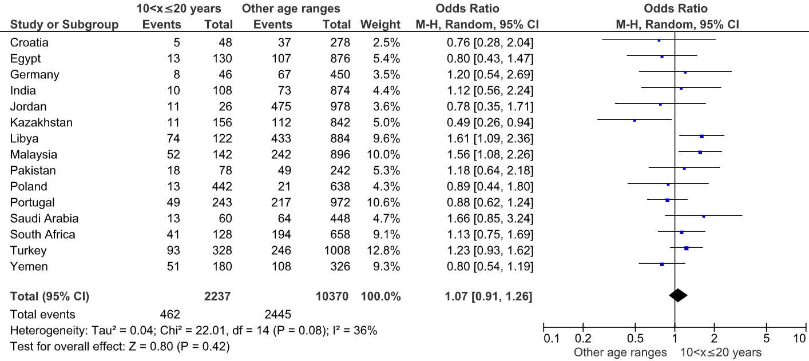
Supplemental Material 4b. Forest plot representation of a comparison of DLC prevalence between 20-30 years and other age ranges
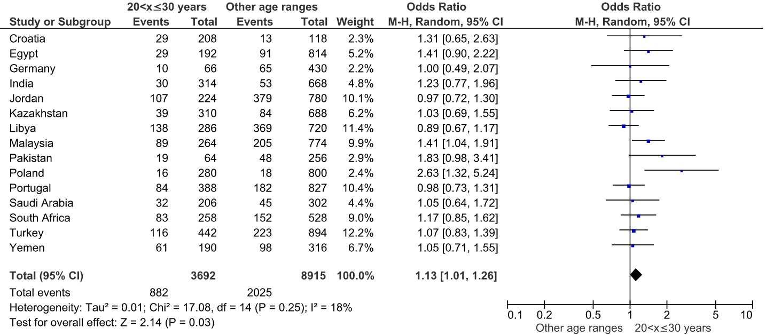
Supplemental Material 4c. Forest plot representation of a comparison of DLC prevalence between 30-40 years and other age ranges
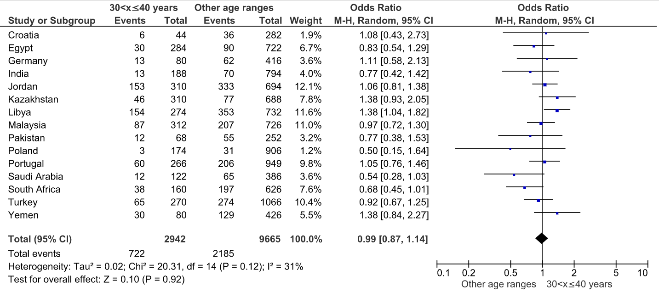

Supplemental Material 4d. Forest plot representation of a comparison of DLC prevalence between 40-50 years and other age ranges
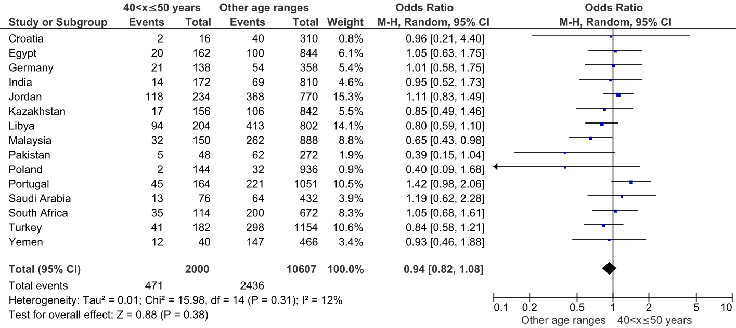
Supplemental Material 4e. Forest plot representation of a comparison of DLC prevalence above 50 years and other age ranges
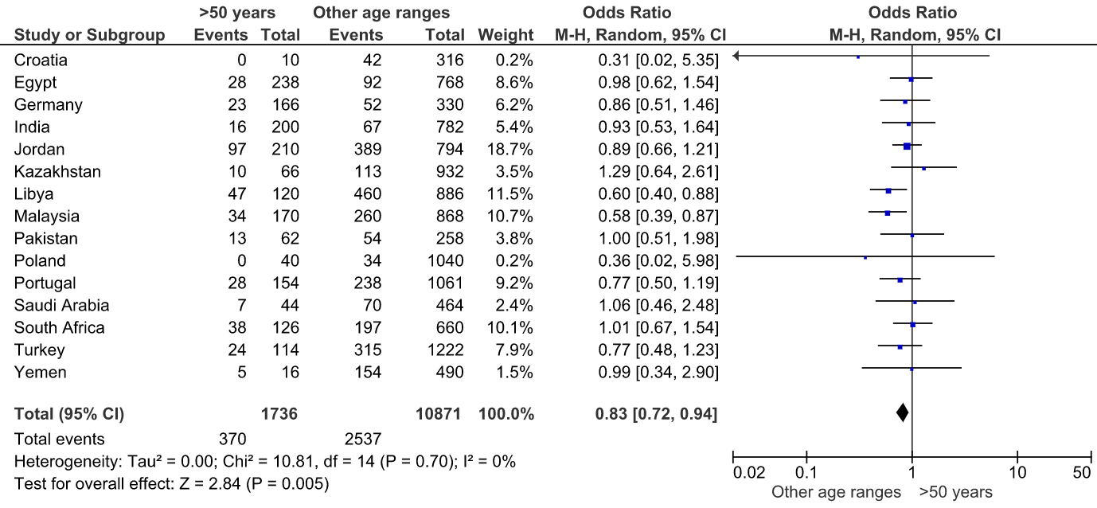
Supplemental Material 4f. Forest plot representation of comparison of DLC prevalence with a voxel size subgroup
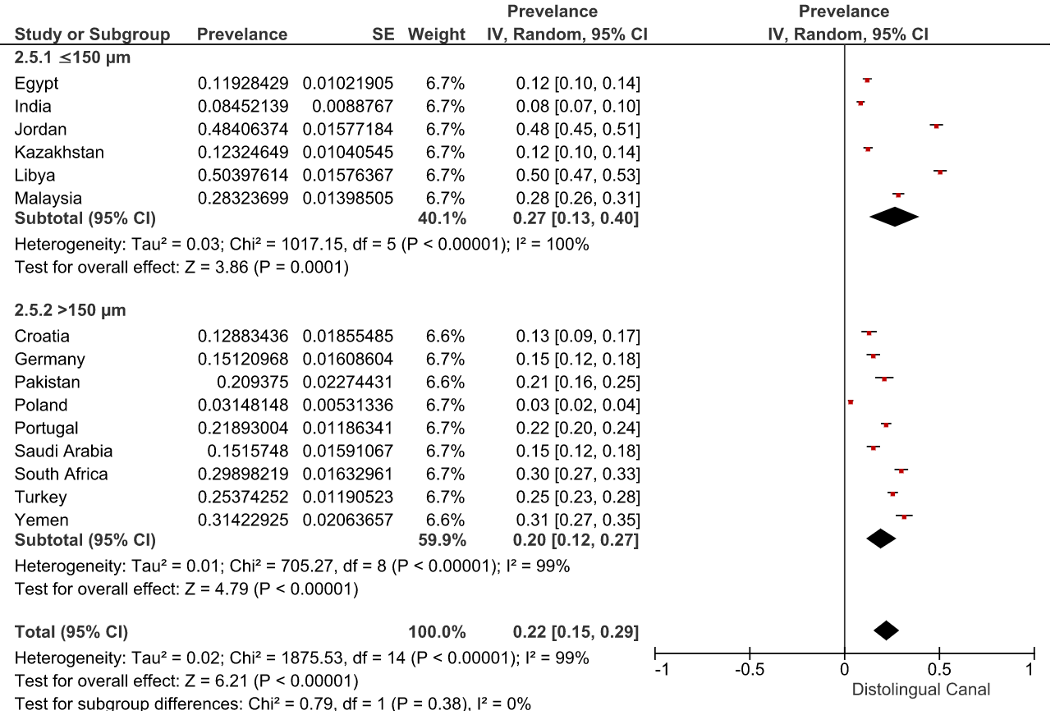
Supplemental Material 4g. Forest plot representation of comparison of RE prevalence with a voxel size subgroup
