Supplemental text and figures

Biofiltration, seasonality, and distribution system factors influence nitrifier communities in a full-scale chloraminated drinking water system

Sarah Potgieter¹, Solize Oosthuizen-Vosloo², Kathryn Langenfeld³, Katherine S. Dowdell^{1,4}, Matthew Vedrin^{1,5}, Rebecca Lahr⁶, Ameet J. Pinto⁷ & Lutgarde Raskin^{1*}

¹Department of Civil and Environmental Engineering, University of Michigan, Ann Arbor, Michigan, USA
²Institute for Cellular and Molecular Medicine, Department of Immunology, Faculty of Health Sciences, University of Pretoria, Pretoria, Gauteng, South Africa
³Ecology and Evolutionary Biology Department, University of Michigan, Ann Arbor, Michigan, USA
⁴Department of Civil and Environmental Engineering, University of Utah, Salt Lake City, Utah, USA
⁵Department of Civil, Architectural, and Environmental Engineering, The University of Texas at Austin, Austin, TX, USA
⁶Water Treatment Services, City of Ann Arbor, Ann Arbor, Michigan, USA
⁷Department of Civil and Environmental Engineering, Georgia Institute of Technology, Atlanta, Georgia, USA

* Corresponding author: Lutgarde Raskin
Email address: raskin@umich.edu

Supplemental text

Text S1: Droplet digital PCR conditions
Probe-based assays: Reaction mixtures (25 µl) consisted of 12.5 µl 1X ddPCR™ Supermix for Probes (No dUTP) (Bio-Rad), 900 nM forward and reverse primers, and 450 nM probes, and 1 and 10 ng of DNA template for amoA and Nitrospira 16S rRNA gene assays, respectively (Table S3). The remaining volume was adjusted with UltraPure™ DNase/RNase-Free Distilled Water (Invitrogen™). Cycle conditions included initial denaturation at 95 ˚C for 10 min followed by 50 cycles of denaturation at 95 ˚C for 30 s, annealing and elongation at 56 ˚C and 61 ˚C for amoA and Nitrospira 16S rRNA assays, respectively, for 1 min, final annealing at 4 ˚C for 5 min, and final denaturation at 95 ˚C for 5 min. Ramp rate was set to 1 ˚C/s.
Evagreen-based assays: Reaction mixtures (25 µl) consisted of 12.5 µl 1X QX200 ddPCR™ EvaGreen Supermix (Bio-Rad), 100 and 200 nM of forward and reverse primers for AOB 16S rRNA and comammox amoB gene assays, respectively, and 1 and 10 ng of DNA template for AOB 16S rRNA and comammox amoB gene assays, respectively (Table S3). The remaining volume was adjusted with UltraPure™ DNase/RNase-Free Distilled Water (Invitrogen™). Cycle conditions included initial denaturation at 95 ˚C for 10 min followed by 50 cycles of denaturation at 95 ˚C for 30 s, annealing and elongation at 52.5 ˚C and 58 ˚C for comammox amoB and Betaproteobacterial AOB 16S rRNA assays, respectively, for 1 min 30 s, final annealing at 4 ˚C for 5 min, and final denaturation at 95 ˚C for 5 min. Ramp rate was set to 1 ˚C/s.
With each ddPCR run, positive gBlock controls and non-template negative controls were included. Droplets were generated using the QX200™ Automated Droplet-Generator (Bio-Rad) with 20 µl of reaction mixture and Droplet Generation Oil for probes or EvaGreen (Bio-Rad) in 96-well plates. Following droplet generation, the plate was sealed and PCR was performed using the C1000 TouchTM Thermal Cycler (Bio-Rad Laboratories, Inc., Hercules, CA). Upon completion of the PCR, plates were transferred to QX200™ Droplet Reader (Bio-Rad) for automated measurement of fluorescent signals of each droplet in each well.
For each ddPCR assay, a limit of blanks (LOB) was performed, i.e., running a background matched negative control sample across a large number of wells (~30) to determine the placement of the threshold. Based on the LOB, a single threshold was applied across all samples for each assay. The empirical limits of detection (LODs) for the four gene targets were determined based on replicate concentration measurements at the lowest dilution levels. The LOD was calculated as the mean concentration at the lowest dilution where detection occurred in at least 95% of replicates, plus three times the standard deviation of those replicates (LOD = mean + 3 × SD). For the amoA gene, this calculation resulted in an empirical LOD of 1.24 copies per reaction. For the AOB 16S rRNA gene, the empirical LOD was higher, at 5.91 copies per reaction. For the Nitrospira 16S rRNA gene, the empirical LOD was calculated as 1.79 copies per reaction. Lastly, for the comammox amoB gene, the LOD was determined to be 3.5 copies per reaction. The quality and performance of each assay were assessed and optimized based on the criteria described by Lievens et al. (2016). Optimization included adjustment of DNA template concentration (to account for potential inhibitor dilution), primer concentrations, annealing temperatures, elongation times, and the number of cycles. Additionally, to reduce rain and improve amplification, primers for Nitrospira 16S rRNA and comammox amoB genes were adjusted to reduce degeneracy to be more specific to the respective MAGs identified in the dataset. The forward primer for the Nitrospira 16S rRNA gene was adjusted, from the 5’ end, by substituting the 17th nucleotide from K to a degenerate base G. Similarly, the reverse primer was modified by changing the 13th nucleotide from Y to a degenerate base A. Additionally, the forward primer for the comammox amoB gene was modified at several positions from the 5′ end: (i) the 6th nucleotide was changed from Y to T, (ii) the 9th from Y to C, (iii) the 12th from N to Y, and (iv) the 13th from S to G. The reverse primer was also modified, with the 3rd nucleotide (from the 5′ end) changed from N to Y. Primer sequences are detailed in Table S3.

Text S2: Detailed metagenomic sequence processing, de novo co-assembly, and binning
Metagenomic sequence data were processed following a modified version of the approach described by Vosloo et al. (2021), optimized to recover high-quality metagenome-assembled genomes (MAGs) and maximize microbial diversity representation in drinking water samples (Fig. S1). Briefly, raw Illumina reads were quality-trimmed and filtered for adapter sequences using fastp v0.20.0 (Chen et al., 2018). Potential vector contamination was identified by aligning reads to the UniVec_Core database (NCBI) using BWA-MEM v0.7.17 (Li, 2013), and matches were removed using samtools v1.9. Negative control samples underwent the same screening to eliminate background contaminants. Resulting BAM files were sorted (samtools sort), and paired-end FASTQ reads were recovered using bedtools bamtofastq v2.29.2. Read coverage and sequencing depth were assessed with Nonpareil v3.303 in kmer mode (Rodriguez et al., 2018), and Nonpareil curves were generated in R with Nonpareil.set (v3.3.4) (Fig. S2).
To assess read-based similarity among samples, MASH v2.2.2 (Ondov et al., 2016) was used to estimate pairwise distances. Paired FASTQ files were first interleaved with interleafq v1.0 and sketched using the sketch function. Sample comparisons were performed with the dist function, based on Jaccard indices of shared k-mers. Optimal sample clustering was determined via k-means analysis in R, using the factoextra package v1.0.7 to evaluate the number of groups by silhouette analysis with 999 Monte Carlo iterations. Clustering was executed with kmeans from the stats package v3.6.2 and visualized using fviz_cluster.
Since clustering did not reveal strong grouping by sample type, season, or location, all quality-filtered reads were pooled for de novo co-assembly using metaSPAdes v3.13.1 (Nurk et al., 2017) with kmer sizes of 21, 33, 55, 77, 99, and 127. The initial assembly produced 940,345 contigs ≥ 1 kb. Evaluation of the assembly process showed that 91.6 ± 1.87 % of raw sequence reads were retained through assembly. Contigs <1 kb were removed using seqtk, and redundant contigs were eliminated using BBTools dedupe v38.76. Assembly quality was evaluated with QUAST v5.0.2 (Gurevich et al., 2013). Mapping rates were determined (Table S4) by aligning paired-end reads to assemblies with BWA-MEM (Li, 2013) and filtering unmapped reads with samtools view (-hbS -F4), followed by sorting and calculating coverage using CoverM v0.4.0 (method = count).
Protein-coding sequences were predicted with Prokka v1.14.6 (Seemann, 2014), which used Prodigal in metagenome mode to identify open reading frames (ORFs). ORFs were annotated against the KEGG database (Kanehisa and Goto, 2020), and nitrogen cycle genes were identified based on KEGG orthologs (KOs) and KEGG pathway assignments. Gene abundance was normalized across samples as reads per kilobase per million (RPKM). Protein sequences were aligned with MAFFT v7 using the L-INS-i method and trimmed for consistency (REF). Maximum likelihood phylogenetic trees were generated with IQ-TREE (Trifinopoulos et al., 2016) using model selection and 1000 bootstrap iterations, and visualized in iTOL (Letunic and Bork, 2024).
Contigs ≥ 1 kb were binned using Anvi'o v6.1 (Eren et al., 2015) with CONCOCT v1.1.1 (Alneberg et al., 2014), MetaBAT v2.12.1 (Kang et al., 2019), and MaxBin v2.2.4 (Wu et al., 2016), incorporating tetranucleotide frequencies and contig coverage across samples. DAS Tool v1.1.0 (Sieber et al., 2018) was used to integrate binning outputs and identify high-quality nonredundant bins using default parameters. This process yielded 2467 MAGs. Anvi'o's anvi-summarize was used to extract bin statistics (i.e., total size, number of contigs, N50, GC content), and CheckM v1.0.18 (Parks et al., 2015) provided quality estimates (completeness, redundancy, strain heterogeneity, etc.). Read mapping rates and coverage calculations followed the same workflow as above using BWA-MEM, samtools, and CoverM.
To enhance bin quality, bins with ≥50% completeness were selected for reassembly (Fig. S2). Paired quality-trimmed reads linked to individual bins were extracted with samtools and reassembled using metaSPAdes v.3.13.1 (Nurk et al., 2017) with kmer sizes 21, 33, 55, 77, 99, and 127. Reassembled contigs were binned and evaluated as previously described. After filtering for completeness >50% and contamination <10%, 1284 MAGs were retained. CONCOCT, MetaBAT2, and DAS Tool bins showed high mapping rates (>81%), while MaxBin2 bins exhibited lower mapping (52.52 ± 3.93%) and were further excluded from downstream analysis (Table S5).
Further manual refinement was performed on the original bin sets from MetaBAT and Das Tool and the reassembled bin sets of CONCOCT using the interactive interface of Anvi'o v6.1 (Fig. S2). MAG characteristics and mapping rates were determined as described above. To assess completeness according to Metagenome-Assembled Genome (MIMAG) standards (Bowers et al., 2017), ribosomal RNAs (rRNAs) and transfer RNAs (tRNAs) were annotated with Prokka v. 1.14.6. Dereplication was performed with dRep v2.6.2 (Olm et al., 2017) to cluster MAGs into species-level representative genomes (SRGs) at 95% average nucleotide identity (ANI). This resulted in 668 dereplicated MAGs with an average completeness of 82.14 ± 15.29% and contamination of 2.23 ± 2.17% (Table S7). MAGs were classified taxonomically using GTDB-Tk v0.3.2 (Chaumeil et al., 2020), which places genomes into reference trees of concatenated marker proteins. MAG abundance (reads, RPKM, and covered bases) was calculated with CoverM. Phylogenomic analysis of nitrifier MAGs was conducted with GToTree v1.6.31 (Lee, 2019), using Nitrosomonas and Nitrospira reference genomes from NCBI. GToTree extracted conserved single-copy marker genes, aligned them with MAFFT, trimmed alignments with trimAl, and constructed maximum likelihood trees using IQ-TREE.

Text S3: Validation of Nitrosomonas cluster 6a amoA gene target
Nitrifier gene targets included the betaproteobacterial AOB 16S rRNA gene (Hermansson and Lindgren, 2001), the Nitrospira 16S rRNA gene (Graham et al., 2007), and the Nitrospira-like comammox amoB gene (Vilardi et al., 2022). In addition to overall AOB quantification via 16S rRNA genes, the metagenomic data revealed that all Nitrosomonas MAGs belonged to Nitrosomonas cluster 6a. Consequently, this group was specifically targeted using the Nitrosomonas cluster 6a amoA gene primer set (Harms et al., 2003; Orschler et al., 2020) (Table S3). Further, all amoA genes identified within the metagenomic dataset were subjected to phylogenetic analysis together with other betaproteobacterial AOB and comammox amoA gene reference sequences (Fig. S4). It was confirmed that all amoA contigs grouped closely within Nitrosomonas cluster 6a, alongside Nitrosomonas oligotropha and Nitrosomonas sp Is79A3, except for those associated with comammox bacteria. To confirm that the amoA primers bound to the expected gene regions, the primer sequences were aligned to the amoA contigs. Primer binding sites were found within the amoA contigs, showing average percentage identities of 96.9%, 99.4%, and 99.4% for the forward, reverse primer, and probe, respectively, with the amoA contigs (Fig. S5). Further, with the exception of MAG_097, the abundance of Nitrosomonas MAGs positively correlated with the gene copy abundance of the amoA gene (τ [Kendall rank correlation coefficient] = 0.52 to 0.58, p < 0.001), indicating that amoA gene abundances accurately reflected the abundance of Nitrosomonas MAGs (Fig. S6).

References
- Alneberg, J., Bjarnason, B.S., de Bruijn, I., Schirmer, M., Quick, J., Ijaz, U.Z., Loman, N.J., Andersson, A.F. and Quince, C., 2013. CONCOCT: clustering contigs on coverage and composition. arXiv preprint arXiv:1312.4038.
- Bowers, R.M., Kyrpides, N.C., Stepanauskas, R., Harmon-Smith, M., Doud, D., Reddy, T.B.K., Schulz, F., Jarett, J., Rivers, A.R., Eloe-Fadrosh, E.A. and Tringe, S.G., 2017. Minimum information about a single amplified genome (MISAG) and a metagenome-assembled genome (MIMAG) of bacteria and archaea. Nature biotechnology, 35(8), pp.725-731.
- Chaumeil, P.A., Mussig, A.J., Hugenholtz, P. and Parks, D.H., 2020. GTDB-Tk: a toolkit to classify genomes with the Genome Taxonomy Database.
- Chen, S., Zhou, Y., Chen, Y., Gu, J. 2018. Fastp: An ultra-fast all-in-one FASTQ preprocessor, p. i884–i890. In Bioinformatics. Oxford University Press.
- Eren, A.M., Esen, Ö.C., Quince, C., Vineis, J.H., Morrison, H.G., Sogin, M.L. and Delmont, T.O., 2015. Anvi’o: an advanced analysis and visualization platform for ‘omics data. PeerJ, 3, p.e1319.
- Graham, C.E., 2007. Experimental demonstration of chaotic instability in biological nitrification. The ISME journal, 1(5), pp.385-393.
- Gurevich, A., Saveliev, V., Vyahhi, N. and Tesler, G., 2013. QUAST: quality assessment tool for genome assemblies. Bioinformatics, 29(8), pp.1072-1075.
- Hermansson, A. and Lindgren, P.E., 2001. Quantification of ammonia-oxidizing bacteria in arable soil by real-time PCR. Applied and environmental microbiology, 67(2), pp.972-976.
- Kanehisa, M. and Goto, S., 2000. KEGG: kyoto encyclopedia of genes and genomes. Nucleic acids research, 28(1), pp.27-30.
- Kang, D.D., Li, F., Kirton, E., Thomas, A., Egan, R., An, H. and Wang, Z., 2019. MetaBAT 2: an adaptive binning algorithm for robust and efficient genome reconstruction from metagenome assemblies. PeerJ, 7, p.e7359.
- Lee, M.D., 2019. GToTree: a user-friendly workflow for phylogenomics. Bioinformatics, 35(20), pp.4162-4164.
- Letunic, I. and Bork, P., 2024. Interactive Tree of Life (iTOL) v6: recent updates to the phylogenetic tree display and annotation tool. Nucleic acids research, 52(W1), pp.W78-W82.
- Li, H. 2013. Aligning sequence reads, clone sequences and assembly contigs with BWAMEM. Li H, Handsaker B, Wysoker A, Fennell T, Ruan J, Homer N, Marth G, Abecasis G, Durbin R. 2009. The Sequence Alignment/Map format and SAMtools. Bioinformatics 25:2078–2079.
- Lievens, A., Jacchia, S., Kagkli, D., Savini, C. and Querci, M., 2016. Measuring digital PCR quality: performance parameters and their optimization. PloS one, 11(5), p.e0153317.
- Nurk, S., Meleshko, D., Korobeynikov, A. and Pevzner, P.A., 2017. metaSPAdes: a new versatile metagenomic assembler. Genome research, 27(5), pp.824-834.
- Olm, M.R., Brown, C.T., Brooks, B. and Banfield, J.F., 2017. dRep: a tool for fast and accurate genomic comparisons that enables improved genome recovery from metagenomes through de-replication. The ISME journal, 11(12), pp.2864-2868.
- Ondov, B.D., Treangen, T.J., Melsted, P., Mallonee, A.B., Bergman, N.H., Koren, S. and Phillippy, A.M., 2016. Mash: fast genome and metagenome distance estimation using MinHash. Genome biology, 17, pp.1-14.
- Parks, D.H., Imelfort, M., Skennerton, C.T., Hugenholtz, P. and Tyson, G.W., 2015. CheckM: assessing the quality of microbial genomes recovered from isolates, single cells, and metagenomes. Genome research, 25(7), pp.1043-1055.
- Rodriguez-R LM, Gunturu S, Tiedje JM, Cole JR, Konstantinidis KT. 2018. Nonpareil 3: Fast Estimation of Metagenomic Coverage and Sequence Diversity. mSystems.
- Seemann, T. 2014. Prokka: rapid prokaryotic genome annotation. Bioinformatics 30, no. 14: 2068-2069.
- Sieber, C.M., Probst, A.J., Sharrar, A., Thomas, B.C., Hess, M., Tringe, S.G. and Banfield, J.F., 2018. Recovery of genomes from metagenomes via a dereplication, aggregation and scoring strategy. Nature microbiology, 3(7), pp.836-843.
- Trifinopoulos, J., Nguyen, L.T., von Haeseler, A. and Minh, B.Q., 2016. W-IQ-TREE: a fast online phylogenetic tool for maximum likelihood analysis. Nucleic acids research, 44(W1), pp.W232-W235.
- Vilardi, K.J., Cotto, I., Sevillano, M., Dai, Z., Anderson, C.L. and Pinto, A., 2022. Comammox Nitrospira bacteria outnumber canonical nitrifiers irrespective of electron donor mode and availability in biofiltration systems. FEMS Microbiology Ecology, 98(4), p.fiac032.
- Vosloo, S., Huo, L., Anderson, C.L., Dai, Z., Sevillano, M. and Pinto, A., 2021. Evaluating de Novo Assembly and Binning Strategies for Time Series Drinking Water Metagenomes. Microbiology spectrum, 9(3), pp.e01434-21.
- Wu, Y.W., Simmons, B.A. and Singer, S.W., 2016. MaxBin 2.0: an automated binning algorithm to recover genomes from multiple metagenomic datasets. Bioinformatics, 32(4), pp.605-607.

Supplemental figures
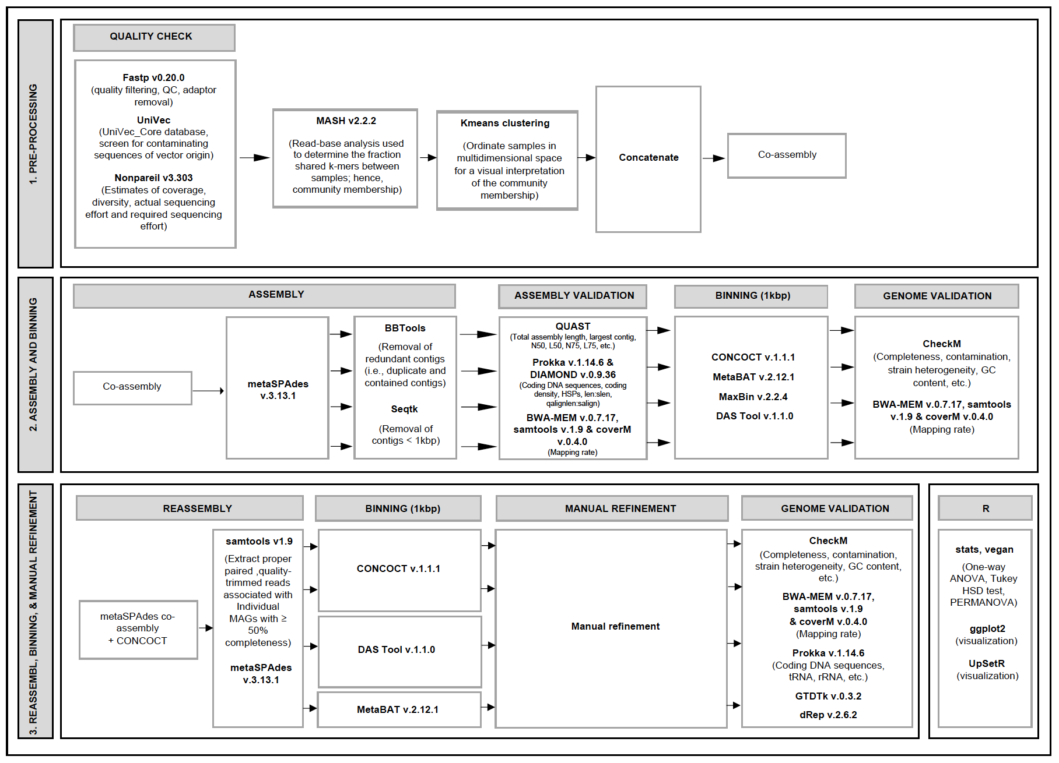
Fig. S1: Metagenomic sequence processing workflow adapted from Vosloo et al., 2021. Workflow including preprocessing and MASH-based distance analysis, assembly (MetaSPAdes), and binning (CONCOCT, MetaBAT, MaxBIN, and DAS Tool), followed by reassembly (MetaSPAdes), binning (CONCOCT, MetaBAT, and DAS Tool), and manual refinement (Anvio). Source: Potgieter et al. (2025). © The Water Research Foundation.

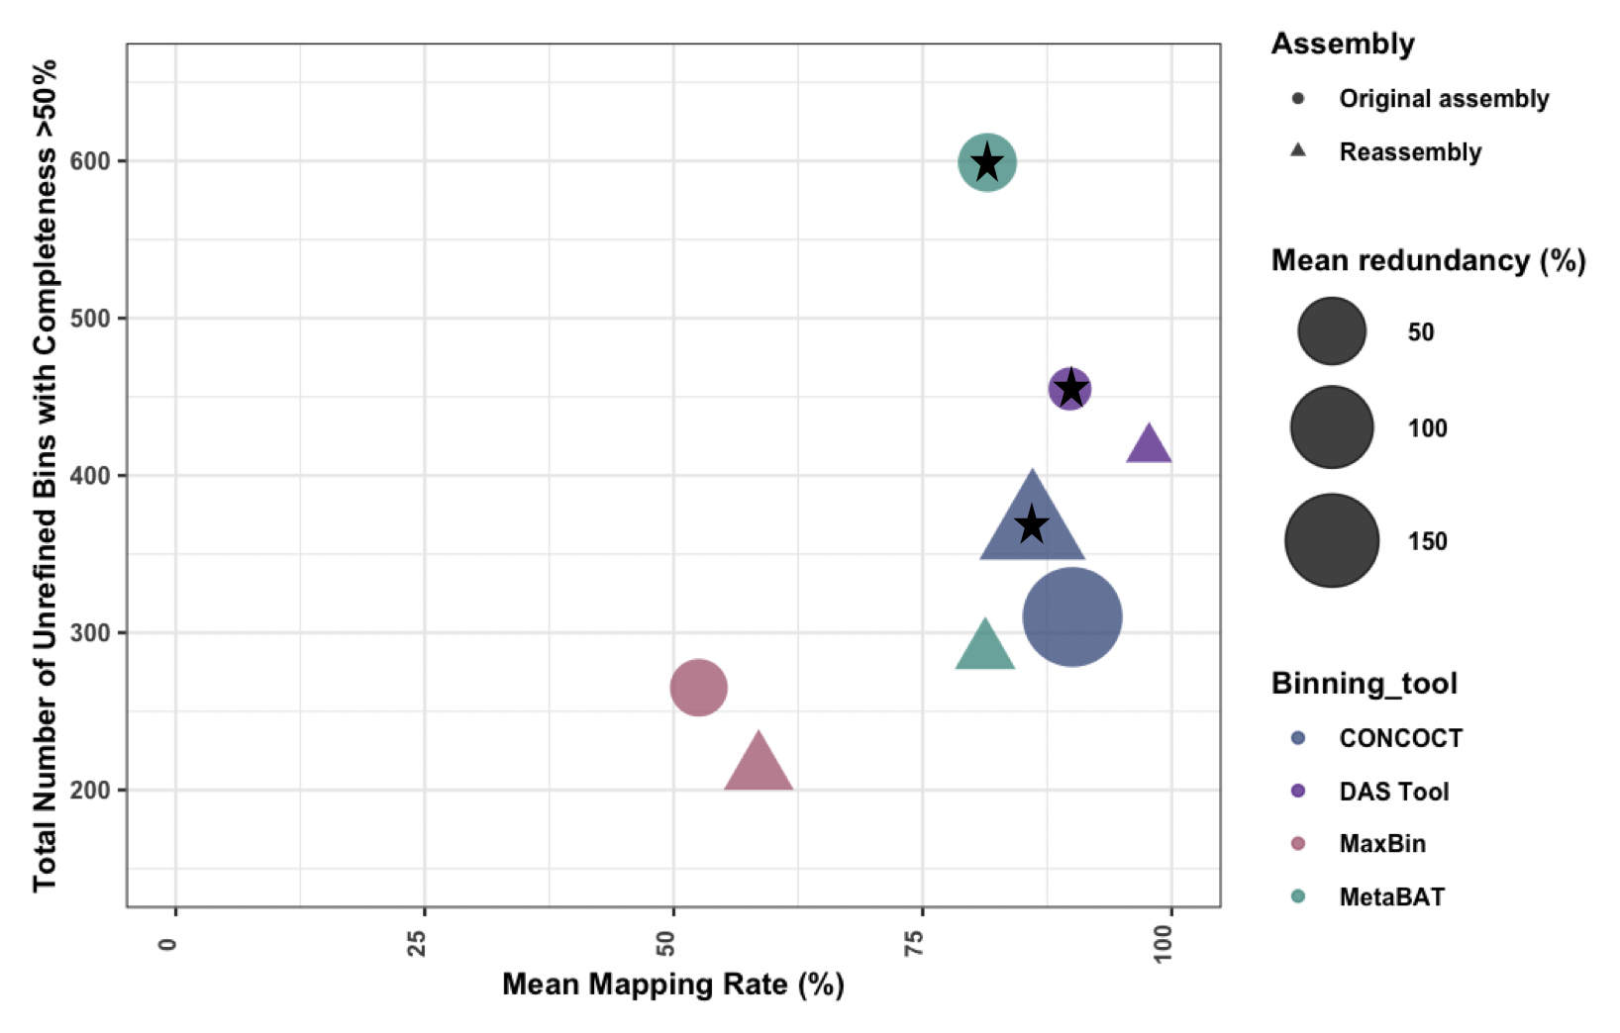
Fig. S2: Bubble plot showing the number of unrefined bins with completeness > 50% and their mean mapping rate for the different binning tools (i.e., CONCOCT, DAS Tool, MaxBin, and MetaBAT) resulting from original assembly (circles) and reassembly (triangles). Circle and triangle sizes indicate the percentage mean redundancy across all bins. Bin sets indicated with a star show those selected for further manual refinement. Source: Potgieter et al. (2025). © The Water Research Foundation.

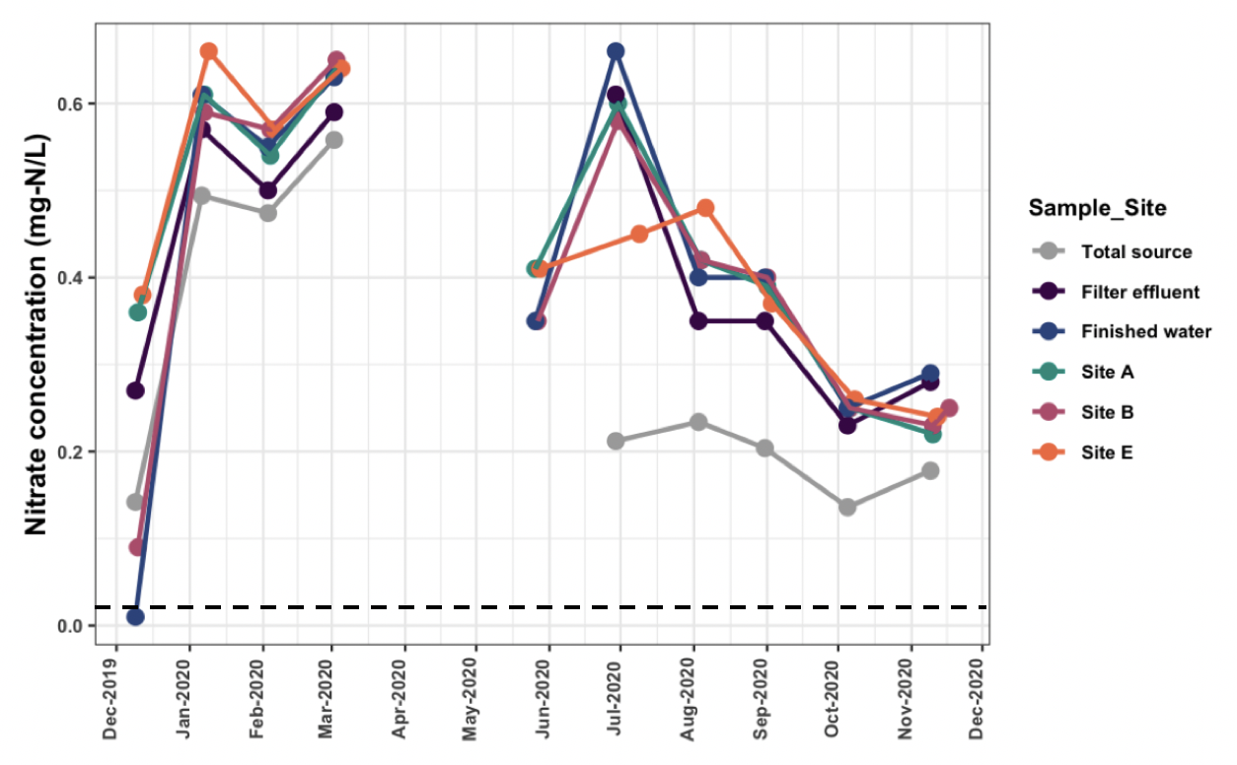
Fig. S3: Nitrate concentrations (mg-N/L) throughout the year for each sample location. Samples were not collected in April and early May due to the COVID-19 pandemic. The limit of detection (LOD) for nitrate was 0.02 mg/L NO₃-N (dashed black line). Total source refers to the nitrate concentrations in the combined surface water and groundwater source waters.
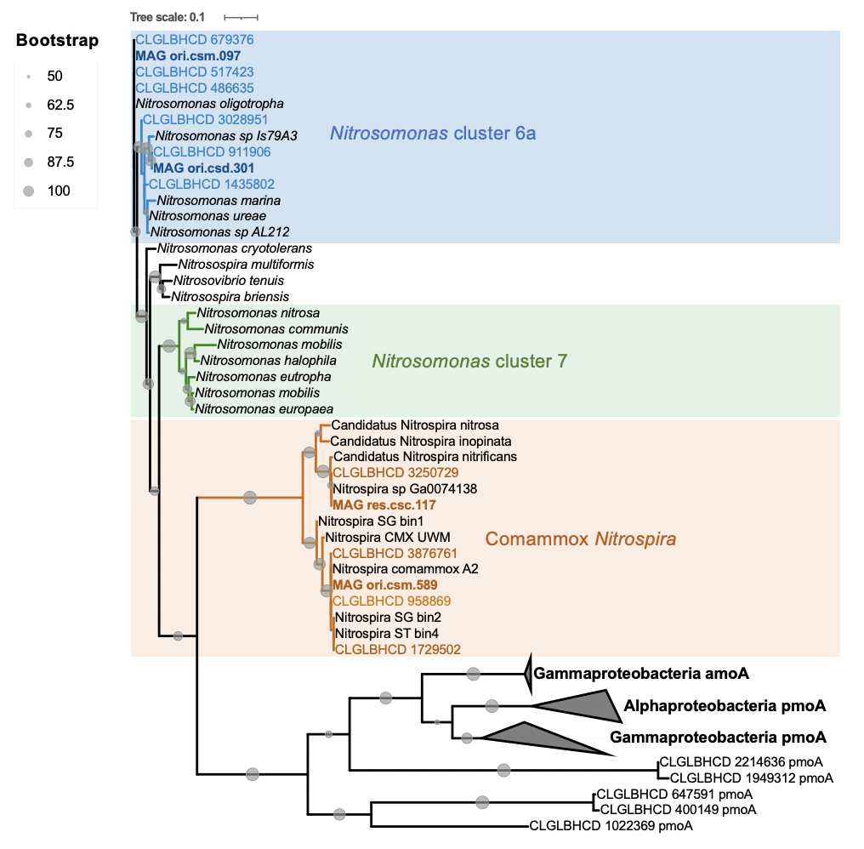

Fig. S4: Maximum likelihood tree based on the ammonia monooxygenase subunit A (amoA) identified within the metagenomic dataset (contigs) and in the respective Nitrosomonas MAGs (bolded). Genes identified from this study are colored according to cluster, while reference genes are in black. Source: Potgieter et al. (2025). © The Water Research Foundation.
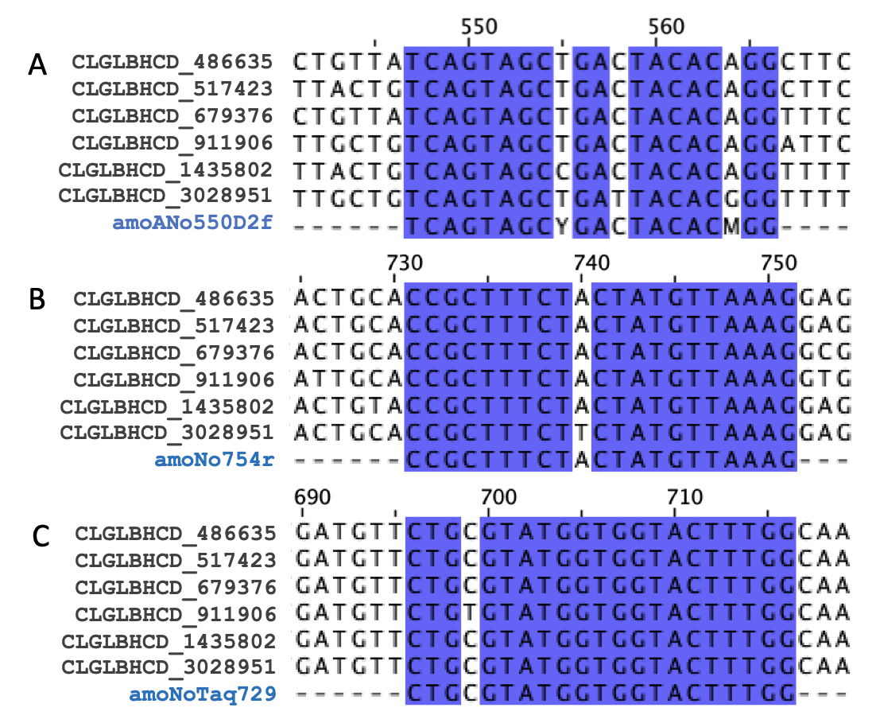
Fig. S5: Primer alignment of Nitrosomonas cluster 6a primer (A, forward; B, reverse) and probe (C) sequences (Harms et al., 2003; Orschler et al., 2019) with amoA contigs identified as Nitrosomonas cluster 6a in Fig. S4. Percentage identities were 96.9% for the forward primer, 99.4% for the reverse primer, and 99.4% for the probe.

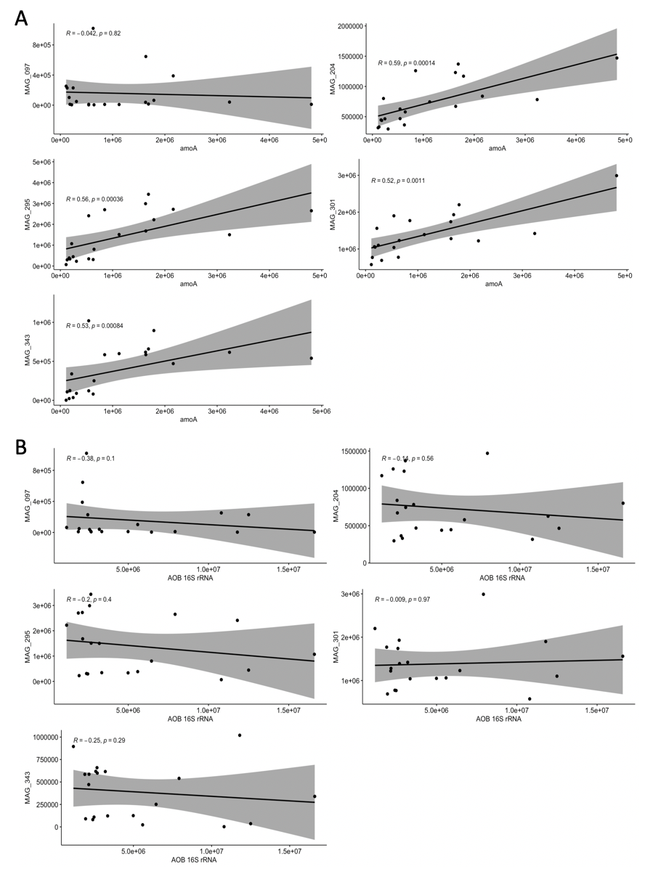
Fig. S6: Correlation analyses using Kendall's rank correlation tau between the abundance of each Nitrosomonas MAG (copies/L) and (A) N. oligotropha amoA ddPCR gene abundance data and (B) AOB 16S rRNA ddPCR gene abundance data.
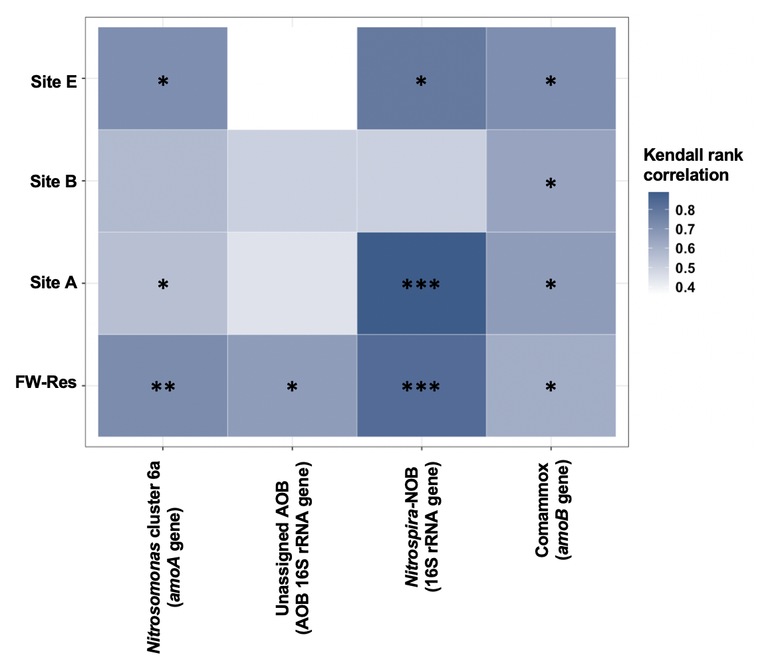
Fig. S7: Kendall's rank correlation tau analysis of nitrifier abundances, as determined through ddPCR (gene copies/L), between different sample locations (FW-Res, Site A, Site B, and Site E) and the filter effluent (FE). P values are indicated as follows: p < 0.05 (*), p < 0.01 (**), p < 0.001 (***).

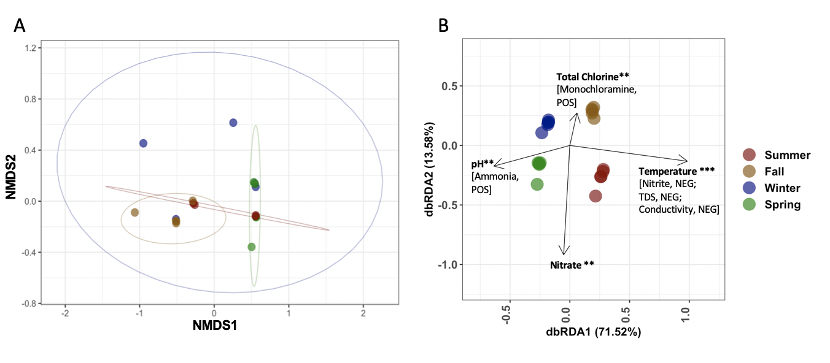
Fig. S8: Bray−Curtis dissimilarity-based ordinations. (A) NMDS (B) dbRDA biplot illustrates the relationship among basic water quality parameters and microbial community structure of the 668 MAGs. Water quality parameters that significantly explained differences in community composition, as determined by PERMANOVA analysis, are indicated by black arrows. Collinear variables are shown in brackets, with “POS” and “NEG” denoting positive and negative correlations at Pearson’s correlation coefficients of >0.70 and <0.70, respectively. Source: Potgieter et al. (2025).⁴² © The Water Research Foundation.

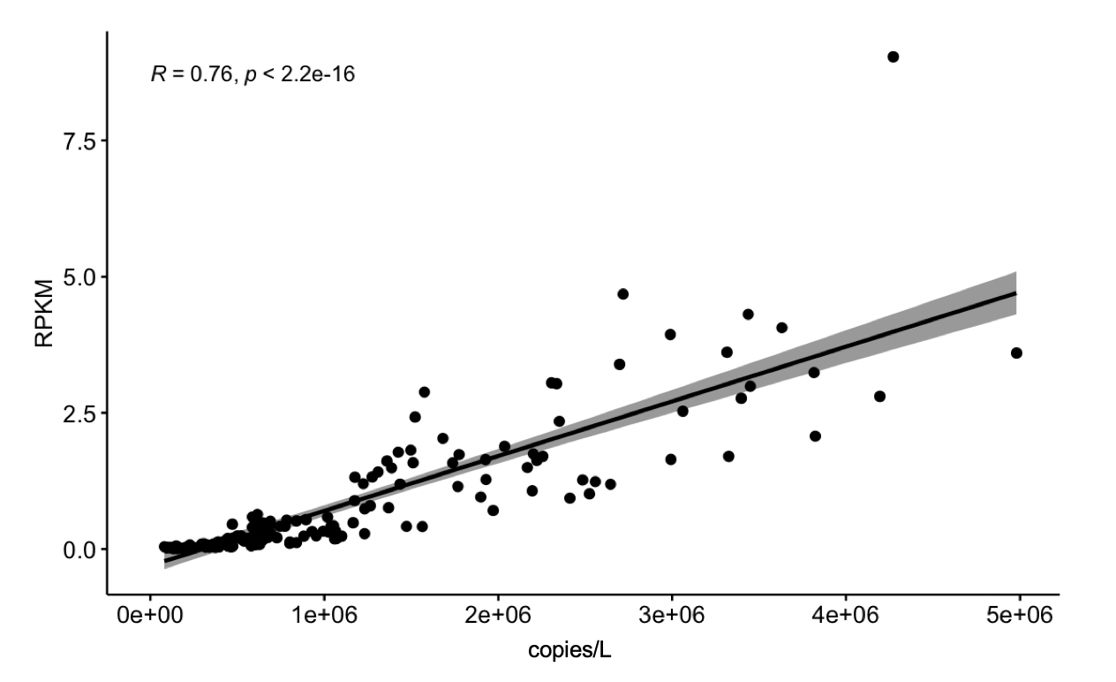
Fig. S9: Correlation analyses using Kendall's rank correlation tau between the RPKM of nitrifier MAGs and absolute abundances (copies/L) of nitrifier MAGs determined using QuantMeta (Langenfeld et al., 2025). Source: Potgieter et al. (2025).⁴² © The Water Research Foundation.
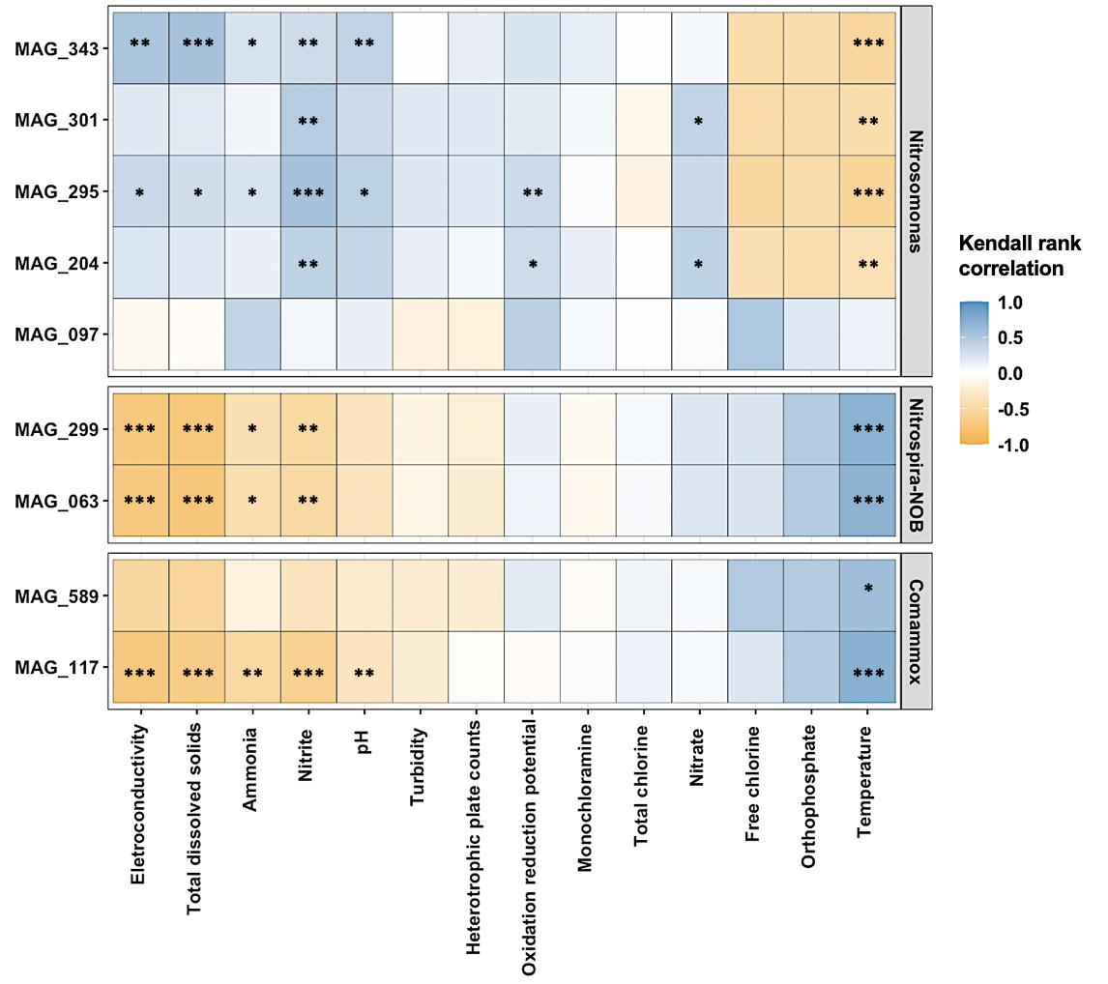
Fig. S10: Kendall's rank correlation tau analysis between water quality parameters and the abundance of nitrifier MAGs (copies/L). P values indicated as follows: p < 0.05 (*), p < 0.01 (**), p < 0.001 (***). Source: Potgieter et al. (2025).⁴² © The Water Research Foundation.

