Supplementary materials

Table S1. Posterior estimates of the scaled and centred body mass (g) by the scaled and centred value of meerkat offspring age (in days), offspring sex (female, F; male, M) and scaled and centred rainfall within the past 30 days (mm). Probabilities of practical significance (ps) above 0.85 and probabilities of direction (pd) above 95% are bolded.
Parameter | Estimate | SD | 95% CrI | pd | ps
Intercept | -0.13 | 0.09 | [-0.30, 0.04] | 92.99% | 0.63
scale(Age) | 0.79 | 0.01 | [0.78, 0.81] | 100% | 1.00
SexM | 0.16 | 0.11 | [0.01, 0.41] | 100% | 0.73
scale(Rainfall) | 0.01 | 0.01 | [0.00, 0.00] | 100% | 0.00
sigma | 0.35 | 0.00 | [0.34, 0.35] | 100% | 1.00
SD/Cor:(ID)  Intercept | 0.51 | 0.05 | [0.43, 0.63] | 100% | 1.00
Estimates are median estimates. CrI = equal-tailed credible interval; SD = standard deviation; N = 3,053; LOO-adjusted (leave-one-out cross-validation) R² = 0.88, [0.86, 0.89]; Variance ratio (ID) = 0.24, [0.20, 0.27].

Table S2. Posterior estimates from a multivariate model for meerkat repeat call proportions per 1 standard deviation (SD) change in age (days), body mass offset (%), linear and quadratic group size, (normalised) linear and quadratic competition score and rainfall across offspring sex (female, F; male, M) and maternal treatment (dominant control, DC; subordinate control, SC; dominant treated, DT). Values for age, body mass offset, group size, normalised competition score and monthly rainfall were scaled and centred. Probabilities of practical significance (ps) above 0.85 and probabilities of direction (pd) above 95% are bolded.
Parameter | Median | SD | 95% CrI | pd | ps | ESS
Intercept (DC, SexF) | -0.52 | 0.47 | [-1.45, 0.38] | 87.41% | 0.78 | 10,317
SC | 0.29 | 0.58 | [-0.80, 1.46] | 69.44% | 0.57 | 9,673
DT | -1.08 | 0.68 | [-2.39, 0.28] | 93.99% | 0.90 | 13,495
Age | -2.15 | 0.29 | [-2.74, -1.59] | 100% | 1.00 | 9,735
SexM | 0.22 | 0.31 | [-0.39, 0.82] | 77.29% | 0.56 | 11,155
Body mass offset | -0.39 | 0.28 | [-0.93, 0.16] | 92.35% | 0.78 | 6,747
Competition | -0.26 | 0.57 | [-1.39, 0.89] | 67.62% | 0.56 | 11,284
Competition² | 0.30 | 0.18 | [-0.03, 0.68] | 96.04% | 0.75 | 10,253
Group size | 0.13 | 0.38 | [-0.56, 0.93] | 64.27% | 0.45 | 7,160
Group size² | -0.56 | 0.31 | [-1.14, 0.07] | 95.89% | 0.88 | 8,511
Rainfall | -0.33 | 0.26 | [-0.85, 0.17] | 90.14% | 0.72 | 6,379
SC:Age | -0.14 | 0.37 | [-0.88, 0.60] | 64.37% | 0.45 | 11,351
DT:Age | 0.40 | 0.66 | [-0.88, 1.70] | 72.60% | 0.63 | 12,019
SC:SexM | 0.52 | 0.41 | [-0.29, 1.33] | 89.63% | 0.80 | 12,277
DT:SexM | -0.12 | 0.44 | [-1.01, 0.73] | 61.32% | 0.44 | 12,365
Age:SexM | 0.55 | 0.38 | [-0.19, 1.31] | 92.58% | 0.84 | 9,339
SC:Body mass offset | 0.29 | 0.36 | [-0.41, 1.01] | 79.14% | 0.62 | 8,411
DT:Body mass offset | 0.40 | 0.74 | [-1.07, 1.84] | 70.76% | 0.62 | 17,685
Age:Body mass offset | -0.23 | 0.85 | [-1.87, 1.45] | 60.82% | 0.52 | 13,070
SC:Competition | -0.08 | 0.94 | [-1.91, 1.78] | 53.63% | 0.46 | 28,553
DT:Competition | -0.60 | 0.42 | [-1.61, 0.01] | 97.25% | 0.89 | 8,832
SC:Competition² | 0.58 | 0.48 | [-0.42, 1.46] | 88.19% | 0.80 | 8,266
DT:Competition² | 0.01 | 0.55 | [-1.08, 1.11] | 50.79% | 0.38 | 13,596
Age:Competition | 0.15 | 0.45 | [-0.82, 0.98] | 62.66% | 0.47 | 8,724
Age:Competition² | 0.87 | 0.56 | [-0.26, 1.94] | 93.43% | 0.89 | 12,416
SC:Group size | 0.27 | 0.40 | [-0.49, 1.05] | 75.44% | 0.59 | 10,520
DT:Group size | -0.31 | 0.39 | [-1.08, 0.45] | 78.30% | 0.63 | 8,707
SC:Group size² | 0.00 | 0.31 | [-0.60, 0.61] | 50.21% | 0.28 | 10,728
DT:Group size² | -0.55 | 0.21 | [-0.96, -0.16] | 99.73% | 0.97 | 7,479
Age:Group size | -0.51 | 0.49 | [-1.44, 0.47] | 84.40% | 0.74 | 12,714
Age:Group size² | -0.36 | 0.41 | [-1.30, 0.25] | 83.26% | 0.67 | 10,654
SC:Rainfall | -0.17 | 0.26 | [-0.71, 0.33] | 74.86% | 0.49 | 8,700
DT:Rainfall | -0.49 | 0.26 | [-1.01, 0.00] | 97.56% | 0.89 | 10,526
Age:Rainfall | -0.11 | 0.22 | [-0.55, 0.31] | 70.35% | 0.38 | 7,674
SC:Age:SexM | -0.15 | 0.43 | [-0.97, 0.70] | 63.76% | 0.47 | 13,279
DT:Age:SexM | -0.11 | 0.39 | [-0.88, 0.64] | 61.04% | 0.43 | 12,720
SC:Age:Body mass offset | 0.45 | 0.29 | [-0.10, 1.03] | 94.51% | 0.83 | 9,921
DT:Age:Body mass offset | 0.47 | 0.28 | [-0.06, 1.02] | 95.81% | 0.86 | 9,014
SC:Age:Competition | 0.23 | 0.69 | [-1.11, 1.59] | 63.33% | 0.53 | 17,525
DT:Age:Competition | -0.70 | 0.93 | [-2.52, 1.13] | 77.06% | 0.71 | 17,220
SC:Age:Competition² | 0.18 | 0.93 | [-1.66, 2.00] | 57.54% | 0.50 | 26,565
DT:Age:Competition² | 0.08 | 0.53 | [-0.97, 1.12] | 56.06% | 0.42 | 10,539
SC:Age:Group size | 0.83 | 0.36 | [0.14, 1.55] | 99.09% | 0.97 | 10,890
DT:Age:Group size | -0.17 | 0.43 | [-0.99, 0.70] | 64.93% | 0.49 | 9,771
SC:Age:Group size² | 0.90 | 0.36 | [0.22, 1.62] | 99.47% | 0.98 | 10,376
DT:Age:Group size² | 0.11 | 0.71 | [-1.27, 1.50] | 56.13% | 0.46 | 11,663
SC:Age:Rainfall | -0.12 | 0.47 | [-1.05, 0.80] | 60.49% | 0.45 | 15,328
DT:Age:Rainfall | -0.31 | 0.38 | [-1.07, 0.42] | 79.40% | 0.64 | 10,677
SD Litter Intercept | 0.81 | 0.26 | [0.39, 1.39] | 100% | 1.00 | 5,420
SD Litter:ID Intercept | 0.33 | 0.16 | [0.04, 0.65] | 100% | 0.84 | 3,235
phi | 2.79 | 0.28 | [2.30, 3.38] | 100% | 1.00 | 16,121
zi | 0.01 | 0.01 | [0.00, 0.03] | 100% | 0.00 | 20,637
Estimates are median estimates and on logit scale. CrI = equal tailed credible interval; ESS = effective sample size. N = 481; LOO-adjusted (leave-one-out cross-validation) R² = 0.73, [0.67, 0.78]; SD Age = 28.76 days; SD Body mass offset = 11.52%; SD Competition = 0.15; SD Group size = 8.70, SD Rainfall = 18.55 mm.
Table S3. Post-hoc hypothesis tests comparing the effect of maternal treatment, age, and other socioecological predictors on repeat call proportions. Each row represents a contrast between different maternal treatment groups (dominant control, DC; subordinate control, SC; dominant treated, DT) for a given predictor. Posterior probabilities exceeding 0.95 are bolded, indicating strong support for the hypothesis.
Maternal treatment:Age:Body mass offset
Hypothesis | Estimate | SD | CI lower | CI upper | Evidence ratio | Posterior probability
DC - SC < 0 | -1.01 | 0.46 | -1.77 | -0.27 | 83.34 | 0.99
DC - DT < 0 | -1.03 | 0.45 | -1.76 | -0.30 | 105.06 | 0.99
SC - DT < 0 | -0.02 | 0.28 | -0.48 | 0.45 | 1.08 | 0.52
Maternal treatment:Competition
Hypothesis | Estimate | SD | CI lower | CI upper | Evidence ratio | Posterior probability
DC - SC < 0 | -0.66 | 1.11 | -2.50 | 1.19 | 2.67 | 0.73
DC - DT < 0 | -0.04 | 1.11 | -1.87 | 1.80 | 1.07 | 0.52
SC - DT > 0 | 0.62 | 1.08 | -1.18 | 2.38 | 2.61 | 0.72
Maternal treatment:Age:Group size
Hypothesis | Estimate | SD | CI lower | CI upper | Evidence ratio | Posterior probability
DC - SC < 0 | -1.00 | 0.57 | -1.95 | -0.08 | 26.83 | 0.96
DC - DT < 0 | -0.02 | 0.62 | -1.06 | 0.98 | 1.01 | 0.50
SC - DT > 0 | 0.99 | 0.44 | 0.26 | 1.71 | 80.87 | 0.99
Maternal treatment:Age:Group size²
Hypothesis | Estimate | SD | CI lower | CI upper | Evidence ratio | Posterior probability
DC - SC < 0 | -1.40 | 0.56 | -2.35 | -0.49 | 183.21 | 0.99
DC - DT < 0 | -0.61 | 0.78 | -1.91 | 0.68 | 3.48 | 0.78
SC - DT > 0 | 0.80 | 0.77 | -0.47 | 2.06 | 5.57 | 0.85
Maternal treatment:Rainfall
Hypothesis | Estimate | SD | CI lower | CI upper | Evidence ratio | Posterior probability
DC - SC < 0 | -0.61 | 0.59 | -1.59 | 0.36 | 5.45 | 0.84
DC - DT < 0 | -0.02 | 0.59 | -1.00 | 0.93 | 1.08 | 0.52
SC - DT > 0 | 0.58 | 0.43 | -0.12 | 1.29 | 10.44 | 0.91
Estimates are median estimates and on logit scale. SD = standard deviation; CI = 90% confidence interval.

Table S4. Estimated marginal means for the slope of repeat call proportions, by meerkat offspring differentiated by maternal treatment (dominant control, DC; subordinate control, SC; dominant treated, DT) and offspring sex (female, F; male, M) and contrasted within and between maternal treatment. Probabilities of practical significance (ps) above 0.85 and probabilities of direction (pd) above 95% are bolded.
Maternal treatment | Sex | Estimate | Lower HPD | Upper HPD | pd | ps
DC | F | -2.15 | -2.71 | -1.56 | 100% | 1.00
SC | F | -2.28 | -2.87 | -1.75 | 100% | 1.00
DT | F | -1.75 | -3.10 | -0.46 | 99.48% | 0.99
DC | M | -2.14 | -2.81 | -1.46 | 100% | 1.00
SC | M | -2.42 | -3.03 | -1.82 | 100% | 1.00
DT | M | -1.86 | -3.26 | -0.52 | 99.61% | 0.99
Contrasts
Maternal treatment and sex |  | Estimate | Lower HPD | Upper HPD | pd | ps
DC F - SC F |  | 0.136 | -0.575 | 0.895 | 64.37% | 0.45
DC F - DT F |  | -0.402 | -1.665 | 0.904 | 72.60% | 0.63
DC F - DC M |  | -0.002 | -0.613 | 0.600 | 50.21% | 0.28
DC F - SC M |  | 0.277 | -0.553 | 1.086 | 74.33% | 0.59
DC F - DT M |  | -0.300 | -1.611 | 1.069 | 66.92% | 0.57
SC F - DT F |  | -0.538 | -1.949 | 0.881 | 76.58% | 0.68
SC F - DC M |  | -0.141 | -0.998 | 0.690 | 62.61% | 0.46
SC F - SC M |  | 0.141 | -0.500 | 0.770 | 66.33% | 0.45
SC F - DT M |  | -0.429 | -1.885 | 1.021 | 71.81% | 0.63
DT F - DC M |  | 0.398 | -0.954 | 1.790 | 71.59% | 0.62
DT F - SC M |  | 0.673 | -0.804 | 2.092 | 81.61% | 0.75
DT F - DT M |  | 0.102 | -0.419 | 0.625 | 64.84% | 0.39
DC M - SC M |  | 0.282 | -0.591 | 1.153 | 73.56% | 0.59
DC M – DT M |  | -0.298 | -1.653 | 1.152 | 65.92% | 0.57
SC M - DT M |  | -0.569 | -2.108 | 0.889 | 77.22% | 0.70
Estimates are median estimates. HPD = 95% Highest posterior density.

Table S5. Estimated marginal means for repeat call proportions by meerkat offspring aged 30 days, differentiated by maternal treatment (dominant control, DC; subordinate control, SC; dominant treated, DT) and offspring sex (female, F; male, M) and contrasted within and between maternal treatment. Probabilities of practical significance (ps) above 0.85 and probabilities of direction (pd) above 95% are bolded.
Maternal treatment | Sex | Estimate  (logit/proportion) | Lower HPD  (logit/proportion) | Upper HPD  (logit/proportion) | pd | ps
DC | F | 3.64 / 0.97 | 2.45 / 0.93 | 4.90 / 1.00 | 100% | 1.00
SC | F | 4.18 / 0.99 | 2.77 / 0.95 | 5.61 / 1.00 | 100% | 1.00
DT | F | 1.79 / 0.86 | -0.97 / 0.39 | 4.35 / 1.00 | 90.49% | 0.88
DC | M | 3.85 / 0.98 | 2.35 / 0.94 | 5.17 / 1.00 | 100% | 1.00
SC | M | 5.20 / 1.00 | 3.64 / 0.98 | 6.83 / 1.00 | 100% | 1.00
DT | M | 2.10 / 0.89 | -0.63 / 0.44 | 4.94 / 1.00 | 92.86% | 0.91
Contrasts
Maternal treatment and sex |  | Estimate | Lower HPD | Upper HPD | pd | ps
DC F - SC F |  | -0.546 | -2.363 | 1.075 | 73.66% | 0.66
DC F - DT F |  | 1.875 | -0.804 | 4.549 | 91.21% | 0.89
DC F - DC M |  | -0.215 | -1.427 | 0.897 | 64.16% | 0.52
DC F - SC M |  | -1.565 | -3.520 | 0.355 | 94.69% | 0.92
DC F - DT M |  | 1.544 | -1.267 | 4.272 | 86.29% | 0.83
SC F - DT F |  | 2.406 | -0.610 | 5.253 | 94.46% | 0.93
SC F - DC M |  | 0.335 | -1.589 | 2.178 | 63.28% | 0.56
SC F - SC M |  | -1.010 | -2.457 | 0.276 | 92.61% | 0.88
SC F - DT M |  | 2.092 | -0.939 | 5.090 | 91.16% | 0.89
DT F - DC M |  | -2.074 | -4.840 | 0.788 | 92.60% | 0.90
DT F - SC M |  | -3.418 | -6.533 | -0.359 | 98.69% | 0.98
DT F - DT M |  | -0.299 | -1.455 | 0.820 | 70.11% | 0.58
DC M - SC M |  | -1.358 | -3.453 | 0.625 | 90.54% | 0.87
DC M - DT M |  | 1.758 | -1.142 | 4.651 | 88.55% | 0.86
SC M - DT M |  | 3.116 | -0.025 | 6.355 | 97.41% | 0.97
Estimates are median estimates and on logit scale. HPD = 95% Highest posterior density.

Table S6. Posterior estimates from a multivariate model for meerkat digging call proportions per 1 standard deviation (SD) change in linear and quadratic age (days), body mass offset (%), group size, (normalised) linear and quadratic competition score and linear and quadratic rainfall across offspring sex (female, F; male, M) and maternal treatment (dominant control, DC; subordinate control, SC; dominant treated, DT). Values for age, body mass offset, group size, normalised competition score and monthly rainfall were scaled and centred. Probabilities of practical significance (ps) above 0.85 and probabilities of direction (pd) above 95% are bolded.
Parameter | Median | SD | 95% CrI | pd | ps | ESS
Intercept (DC, SexF) | -0.18 | 0.35 | [-0.86, 0.53] | 69.27% | 0.50 | 9,752
SC | 0.44 | 0.47 | [-0.52, 1.33] | 81.99% | 0.71 | 9,908
DT | -0.06 | 0.51 | [-1.09, 0.93] | 54.54% | 0.41 | 13,531
Age | 0.74 | 0.29 | [0.18, 1.31] | 99.61% | 0.98 | 7,446
Age² | -0.75 | 0.30 | [-1.35, -0.15] | 99.34% | 0.97 | 8,107
SexM | -0.22 | 0.32 | [-0.86, 0.41] | 75.51% | 0.55 | 9,835
Body mass offset | 0.02 | 0.29 | [-0.54, 0.58] | 53.14% | 0.29 | 7,553
Competition | -0.80 | 0.53 | [-1.84, 0.27] | 93.24% | 0.87 | 10,812
Competition² | 0.03 | 0.17 | [-0.31, 0.37] | 56.69% | 0.19 | 6,925
Group size | 0.05 | 0.29 | [-0.54, 0.61] | 57.14% | 0.34 | 6,306
Rainfall | 0.17 | 0.33 | [-0.47, 0.80] | 69.91% | 0.49 | 9,012
Rainfall² | -0.11 | 0.10 | [-0.31, 0.09] | 85.97% | 0.24 | 7,790
SC:Age | 0.29 | 0.39 | [-0.48, 1.06] | 77.06% | 0.61 | 11,668
DT:Age | 0.81 | 0.48 | [-0.13, 1.76] | 95.45% | 0.90 | 11,496
SC:Age² | 0.02 | 0.41 | [-0.81, 0.82] | 51.84% | 0.35 | 10,597
DT:Age² | 0.01 | 0.47 | [-0.92, 0.92] | 51.01% | 0.36 | 10,046
SC:SexM | -0.25 | 0.45 | [-1.12, 0.63] | 71.24% | 0.56 | 10,900
DT:SexM | -0.16 | 0.48 | [-1.09, 0.79] | 63.04% | 0.48 | 11,909
Age:SexM | -0.48 | 0.44 | [-1.35, 0.39] | 86.23% | 0.76 | 8,919
Age²:SexM | 0.13 | 0.36 | [-0.57, 0.82] | 63.71% | 0.44 | 9,305
SC:Body mass offset | 0.40 | 0.71 | [-0.99, 1.80] | 71.60% | 0.62 | 13,777
DT:Body mass offset | -0.36 | 0.74 | [-1.81, 1.09] | 68.51% | 0.59 | 15,863
Age:Body mass offset | -0.03 | 0.94 | [-1.86, 1.83] | 51.31% | 0.44 | 25,029
Age²:Body mass offset | -0.13 | 0.44 | [-1.01, 0.74] | 62.14% | 0.45 | 15,601
SC:Competition | -0.72 | 0.42 | [-1.49, 0.15] | 94.88% | 0.89 | 7,100
DT:Competition | -0.24 | 0.43 | [-1.06, 0.64] | 70.81% | 0.56 | 8,789
SC:Competition² | -0.83 | 0.46 | [-1.73, 0.07] | 96.68% | 0.92 | 12,467
DT:Competition² | -0.01 | 0.51 | [-1.01, 1.00] | 50.55% | 0.37 | 12,741
Age:Competition | -0.43 | 0.54 | [-1.46, 0.66] | 78.53% | 0.67 | 13,591
Age:Competition² | 0.29 | 0.39 | [-0.45, 1.08] | 78.25% | 0.62 | 14,085
Age²:Competition | -0.32 | 0.28 | [-0.86, 0.24] | 87.58% | 0.70 | 8,627
Age²:Competition² | -0.30 | 0.25 | [-0.78, 0.18] | 89.01% | 0.69 | 7,298
SC:Group size | -0.55 | 0.47 | [-1.49, 0.34] | 88.36% | 0.79 | 12,274
DT:Group size | 0.40 | 0.48 | [-0.55, 1.35] | 79.90% | 0.68 | 6,537
Age:Group size | 0.29 | 0.18 | [-0.07, 0.65] | 94.11% | 0.72 | 7,591
Age²:Group size | -0.28 | 0.37 | [-1.02, 0.44] | 78.21% | 0.61 | 7,509
SC:Rainfall | -0.35 | 0.29 | [-0.92, 0.23] | 88.39% | 0.71 | 7,202
DT:Rainfall | 0.10 | 0.25 | [-0.39, 0.60] | 64.89% | 0.37 | 9,833
SC:Rainfall² | -0.14 | 0.21 | [-0.55, 0.28] | 75.17% | 0.43 | 4,933
DT:Rainfall² | 0.20 | 0.43 | [-0.64, 1.04] | 68.04% | 0.52 | 9,997
Age:Rainfall | -0.15 | 0.32 | [-0.78, 0.48] | 68.06% | 0.46 | 7,313
Age:Rainfall² | 0.13 | 0.18 | [-0.22, 0.49] | 76.98% | 0.39 | 6,068
Age²:Rainfall | -0.19 | 0.35 | [-0.89, 0.50] | 70.09% | 0.51 | 9,095
Age²:Rainfall² | -0.12 | 0.19 | [-0.50, 0.24] | 74.32% | 0.38 | 7,801
SC:Age:SexM | 0.93 | 0.40 | [0.14, 1.71] | 98.91% | 0.97 | 11,665
DT:Age:SexM | 0.65 | 0.33 | [0.00, 1.28] | 97.48% | 0.92 | 9,956
SC:Age²:SexM | 0.10 | 0.35 | [-0.58, 0.78] | 61.39% | 0.41 | 10,512
DT:Age²:SexM | -0.30 | 0.34 | [-0.97, 0.36] | 81.06% | 0.64 | 10,008
SC:Age:Body mass offset | 0.34 | 0.68 | [-0.99, 1.66] | 69.24% | 0.59 | 17,803
DT:Age:Body mass offset | 0.41 | 0.76 | [-1.11, 1.89] | 70.52% | 0.62 | 14,902
SC:Age²:Body mass offset | -0.40 | 0.93 | [-2.23, 1.46] | 66.39% | 0.59 | 23,255
DT:Age²:Body mass offset | -0.31 | 0.49 | [-1.25, 0.65] | 72.78% | 0.60 | 6,488
SC:Age:Competition | -0.45 | 0.30 | [-1.05, 0.14] | 93.37% | 0.82 | 10,211
DT:Age:Competition | -0.73 | 0.25 | [-1.23, -0.24] | 99.80% | 0.99 | 9,692
SC:Age:Competition² | 0.37 | 0.53 | [-0.65, 1.43] | 76.56% | 0.65 | 13,029
DT:Age:Competition² | 1.08 | 0.57 | [-0.04, 2.21] | 97.07% | 0.94 | 11,933
SC:Age²:Competition | -0.39 | 0.64 | [-1.63, 0.85] | 72.60% | 0.63 | 16,410
DT:Age²:Competition | -0.82 | 0.58 | [-1.96, 0.32] | 91.96% | 0.86 | 12,806
SC:Age²:Competition² | -0.05 | 0.40 | [-0.85, 0.73] | 54.94% | 0.38 | 13,574
DT:Age²:Competition² | 0.16 | 0.30 | [-0.43, 0.76] | 70.12% | 0.47 | 11,353
SC:Age:Group size | 0.16 | 0.31 | [-0.46, 0.76] | 69.68% | 0.48 | 8,066
DT:Age:Group size | -0.31 | 0.28 | [-0.87, 0.22] | 87.14% | 0.68 | 6,709
SC:Age²:Group size | -0.25 | 0.67 | [-1.55, 1.08] | 64.76% | 0.54 | 15,933
DT:Age²:Group size | -0.30 | 0.65 | [-1.59, 0.95] | 68.01% | 0.57 | 12,375
SC:Age:Rainfall | -0.01 | 0.92 | [-1.81, 1.79] | 50.34% | 0.43 | 22,722
DT:Age:Rainfall | 0.22 | 0.41 | [-0.58, 1.02] | 70.41% | 0.54 | 9,136
SC:Age:Rainfall² | -0.27 | 0.28 | [-0.82, 0.27] | 83.57% | 0.62 | 8,844
DT:Age:Rainfall² | -0.53 | 0.23 | [-0.98, -0.06] | 98.76% | 0.93 | 7,156
SC:Age²:Rainfall | 0.47 | 0.50 | [-0.53, 1.46] | 82.19% | 0.72 | 12,564
DT:Age²:Rainfall | -1.03 | 0.49 | [-2.01, -0.07] | 98.30% | 0.96 | 11,883
SC:Age²:Rainfall² | 0.33 | 0.57 | [-0.81, 1.42] | 71.74% | 0.60 | 17,010
DT:Age²:Rainfall² | -0.53 | 0.50 | [-1.52, 0.42] | 85.58% | 0.76 | 13,120
SD Litter Intercept | 0.41 | 0.21 | [0.04, 0.86] | 100% | 0.86 | 3,007
SD Litter:ID Intercept | 0.50 | 0.12 | [0.29, 0.76] | 100% | 1.00 | 5,127
phi | 3.65 | 0.30 | [3.09, 4.29] | 100% | 1.00 | 17,887
zi | 0.01 | 0.01 | [0.00, 0.02] | 100% | 0.00 | 19,265
Estimates are median estimates and on logit scale. CrI = equal-tailed credible interval; ESS = effective sample size. N= 481; LOO-adjusted (leave-one-out cross-validation) R² = 0.45, [0.37, 0.54]; SD Age = 28.76 days; SD Body mass offset = 11.52%; SD Competition = 0.15; SD Group size = 8.70, SD Rainfall = 18.55 mm.

Table S7. Post-hoc hypothesis tests comparing the effect of maternal treatment, and other socioecological predictors on digging call proportions. Each row represents a contrast between different maternal treatment groups (dominant control, DC; subordinate control, SC; dominant treated, DT) for a given predictor combination. Posterior probabilities exceeding 0.95 are bolded, indicating strong support for the hypothesis.
Maternal treatment:Age:Competition²
Hypothesis | Estimate | SD | CI lower | CI upper | Evidence ratio | Posterior probability
DC - SC > 0 | 0.8 | 1.07 | -0.97 | 2.57 | 3.45 | 0.78
DC - DT > 0 | 0.7 | 0.95 | -0.86 | 2.26 | 3.33 | 0.77
SC - DT < 0 | -0.1 | 1.04 | -1.81 | 1.62 | 1.18 | 0.54
Maternal treatment:Age²:Competiton
Hypothesis | Estimate | SD | CI lower | CI upper | Evidence ratio | Posterior probability
DC - SC > 0 | 0.45 | 0.93 | -1.11 | 1.96 | 2.17 | 0.68
DC - DT > 0 | 0.51 | 0.91 | -0.98 | 1.99 | 2.40 | 0.71
SC - DT > 0 | 0.06 | 0.84 | -1.32 | 1.45 | 1.11 | 0.53
Maternal treatment:Age:Rainfall²
Hypothesis | Estimate | SD | CI lower | CI upper | Evidence ratio | Posterior probability
DC - SC > 0 | 0.04 | 0.78 | -1.24 | 1.31 | 1.08 | 0.52
DC - DT > 0 | 0.47 | 0.72 | -0.70 | 1.66 | 2.85 | 0.74
SC - DT > 0 | 0.43 | 0.83 | -0.92 | 1.82 | 2.33 | 0.70
Maternal treatment:Age²:Rainfall
Hypothesis | Estimate | SD | CI lower | CI upper | Evidence ratio | Posterior probability
DC - SC < 0 | -0.66 | 0.76 | -1.91 | 0.58 | 4.05 | 0.80
DC - DT > 0 | 0.85 | 0.74 | -0.37 | 2.07 | 6.90 | 0.87
SC - DT > 0 | 1.50 | 0.59 | 0.54 | 2.47 | 185.67 | 0.99
Estimates are median estimates and on logit scale. SD = standard deviation; CI = 90% confidence interval.

Table S8. Estimated marginal means for the linear and quadratic slope of digging call proportions, by meerkat offspring differentiated by maternal treatment (dominant control, DC; subordinate control, SC; dominant treated, DT) and offspring sex (female, F; male, M) and contrasted within and between maternal treatment. Probabilities of practical significance (ps) above 0.85 and probabilities of direction (pd) above 95% are bolded.
Maternal treatment | Sex | degree | Estimate | Lower HPD | Upper HPD | pd | ps
DC | F | linear | 0.738 | 0.193 | 1.316 | 99.62% | 0.98
SC | F | linear | 1.031 | 0.392 | 1.636 | 99.97% | 1.00
DT | F | linear | 1.550 | 0.658 | 2.475 | 99.98% | 1.00
DC | M | linear | 0.416 | -0.230 | 1.104 | 89.16% | 0.76
SC | M | linear | 1.639 | 0.933 | 2.355 | 100% | 1.00
DT | M | linear | 1.876 | 0.956 | 2.803 | 100% | 1.00
DC | F | quadratic | -0.754 | -1.345 | -0.152 | 99.34% | 0.97
SC | F | quadratic | -0.733 | -1.383 | -0.059 | 98.56% | 0.95
DT | F | quadratic | -0.741 | -1.579 | 0.085 | 96.06% | 0.91
DC | M | quadratic | -0.655 | -1.314 | -0.037 | 97.79% | 0.92
SC | M | quadratic | -0.685 | -1.355 | -0.044 | 98.01% | 0.94
DT | M | quadratic | -0.480 | -1.304 | 0.358 | 87.41% | 0.76
Contrasts
Maternal treatment and sex |  | degree | Estimate | Lower HPD | Upper HPD | pd | ps
DC F - SC F |  | linear | -0.293 | -1.083 | 0.452 | 77.04% | 0.61
DC F - DT F |  | linear | -0.811 | -1.752 | 0.137 | 95.44% | 0.90
DC F - DC M |  | linear | 0.325 | -0.236 | 0.858 | 87.61% | 0.70
DC F - SC M |  | linear | -0.900 | -1.743 | -0.013 | 97.94% | 0.95
DC F - DT M |  | linear | -1.135 | -2.124 | -0.197 | 98.91% | 0.97
SC F - DT F |  | linear | -0.524 | -1.572 | 0.567 | 82.77% | 0.73
SC F - DC M |  | linear | 0.619 | -0.256 | 1.459 | 91.65% | 0.84
SC F - SC M |  | linear | -0.605 | -1.202 | -0.005 | 97.76% | 0.92
SC F - DT M |  | linear | -0.845 | -1.960 | 0.204 | 93.69% | 0.88
DT F - DC M |  | linear | 1.131 | 0.161 | 2.198 | 98.55% | 0.97
DT F- SC M |  | linear | -0.089 | -1.180 | 1.093 | 56.10% | 0.43
DT F - DT M |  | linear | -0.322 | -0.724 | 0.035 | 95.56% | 0.78
DC M - SC M |  | linear | -1.220 | -2.134 | -0.295 | 99.51% | 0.99
DC M - DT M |  | linear | -1.455 | -2.468 | -0.420 | 99.74% | 0.99
SC M - DT M |  | linear | -0.236 | -1.390 | 0.908 | 65.69% | 0.54
DC F - SC F |  | quadratic | -0.019 | -0.851 | 0.770 | 51.84% | 0.35
DC F - DT F |  | quadratic | -0.011 | -0.897 | 0.936 | 51.01% | 0.36
DC F - DC M |  | quadratic | -0.098 | -0.598 | 0.393 | 64.89% | 0.37
DC F - SC M |  | quadratic | -0.074 | -0.941 | 0.803 | 56.79% | 0.41
DC F - DT M |  | quadratic | -0.272 | -1.213 | 0.645 | 71.51% | 0.58
SC F - DT F |  | quadratic | 0.014 | -1.073 | 1.004 | 51.05% | 0.37
SC F - DC M |  | quadratic | -0.078 | -0.938 | 0.814 | 57.13% | 0.41
SC F - SC M |  | quadratic | -0.050 | -0.712 | 0.620 | 55.77% | 0.34
SC F - DT M |  | quadratic | -0.250 | -1.274 | 0.822 | 68.04% | 0.55
DT F - DC M |  | quadratic | -0.086 | -1.080 | 0.884 | 56.96% | 0.43
DT F- SC M |  | quadratic | -0.058 | -1.115 | 1.008 | 54.43% | 0.41
DT F - DT M |  | quadratic | -0.260 | -0.627 | 0.124 | 90.95% | 0.66
DC M - SC M |  | quadratic | 0.026 | -0.859 | 0.934 | 52.28% | 0.37
DC M - DT M |  | quadratic | -0.172 | -1.099 | 0.862 | 63.34% | 0.49
SC M - DT M |  | quadratic | -0.202 | -1.297 | 0.842 | 64.51% | 0.52
Estimates are median estimates. HPD = 95% Highest posterior density.

Table S9. Estimated marginal means for digging call proportions by meerkat offspring at the age of 75 days, differentiated by maternal treatment (dominant control, DC; subordinate control, SC; dominant treated, DT) and offspring sex (female, F; male, M) and contrasted within and between maternal treatment. Probabilities of practical significance (ps) above 0.85 and probabilities of direction (pd) above 95% are bolded.
Maternal treatment | Sex | Estimate  (logit/proportion) | Lower HPD  (logit/proportion) | Upper HPD (logit/proportion) | pd | ps
DC | F | -0.56 / 0.36 | -1.19/ 0.23 | 0.09 / 0.52 | 95.69% | 0.88
SC | F | -0.23 / 0.44 | -1.00 / 0.27 | 0.52 / 0.63 | 72.51% | 0.55
DT | F | -0.93 / 0.28 | -1.82 / 0.12 | 0.03 / 0.48 | 97.54% | 0.94
DC | M | -0.65 / 0.343 | -1.33 / 0.21 | 0.00 / 0.50 | 97.00% | 0.91
SC | M | -0.91 / 0.29 | -1.72 / 0.14 | -0.11 / 0.46 | 98.85% | 0.96
DT | M | -1.39 / 0.20 | -2.32 / 0.08 | -0.44 / 0.37 | 99.79% | 0.99
Contrasts
Maternal treatment and sex |  | Estimate | Lower HPD | Upper HPD | pd | ps
DC F - SC F |  | -0.334 | -1.240 | 0.561 | 76.84% | 0.64
DC F - DT F |  | 0.3647 | -0.631 | 1.361 | 76.80% | 0.65
DC F - DC M |  | 0.086 | -0.526 | 0.706 | 60.86% | 0.38
DC F - SC M |  | 0.351 | -0.628 | 1.353 | 75.82% | 0.63
DC F - DT M |  | 0.824 | -0.253 | 1.932 | 93.51% | 0.88
SC F - DT F |  | 0.698 | -0.461 | 1.858 | 88.01% | 0.81
SC F - DC M |  | 0.420 | -0.600 | 1.348 | 80.24% | 0.69
SC F - SC M |  | 0.687 | -0.011 | 1.413 | 97.19% | 0.92
SC F - DT M |  | 1.166 | -0.049 | 2.305 | 97.10% | 0.95
DT F - DC M |  | -0.278 | -1.346 | 0.825 | 69.67% | 0.57
DT F - SC M |  | -0.005 | -1.185 | 1.231 | 50.39% | 0.39
DT F - DT M |  | 0.467 | -0.362 | 1.280 | 86.85% | 0.75
DC M - SC M |  | 0.271 | -0.720 | 1.300 | 70.14% | 0.57
DC M - DT M |  | 0.744 | -0.394 | 1.809 | 91.12% | 0.84
SC M - DT M |  | 0.468 | -0.819 | 1.642 | 77.86% | 0.68
Estimates are median estimates and on logit scale. HPD = 95% Highest posterior density.
Table S10. Posterior estimates from a multivariate model for meerkat close call proportions per 1 standard deviation (SD) change in age (days), body mass offset (%), linear and quadratic group size, (normalised) linear and quadratic competition score and rainfall across offspring sex (female, F; male, M) and maternal treatment (dominant control, DC; subordinate control, SC; dominant treated, DT). Values for age, body mass offset, group size, normalised competition score and monthly rainfall were scaled and centred. Probabilities of practical significance (ps) above 0.85 and probabilities of direction (pd) above 95% are bolded.
Parameter | Median | SD | 95% CrI | pd | ps | ESS
Intercept (DC, SexF) | -1.94 | 0.64 | [-3.17, -0.67] | 99.84% | 1.00 | 10,911
SC | -0.70 | 0.71 | [-2.08, 0.69] | 83.58% | 0.77 | 13,062
DT | 0.80 | 0.77 | [-0.72, 2.32] | 85.09% | 0.78 | 17,202
Age | 2.46 | 0.28 | [1.91, 3.02] | 100% | 1.00 | 13,624
SexM | -0.26 | 0.37 | [-0.99, 0.48] | 75.82% | 0.58 | 12,305
Body mass offset | -0.12 | 0.28 | [-0.67, 0.43] | 66.81% | 0.41 | 9,232
Competition | 0.38 | 0.59 | [-0.78, 1.54] | 73.98% | 0.63 | 9,635
Competition² | -0.08 | 0.14 | [-0.36, 0.21] | 69.98% | 0.23 | 10,082
Group size | -0.52 | 0.46 | [-1.46, 0.36] | 87.87% | 0.78 | 9,133
Group size² | 0.07 | 0.38 | [-0.70, 0.81] | 57.01% | 0.38 | 9,137
Rainfall | 0.65 | 0.18 | [0.28, 1.00] | 99.98% | 0.99 | 11,291
SC:Age | 0.21 | 0.51 | [-0.76, 1.24] | 65.97% | 0.52 | 14,109
DT:Age | -0.77 | 0.62 | [-1.98, 0.45] | 89.69% | 0.84 | 12,229
SC:SexM | -0.68 | 0.62 | [-1.91, 0.52] | 86.47% | 0.79 | 15,786
DT:SexM | 0.49 | 0.54 | [-0.55, 1.57] | 82.54% | 0.72 | 14,224
Age:SexM | -0.11 | 0.45 | [-0.99, 0.76] | 60.29% | 0.44 | 12,017
SC:Body mass offset | 0.31 | 0.38 | [-0.40, 1.11] | 79.71% | 0.64 | 10,198
DT:Body mass offset | -0.83 | 0.82 | [-2.45, 0.79] | 84.21% | 0.79 | 18,858
Age:Body mass offset | -0.36 | 0.83 | [-1.98, 1.27] | 66.04% | 0.58 | 14,613
SC:Competition | 0.07 | 0.97 | [-1.88, 1.96] | 52.69% | 0.45 | 29,489
DT:Competition | -0.53 | 0.28 | [-1.20, -0.08] | 98.96% | 0.93 | 9,507
SC:Competition² | 0.34 | 0.59 | [-0.81, 1.52] | 71.81% | 0.61 | 11,516
DT:Competition² | -0.16 | 0.69 | [-1.51, 1.17] | 59.17% | 0.49 | 13,338
Age:Competition | 0.25 | 0.52 | [-0.77, 1.28] | 68.47% | 0.55 | 11,644
Age:Competition² | -0.01 | 0.63 | [-1.26, 1.22] | 50.72% | 0.40 | 14,758
SC:Group size | 0.66 | 0.47 | [-0.27, 1.57] | 91.98% | 0.85 | 18,916
DT:Group size | 0.43 | 0.29 | [-0.14, 1.00] | 93.45% | 0.81 | 13,441
SC:Group size² | 0.27 | 0.30 | [-0.30, 0.87] | 82.23% | 0.62 | 12,626
DT:Group size² | 0.33 | 0.17 | [-0.02, 0.66] | 96.79% | 0.81 | 9,339
Age:Group size | 0.81 | 0.51 | [-0.23, 1.79] | 93.77% | 0.89 | 6,970
Age:Group size² | -0.26 | 0.15 | [-0.54, 0.04] | 95.76% | 0.70 | 7,049
SC:Rainfall | -0.27 | 0.22 | [-0.70, 0.17] | 89.04% | 0.66 | 8,520
DT:Rainfall | -0.18 | 0.23 | [-0.64, 0.25] | 79.55% | 0.51 | 8,855
Age:Rainfall | 0.16 | 0.19 | [-0.21, 0.52] | 79.79% | 0.45 | 11,244
SC:Age:SexM | 0.16 | 0.54 | [-0.89, 1.24] | 61.61% | 0.48 | 15,770
DT:Age:SexM | -1.14 | 0.39 | [-1.91, -0.38] | 99.88% | 0.99 | 15,213
SC:Age:Body mass offset | -0.10 | 0.35 | [-0.78, 0.59] | 60.98% | 0.41 | 13,705
DT:Age:Body mass offset | 0.37 | 0.30 | [-0.18, 0.99] | 90.64% | 0.74 | 10,419
SC:Age:Competition | -0.01 | 0.78 | [-1.52, 1.54] | 50.30% | 0.41 | 18,119
DT:Age:Competition | -0.06 | 0.65 | [-1.34, 1.23] | 53.54% | 0.42 | 9,257
SC:Age:Competition² | -0.10 | 0.95 | [-1.98, 1.75] | 54.05% | 0.47 | 27,174
DT:Age:Competition² | 0.54 | 0.24 | [0.12, 1.07] | 99.54% | 0.96 | 7,466
SC:Age:Group size | 0.59 | 0.36 | [-0.12, 1.29] | 94.71% | 0.87 | 12,049
DT:Age:Group size | 0.82 | 0.42 | [0.01, 1.65] | 97.56% | 0.94 | 9,488
SC:Age:Group size² | -0.37 | 0.35 | [-1.04, 0.33] | 85.08% | 0.70 | 11,044
DT:Age:Group size² | 0.76 | 0.67 | [-0.57, 2.05] | 86.76% | 0.80 | 10,765
SC:Age:Rainfall | 0.08 | 0.47 | [-0.80, 1.05] | 56.75% | 0.42 | 18,552
DT:Age:Rainfall | -0.68 | 0.34 | [-1.33, -0.01] | 97.70% | 0.93 | 14,474
SD Litter Intercept | 1.50 | 0.37 | [0.92, 2.37] | 100% | 1.00 | 6,693
SD Litter:ID Intercept | 0.56 | 0.18 | [0.26, 0.95] | 100% | 0.99 | 4,400
phi | 4.65 | 0.60 | [3.62, 5.97] | 100% | 1.00 | 16,647
zi | 0.03 | 0.02 | [0.01, 0.09] | 100% | 0.00 | 11,266
Estimates are median estimates and on logit scale. CrI = equal-tailed credible interval; ESS = effective sample size. N= 481; LOO-adjusted (leave-one-out cross-validation) R² = 0.75, [0.69, 0.81]; SD Age = 28.76 days; SD Body mass offset = 11.52%; SD Competition = 0.15; SD Group size = 8.70, SD Rainfall = 18.55 mm.
Table S11. Post-hoc hypothesis tests comparing the effect of maternal treatment, and other socioecological predictors on close call proportions. Each row represents a contrast between different maternal treatment groups (dominant control, DC; subordinate control, SC; dominant treated, DT) for a given predictor combination. Posterior probabilities exceeding 0.95 are bolded, indicating strong support for the hypothesis.
Maternal treatment:Age:Competiton²
Hypothesis | Estimate | SD | CI lower | CI upper | Evidence ratio | Posterior probability
DC - SC < 0 | -0.15 | 0.98 | -1.75 | 1.44 | 1.31 | 0.57
DC - DT < 0 | -0.81 | 0.33 | -1.36 | -0.27 | 193.44 | 0.99
SC - DT < 0 | -0.65 | 0.96 | -2.26 | 0.92 | 3.05 | 0.75
Maternal treatment:Age:Group size²
Hypothesis | Estimate | SD | CI lower | CI upper | Evidence ratio | Posterior probability
DC - SC > 0 | 0.18 | 0.50 | -0.66 | 1.00 | 1.81 | 0.64
DC - DT < 0 | -0.94 | 0.73 | -2.13 | 0.27 | 9.01 | 0.90
SC - DT < 0 | -1.11 | 0.74 | -2.32 | 0.11 | 14.30 | 0.93
Maternal treatment:Age:Rainfall
Hypothesis | Estimate | SD | CI lower | CI upper | Evidence ratio | Posterior probability
DC - SC > 0 | 0.07 | 0.56 | -0.85 | 0.97 | 1.24 | 0.55
DC - DT > 0 | 0.83 | 0.47 | 0.06 | 1.59 | 24.69 | 0.96
SC - DT > 0 | 0.76 | 0.53 | -0.11 | 1.64 | 12.16 | 0.92
Estimates are median estimates and on logit scale. SD = standard deviation; CI = 90% confidence interval.

Table S12. Estimated marginal means for the slope of close call proportions, by meerkat offspring differentiated by maternal treatment (dominant control, DC; subordinate control, SC; dominant treated, DT) and offspring sex (female, F; male, M) and contrasted within and between maternal treatment. Probabilities of practical significance (ps) above 0.85 and probabilities of direction (pd) above 95% are bolded.
Maternal treatment | Sex | Estimate | Lower HPD | Upper HPD | pd | ps
DC | F | 2.46 | 1.90 | 3.01 | 100% | 1.00
SC | F | 2.67 | 1.78 | 3.68 | 100% | 1.00
DT | F | 1.68 | 0.49 | 2.89 | 99.71% | 0.99
DC | M | 2.73 | 2.10 | 3.37 | 100% | 1.00
SC | M | 3.09 | 1.92 | 4.34 | 100% | 1.00
DT | M | 0.81 | -0.37 | 2.09 | 90.21% | 0.84
Contrasts
Maternal treatment and sex |  | Estimate | Lower HPD | Upper HPD | pd | ps
DC F - SC F |  | -0.210 | -1.211 | 0.780 | 65.97% | 0.52
DC F - DT F |  | 0.774 | -0.440 | 1.981 | 89.69% | 0.84
DC F - DC M |  | -0.269 | -0.867 | 0.302 | 82.23% | 0.62
DC F - SC M |  | -0.636 | -1.964 | 0.598 | 83.83% | 0.76
DC F - DT M |  | 1.635 | 0.369 | 2.876 | 99.44% | 0.99
SC F - DT F |  | 0.994 | -0.559 | 2.454 | 90.46% | 0.86
SC F - DC M |  | -0.066 | -1.130 | 1.044 | 54.49% | 0.41
SC F - SC M |  | -0.427 | -1.393 | 0.569 | 80.54% | 0.69
SC F - DT M |  | 1.860 | 0.341 | 3.395 | 99.26% | 0.99
DT F - DC M |  | -1.055 | -2.375 | 0.228 | 94.50% | 0.91
DT F - SC M |  | -1.417 | -3.188 | 0.185 | 95.27% | 0.93
DT F - DT M |  | 0.868 | 0.302 | 1.396 | 99.90% | 0.99
DC M - SC M |  | -0.368 | -1.643 | 0.929 | 71.44% | 0.61
DC M - DT M |  | 1.919 | 0.589 | 3.228 | 99.80% | 0.99
SC M - DT M |  | 2.287 | 0.546 | 3.957 | 99.66% | 0.99
Estimates are median estimates. HPD = 95% Highest posterior density.

Table S13. Estimated marginal means for close call proportions by meerkat offspring aged 120 days, differentiated by maternal treatment (dominant control, DC; subordinate control, SC; dominant treated, DT) and offspring sex (female, F; male, M) and contrasted within and between maternal treatment. Probabilities of practical significance (ps) above 0.85 and probabilities of direction (pd) above 95% are bolded.
Maternal treatment | Sex | Estimate  (logit/proportion) | Lower HPD  (logit/proportion) | Upper HPD  (logit/proportion) | pd | ps
DC | F | 0.98 / 0.73 | -0.41 / 0.43 | 2.46 / 0.94 | 91.21% | 0.87
SC | F | 0.54 / 0.63 | -0.82 / 0.33 | 2.07 / 0.91 | 77.99% | 0.69
DT | F | 0.88 / 0.71 | -1.39 / 0.27 | 3.00 / 0.98 | 77.77% | 0.73
DC | M | 1.05 / 0.74 | -0.52 / 0.44 | 2.60 / 0.96 | 91.44% | 0.87
SC | M | 0.13 / 0.53 | -1.54 / 0.18 | 1.76 / 0.85 | 56.11% | 0.47
DT | M | 0.07 / 0.52 | -2.10 / 0.11 | 2.41 / 0.92 | 52.62% | 0.46
Contrasts
Maternal treatment and sex |  | Estimate | Lower HPD | Upper HPD | pd | ps
DC F - SC F |  | 0.434 | -1.344 | 2.133 | 68.89% | 0.61
DC F - DT F |  | 0.1225 | -2.068 | 2.163 | 54.65% | 0.48
DC F - DC M |  | -0.076 | -1.082 | 0.915 | 55.52% | 0.41
DC F - SC M |  | 0.863 | -1.093 | 2.837 | 80.31% | 0.75
DC F - DT M |  | 0.928 | -1.226 | 3.260 | 79.08% | 0.74
SC F - DT F |  | -0.316 | -2.816 | 2.219 | 59.75% | 0.54
SC F - DC M |  | -0.501 | -2.425 | 1.393 | 69.81% | 0.63
SC F - SC M |  | 0.418 | -0.685 | 1.554 | 77.29% | 0.66
SC F - DT M |  | 0.482 | -2.068 | 3.076 | 64.49% | 0.59
DT F - DC M |  | -0.197 | -2.423 | 2.088 | 56.76% | 0.51
DT F - SC M |  | 0.748 | -1.976 | 3.266 | 70.95% | 0.66
DT F - DT M |  | 0.805 | -0.189 | 1.731 | 94.63% | 0.90
DC M - SC M |  | 0.936 | -1.169 | 2.906 | 81.43% | 0.77
DC M - DT M |  | 1.004 | -1.332 | 3.275 | 79.91% | 0.76
SC M - DT M |  | 0.050 | -2.666 | 2.746 | 51.40% | 0.46
Estimates are median estimates and on logit scale. HPD = 95% Highest posterior density.
Table S14. Posterior estimates for age (in days) at which digging call proportions exceed repeat call proportions in meerkat offspring, differentiated by maternal treatment (dominant control, DC; subordinate control, SC; dominant treated, DT) and offspring sex (female, F; male, M). Probabilities of practical significance (ps) above 0.85 and probabilities of direction (pd) above 95% are bolded.
Parameter | Median | SD | 95% CrI | pd | ps | ESS
Intercept (DC, SexF) | 4.42 | 0.03 | [4.36, 4.49] | 100% | 1.00 | 2,454
SC | -0.01 | 0.05 | [-0.10, 0.08] | 60.79% | 0.52 | 2,477
DT | -0.09 | 0.05 | [-0.19, 0.01] | 96.55% | 0.95 | 2,577
SexM | 0.03 | 0.05 | [-0.07, 0.12] | 71.51% | 0.64 | 2,497
SC:SexM | 0.08 | 0.07 | [-0.06, 0.21] | 86.22% | 0.83 | 2,415
DT:SexM | -0.06 | 0.07 | [-0.20, 0.09] | 78.82% | 0.75 | 2,625
sigma | 0.10 | 0.01 | [0.10, 0.10] | 100% | 1.00 | 9,539
SD/Cor ID | 0.11 | 0.01 | [0.09, 0.13] | 100% | 1.00 | 2,058
Estimates are median estimates and on log scale. SD = standard deviation; CrI = equal-tailed credible interval; ESS = effective sample size. N=5,499; LOO-adjusted (leave-one-out cross-validation) R² = 0.60, [0.57, 0.61]; Variance ratio (ID) = 0.38, [0.17, 0.51].

Table S15. Estimated marginal means for the age (in days) at which digging call proportions exceed repeat call proportions in meerkat offspring, differentiated by maternal treatment (dominant control, DC; subordinate control, SC; dominant treated, DT) and offspring and sex (female, F; male, M), and contrasted within and between maternal treatment. Probabilities of practical significance (ps) above 0.85 and probabilities of direction (pd) above 95% are bolded.
Maternal treatment | Sex | Estimate  (log/days) | Lower HPD  (log/days) | Upper HPD  (log/days) | pd | ps
DC | F | 4.42 / 83.3 | 4.36 / 78.3 | 4.49 / 88.8 | 100% | 1.00
SC | F | 4.41 / 82.3 | 4.34 / 77.0 | 4.48 / 88.1 | 100% | 1.00
DT | F | 4.33 / 76.1 | 4.26 / 70.7 | 4.41 / 82.2 | 100% | 1.00
DC | M | 4.45 / 85.6 | 4.38 / 79.9 | 4.52 / 91.9 | 100% | 1.00
SC | M | 4.51 / 91.1 | 4.44 / 85.1 | 4.58 / 97.2 | 100% | 1.00
DT | M | 4.30 / 73.8 | 4.22 / 68.0 | 4.38 / 79.7 | 100% | 1.00
Contrast
Maternal treatment and sex |  | Estimate | Lower HPD | Upper HPD | pd | ps
DC F - SC F |  | 0.013 | -0.081 | 0.104 | 60.79% | 0.52
DC F - DT F |  | 0.091 | -0.003 | 0.192 | 96.55% | 0.95
DC F - DC M |  | -0.027 | -0.123 | 0.067 | 71.51% | 0.64
DC F - SC M |  | -0.089 | -0.181 | 0.003 | 97.17% | 0.95
DC F - DT M |  | 0.122 | 0.023 | 0.226 | 99.00% | 0.98
SC F - DT F |  | 0.079 | -0.024 | 0.176 | 93.77% | 0.91
SC F - DC M |  | -0.039 | -0.135 | 0.058 | 78.79% | 0.73
SC F - SC M |  | -0.101 | -0.193 | -0.001 | 98.07% | 0.97
SC F - DT M |  | 0.110 | 0.001 | 0.214 | 97.94% | 0.97
DT F - DC M |  | -0.118 | -0.223 | -0.015 | 98.68% | 0.98
DT F - SC M |  | -0.180 | -0.278 | -0.079 | 99.95% | 1.00
DT F - DT M |  | 0.031 | -0.081 | 0.140 | 71.17% | 0.65
DC M - SC M |  | -0.063 | -0.162 | 0.034 | 90.06% | 0.86
DC M - DT M |  | 0.149 | 0.041 | 0.254 | 99.68% | 0.99
SC M - DT M |  | 0.211 | 0.109 | 0.317 | 99.99% | 1.00
Estimates are median estimates and on log scale. HPD = 95% Highest posterior density.
Table S16. Posterior estimates for age (in days) at which digging call proportions are at the peak in meerkat offspring, differentiated by maternal treatment (dominant control, DC; subordinate control, SC; dominant treated, DT) and offspring sex (female, F; male, M). Probabilities of practical significance (ps) above 0.85 and probabilities of direction (pd) above 95% are bolded.
Parameter | Median | SD | 95% CrI | pd | ps | ESS
Intercept (DC, SexF) | 4.58 | 0.02 | [4.54, 4.62] | 100% | 1.00 | 1,748
SC | 0.06 | 0.03 | [0.00, 0.12] | 98.20% | 0.96 | 1,943
DT | 0.08 | 0.03 | [0.02, 0.14] | 99.30% | 0.98 | 1,817
Sex SexM | 0.00 | 0.03 | [-0.06, 0.06] | 50.85% | 0.38 | 1,720
SC:SexM | 0.08 | 0.04 | [-0.01, 0.16] | 96.28% | 0.94 | 1,831
DT:SexM | 0.16 | 0.05 | [0.07, 0.26] | 99.90% | 1.00 | 1,752
sigma | 0.13 | 0.00 | [0.12, 0.13] | 100% | 1.00 | 12,157
SD/Cor ID | 0.07 | 0.01 | [0.06, 0.09] | 100% | 1.00 | 2,784
Estimates are median estimates and on log scale. SD = standard deviation; CrI = equal-tailed credible interval; ESS = effective sample size. N=5,499; LOO-adjusted (leave-one-out cross-validation) R² = 0.34, [0.32, 0.37]; Variance ratio (ID) = 0.14, [-0.01, 0.27].

Table S17. Estimated marginal means for the age (in days) at which digging call proportions are at the peak, differentiated by maternal treatment (dominant control, DC; subordinate control, SC; dominant treated, DT) and sex (female, F; male, M) and contrasted within, and between maternal treatment. Probabilities of practical significance (ps) above 0.85 and probabilities of direction (pd) above 95% are bolded.
Maternal treatment | Sex | Estimate  (log/days) | Lower HPD  (log/days) | Upper HPD  (log/days) | pd | ps
DC | F | 4.58 / 97.6 | 4.54 / 93.6 | 4.62 / 101.6 | 100% | 1.00
SC | F | 4.64 / 104.0 | 4.60 / 99.7 | 4.69 / 108.6 | 100% | 1.00
DT | F | 4.66 / 105.7 | 4.61 / 100.7 | 4.71 / 111.2 | 100% | 1.00
DC | M | 4.58 / 97.6 | 4.54 / 93.5 | 4.63 / 102.2 | 100% | 1.00
SC | M | 4.72 / 112.5 | 4.68 / 107.7 | 4.77 / 117.4 | 100% | 1.00
DT | M | 4.82 / 124.3 | 4.77 / 118.0 | 4.88 / 131.0 | 100% | 1.00
Contrast
Maternal treatment and sex |  | Estimate | Lower HPD | Upper HPD | pd | ps
DC F - SC F |  | -0.064 | -0.123 | -0.004 | 98.20% | 0.96
DC F - DT F |  | -0.080 | -0.143 | -0.015 | 99.30% | 0.98
DC F - DC M |  | -0.000 | -0.060 | 0.062 | 50.85% | 0.38
DC F - SC M |  | -0.143 | -0.203 | -0.085 | 100% | 1.00
DC F - DT M |  | -0.242 | -0.309 | -0.176 | 100% | 1.00
SC F - DT F |  | -0.017 | -0.082 | 0.049 | 69.43% | 0.58
SC F - DC M |  | 0.064 | 0.001 | 0.123 | 97.68% | 0.95
SC F - SC M |  | -0.079 | -0.138 | -0.019 | 99.52% | 0.99
SC F - DT M |  | -0.178 | -0.246 | -0.109 | 100% | 1.00
DT F - DC M |  | 0.080 | 0.015 | 0.146 | 99.20% | 0.98
DT F - SC M |  | -0.063 | -0.128 | 0.003 | 96.69% | 0.94
DT F - DT M |  | -0.162 | -0.233 | -0.092 | 100.00% | 1.00
DC M - SC M |  | -0.143 | -0.202 | -0.078 | 100% | 1.00
DC M - DT M |  | -0.242 | -0.310 | -0.173 | 100% | 1.00
SC M - DT M |  | -0.099 | -0.166 | -0.031 | 99.79% | 1.00
Estimates are median estimates and on log scale. HPD = 95% Highest posterior density.

Table S18. Posterior estimates for age (in days) at which close call proportions exceed digging call proportions in meerkat offspring, differentiated by maternal treatment (dominant control, DC; subordinate control, SC; dominant treated, DT) and offspring sex (female, F; male, M). Probabilities of practical significance (ps) above 0.85 and probabilities of direction (pd) above 95% are bolded.
Parameter | Median | SD | 95%CI | pd | ps | ESS
Intercept (DC, SexF) | 4.71 | 0.02 | [4.67, 4.76] | 100% | 1.00 | 3,024
SC | 0.12 | 0.03 | [0.06, 0.18] | 99.99% | 1.00 | 3,151
DT | 0.10 | 0.03 | [0.04, 0.17] | 99.83% | 1.00 | 2,833
SexM | -0.02 | 0.03 | [-0.09, 0.04] | 76.00% | 0.66 | 3,224
SC:SexM | 0.11 | 0.05 | [0.01, 0.20] | 98.72% | 0.98 | 3,141
DT:SexM | 0.12 | 0.05 | [0.02, 0.22] | 98.96% | 0.98 | 3,047
sigma | 0.11 | 0.00 | [0.11, 0.11] | 100% | 1.00 | 14,602
SD/Cor ID | 0.07 | 0.01 | [0.06, 0.09] | 100% | 1.00 | 3,162
Estimates are median estimates and on log scale. SD = standard deviation; CrI = equal-tailed credible interval; ESS = effective sample size. N=4,924; LOO-adjusted (leave-one-out cross-validation) R² = 0.48, [0.46, 0.50]; Variance ratio (ID) = 0.17, [-0.01, 0.30].

Table S19. Estimated marginal means for the age at which close call proportions exceed digging call proportions, differentiated by maternal treatment (dominant control, DC; subordinate control, SC; dominant treated) and sex (female, F; male, M) and contrasted within, and between maternal treatment. Probabilities of practical significance (ps) above 0.85 and probabilities of direction (pd) above 95% are bolded.
Maternal treatment | Sex | Estimate  (log/days) | Lower HPD  (log/days) | Upper HPD  (log/days) | pd | ps
DC | F | 4.71 / 111.0 | 4.67 / 106.3 | 4.75 / 116.1 | 100% | 1.00
SC | F | 4.83 / 125.4 | 4.79 / 119.7 | 4.88 / 131.1 | 100% | 1.00
DT | F | 4.81 / 123.2 | 4.76 / 117.1 | 4.87 / 129.9 | 100% | 1.00
DC | M | 4.69 / 108.4 | 4.64 / 103.2 | 4.74 / 113.9 | 100% | 1.00
SC | M | 4.91 / 136.1 | 4.87 / 130.0 | 4.96 / 142.6 | 100% | 1.00
DT | M | 4.91 / 135.6 | 4.85 / 128.3 | 4.97 / 143.6 | 100% | 1.00
Contrast
Maternal treatment and sex |  | Estimate | Lower HPD | Upper HPD | pd | ps
DC F - SC F |  | -0.122 | -0.185 | -0.060 | 99.99% | 1.00
DC F - DT F |  | -0.104 | -0.171 | -0.036 | 99.83% | 1.00
DC F - DC M |  | 0.024 | -0.043 | 0.089 | 76.00% | 0.66
DC F- SC M |  | -0.203 | -0.266 | -0.138 | 100% | 1.00
DC F - DT M |  | -0.200 | -0.271 | -0.128 | 100% | 1.00
SC F - DT F |  | 0.018 | -0.054 | 0.089 | 69.75% | 0.59
SC F - DC M |  | 0.145 | 0.077 | 0.213 | 99.97% | 1.00
SC F - SC M |  | -0.082 | -0.148 | -0.018 | 99.26% | 0.98
SC F - DT M |  | -0.078 | -0.152 | -0.004 | 98.14% | 0.96
DT F - DC M |  | 0.127 | 0.057 | 0.199 | 99.98% | 1.00
DT F - SC M |  | -0.100 | -0.168 | -0.029 | 99.77% | 0.99
DT F - DT M |  | -0.096 | -0.176 | -0.023 | 99.25% | 0.99
DC M - SC M |  | -0.227 | -0.293 | -0.159 | 100% | 1.00
DC M - DT M |  | -0.224 | -0.296 | -0.148 | 100% | 1.00
SC M - DT M |  | 0.003 | -0.069 | 0.077 | 53.68% | 0.43
Estimates are median estimates and on log scale. HPD = 95% Highest posterior density.
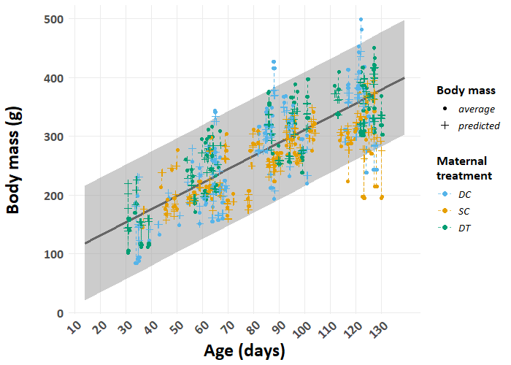Figure S1. Predicted and average body mass (g) across the first 130 days of life for meerkat offspring, differentiated by maternal treatment (indicated by colour; DC = dominant control; SC = subordinate control; DT = dominant treated). Dots indicate the average measured body mass and crosses (+) indicate the predicted mass, with dashed lines connecting the corresponding values. The grey ribbon depicts the 95% equal-tailed credible interval. N = 491.
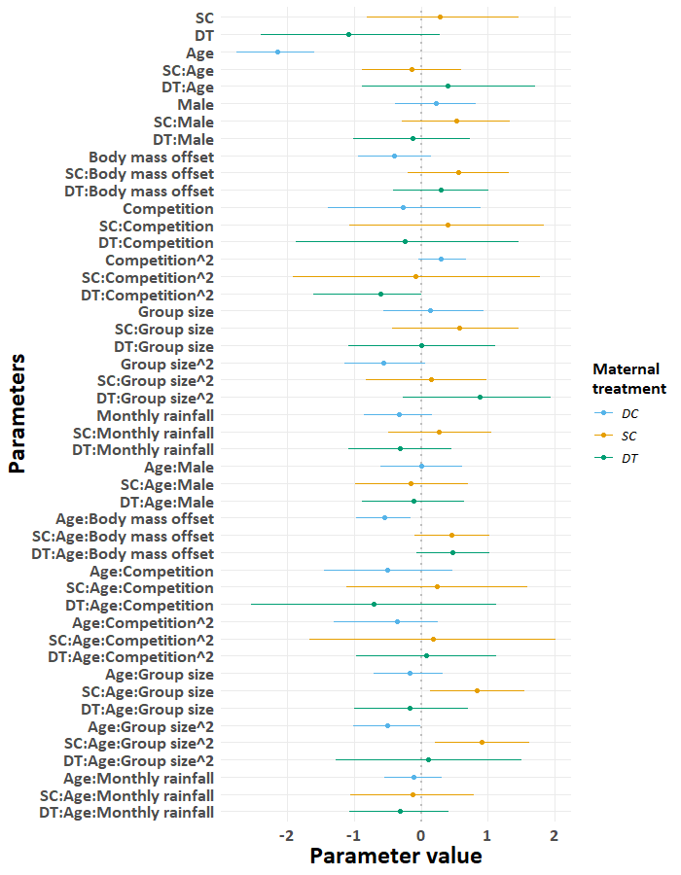
Figure S2. Forest plot displaying the estimated coefficients for repeat call proportions by meerkat offspring differentiated by maternal treatment (indicated by colours; dominant control, DC; subordinate control, SC; dominant treated, DT). Each point represents the estimated coefficient for the predictor, and the horizontal lines indicate the corresponding 95% credible intervals. Coefficients to the right of the vertical line at zero suggest a positive association, while those to the left indicate a negative association. N = 481.
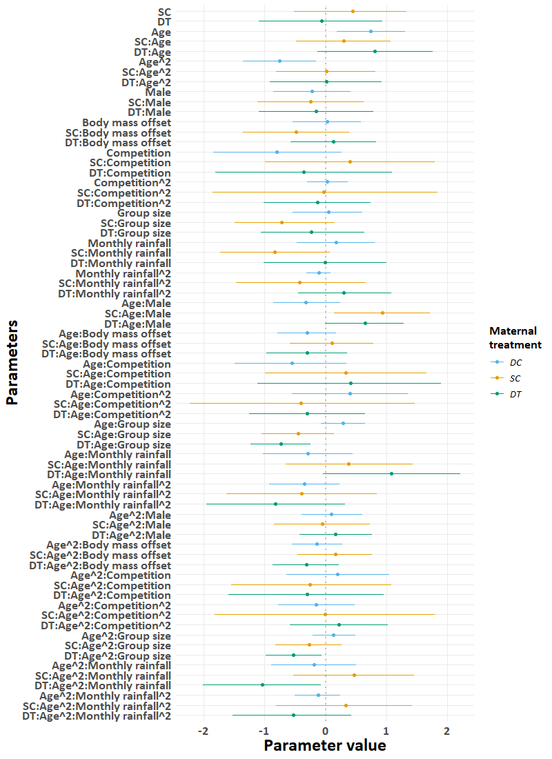Figure S3. Forest plot displaying the estimated coefficients for digging call proportions by meerkat offspring differentiated by maternal treatment (indicated by colours; dominant control, DC; subordinate control, SC; dominant treated, DT). Each point represents the estimated coefficient for the predictor, and the horizontal lines indicate the corresponding 95% credible intervals. Coefficients to the right of the vertical line at zero suggest a positive association, while those to the left indicate a negative association. N = 481.
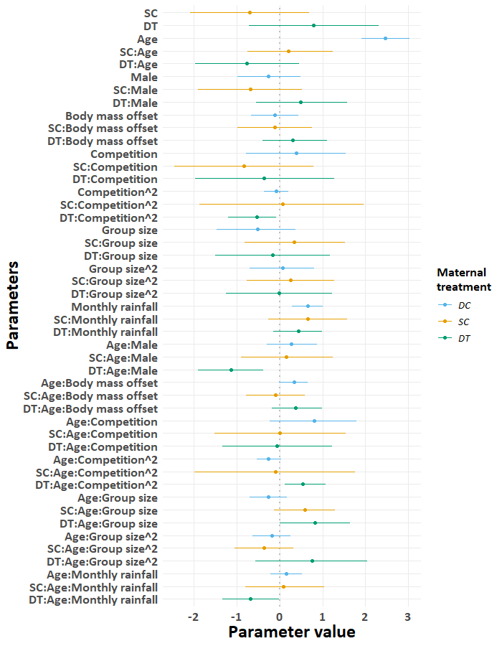Figure S4. Forest plot displaying the estimated coefficients for close call proportions by meerkat offspring differentiated by maternal treatment (indicated by colours; dominant control, DC; subordinate control, SC; dominant treated, DT). Each point represents the estimated coefficient for the predictor, and the horizontal lines indicate the corresponding 95% credible intervals. Coefficients to the right of the vertical line at zero suggest a positive association, while those to the left indicate a negative association. N = 481.
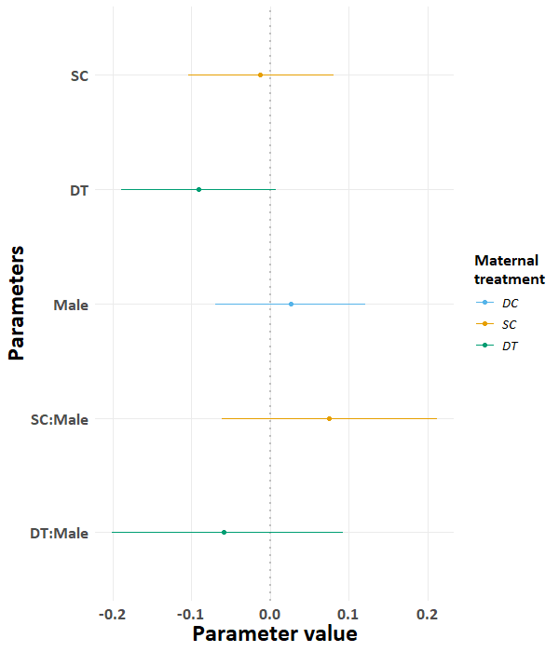
Figure S5. Forest plot displaying the estimated coefficients for the age at which digging call proportions exceed repeat call proportions based on posterior samples (N = 5,499) from all subjects (N =55). Each point represents the estimated coefficient for the predictor, and the horizontal lines indicate the corresponding 95% credible intervals. Coefficients to the right of the vertical line at zero suggest a positive association, while those to the left indicate a negative association. Colours indicate the maternal treatment (dominant control, DC; subordinate control, SC; dominant treated, DT).
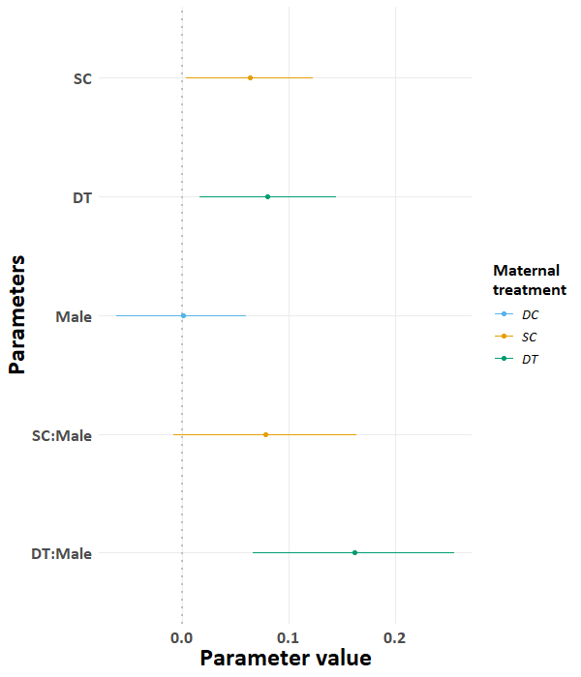
Figure S6. Forest plot displaying the estimated coefficients for the age at which digging call proportions are at their peak based on posterior samples (N = 5,499) from all subjects (N =55). Each point represents the estimated coefficient for the predictor, and the horizontal lines indicate the corresponding 95% credible intervals. Coefficients to the right of the vertical line at zero suggest a positive association, while those to the left indicate a negative association. Colours indicate the maternal treatment (dominant control, DC; subordinate control, SC; dominant treated, DT).
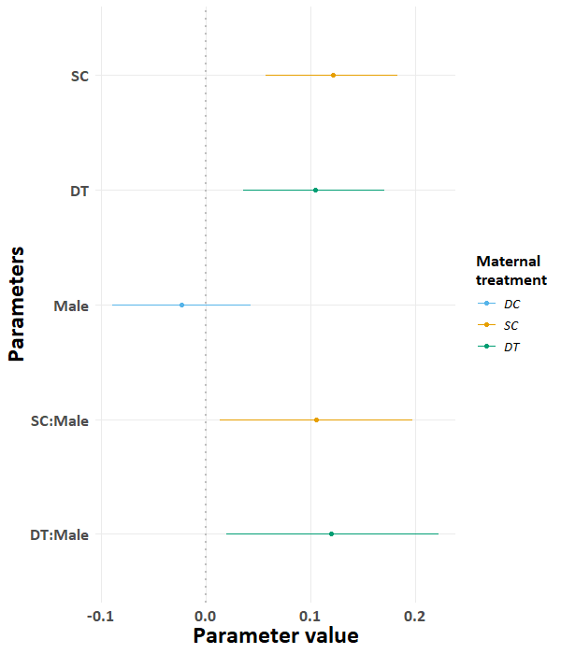
Figure S7. Forest plot displaying the estimated coefficients for the age at which close call proportions exceed digging call proportions based on posterior samples (N = 4,924) from all subjects (N =55). Each point represents the estimated coefficient for the predictor, and the horizontal lines indicate the corresponding 95% credible intervals. Coefficients to the right of the vertical line at zero suggest a positive association, while those to the left indicate a negative association. Colours indicate the maternal treatment (dominant control, DC; subordinate control, SC; dominant treated, DT).

