First-Principles Investigation of Structural, Mechanical, Electronic, and Thermal Properties of Half-Heusler ZrPtSn
Lynet Allan*, Julius M. Mwabora, Winfred M. Mulwa, Edwin Mapasha, Robinson J. Musembi
*Corresponding author(s). E-mail(s): allanlynet3@students.uonbi.ac.ke

Supplementary Material
Manuscript Number: MRSA-D-25-00099R1
APPENDICES
Appendix 1: The crystal structure and lattice constants of ZrPtSn half Heusler Alloy

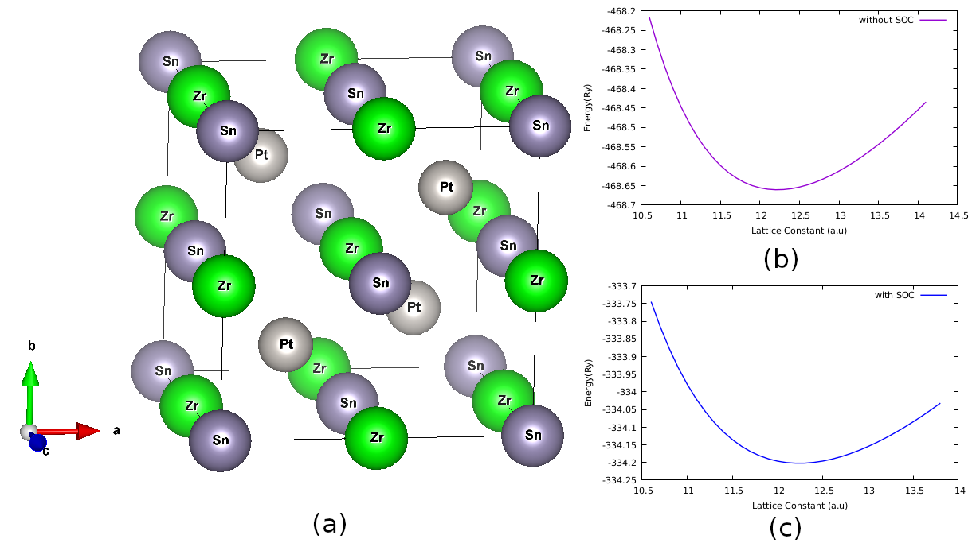
Figure 1;(a) The crystal structure of ZrPtSn half Heusler Alloy, (b) Energy vs Lattice constant without SOC effects, and (c) Energy vs Lattice constant with SOC effects

Appendix 2: Elastic Properties and Stiffness Matrix Eigenvalues of ZrPtSn
Table 1(a)Elastic Properties of ZrPtSn
Property | Value
$$C_{11}$$ | 180.1
$$C_{12}$$ | 26.8
$$C_{44}$$ | 71.1
Poisson’s Ratio ($ν$) | 0.30
Universal Anisotropy ($A_{U}$) | 0.09

Table 1 (b)Stiffness Matrix Eigenvalues of ZrPtSn
Eigenvalue | $$λ_{1}$$ | $$λ_{2}$$ | $$λ_{3}$$ | $$λ_{4}$$ | $$λ_{5}$$ | $$λ_{6}$$
Value (GPa) | 70 | 70 | 70 | 108 | 108 | 402
Appendix 3: Averaged and Variational Elastic Properties of ZrPtSn
Table 2 (a) Averaged Elastic Properties of ZrPtSn
Averaging Scheme | Bulk Modulus (GPa) | Young's Modulus (GPa) | Shear Modulus (GPa) | Poisson's Ratio
Voigt (K_{v}, E_{v}, G_{v}, ν_{v}) | 134 | 164.74 | 63.6 | 0.2951
Reuss (K_{R}, E_{R},G_{R},ν_{R}) | 134 | 162.46 | 62.583 | 0.29794
Hill (K_{H}, E_{H}, G_{H}, ν_{H}) | 134 | 163.6 | 63.091 | 0.29652

Table 2 (b) Variations of the Elastic Moduli for ZrPtSn
Property | E_{min} (GPa) | E_{max} (GPa) | β_{min} (TPa⁻¹) | β_{max} (TPa⁻¹) | G_{min} (GPa) | G_{max} (GPa) | ν_{min} | ν_{max}
Value | 142.82 | 178.86 | 2.4876 | 2.4876 | 54 | 70 | 0.20173 | 0.37976
Anisotropy | 1.252 | 1.0000 | 1.296 | 1.8825 | -- | -- | -- | --
Appendix 4: Elastic moduli and anisotropy variations for ZrPtSn, analyzed using ELATE software.

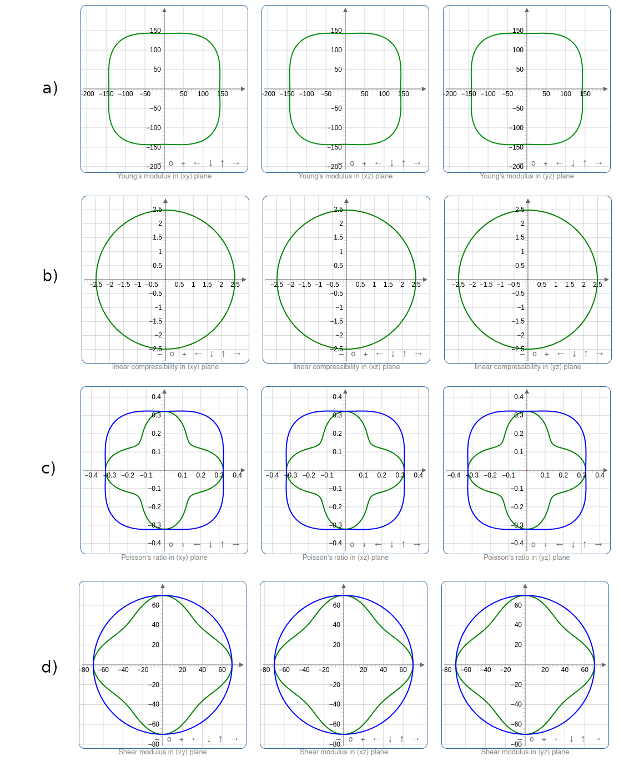
Figure 4 ; The directional dependencies of (a) Young’s modulus, (b) Linear Compressibility, (c) Poisson’s ratio and (d) shear modulus (blue indicates the maximum values while green represents the minimum values across crystallographic directions.).

