Mycological Progress: https://doi.org/10.1007/s11557-025-02056-5

Diversity and distribution of Lophodermium species on non-native Pinus species in the Southern Hemisphere
Cheyenne A. Theronª, M. J. Wingfield^{b}, R. Ahumada^{c}, A. J. Carnegie^{d}, S. Fraser^{e}, C. A. Rodas^{b}, I. Barnes^{b*}
ªDepartment of Plant and Soil Sciences, Forestry and Agricultural Biotechnology Institute (FABI), University of Pretoria, Pretoria, South Africa; ^{b}Department of Biochemistry, Genetics and Microbiology, Forestry and Agricultural Biotechnology Institute (FABI), University of Pretoria, Pretoria, South Africa; ^{c}Silviculture and Forest Health Division Manager, Bioforest, Concepción, Chile; ^{d}Forest Science, Department of Primary Industries and Regional Development, Parramatta (Sydney), NSW, Australia; ^{e}Scion, Titokorangi Drive, Private Bag 3020, Rotorua 3046, New Zealand
* Corresponding author: irene.barnes@fabi.up.ac.za

Fig. S1. Maximum likelihood tree based on the actin (ACT) region for representative Lophodermium species and related taxa. Isolates generated in this study from five countries located in the Southern Hemisphere, indicated according to the key, fall within five clades. Ex-type specimens are indicated with a “T” and Hymenoscyphus epiphyllus was used as the outgroup taxon. Numbers at the nodes indicate the bootstrap support (>60%) and posterior probabilities from Bayesian inference, respectively.

Fig. S2. Maximum likelihood tree based on the translation elongation factor 1-α (TEF1) region for representative Lophodermium species and related taxa. Isolates generated in this study from five countries located in the Southern Hemisphere, indicated according to the key, fall within five clades. Strasseria geniculata was used as the outgroup taxon. Numbers at the nodes indicate the bootstrap support (>60%) and posterior probabilities from Bayesian inference, respectively.

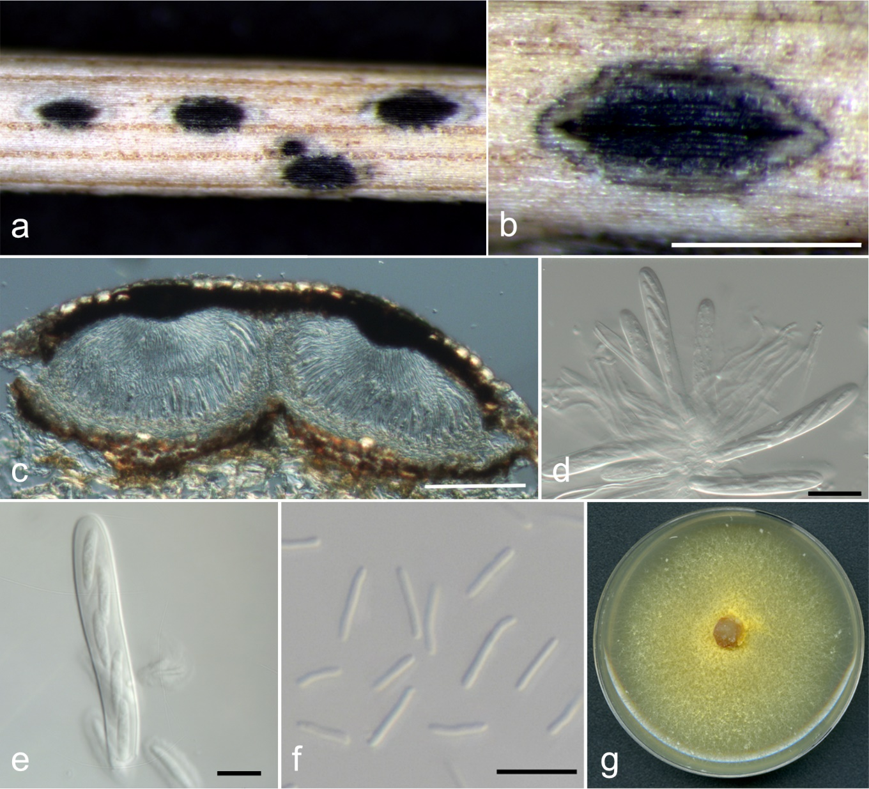
Fig. S3. Micrographs of Meloderma desmazierii collected from Pinus radiata in Chile. (a) Ascomata on needle surface. (b) Close-up of a single ascocarp. (c) Midpoint vertical section showing the epidermal positioning of two ascocarps with displaced epidermal cells at the base. (d and e) Asci. (f) Conidia. (g) Culture morphology on MEA. Scale bars: b = 500 μm; c = 100 μm; d = 20 μm; e─f = 10 μm

