Pharmacokinetics and Bioavailability of Pembrolizumab With Berahyaluronidase Alfa for Subcutaneous Administration in Participants With Advanced or Metastatic Solid Tumors: The Phase 1 Study 3475A-C18

Cohen G. L. et al.

SUPPLEMENTARY MATERIALS

Supplementary Methods

Standard-of-Care Background Therapy
Participants with non-small cell lung cancer (NSCLC) received 4 cycles of platinum-doublet chemotherapy as the standard-of-care background therapy. In each cycle, participants with nonsquamous histology received intravenous (IV) cisplatin 75 mg/m² or IV carboplatin area under the curve (AUC) 5 mg/mL/min plus IV pemetrexed 500 mg/m² on day 1 of every 21-day cycle, and participants with squamous histology received IV carboplatin AUC 6 mg/mL/min on day 1 plus IV paclitaxel 200 mg/m² on day 1 or IV nab-paclitaxel 100 mg/m² on days 1, 8, and 15 of every 21-day cycle.
Participants with renal cell carcinoma (RCC) received oral axitinib 5 mg twice daily as the standard-of-care background therapy.

Inclusion and Exclusion Criteria

Inclusion Criteria
An individual was eligible for inclusion in the study if all the following criteria were met:
- Has histologically or cytologically confirmed advanced/metastatic solid tumor by pathology report and meets all the listed conditions of eligibility for 1 of the following indications:
  - Melanoma (arms 1, 2, and 4)
    - Unresectable stage III or IV melanoma per current AJCC staging system not amenable to local therapy OR
    - Untreated for advanced or metastatic disease, except as follows:
      - Participants with BRAF V600–mutant melanoma may have received standard-of-care targeted therapy (eg, BRAF/MEK inhibitor, alone or in combination) and be eligible for this study.
Note: Targeted therapy is not required for eligibility.
      - Prior adjuvant or neoadjuvant melanoma therapy is permitted if it was completed at least 4 weeks before allocation and all related adverse events (AEs) have either returned to baseline or stabilized (resolution of toxic effect(s) of the most recent prior therapy to grade 1 or less [except alopecia]). If a participant received major surgery or radiation therapy of >30 Gy, they must have recovered from the toxicity and/or complications from the intervention.
  - NSCLC (arms 1 and 2)
    - Metastatic nonsquamous NSCLC (stage IV: M1a, M1b, or M1c per current AJCC staging system) with no EGFR, ALK, or ROS1 genomic tumor alterations OR
    - Metastatic squamous NSCLC (stage IV: M1a, M1b, or M1c per current AJCC staging system)
Note: If a participant’s tumor is known to have predominantly squamous histology, molecular testing for EGFR mutation and ALK or ROS1 translocations will not be required, as this is not part of the current diagnostic guidelines.
Note: Participants with EGFR, ALK, or ROS1 genomic tumor alterations should have disease progression on therapy for these alterations before receiving MK-3475A.
  - NSCLC (arm 3)
    - Metastatic nonsquamous NSCLC (stage IV: M1a, M1b, or M1c per current AJCC staging system) with no EGFR, ALK, or ROS1 genomic tumor alterations OR
    - Metastatic squamous NSCLC (stage IV: M1a, M1b, or M1c per current AJCC staging system)
    - Received no prior systemic therapy for advanced or metastatic disease except prior treatment with chemotherapy and/or radiation as part of neoadjuvant/adjuvant therapy, as long as therapy was completed at least 6 months before the diagnosis of metastatic NSCLC.
Note: If a participant’s tumor is known to have predominantly squamous histology, molecular testing for EGFR mutation and ALK or ROS1 translocations will not be required, as this is not part of the current diagnostic guidelines.
  - RCC (arms 1 and 2)
    - Unresectable, locally advanced/metastatic RCC (stage IV RCC per AJCC) with clear cell component with or without sarcomatoid features
    - Received no prior systemic therapy for advanced clear cell RCC
- Participant can provide an archival tumor tissue sample or newly obtained core or excisional biopsy of a tumor lesion not previously irradiated. FFPE tissue blocks are preferred over slides. Newly obtained biopsies are preferred to archived tissue. Biopsies obtained before receipt of adjuvant/neoadjuvant therapy will be permitted if recent biopsy is not feasible.
- Measurable disease per Response Evaluation Criteria in Solid Tumors version 1.1 (RECIST v1.1) as assessed by the local site investigator/radiology.
  - Lesions situated in a previously irradiated area are considered measurable if progression has been shown in such lesions.
  - Metastatic lesions situated in the brain are not considered measurable and should be considered nontarget lesions.
- Have an Eastern Cooperative Oncology Group performance status of 0 or 1.
- Show adequate organ function as defined in the following table:
System | Laboratory Value
Hematologic
Absolute neutrophil count | >1500/μL
Platelets | >100,000/μL
Hemoglobin | >9 g/dL or >5.6 mmol/Lª
Renal
Measured or calculated^{b} CrCl or eGFR^{c} | ≥30 mL/min (arms 1, 2, and 4) or ≥60 mL/min (arm 3)
Hepatic
Total bilirubin | ≤1.5×ULN or direct bilirubin ≤ULN for participants with total bilirubin levels >1.5×ULN
AST (SGOT) and ALT (SGPT) | <2.5×ULN or ≤5×ULN for participants with liver metastases
Coagulation
INR, PT, or activated PTT | <1.5×ULN unless participant is receiving anticoagulant therapy
ALT (SGPT), alanine aminotransferase (serum glutamic pyruvic transaminase); AST (SGOT), aspartate aminotransferase (serum glutamic oxaloacetic transaminase); CrCl, creatinine clearance; eGFR, estimated glomerular filtration rate; INR, international normalized ratio; PT, prothrombin time; PTT, partial thromboplastin time; ULN, upper limit of normal.
ªCriteria must be met without packed red blood cell transfusion within the prior 2 weeks. Participants can be on stable dose of erythropoietin (at least approximately 3 months).
^{b}Cockcroft-Gault formula: [((140 – age) × weight) ÷ (serum creatinine × 72)] × F; with age in years, weight in kg, and serum creatinine in mg/dL. F=0.85 for females and F=1 for males.
ceGFR=mL/min/1.73 m2.
- Male or female, from 18 years to unlimited years of age, at the time of providing informed consent.
- For male participants for whom treatment with pembrolizumab alone (MK-3475A subcutaneous [SC] formulation only or MK-3475A SC followed by pembrolizumab IV) is indicated: there are no requirements for contraception.
- For male participants for whom a combination of pembrolizumab (MK-3475A SC formulation of pembrolizumab IV) and chemotherapy is indicated, the following contraception guidance applies: if capable of producing sperm, the participant agrees to the following during the intervention period and for at least the time needed to eliminate each study intervention after the last dose of study intervention.
  - The length of time required to continue contraception for each study intervention is as follows:
    - Pembrolizumab: no measures
    - Chemotherapy: 180 days
  - Refrains from donating sperm PLUS either
    - Abstains from penile-vaginal intercourse as their preferred and usual lifestyle (abstinent on a long-term and persistent basis) and agrees to remain abstinent OR
    - Uses contraception unless confirmed to be azoospermic (vasectomized or secondary to medical cause, documented from the site personnel’s review of the participant’s medical records, medical examination, or medical history interview) as detailed below:
      - Uses a penile/external condom when having penile-vaginal intercourse with a nonparticipant of childbearing potential who is not currently pregnant PLUS partner use of an additional contraceptive method, as a condom may break or leak.
Note: Participants capable of producing ejaculate whose partner is pregnant or breastfeeding must agree to use a penile/external condom during each episode of sexual activity in which the partner is at risk of drug exposure via ejaculate.
      - Contraceptive use by participants capable of producing sperm should be consistent with local regulations regarding the methods of contraception for those participating in clinical studies. If the contraception requirements in the local label for any of the study interventions are more stringent than the requirements above, the local label requirements are to be followed.
- For participants for whom treatment with pembrolizumab (MK-3475A SC formulation followed by pembrolizumab IV) treatment alone is indicated: a participant assigned female sex at birth is eligible to participate if not pregnant or breastfeeding and at least 1 of the following conditions applies:
  - Is not a person of child-bearing potential (POCBP) OR
  - Is a POCBP AND
    - Uses a contraceptive method that is highly effective (with a failure rate of <1% per year), with low user dependency, or is abstinent from penile-vaginal intercourse as their preferred and usual lifestyle (abstinent on a long-term and persistent basis) during the intervention period and for at least the time needed to eliminate each study intervention after the last dose of study intervention. The investigator should evaluate the potential for contraceptive method failure (ie, noncompliance, recently initiated) in relationship to the first dose of study intervention. Contraceptive use by POCBPs should be consistent with local regulations regarding the methods of contraception for those participating in clinical studies. If the contraception requirements in the local label for any of the study interventions are more stringent than the requirements above, the local label requirements are to be followed.
    - Has a negative highly sensitive pregnancy test (as required by local regulations) within 24 hours (for urine test) or within 72 hours (for serum test) before the first dose of study intervention. If a urine test cannot be confirmed as negative (eg, an ambiguous result), a serum pregnancy test is required. In such cases, the participant must be excluded from participation if the serum pregnancy result is positive.
    - Abstains from breastfeeding during the study intervention period and for at least 120 days after study intervention.
    - Medical history, menstrual history, and recent sexual activity has been reviewed by the investigator to decrease the risk of inclusion of a POCBP with an early undetected pregnancy.
- For participants for whom treatment with pembrolizumab (MK-3475A SC formulation followed by pembrolizumab IV) in combination with chemotherapy is indicated: a participant assigned female sex at birth is eligible to participate if not pregnant or breastfeeding and at least 1 of the following conditions applies:
  - Is not a POCBP OR
  - Is a POCBP AND
    - Uses a contraceptive method that is highly effective (with a failure rate of <1% per year), with low user dependency, or is abstinent from penile-vaginal intercourse as their preferred and usual lifestyle (abstinent on a long-term and persistent basis) during the intervention period and for at least the time needed to eliminate each study intervention after the last dose of study intervention. The participant agrees not to donate eggs (ova, oocytes) to others or freeze/store during this period for the purpose of reproduction. The length of time required to continue contraception for each study intervention is as follows:
      - Chemotherapy: 180 days
      - Pembrolizumab: 120 days
    - The investigator should evaluate the potential for contraceptive method failure (ie, noncompliance, recently initiated) in relationship to the first dose of study intervention. Contraceptive use by POCBPs should be consistent with local regulations regarding the methods of contraception for those participating in clinical studies. If the contraception requirements in the local label for any of the study interventions are more stringent than the requirements above, the local label requirements are to be followed.
    - Has a negative highly sensitive pregnancy test (as required by local regulations) within 24 hours (for urine test) or within 72 hours (for serum test) before the first dose of study intervention. If a urine test cannot be confirmed as negative (eg, an ambiguous result), a serum pregnancy test is required. In such cases, the participant must be excluded from participation if the serum pregnancy result is positive.
    - Abstains from breastfeeding during the study intervention period and for at least 120 days after study intervention.
    - Medical history, menstrual history, and recent sexual activity has been reviewed by the investigator to decrease the risk of inclusion of a POCBP with an early undetected pregnancy.
- The participant (or legally acceptable representative) has provided documented informed consent for the study. The participant may also provide consent for future biomedical research. However, the participant may participate in the study without participating in future biomedical research.
- HIV-infected participants must have well-controlled HIV on antiretroviral therapy (ART), defined as
  - Participants on ART must have a CD4+ T-cell count >350 cells/mm³ at the time of screening
  - Participants on ART must have achieved and maintained virologic suppression, defined as confirmed HIV RNA level below 50 or below the limit of detection using the locally available assay at the time of screening and for at least 12 weeks before screening
  - Participants on ART must have been on a stable regimen, without changes in drugs or dose modification, for at least 4 weeks before study entry (day 1).
  - The combination ART regimen for participants with RCC receiving axitinib must not contain any antiretroviral medications other than abacavir, dolutegravir, emtricitabine, lamivudine, raltegravir, rilpivirine, or tenofovir.

Exclusion Criteria
An individual must be excluded from the study if any of the following criteria are met:
- Diagnosis of immunodeficiency or receipt of chronic systemic steroid therapy (in dosing exceeding 10 mg daily of prednisone equivalent) or any other form of immunosuppressive therapy within 7 days before the first dose of study medication.
- Has had chemotherapy, definitive radiation, or biological cancer therapy within 4 weeks (2 weeks for palliative radiation) before the first dose of study intervention or has not recovered to NCI CTCAE grade 1 or better from any AEs that were due to cancer therapeutics administered more than 4 weeks earlier (this includes participants with previous immunomodulatory therapy with residual immune-related AEs). Participants receiving ongoing replacement hormone therapy for endocrine immune-related AEs will not be excluded from participation in this study.
Note: Participants with grade ≤2 neuropathy or grade ≤2 alopecia are an exception to this criterion and may qualify for the study.
Note: If participant received major surgery, they must have recovered adequately from the toxicity and/or complications from the intervention before starting therapy.
Note (arm 3 only): Radiation therapy to the lung that is >30 Gy within 6 months of the first dose of study intervention is not permitted.
Note (arm 3 only): For palliative radiation (≤2 weeks of radiotherapy) to non-CNS disease, the last radiotherapy treatment must have been performed at least 7 days before the first dose of study intervention.
- Has a history of a second malignancy, unless potentially curative treatment has been completed with no evidence of malignancy for 2 years.
Note: The time requirement does not apply to participants who underwent successful definitive resection of basal cell carcinoma of the skin, squamous cell carcinoma of the skin, superficial bladder cancer, in situ cervical cancer, or other in situ cancers. Participants with low-risk early-stage prostate cancer (T1–T2a, Gleason score ≤6, and PSA <10 ng/mL) either treated with definitive intent or untreated in active surveillance with stable disease are not excluded.
- Has clinically active CNS metastases and/or carcinomatous meningitis. Participants with previously treated brain or meningeal metastases may participate and be eligible for treatment provided they are stable and asymptomatic (without evidence of progression by MRI scan of the brain separated by at least 4 weeks after treatment), have no evidence of new or enlarging brain metastases, are evaluated within 4 weeks before first study intervention administration, and are off immunosuppressive doses of systemic steroids at least 14 days before the first dose of study intervention.
- Has severe hypersensitivity (grade ≥3) to pembrolizumab and/or any of its excipients.
- Has an active infection requiring therapy.
- Has a history of (noninfectious) pneumonitis/interstitial lung disease that required steroids or current pneumonitis/interstitial lung disease.
- Has an active autoimmune disease that has required systemic treatment in the past 2 years (ie, with use of disease modifying agents, corticosteroids, or immunosuppressive drugs) except vitiligo or resolved childhood asthma/atopy. Replacement therapy, such as thyroxine, insulin, or physiologic corticosteroid replacement therapy for adrenal or pituitary insufficiency, is not considered a form of systemic treatment and is allowed. Use of nonsystemic steroids is permitted.
- Participants with known hepatitis B or C infections or who are known to be positive for HBsAg/HBV DNA or hepatitis C antibody and RNA. Active hepatitis C is defined by a known positive hepatitis C antibody result and known quantitative HCV RNA results greater than the lower limits of detection of the assay.
Note (arm 3 only): Participants known to be positive for HBc antibody and HBs antibody. However, participants known to be positive for HBs antibody but negative for HBc antibody with a history of HBV vaccination can be included.
- HIV-infected participants with a history of Kaposi’s sarcoma and/or multicentric Castleman’s disease.
- Has a history or current evidence of a GI condition (eg, inflammatory bowel disease, Crohn’s disease, ulcerative colitis) or impaired liver function or diseases that in the opinion of the investigator may significantly alter the absorption or metabolism of oral medications; or any condition, therapy, or laboratory abnormality that might confound the results of the study, interfere with the participant’s participation for the full duration of the study, make administration of the study drugs hazardous, or make it difficult to monitor adverse effects such that it is not in the best interest of the participant to participate, in the opinion of the treating investigator.
- Has known psychiatric or substance abuse disorders that would interfere with the participant’s ability to cooperate with the requirements of the study.
- Is pregnant, breastfeeding, or expecting to conceive or father children within the projected duration of the study, starting with the screening visit through 120 days after the last dose of MK-3475A/pembrolizumab is received and through 180 days after the last dose of chemotherapeutic agents as specified in the protocol.
Note (arm 3 only): A breastfeeding woman is eligible to participate if she refrains from lactating during the study treatment period and does not wish to resume lactating.
Note (arm 3 only): A woman with negative pregnancy test result but judged by investigator to be possibly pregnant based on interviews, etc, is not eligible to participate.
- Has not fully recovered from any effects of major surgery without significant detectable infection. Surgeries that required general anesthesia must be completed at least 2 weeks before the first study intervention administration. Surgery requiring regional/epidural anesthesia must be completed at least 72 hours before first study intervention administration and participants should be recovered.
- Has a known sensitivity to any component of cisplatin, carboplatin, paclitaxel, nab-paclitaxel, pemetrexed, or axitinib.
Note: This applies only to participants for whom combination therapy with 1 or more of these interventions is indicated.
- Has symptomatic ascites or pleural effusion. A subject who is clinically stable following treatment for these conditions (including therapeutic thoraco- or paracentesis) is eligible.
- Has preexisting peripheral neuropathy that is grade >2 by latest NCI CTCAE version 5.
- Has a known sensitivity to rhPH20 or other form of hyaluronidase.
- Has a history of severe hypersensitivity reactions (eg, generalized rash/erythema, hypotension, bronchospasm, angioedema, or anaphylaxis) to pemetrexed, cisplatin, axitinib, carboplatin, paclitaxel, or nab-paclitaxel.
Note: This applies only to participants for whom combination therapy with 1 or more of these interventions is indicated.
- Has received a live or live-attenuated vaccine within 30 days before the first dose of study intervention. Administration of killed vaccines is allowed.
- Is currently participating and receiving study intervention in a study of an investigational agent or has participated and received study intervention in a study of an investigational agent or has used an investigational device within 28 days of administration of MK-3475A.
Note: Participants who have entered the follow-up phase of an investigational study may participate as long as it has been 4 weeks since the last dose of the previous investigational agent.
- Has had an allogenic tissue/solid organ transplant.

Assessments
For arms 1 and 2, pharmacokinetics (PK) analyses used blood samples collected in cycles 1 and 3 (predose on day 1 and on days 2–6, 8, 10, 15, 22, 29, and 36), cycle 2 (predose, at the end of infusion within 10 minutes postdose on day 1, and on days 3, 5, 15, and 29), and cycle 4 (predose on day 1). For arm 3, PK analyses used blood samples collected in cycles 1 (predose on day 1 and on days 2–6, 8, 10, 15, 22, 29, and 36), cycle 2 (predose, at the end of infusion within 10 minutes postdose on day 1, and on day 3), and cycle 3 (predose on day 1). For arm 4, PK analyses used blood samples collected in cycles 1 and 6 (predose on day 1 and on days 2, 4, 6, 10, and 15) and in cycles 2, 4, and 7 (predose on day 1). Blood samples used to determine systemic berahyaluronidase alfa concentrations were collected predose on day 1 of cycles 1–4 and postdose on days 2 and 3 of cycles 1 and 3 (arms 1 and 2), predose on day 1 of cycles 1 and 2 and postdose on days 2 and 3 of cycle 1 (arm 3), and predose on day 1 cycles 1, 2, and 6 and postdose on day 2 of cycles 1 and 6 (arm 4).
Blood samples used to determine antidrug antibodies (ADAs) against pembrolizumab and/or berahyaluronidase alfa were collected predose on day 1 of cycles 1‒4 (arms 1 and 2), predose on day 1 of cycles 1 and 2 (arm 3), and predose on day 1 of cycles 1, 2, and 6 (arm 4). ADA data from all available cycles were summarized.
All AEs from the time of treatment allocation through 30 days and all serious AEs through 90 days after the end of study treatment were recorded. A Subcutaneous Injection Site Signs and Symptoms questionnaire was administered to all participants approximately 60 minutes postdose on day 1 of cycle 1 (all arms) and cycle 3 (arms 1 and 2) of pembrolizumab SC administration. This questionnaire asked participants to self-assess the injection site for pain, itching, swelling, and redness as “none,” “mild,” “moderate,” or “severe.”
Tumor imaging was performed at baseline and postbaseline at 6 weeks, 12 weeks, every 9 weeks until 48 weeks, and every 12 weeks thereafter until disease progression, the start of new anticancer treatment, pregnancy, death, withdrawal of consent, or end of study. Participants with known brain metastases underwent brain imaging during screening to confirm the stability of the metastases and during the study, if clinically indicated or to confirm complete response (CR).

Population Pharmacokinetic Analysis Approach for Pembrolizumab SC
Serum pembrolizumab concentration data collected from arms 1‒4 of this study were used to inform the population pharmacokinetic analysis of pembrolizumab SC and IV. In addition, the established reference pembrolizumab IV pharmacokinetic model based on historical pembrolizumab data was used to inform the analysis. Model parameters describing distribution and elimination phase parameters, including fixed effects and random effects, were fixed from the reference pembrolizumab IV pharmacokinetic model because systemic pharmacokinetic is expected to be similar for SC and IV administration. Given the relatively small sample size, parameters describing covariate effects were also largely based on the reference pembrolizumab IV pharmacokinetic model.

Statistical analysis for efficacy endpoints
Objective response rate (ORR) point estimates and 95% CIs were determined using the exact binomial method per the Clopper and Pearson method. The Kaplan-Meier method was used for analyses of duration of response (DOR), progression-free survival (PFS), and overall survival (OS; arm 4 only). ORR, DOR, and PFS were reported by pooling all participants in arms 1‒3 with the same indication. ORR, DOR, and PFS, and OS in arm 4 were reported separately from arms 1‒3.

Supplementary Table S1. List of Sites and Study Investigators who Enrolled at Least 1 Participant
Country or Region | Site Name (Site Number) | Principal Investigator
Chile | Bradfordhill (0100) | Carlos I. Rojas
Chile | FALP-UIDO (0101) | Christian Caglevic
Chile | James Lind Centro de Investigacion del Cancer (0102) | Patricio Yañez Weber
Hungary | Magyar Honvedseg Egeszsegugyi Kozpont-Onkologiai Osztaly (0020) | Zsuzsanna Papai
Hungary | Országos Onkológiai Intézet-Urogenital Tumors Department and Clinical Pharmacology (0021) | Lajos Geczi
Japan | Saitama Prefectural Cancer Center (0110) | Yasutaka Watanabe
Japan | Shizuoka Cancer Center (0111) | Toshiaki Takahashi
Japan | Kansai Medical University Hospital (0112) | Takayasu Kurata
Japan | Osaka International Cancer Institute (0113) | Motohiro Tamiya
South Africa | Cape Town Oncology Trials (0050) | Corlia Coetzee;  Conrad Rudolph Jacobsª
South Africa | Cancercare Langenhoven Drive Oncology Centre (0051) | John Malcom Crockett;  Cathryn A. Waltonª
South Africa | Life Groenkloof-Mary Potter Cancer Centre (0052) | Graham L. Cohen
South Africa | Sandton Oncology Medical Group (0053) | Sze W. Chan
South Africa | Cancercare Rondebosch Oncology (0055) | Georgina McAdam
South Africa | Steve Biko Academic Hospital (0057) | Richard Khanyile
South Africa | Medical Oncology Centre of Rosebank (0058) | Bernardo L. Rapoport
South Korea | Severance Hospital, Yonsei University Health System (0062) | Byoung Chul Cho
South Korea | Samsung Medical Center (0063) | Se-Hoon Lee
Spain | Hospital Universitario Virgen de la Victoria-Phase I Trials Unit (0042) | Laura Medina Rodríguez
Spain | Hospital Clínic De Barcelona Department of Medical Oncology (0043) | Òscar Reig Torras
ªFormer investigator.

Supplementary Table S2. Summary of Drug Exposure
 | Arm 1  (n=46) | Arm 2  (n=44) | Arm 3  (n=6) | Arm 4  (n=44)
Median (range) time on study therapy, mo | 15.1  (0.03–25.8) | 11.6  (0.03–25.6) | 4.3  (1.4–16.7) | 4.9  (0.03–11.4)
Median (range) number of cycles | 11  (1–18) | 8.5  (1–18) | 3.5  (2–13) | 8  (1–17)
Received ≥4 cycles, n (%) | 34 (74) | 34 (77) | 3 (50) | 35 (80)

Supplementary Table S3. Summary of Immunogenicity Results After Pembrolizumab SC Administration
Pembrolizumab Immunogenicity Status | n=129ª
Participants with inconclusive data,^{b} n | 2
Participants with evaluable data, ^{c} n | 127
Negative, n (%) | 124 (98)
Non–treatment-emergent positive, n (%) | 2 (2)
Neutralizing negative, n (%) | 2 (2)
Neutralizing positive, n (%) | 0 (0)
Treatment-emergent positive, n (%) | 1 (1)
Neutralizing negative, n (%) | 1 (1)
Neutralizing positive, n (%) | 0 (0)
Berahyaluronidase Alfa Immunogenicity Status | n=129ª
Participants with inconclusive data,^{b} n | 0
Participants with evaluable data,^{c} n | 129
Negative, n (%) | 123 (95)
Non–treatment-emergent positive, n (%) | 3 (2)
Treatment-emergent positive, n (%) | 3 (2)
Treatment-emergent positive,^{d} n (%) | 2 (2)
Treatment-boosted positive,^{d} n (%) | 1 (1)
ADA, antidrug antibody.
ªAt least 1 ADA sample available after treatment with pembrolizumab SC.
^{b}No positive ADA samples present and the drug concentration in the last sample was above the drug tolerance level.
^{c}Includes the total number of negative and positive participants (non–treatment-emergent and treatment-emergent).
^{d}Analyses for neutralizing antibodies were not performed for samples positive for ADA against berahyaluronidase alfa.

Supplementary Table S4. Summary of AEs
 | Arms 1–3  Cycle 1  (n=96) | Arm 4  All Cycles  (n=44)
Participants with ≥1 AEª | 76 (79) | 42 (95)
Grade 3–5^{c} AEs | 24 (25) | 7 (16)
Serious AEs | 10 (10) | 6 (14)
Led to death | 2 (2)^{d} | 2 (5)^{e}
Led to treatment discontinuation | 6 (6) | 2 (5)
Serious AEs that led to treatment discontinuation | 4 (4) | 2 (5)
Participants with ≥1 treatment-related^{b} AE | 57 (59) | 24 (55)
Grade 3–5^{c} treatment-related AEs | 14 (15) | 1 (2)
Serious treatment-related AEs | 5 (5) | 1 (2)
Led to death | 1 (1)^{d} | 0 (0)
Led to treatment discontinuation | 5 (5) | 0 (0)
Serious AE that led to treatment discontinuation | 3 (3) | 0 (0)
All data are n (%).
AE, adverse event.
ªNonserious AEs up to 30 days and serious AEs up to 90 days after last dose of study intervention were included.
^{b}Determined by the investigator to be related to treatment.
^{c}Grade was based on National Cancer Institute Common Terminology Criteria for Adverse Events version 5.0.
^{d}AEs resulting in death in cycle 1 of arms 1–3 (pooled) were febrile neutropenia (n=1; determined by the investigator to be related to treatment) and respiratory failure (n=1).
^{e}AEs resulting in death in arm 4 were death (n=1) and sepsis (n=1). The preferred term of “death” was reported in cases in which limited information on the cause of death was available or the investigator could not assign a specific AE term.

Supplementary Table S5. Immune-Mediated AEs and Infusion Reactionsª With Incidence >0%
 | Arms 1–3  All Cycles  (n=96) |  | Arm 4  All Cycles  (n=44)
Participants with ≥1 AE | 39 (41) |  | 8 (18)
Type of AE^{b} | Any Grade | Grade 3–5 | Any Grade | Grade 3–5
Adrenal insufficiency | 3 (3) | 2 (2) | 1 (2) | 0 (0)
Colitis | 1 (1) | 0 (0) | 0 (0) | 0 (0)
Encephalitis | 1 (1) | 1 (1) | 0 (0) | 0 (0)
Gastritis | 1 (1) | 1 (1) | 1 (2) | 0 (0)
Hepatitis | 1 (1) | 1 (1) | 1 (2) | 1 (2)
Hyperthyroidism | 8 (8) | 0 (0) | 1 (2) | 0 (0)
Hypothyroidism | 18 (19) | 0 (0) | 3 (7) | 0 (0)
Infusion reactions | 2 (2) | 1 (1) | 1 (2) | 0 (0)
Myositis | 1 (1) | 1 (1) | 0 (0) | 0 (0)
Pneumonitis | 9 (9) | 5 (5) | 1 (2) | 0 (0)
Severe skin reactions | 4 (4) | 3 (3) | 0 (0) | 0 (0)
Thyroiditis | 1 (1) | 0 (0) | 0 (0) | 0 (0)
Uveitis | 1 (1) | 0 (0) | 0 (0) | 0 (0)
All data are n (%).
AE, adverse event; IV, intravenous; SC, subcutaneous.
ªImmune-mediated AEs and infusion reactions are based on a list of preferred terms specified by the sponsor intended to capture the known risks of pembrolizumab and are considered regardless of attribution to trial treatment by the investigator.
^{b}Participants were counted a single time for each applicable row and column.

Supplementary Table S6. Participants With AEs Resulting in Death by Preferred Term
 | Arms 1–3  Cycle 1  (n=96) | Arms 1–3  All Cyclesª  (n=96) | Arm 4  All Cycles  (n=44)
Participants with ≥1 AE resulting in death | 2 (2) | 5 (5) | 2 (5)
Febrile neutropenia^{b,c} | 1 (1) | 1 (1) | 0 (0)
Respiratory failure^{b} | 1 (1) | 1 (1) | 0 (0)
Congestive cardiac failure | 0 (0) | 1 (1) | 0 (0)
Septic shock | 0 (0) | 1 (1) | 0 (0)
Pneumonitis^{c} | 0 (0) | 1 (1) | 0 (0)
Death^{d} | 0 (0) | 0 (0) | 1 (2)
Sepsis | 0 (0) | 0 (0) | 1 (2)
All data are n (%).
ªAll cycles for pooled arms 1–3 include treatment cycles in which pembrolizumab SC was not administered.
^{b}AEs resulting in death in arms 1–3 (pooled) were febrile neutropenia (n=1) and respiratory failure (n=1) that occurred in cycle 1.
^{c}Considered by the investigator to be related to treatment.
^{d}AEs resulting in death in arm 4 were death (n=1) and sepsis (n=1). The preferred term of “death” was reported in cases in which limited information on the cause of death was available or the investigator could not assign a specific AE term.

Supplementary Table S7. Summary of Best Objective Responses (Confirmed) per RECIST version 1.1 Based on Investigator Assessment in Arms 1–4 and Best Objective Response (Confirmed) Based on BICR in Arm 4
 | Arms 1–3 |  |  | Arm 4
 | Investigator Assessment  (Confirmed) |  |  | Investigator Assessment  (Confirmed) | BICR  (Confirmed)
 | Melanoma  (n=32) | NSCLC  (n=33) | RCC  (n=31) | Melanoma  (n=44) | Melanoma  (n=44)
ORR (95% CI),ª % | 50  (32–68) | 42  (26–61) | 52  (33–70) | 27  (15–43) | 27  (15–43)
DCR (95% CI),ª % | 78  (60–91) | 91  (76–98) | 84  (66–95) | 55  (39–70) | 57  (41–72)
Best objective response, n (%)
CR | 2 (6) | 0 (0) | 4 (13) | 0 (0) | 0 (0)
PR | 14 (44) | 14 (42) | 12 (39) | 12 (27) | 12 (27)
SD | 9 (28) | 16 (48) | 10 (32) | 12 (27) | 13 (30)
PD | 6 (19) | 0 (0) | 3 (10) | 15 (34) | 15 (34)
Nonevaluable^{b} | 0 (0) | 0 (0) | 2 (6) | 1 (2) | 0 (0)
No assessment^{c} | 1 (3) | 3 (9) | 0 (0) | 4 (9) | 4 (9)
BICR, blinded independent central review; CR, complete response; DCR, disease control rate (defined as the rate of CR + PR + SD); ORR, objective response rate (defined as the rate of CR + PR); NSCLC, non–small-cell lung cancer; PD, progressive disease; PR, partial response; RCC, renal cell carcinoma; SD, stable disease.
ª95% CI based on the exact method for binomial data.
^{b}Not evaluable includes participants with insufficient data for assessment of response per RECIST version 1.1.
^{c}No assessment includes participants without postbaseline assessment on data cutoff date (June 24, 2024).

Supplementary Figure S1. Study 3475A-C18 schema. DLT, dose-limiting toxicity; ECOG PS, Eastern Cooperative Oncology Group performance status; IV, intravenous; NSCLC, non–small-cell lung cancer; PK, pharmacokinetic; RCC, renal cell carcinoma; SC, subcutaneous.
A. Arms 1 and 2
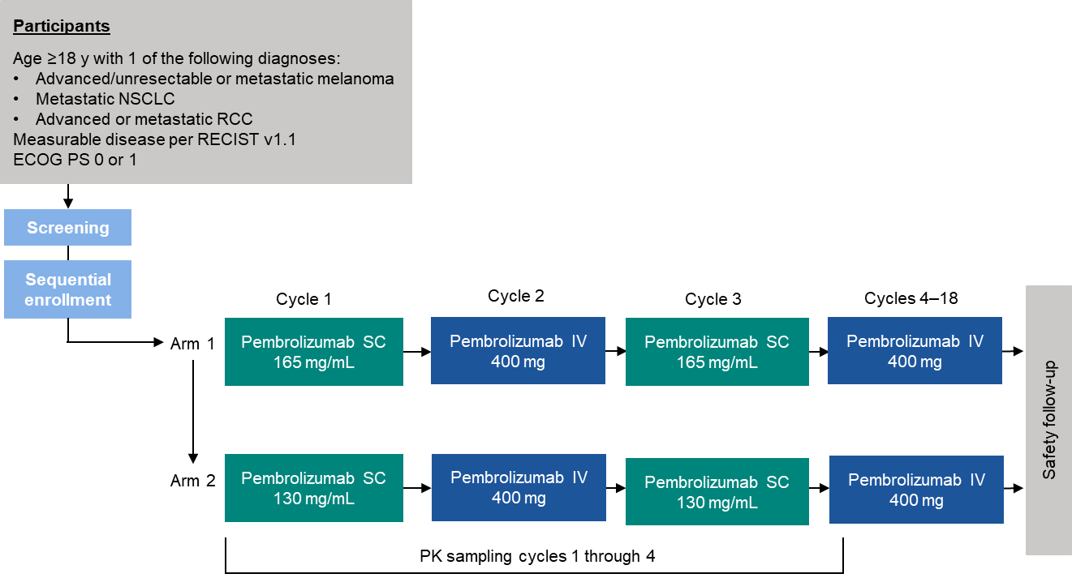

B. Arm 3
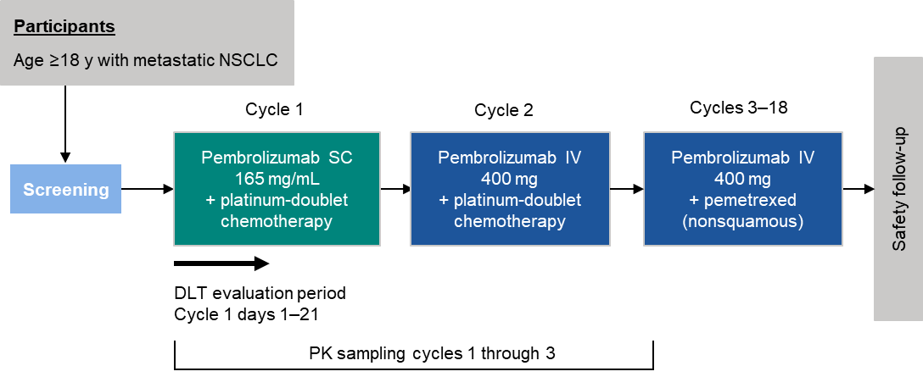
C. Arm 4
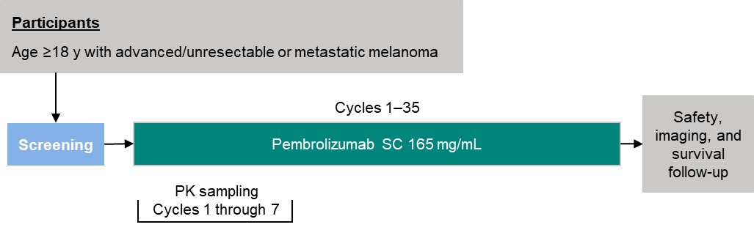
Supplementary Figure S2. Best percentage change from baseline in target lesion size for each participant per RECIST version 1.1 by tumor type. (A) Best percentage change from baseline per investigator assessment for 33 participants with NSCLC from arms 1–3; (B) best percentage change from baseline per investigator assessment for 31 participants with RCC from arms 1 and 2; (C) best percentage change from baseline per investigator assessment for 32 participants with melanoma from arms 1 and 2; and best percentage change from baseline per (D) investigator and (E) BICR assessment for 44 participants with melanoma from arm 4. Dashed lines indicate +20% and −30% change from baseline for target lesions. BICR, blinded independent central review; NSCLC, non–small-cell lung cancer; RCC, renal cell carcinoma; RECIST, Response Evaluation Criteria in Solid Tumors.
A. NSCLC

B. RCC
C. Melanoma

D. Melanoma
E. Melanoma

Supplementary Figure S3. Kaplan-Meier estimates of (A) duration of response and (B) progression-free survival by tumor type for participants in arms 1–3. NSCLC, non–small-cell lung cancer; RCC, renal cell carcinoma.
A.

B.

Supplementary Figure S4. Kaplan-Meier estimates of (A) duration of response, (B) progression-free survival, and (C) overall survival for participants in arm 4. BICR, blinded independent central review; IA, investigator assessment.
A.
B.

C.

