Supplementary Information – BRIG Analysis
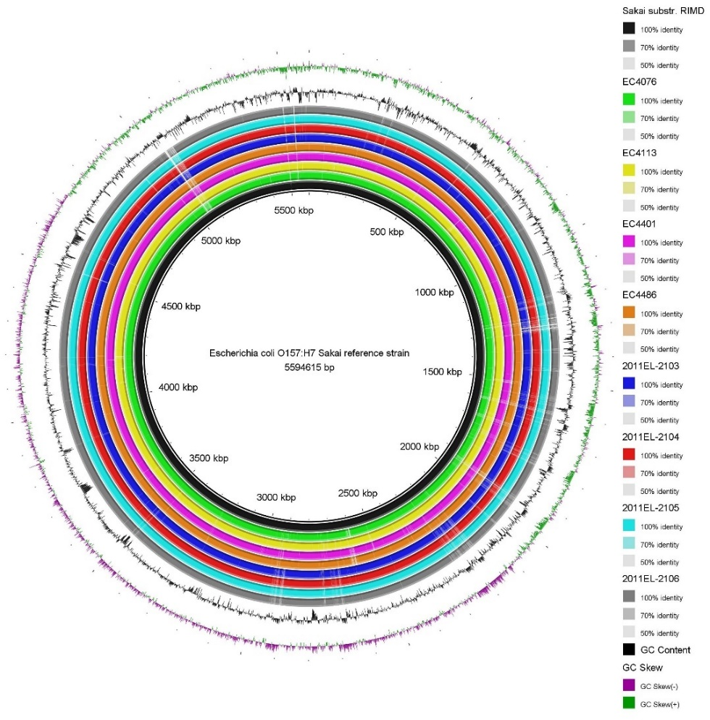
Figure 1: Comparison of BLAST Ring Image (BRIG) generated for E. coli O157:H7 strains, illustrating genomic similarities and differences between a reference strain and multiple query strains. The analysis was conducted using data obtained from NCBI, focusing on strains isolated from EC4076, EC4113, EC4401, EC4486, 2011EL-2103, 2011EL-2104, 2011EL-2105, and 2011EL-2106 sources. The BLAST Ring Image highlights the genomic alignments, enabling a comparative overview of genetic variations and conserved regions across the selected strains.
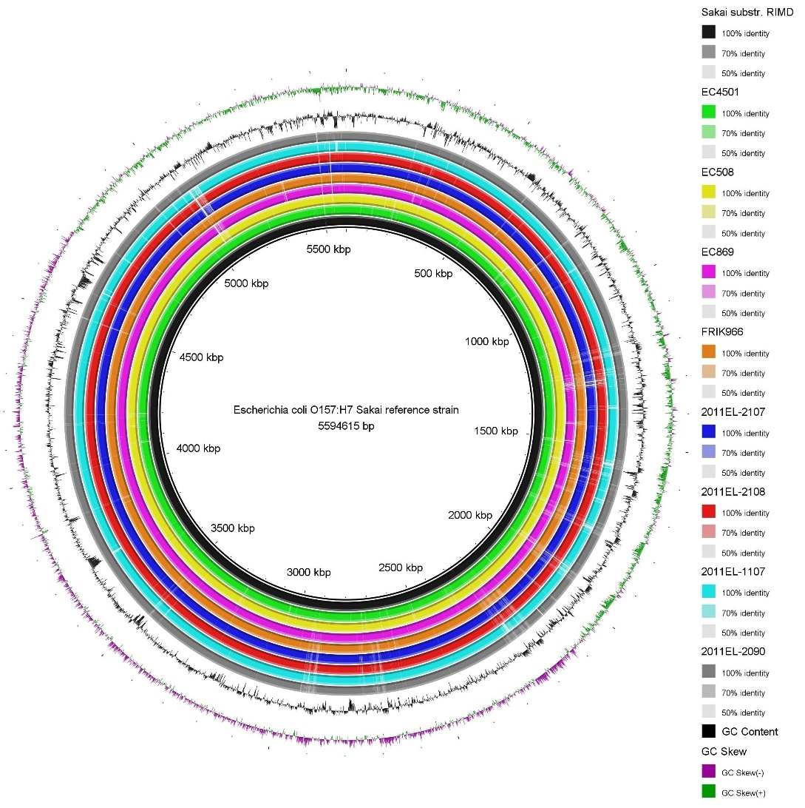
Figure 2: Comparison of BLAST Ring Image (BRIG) generated for E. coli O157:H7 strains, illustrating genomic similarities and differences between a reference strain and multiple query strains. The analysis was conducted using data obtained from NCBI, focusing on strains isolated from EC4501, EC508, EC869, FRIK966, 2011EL-2107, 2011EL-2108, 2011EL-1107, and 2011EL-2090 sources. The BLAST Ring Image highlights the genomic alignments, enabling a comparative overview of genetic variations and conserved regions across the selected strains.

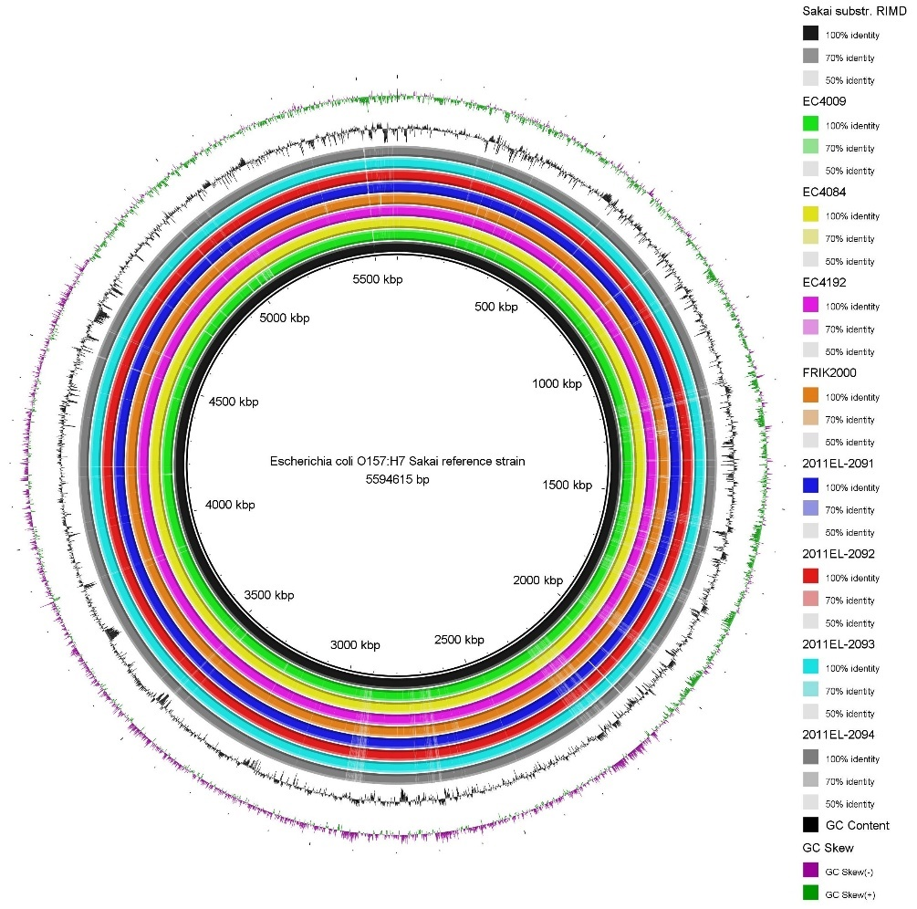
Figure 3: Comparison of BLAST Ring Image (BRIG) generated for E. coli O157:H7 strains, illustrating genomic similarities and differences between a reference strain and multiple query strains. The analysis was conducted using data obtained from NCBI, focusing on strains isolated from EC4009, EC4084, EC4192, FRIK2000, 2011EL-2091, 2011EL-2092, 2011EL-2093, and 2011EL-2094 sources. The BLAST Ring Image highlights the genomic alignments, enabling a comparative overview of genetic variations and conserved regions across the selected strains.
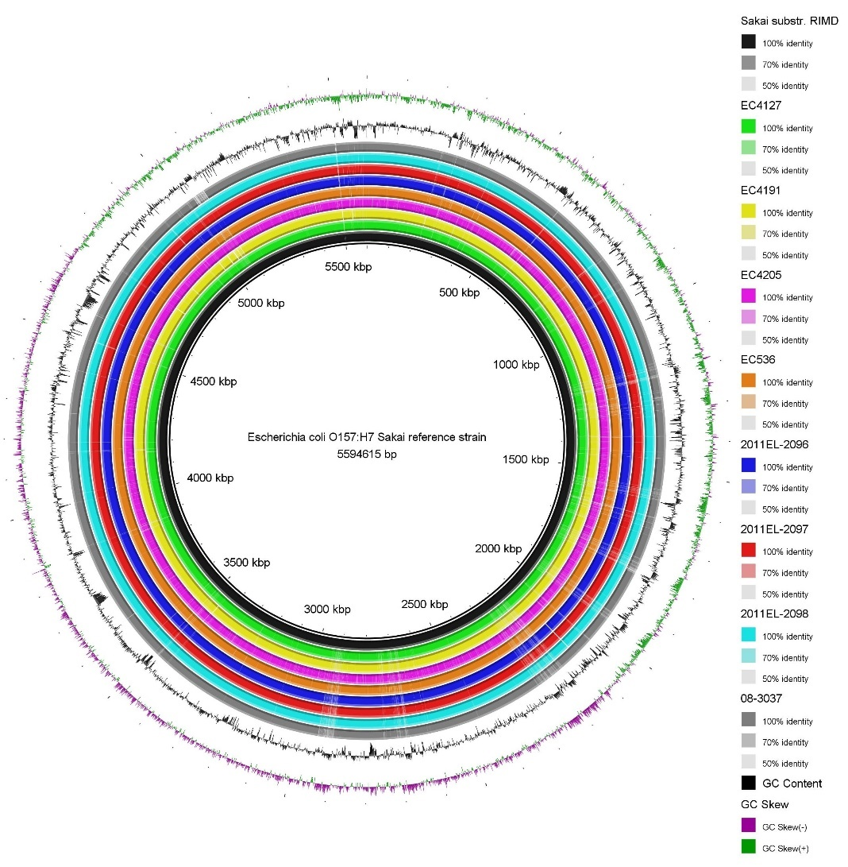
Figure 4: Comparison of BLAST Ring Image (BRIG) generated for E. coli O157:H7 strains, illustrating genomic similarities and differences between a reference strain and multiple query strains. The analysis was conducted using data obtained from NCBI, focusing on strains isolated from EC4127, EC4191, EC4205, EC536, 2011EL-2096, 2011EL-2097, 2011EL-2098, and 08-3037 sources. The BLAST Ring Image highlights the genomic alignments, enabling a comparative overview of genetic variations and conserved regions across the selected strains.
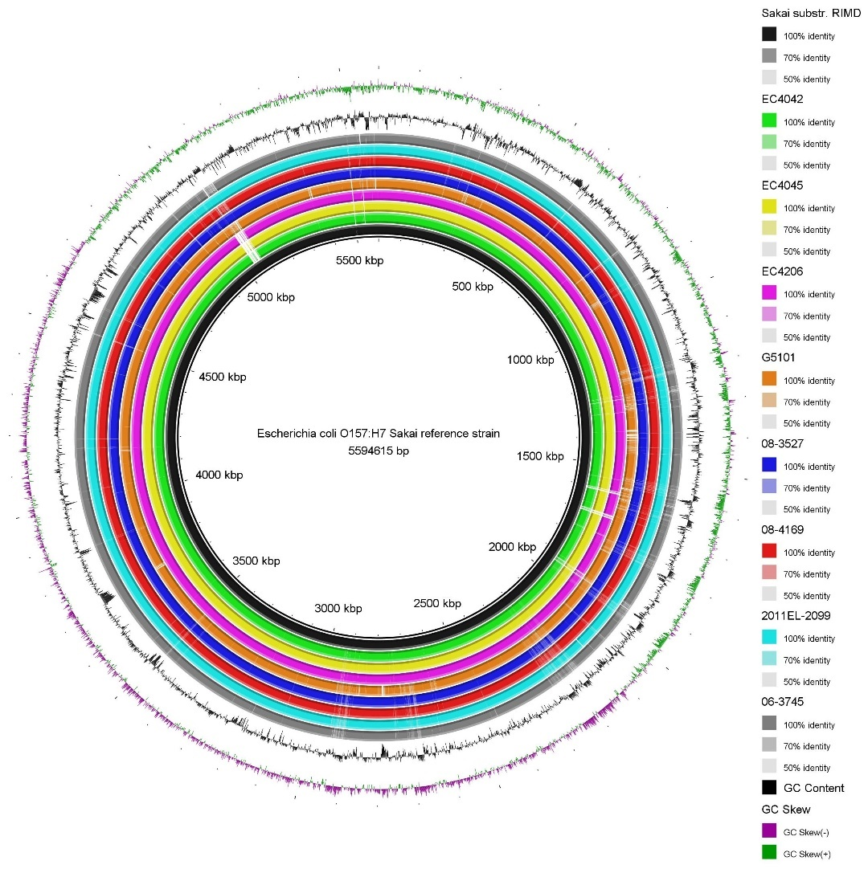
Figure 5: Comparison of BLAST Ring Image (BRIG) generated for E. coli O157:H7 strains, illustrating genomic similarities and differences between a reference strain and multiple query strains. The analysis was conducted using data obtained from NCBI, focusing on strains isolated from sources EC4042, EC4045, EC4206, G5101, 08-3527, 08-4169, 2011EL-2099, and 06-3745. The BLAST Ring Image highlights the genomic alignments, enabling a comparative overview of genetic variations and conserved regions across the selected strains.
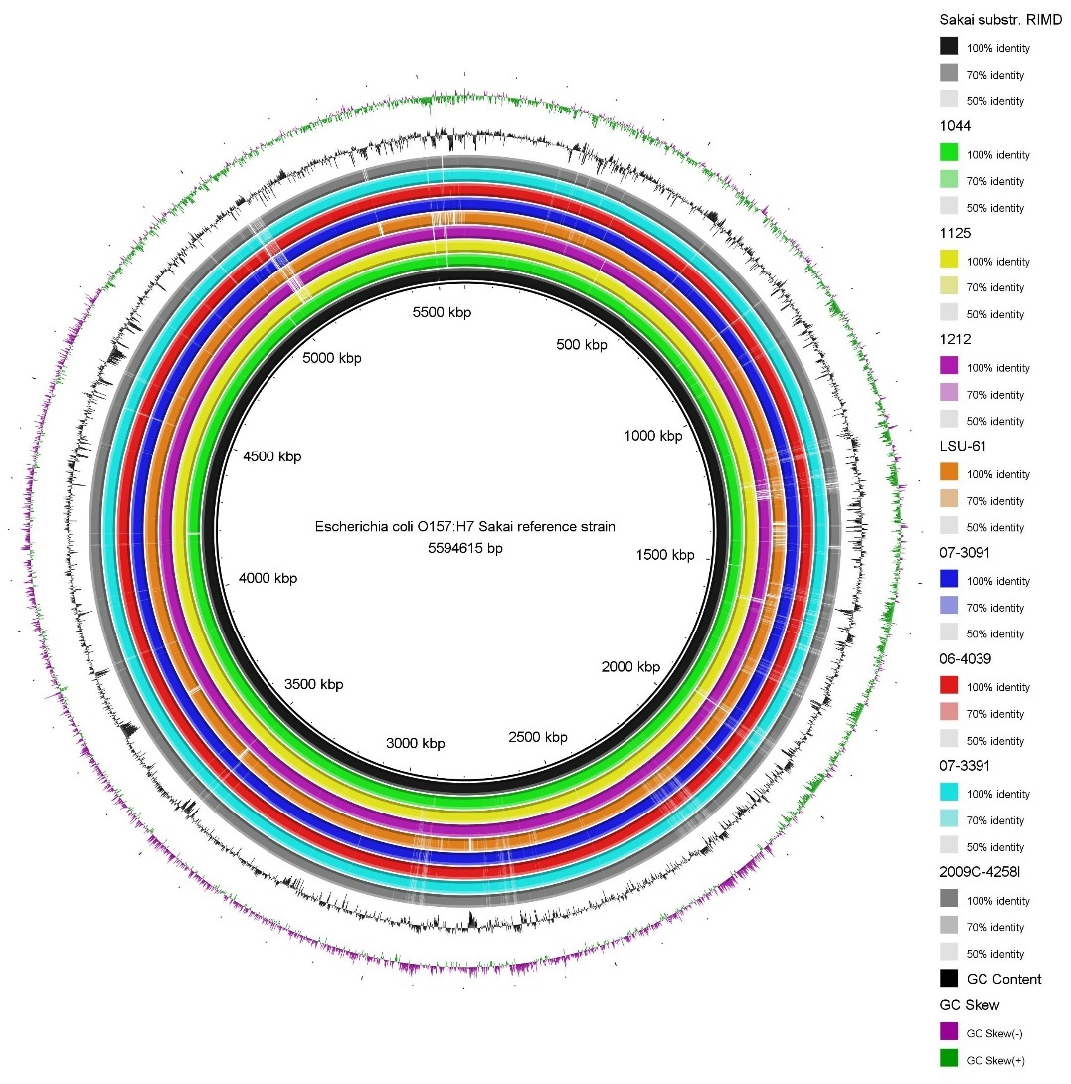
Figure 6: Comparison of BLAST Ring Image (BRIG) generated for E. coli O157:H7 strains, illustrating genomic similarities and differences between a reference strain and multiple query strains. The analysis was conducted using data obtained from NCBI, focusing on strains isolated from sources 1044, 1125, 1212, LSU-61, 07-3091, 06-4039, 07-3391, and 2009C-42581. The BLAST Ring Image highlights the genomic alignments, enabling a comparative overview of genetic variations and conserved regions across the selected strains.
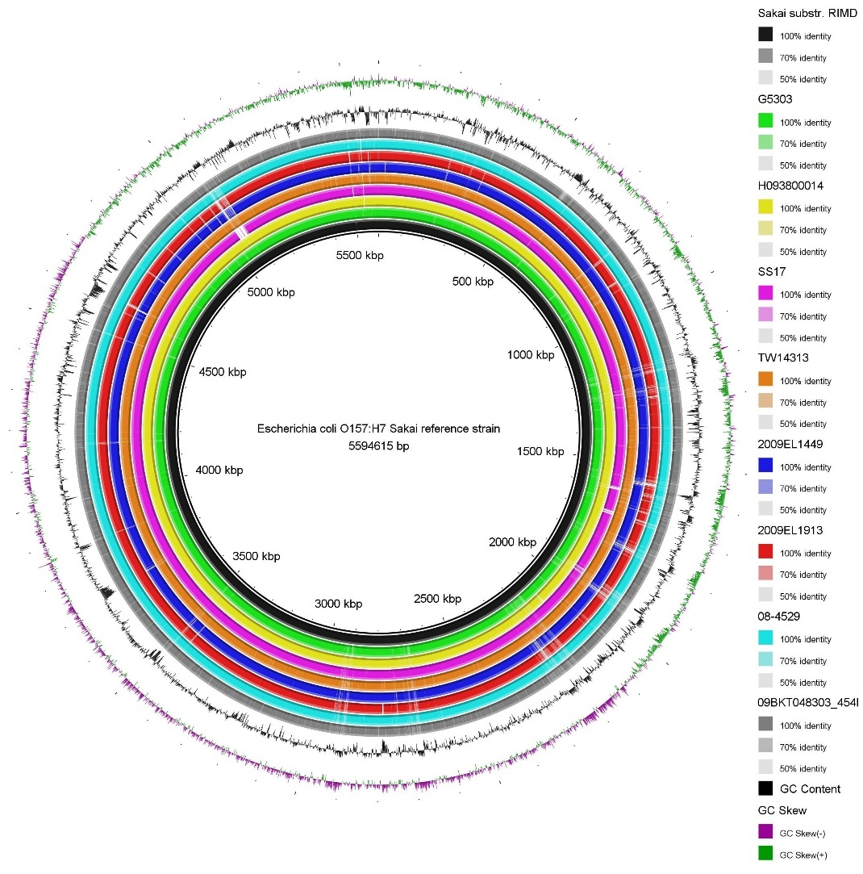
Figure 7: Comparison of BLAST Ring Image (BRIG) generated for E. coli O157:H7 strains, illustrating genomic similarities and differences between a reference strain and multiple query strains. The analysis was conducted using data obtained from NCBI, focusing on strains isolated from sources G5303, H093800014, SS17, TW14313, 2009EL1449, 2009EL1913, 08-4529, and 09BKT048303_4541. The BLAST Ring Image highlights the genomic alignments, enabling a comparative overview of genetic variations and conserved regions across the selected strains.
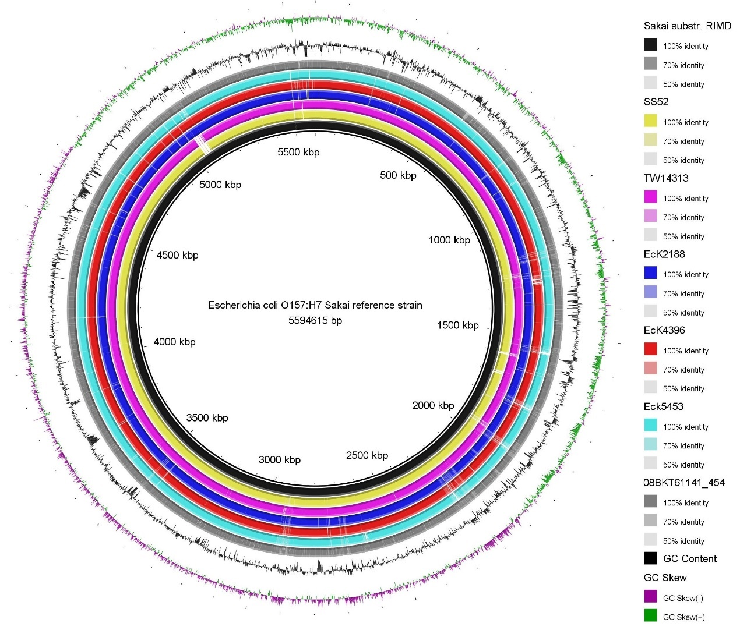
Figure 8: Comparison of BLAST Ring Image (BRIG) generated for E. coli O157:H7 strains, illustrating genomic similarities and differences between a reference strain and multiple query strains. The analysis was conducted using data obtained from NCBI, focusing on strains isolated from sources SS52, TW14313, EcK2188, EcK4396, EcK5453, and 08BKT61141_454. The BLAST Ring Image highlights the genomic alignments, enabling a comparative overview of genetic variations and conserved regions across the selected strains.
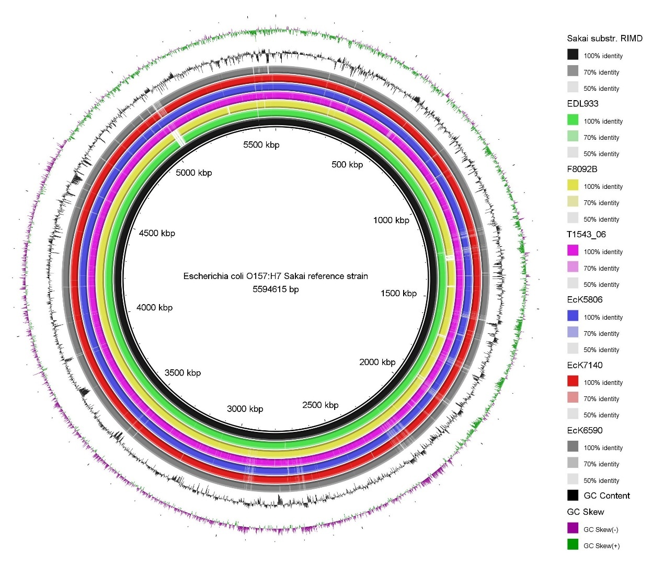
Figure 9: Comparison of BLAST Ring Image (BRIG) generated for E. coli O157:H7 strains, illustrating genomic similarities and differences between a reference strain and multiple query strains. The analysis was conducted using data obtained from NCBI, focusing on strains isolated from sources EDL933, F8092B, T1543_06, EcK5806, EcK7140, and EcK6590. The BLAST Ring Image highlights the genomic alignments, enabling a comparative overview of genetic variations and conserved regions across the selected strains.
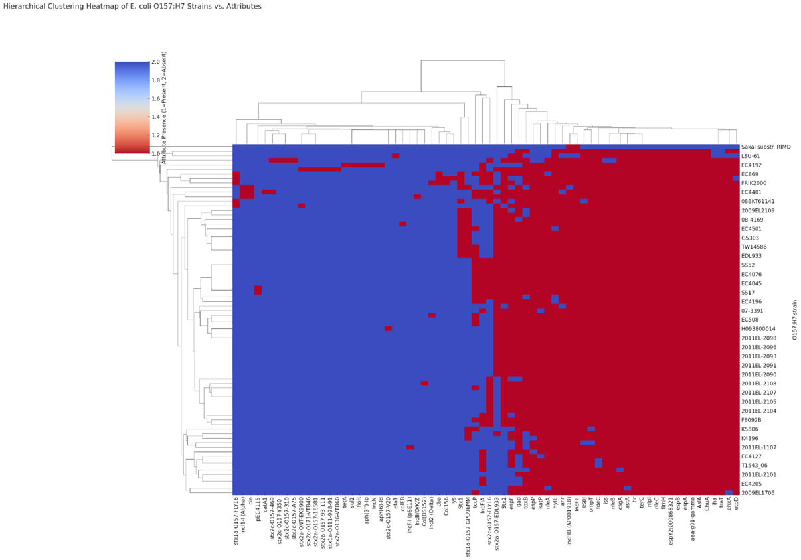
Figure 10: A strain representative double-hierarchical clustering heatmap (plasmids, virulence, and antimicrobial resistance genes) of E. coli O157:H7 strains versus genetic attributes.
Key:
1 | IncFIB (AP001918)
2 | IncFII
3 | IncFIA
4 | pEC4115
5 | IncI1-I (Alpha)
6 | IncB/O/K/Z
7 | Col156
8 | IncI2 (Delta)
9 | IncN
10 | Col (BS152)
11 | IncFII (pSE11)
 | Present
 | Absent
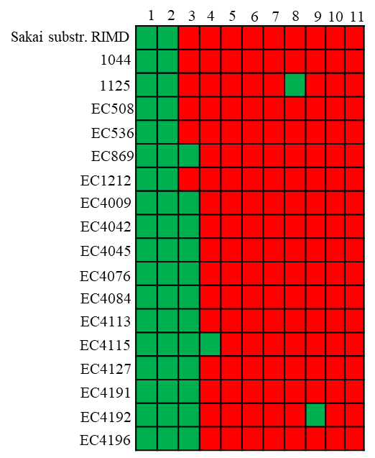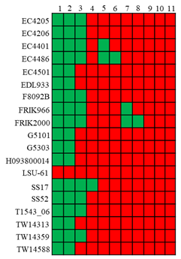

Figure 10: Comparison of Plasmid Finder generated for E. coli O157:H7 strains, indicating the presence or absence of plasmids in the reference strain and multiple query strains. The analysis was conducted using data obtained from NCBI.

Key:
1 | IncFIB (AP001918)
2 | IncFII
3 | IncFIA
4 | pEC4115
5 | IncI1-I (Alpha)
6 | IncB/O/K/Z
7 | Col156
8 | IncI2 (Delta)
9 | IncN
10 | Col (BS152)
11 | IncFII (pSE11)
 | Present
 | Absent
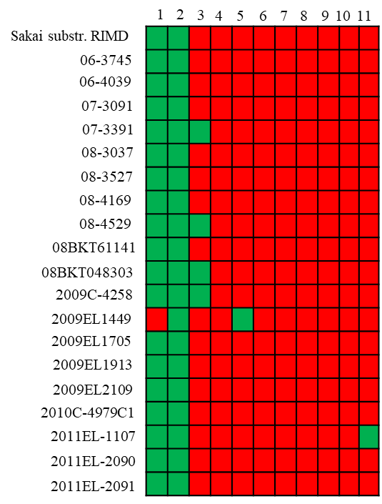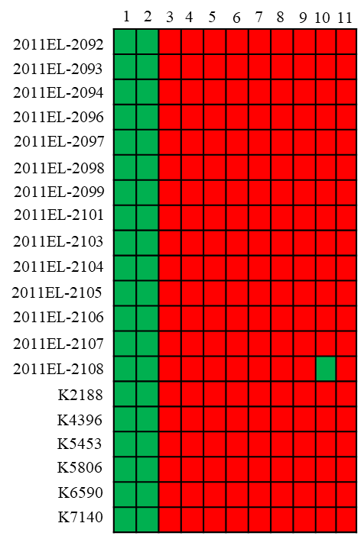
Figure 11: Comparison of Plasmid Finder generated for E. coli O157:H7 strains, indicating the presence or absence of plasmids in the reference strain and multiple query strains. The analysis was conducted using data obtained from NCBI.

Key:
1 | Stx1
2 | Stx2
3 | AslA
4 | anr
5 | astA
6 | cba
7 | ChuA
8 | cia
9 | colE8
10 | csgA
 | Present
 | Absent
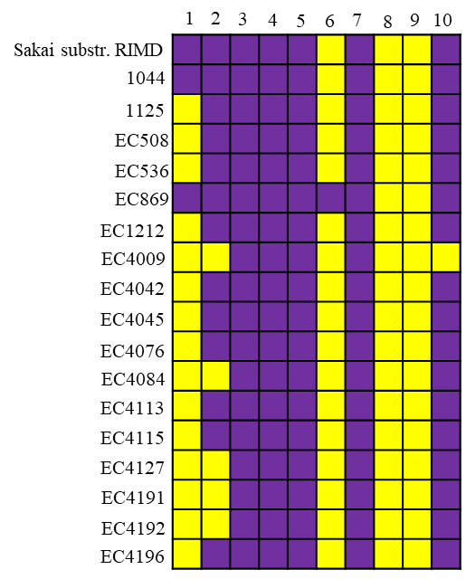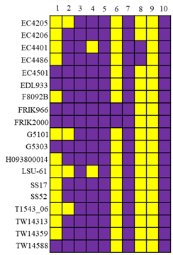

Key:
1 | aea-g01-gamma
2 | efa1
3 | ehxA
4 | espA
5 | espB
6 | espF
7 | espJ
8 | espP
9 | espY2:000868321
10 | etpD
 | Present
 | Absent
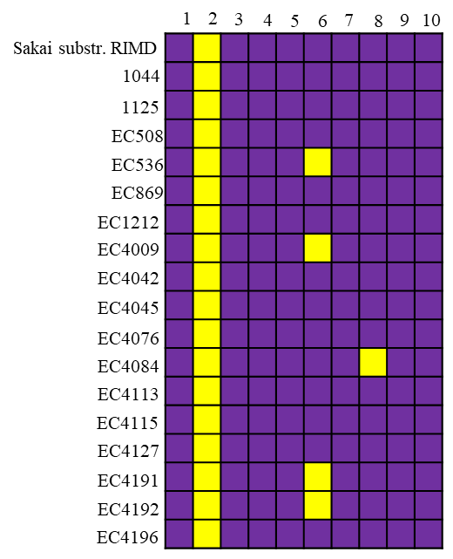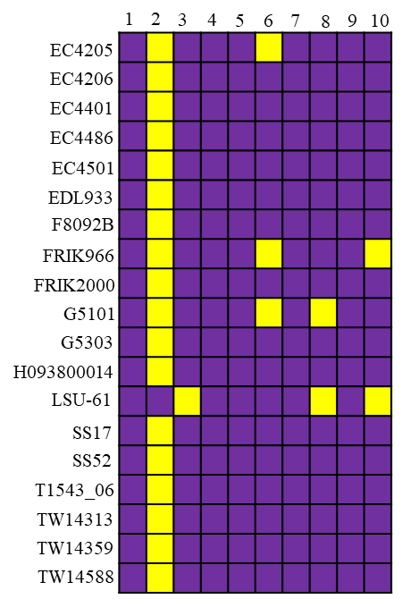

Key:
1 | fdeC
2 | fimH
3 | gad
4 | hylE
5 | iha
6 | iss
7 | katP
8 | lys
9 | nleA
10 | nleB
 | Present
 | Absent
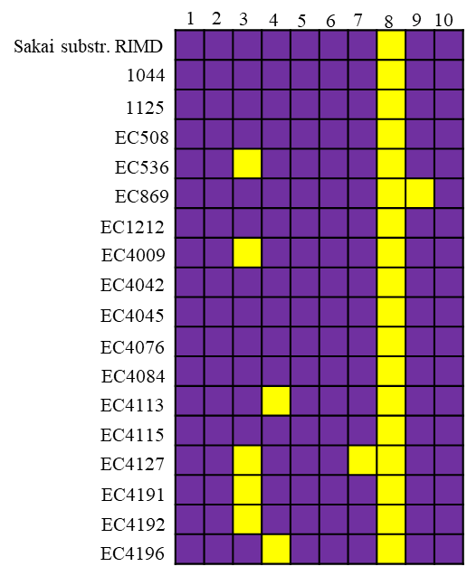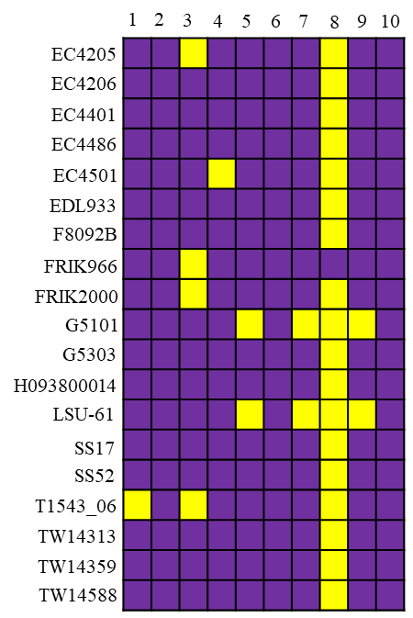

Key:
1 | nleC
2 | nlpI
3 | ompT
4 | Stx1a-O157-FLY16
5 | Stx1a-O157-GPU96MM
6 | Stx1a-O111-928-91
7 | Stx2a-O157-EDL933
8 | Stx2a-O136-VTB60
9 | Stx2a-O157-93-111
10 | Stx2a-O157-16581
 | Present
 | Absent
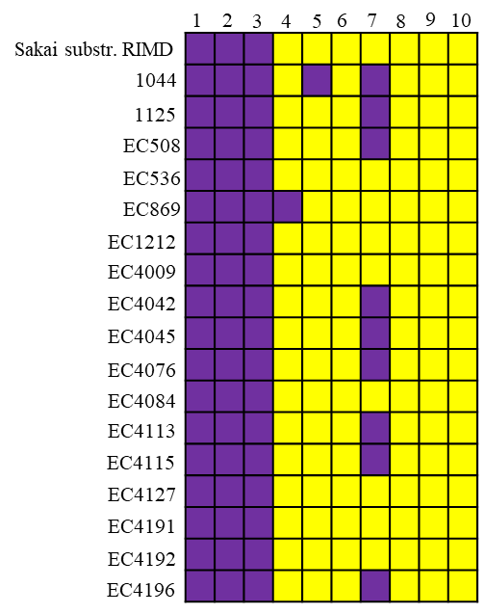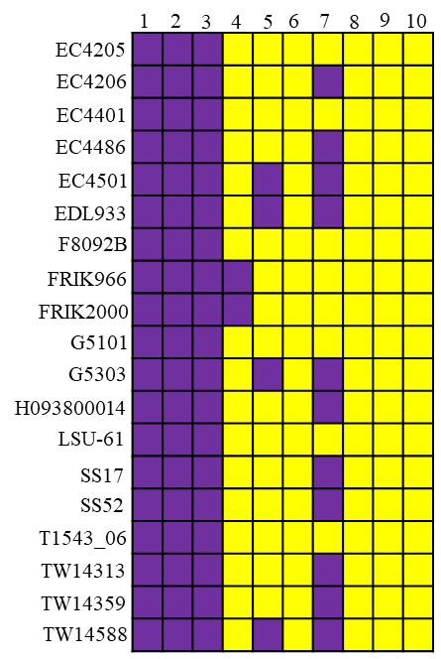

Key:
1 | Stx2a-ONT-EK9900
2 | Stx2c-O157-FLY16
3 | Stx2c-O157-V20
4 | Stx2c-O157-310
5 | Stx2c-O157-469
6 | Stx2c-O157-A75
7 | Stx2c-O157-Y350-
8 | Stx2c-O171-VTB46
9 | tccP
10 | terC
 | Present
 | Absent
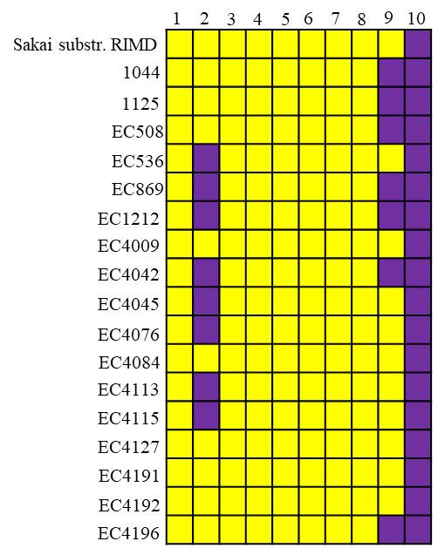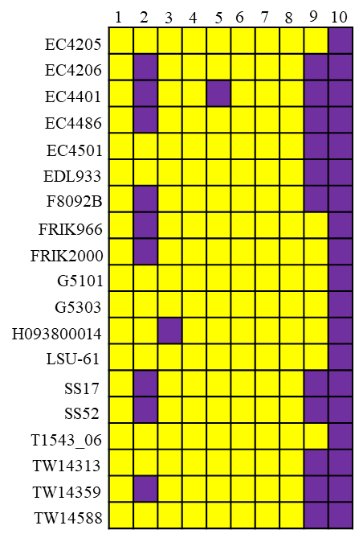
Key:
1 | tir
2 | toxB
3 | traT
 | Present
 | Absent
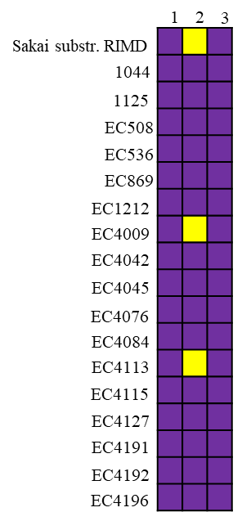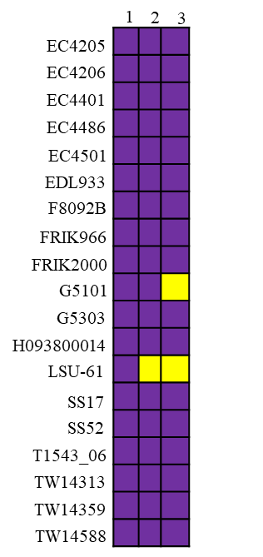
Figure 12: Comparison of Virulence Finder generated for E. coli O157:H7 strains, indicating the presence or absence of virulence genes in the reference strain and multiple query strains. The analysis was conducted using data obtained from NCBI.

Key:
1 | aea-g01-gamma
2 | efa1
3 | ehxA
4 | espA
5 | espB
6 | espF
7 | espJ
8 | espP
9 | espY2:000868321
10 | etpD
 | Present
 | Absent
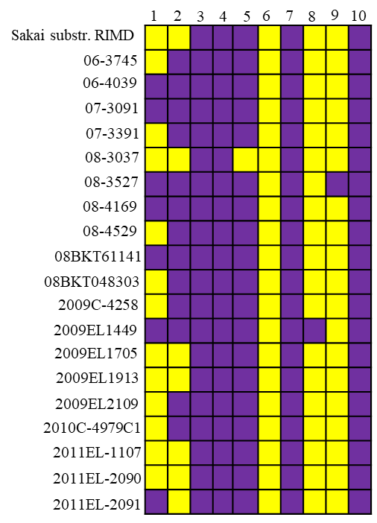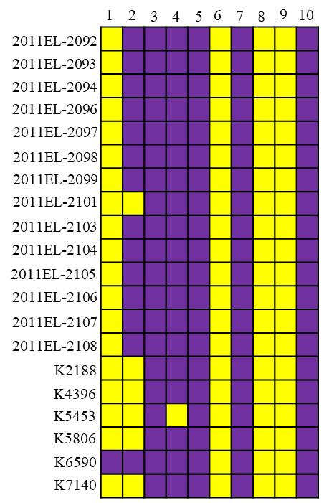
Key:
1 | Stx1
2 | Stx2
3 | AslA
4 | anr
5 | astA
6 | cba
7 | ChuA
8 | cia
9 | colE8
10 | csgA
 | Present
 | Absent
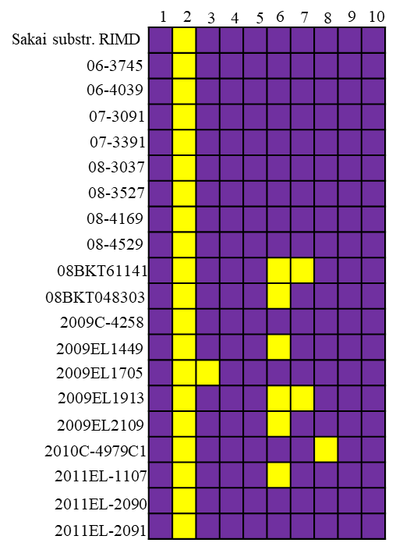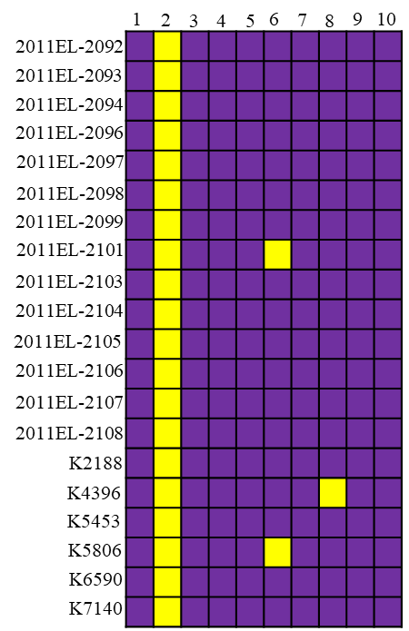
Key:
1 | fdeC
2 | fimH
3 | gad
4 | hylE
5 | iha
6 | iss
7 | katP
8 | lys
9 | nleA
10 | nleB
 | Present
 | Absent
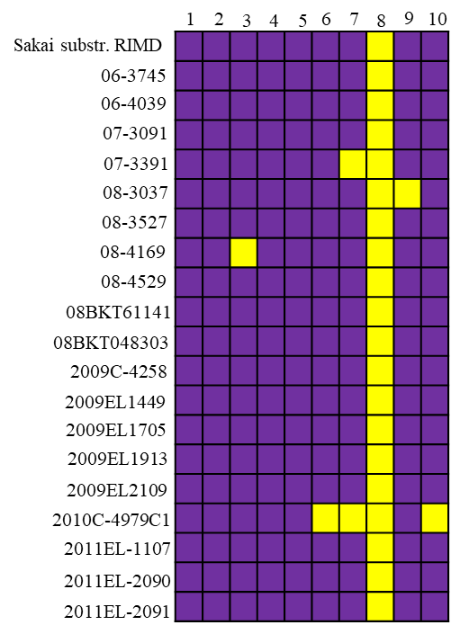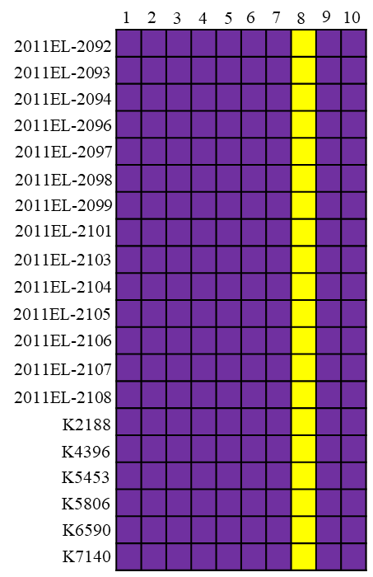
Key:
1 | nleC
2 | nlpI
3 | ompT
4 | Stx1a-O157-FLY16
5 | Stx1a-O157-GPU96MM
6 | Stx1a-O111-928-91
7 | Stx2a-O157-EDL933
8 | Stx2a-O136-VTB60
9 | Stx2a-O157-93-111
10 | Stx2a-O157-16581
 | Present
 | Absent
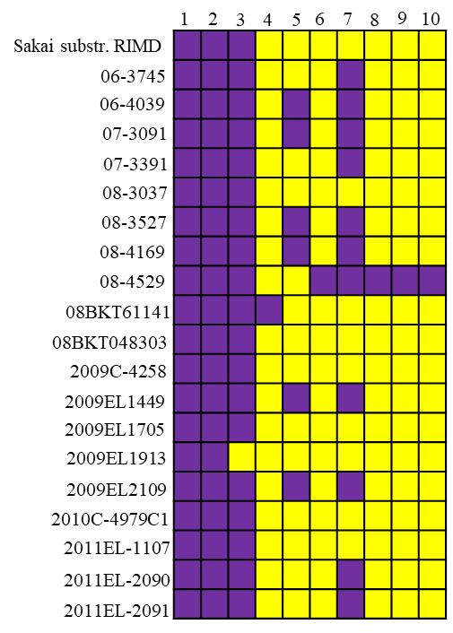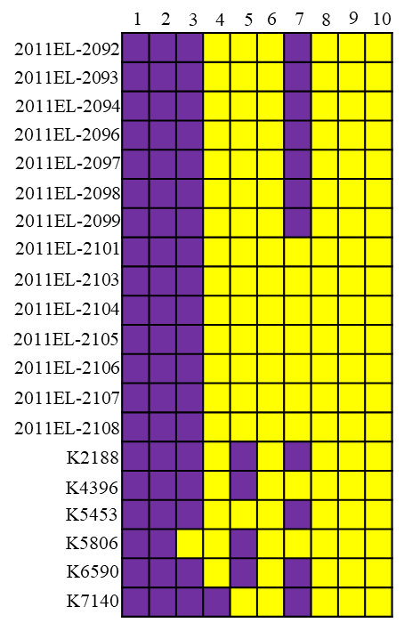
Key:
1 | Stx2a-ONT-EK9900
2 | Stx2c-O157-FLY16
3 | Stx2c-O157-V20
4 | Stx2c-O157-310
5 | Stx2c-O157-469
6 | Stx2c-O157-A75
7 | Stx2c-O157-Y350-
8 | Stx2c-O171-VTB46
9 | tccP
10 | terC
 | Present
 | Absent
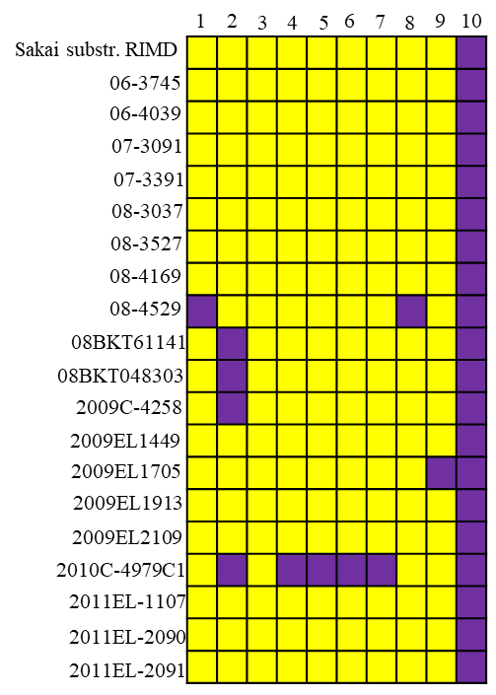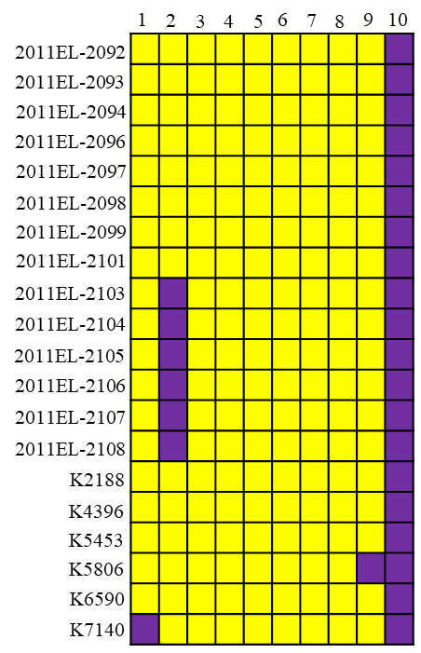
Key:
1 | tir
2 | toxB
3 | traT
 | Present
 | Absent
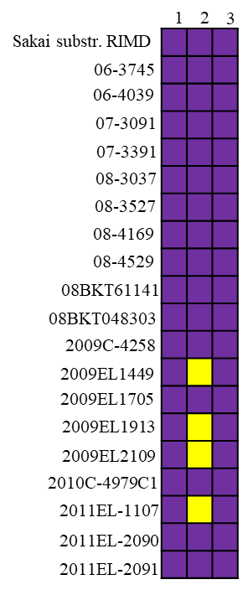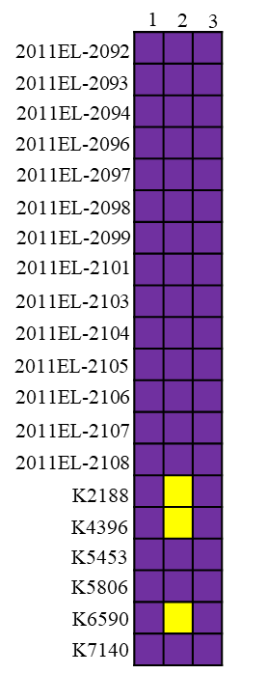
Figure 13: Comparison of Virulence Finder generated for E. coli O157:H7 strains, indicating the presence or absence of virulence genes in the reference strain and multiple query strains. The analysis was conducted using data obtained from NCBI.
Key:
1 | CatA1
2 | aph(6)-Id
3 | aph(3'')-Ib
4 | FloR
5 | sul2
6 | tetA
 | Present
 | Absent
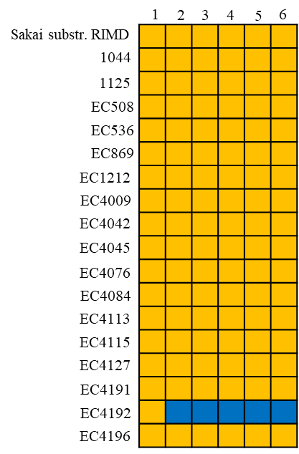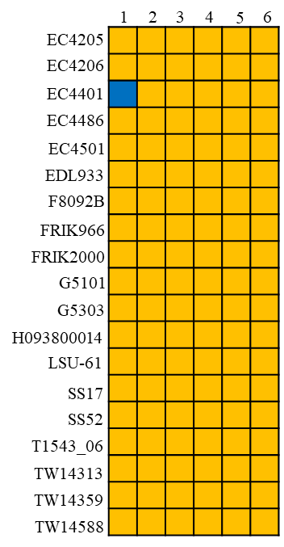
Figure 14: Comparison of ResFinder generated for E. coli O157:H7 strains, indicating the presence or absence of antimicrobial resistance genes in the reference strain and multiple query strains. The analysis was conducted using data obtained from NCBI.

Key:
1 | CatA1
2 | aph(6)-Id
3 | aph(3'')-Ib
4 | FloR
5 | sul2
6 | tetA
 | Present
 | Absent
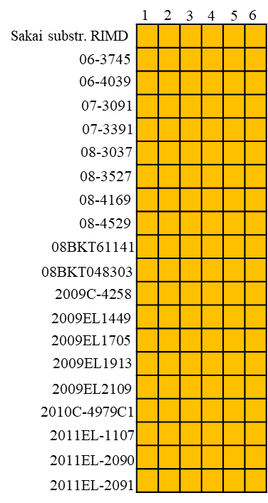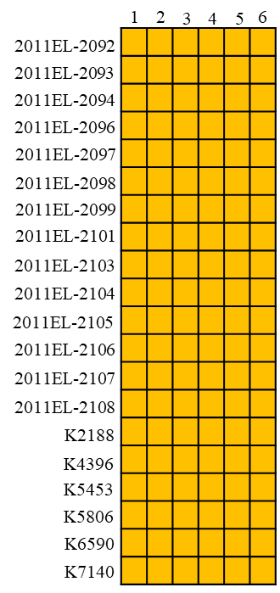
Figure 15: Comparison of ResFinder generated for E. coli O157:H7 strains, indicating the presence or absence of antimicrobial resistance genes in the reference strain and multiple query strains. The analysis was conducted using data obtained from NCBI.

