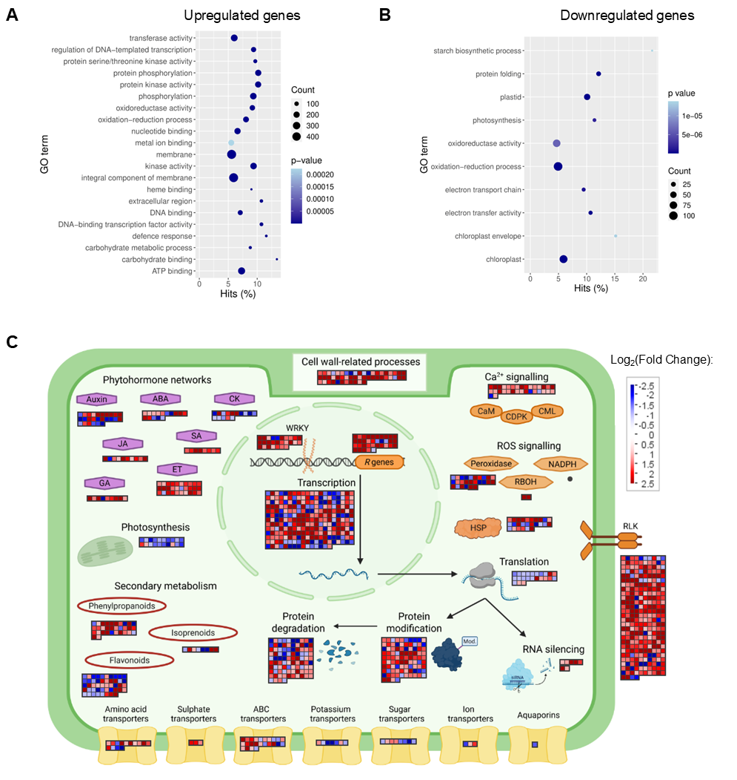
Fig. S1. Functional categorisation of genes with differential expression (DEGs, padj < 0.05; |log₂(Fold Change)| ≥ 1) in yellow sectors (SY) relative to green sectors (SG) of bleached ASBVd-infected leaves. (A & B) Top enriched gene ontology (GO) terms (over-represented p-value (FDR) < 0.05) for significantly upregulated or downregulated DEGs, respectively. The top 20 enriched GO terms are shown for upregulated DEGs, while only 10 GO terms were enriched for downregulated DEGs. Relative abundance of DEGs, compared to total annotated avocado genes per category, is shown on scatterplots (Hits % on x-axes), with DEG counts and FDR (p-value) being indicated by the accompanying legends. (C) MapMan analysis classified genes according to functions in particular cellular pathways. Individual coloured blocks denote DEGs associated with each specific pathway, with red indicating upregulation and blue indicating downregulation, according to the accompanying scale. Abbreviations: ABA—abscisic acid; ABC—ATP-binding cassette; CAM—calcium-binding calmodulin proteins; CDPK—calcium-dependent protein kinase; CK—cytokinin; CML—calmodulin-like protein; ET—ethylene; GA—gibberellic acid; HSP—heat shock protein; JA—jasmonic acid; R genes—nucleotide-binding site leucine-rich repeat (NBS-LRR) and pathogenesis-related (PR) genes; RBOH—respiratory burst oxidase homologue; RLK—receptor-like kinase; ROS—reactive oxygen species; SA—salicylic acid.

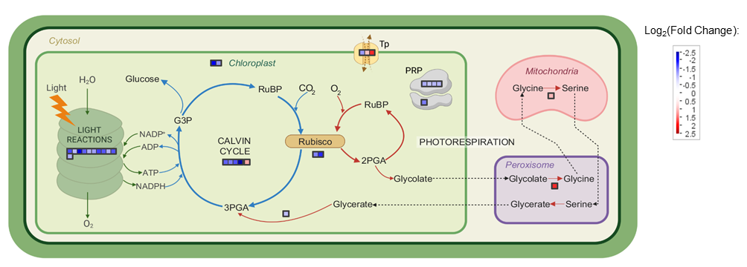
Fig. S2. MapMan representation of photosynthesis-related genes differentially expressed (DEGs, padj < 0.05; |log₂(Fold Change)| ≥ 1) in yellow sectors (SY) compared to green sectors (SG) of bleached ASBVd-infected leaves. Transcripts belonging to chloroplast- or photosynthesis-associated functional bins are depicted as individual coloured blocks, with red indicating upregulation and blue indicating downregulation, according to the scale provided. Abbreviations: G3P—Glyceraldehyde-3-phosphate; PGA—Phosphoglycerate; PRP—Plastid ribosomal protein (chloroplastic); RuBP—Ribulose bisphosphate; Tp—Transporter (chloroplastic).

