PREDATORS AND MANAGEMENT INFLUENCE ADULT SEX RATIO OF UNGULATE COMMUNITIES: SYNERGIES AND CHALLENGES FOR CONTEMPORARY CONSERVATION

Running: Predation and ungulate sex structure

Contents:

Supplementary text:
- Text S1: Comparison of environmental conditions between sections of Tswalu
- Text S2: Estimation of ungulate population abundance and density at Tswalu
- Text S3: Non-consumptive effects of predators on ungulate behaviour, nutrition and body condition

Supplementary tables:
- Table S1: Statistical results of environmental comparison between sections of Tswalu
- Table S1: Ungulate communities at Tswalu
- Table S2: Sex bias in prey kill rate by large African carnivores

Supplementary figures:
- Figure S1: Comparison of environmental conditions between sections of Tswalu
- Figure S2: Routes driven during ungulate demographic assessments at Tswalu
- Figure S3. Ungulate sex demographics presented by year and season
- Figure S4: Comparison of predator prey preference at Tswalu to continental averages
- Figure S5: Predator sex bias for prey species with sufficient kill records
- Figure S6: Predator prey preference and sex bias by season
- Figure S7: Predator non-consumptive effects on ungulate nutrition at Tswalu
- Figure S8: Ungulate supplementation and removal in the Lekgaba section of Tswalu

References

Text S1: Comparison of abiotic conditions between sections of Tswalu Kalahari Reserve

Tswalu is divided into two sections separated by an electrified fence; the Korranaberg (92,231 ha) and Lekgaba sections (18,649 ha). Predator guilds are different between these sections (Figure 1), offering a unique opportunity to isolate the effects of predators and management interventions on ungulate adult sex ratio (ASR). However, to ensure that additional environmental factors (e.g., resource availability, disease effects) that could potentially also influence ungulate ASR are comparable between sections, we first undertook a number of abiotic and biotic comparisons.

Water and mineral lick availability:
Tswalu is necessarily fenced to prevent human-wildlife conflict with neighbouring farms. However, this restricts seasonal movement of ungulates to find nutrient and water resources. Management therefore pump groundwater to the surface at permanent waterholes (n~22 sites) and provide artificial mineral licks at these sites (Abraham et al., 2023). Additional natural waterholes are seasonally present across the reserve. To ensure that water/artificial mineral lick resources are equally distributed between sections we calculated the area/number of waterhole and ungulate abundance/number of waterhole (permanent and seasonal) in each section (Figure S1). Per unit area, there are more waterholes in the Lekgaba section. However, waterhole/mineral resource availability is remarkably similar between sections when standardised by the number of animals (1 waterhole/~400 ungulates in both sections).

Forage nutrient availability:
To quantify nutrient availability in the diets of grazing and browsing ungulate populations, we collected 50g samples from ten commonly consumed plants during three collection periods through the seasonal cycle of 2022/23 (n=297): dry season (June-July), early wet season flush (October-November) and wet season (February). Plant species represented six C₃ plants (trees) commonly consumed by browsers at TKR (Boscia albitrunca, Grevia flava, Senegalia mellifera, Vachellia erioloba, Vachellia haematoxylon and Ziziphus mucronata; Shaw, 2011) and four C₄ grasses commonly consumed by grazers (Digitaria spp, Eragrostis chloramella, Eragrostis curvula, and Stripagrostis uniplumis). All samples were dried, ground and transported to the Soil Sciences Laboratory, University of Pretoria, where 0.25-0.30g of each sample was digested in EMSURE Nitric acid (65%) and analysed for 10 key nutrients potentially limiting wildlife populations in the Kalahari: Ca, Cu, Fe, K, Mg, Mn, Na, P, S and Zn (Abraham et al., 2023). Nutrient analysis was conducted using a SPECRO GENESIS Inductively coupled plasma optical emission spectrometer (ICP-OES). Data were not normally distributed, so we used a wilcox-test to examine if there was a statistical difference between sections for both grass (C₄) and tree (C₃) functional groups. These tests revealed no statistical difference (p<0.05) in all comparisons, except Mn in trees (Table S1). However, this result is not significant if a Bonferroni correction is applied to account for multiple (n=20) tests. Together, this indicates that forage quality was directly comparable between sections (Figure S1b). Unfortunately, no information was available on forage nitrogen (N) content, an important macro-nutrient and metric of protein availability, although we have no reason to believe that this would differ between sections either. Furthermore, an assessment of faecal N across three ungulate species (see Section 2.4) revealed no statistical differences in blue wildebeest and kudu, although springbok did demonstrate marginally higher N in Lekgaba (Figure S6).

Rainfall:
Tswalu maintains 40+ rainfall gauges distributed across the reserve to monitor rainfall. This number are required to capture the high degree of spatial heterogeneity in Kalahari rainfall events (Yu et al., 2017). We used data from 2015-2023 and compared mean annual precipitation (MAP) for rainfall gauges located between sections. A t-test revealed no statistical difference between sections (p<0.05) (Table S1). The range of MAP values was, however, larger in Korannaberg, likely influenced by the greater area of this section (Figure S1c).

Ungulate nutrition and body condition:
In our assessment of possible predator non-consumptive effects on ungulate ASR, we examined ungulate nutrition and body condition (see Section 2.4). However, differences in these metrics may also arise from differences in environmental conditions between sections, including resource availability or disease (Toïgo and Gaillard, 2003). We did not, however, observe any consistent differences in ungulate nutrition assessed via faecal nutrient concentration (N, P, Na) or differences in body condition; a composite metric of large mammal nutritional status and overall health (Figure S6).

Overall:
We found no evidence from either our direct assessment of environmental conditions (water availability, mineral lick availability, forage quality, and rainfall) or our indirect ungulate assessments (faecal nutrition and body condition scores) to suggest major environmental differences between the Korannaberg and Lekgaba sections of Tswalu.
Text S2: Estimation of ungulate population abundance at Tswalu Kalahari Reserve

TKR undertakes an aerial census of large herbivore species >10kg in March-April annually. Census data was collected using an Augusta Westland 139 helicopter flying parallel transects at a height of 100ft AGL and speed of 50-60 knots. Four observers (two port, two starboard) and two recorders were used to count large herbivores (>10kg) from both sides of the helicopter. Observations are recorded at the point at which animals are perpendicular to the helicopter and classified into four distance categories (0-50m, 50-100m, 100-200m, 200-400m). Transects are spaced 800m apart to ensure that the entire area of TKR is recorded. Raw data was transformed into total estimates of each species within each section using the principles of ‘distance’ sampling (Buckland et al., 2015). For each species, we fitted three probability of detection models using the ‘distance’ package in R statistical software (Miller et al., 2019). Following (Thomas et al., 2010) we used (i) half-normal key with cosine adjustments, (ii) half-normal key with Hermite polynomial adjustments and (iii) hazard-rate key with simple polynomial adjustments. These three models fit most cases and rarely are other, more complex, models required. Best estimates of herbivore population size in each section were calculated by averaging across models. See Abraham et al. (2023) for validation of aerial census estimates with ground-based estimates of large herbivore abundance.

Text S3: Non-consumptive effects of predators on herbivore nutrition and body condition

Predators may exert non-consumptive effects on prey ASR via sex differences in behaviour, nutrition and body condition, with subsequent impact on survivorship and fecundity (O’Kane and Macdonald, 2017; Owen-Smith, 1993). To evaluate such possible effects, we compared four metrics of herbivore health: (i) herd size, (ii) social segregation, (iii) nutrition, and (iv) body condition.

- We calculated mean ungulate herd size in each section from aerial surveys during the period 2019-2023. We used a Wilcoxon rank sum test to compare differences between sections for each herbivore species individually.

- We calculated a measure of social segregation from our five ground-based herbivore demographic surveys. We considered groups as all animals observed when the vehicle was stopped. Following (Conradt, 1998), we estimated a metric of social segregation based on equation S1:

${SC}_{social}=1-\frac{N}{X.Y}.\sum_{i=1}^{k}{\frac{x_{i}.y_{i}}{n_{i}-1}}$ (Equation S1)

where x_{i} is the number of males in the ith group; y_{i} is the number of females in ith group; n_{i} is the group size of the ith group (n_{i} = x_{i} + y_{i}); k is the number of groups with at least two animals; X is the total number of males sampled (excluding solitary animals); Y is the total number of females sampled (excluding solitary animals); and N is the total number of males and females sampled (N = X + Y). SC_{social} takes a value of 0 in the case of no segregation and of 1 in the case of complete segregation. To ensure we had sufficient data, we only calculated SC_{social} when X and Y were both >30 (Conradt, 1998). To generate a central estimate and 95% confidence intervals, we bootstrapped this procedure 1000 times using sampling with replacement. We used a chi-squared test (𝜒²) test to test for statistical difference (p<0.05) in SC_{social} between sections.

- To quantify differences in herbivore nutrition between sections, we collected fresh faeces (<10-minute post-defecation) from three abundant ruminant species: a lion-preferred prey (blue wildebeest), an all-preferred prey (kudu), and a cheetah-preferred prey (springbok). Faeces represent a practical, non-invasive approach to measure nutrient stress in herbivores, reflecting the quality and digestibility of resources consumed (Abraham et al., 2021; Grant et al., 2000; Stapelberg et al., 2008). Faecal collection (30/species/section; total n =180) was conducted in July-September 2021, which coincided with our first herbivore demographic survey, when herbivores in the southern Kalahari are typically nutrient stressed (Abraham et al., 2023; Stapelberg et al., 2008). All faecal samples were lyophilised and homogenised prior to quantification of crude protein content, expressed as nitrogen (N), and two important additional nutrients considered limiting for herbivores in the southern Kalahari, phosphorus (P) and sodium (Na) (Abraham et al., 2023). N was determined using a LECO® instrument equipped with TruMac CN/N determinator software (v1.5x) for instrument control and data processing, while P and Na were assessed using Suprapur Nitric acid (65%) digestion and SPECRO GENESIS Inductively Coupled Plasma Optical Emission Spectrometry (ICP-OES). We used a Wilcoxon rank sum test to compare differences between sections for each herbivore species individually. Unfortunately, it was not possible to reliably determine the sex of individuals that produced faecal piles as individuals were often part of herds. Consequently, inferences of differences in herbivore nutrition between sections is limited at the population-level, and specific differences by sex cannot be made. Nevertheless, if nutrient metrics are similar between populations, it is likely that there are no sizeable differences within sex. We used a Wilcoxon rank sum test to compare differences between sections for each herbivore species individually.

- A broader evaluation of animal health, incorporating animal nutritional status with additional effects such as parasite loads and disease (Ezenwa et al., 2009), can be obtained through visual body condition assessments. During herbivore demographic assessments, the body condition score of herbivores was recorded. For animals that could be fully assessed, a body condition value of 1 (low) to 5 (high) in 0.5 increments was quantified based on clearly detectable characteristics (such as the protrusion of ribs vs the presence of fat deposits (see Abraham et al. (2023) for detailed description of body condition assessments). We used a Wilcoxon rank sum test to compare differences between sections for each herbivore species and sex combination individually.

Table S1. Statistical comparison of environmental conditions between the Korannaberg and Lekgaba sections of Tswalu Kalahari Reserve. Only Mn concentration in trees was found statistically significant (p<0.05), although this was not considered significant when a Bonferroni correction was applied.

Environmental conditions | Variable | Functional group | Korannaberg  median | Lekgaba  median | Test Statistic W | P value | Conclusion
Forage quality | Ca_mgkg | Grass | 1347.989 | 1547.583 | 1859 | 0.247 | Not significant
Forage quality | Ca_mgkg | Tree | 13296.421 | 14350.838 | 3480 | 0.994 | Not significant
Forage quality | Cu_mgkg | Grass | 1.178 | 1.314 | 1800 | 0.151 | Not significant
Forage quality | Cu_mgkg | Tree | 1.248 | 1.576 | 3086 | 0.202 | Not significant
Forage quality | Fe_mgkg | Grass | 174.928 | 159.250 | 2113 | 0.983 | Not significant
Forage quality | Fe_mgkg | Tree | 73.081 | 77.540 | 3279 | 0.515 | Not significant
Forage quality | K_mgkg | Grass | 4817.871 | 4919.889 | 2109 | 0.998 | Not significant
Forage quality | K_mgkg | Tree | 6756.488 | 7756.591 | 3401 | 0.794 | Not significant
Forage quality | Mg_mgkg | Grass | 498.994 | 512.053 | 2167 | 0.785 | Not significant
Forage quality | Mg_mgkg | Tree | 2654.253 | 2484.794 | 3702 | 0.484 | Not significant
Forage quality | Mn_mgkg | Grass | 51.005 | 56.116 | 1770 | 0.116 | Not significant
Forage quality | Mn_mgkg | Tree | 55.282 | 64.397 | 2862 | 0.047 | Significant (p<0.05)
Forage quality | Na_mgkg | Grass | 31.475 | 32.200 | 2036 | 0.739 | Not significant
Forage quality | Na_mgkg | Tree | 22.831 | 22.151 | 3815 | 0.288 | Not significant
Forage quality | P_mgkg | Grass | 380.486 | 487.644 | 1691 | 0.052 | Not significant
Forage quality | P_mgkg | Tree | 888.409 | 813.224 | 3746 | 0.401 | Not significant
Forage quality | S_mgkg | Grass | 792.834 | 812.557 | 2017 | 0.673 | Not significant
Forage quality | S_mgkg | Tree | 2130.373 | 2040.922 | 3766 | 0.366 | Not significant
Forage quality | Zn_mgkg | Grass | 22.925 | 25.036 | 1934 | 0.417 | Not significant
Forage quality | Zn_mgkg | Tree | 13.104 | 13.574 | 3450 | 0.917 | Not significant
Rainfall | MAP | n/a | 288 | 309 | 3670 | 0.156 | Not significant

Table S2. Mean and range [min, max] of abundance and density estimates of large ungulate (>10kg) species for the period 2020-2023 in the Greater Korannaberg and Lekgaba sections of Tswalu Kalahari Reserve, South Africa. Values in brackets represent minimum and maximum estimates. Information pertaining to sensitive species (rhinos) has been omitted for security reasons. Some species (e.g. buffalo, roan and sable) only occur at low-densities in the Greater Korannaberg section and have thus not been included in analysis of adult sex ratios.
Species | Mass  (kg) | Greater Korannaberg  2020-2023 |  | Lekgaba  2020-2023
Species | Mass  (kg) | Abundance | Density (n/km²) | Abundance | Density (n/km²)
White rhino (Ceratotherium simum) | 2196 | - | - | - | -
Giraffe (Giraffa camelopardalis) | 1118 | 229 [213, 251] | 0.25 [0.23, 0.27] | 24 [13, 29] | 0.13 [0.07, 0.16]
Black rhino (Diceros bicornis) | 1000 | - | - | - | -
Eland (Taurotragus oryx) | 511 | 514 [257, 790] | 0.56 [0.28, 0.86] | 79 [62, 88] | 0.42 [0.33, 0.47]
Buffalo (Syncerus caffer) | 486 | 20 [11, 44] | 0.02 [0.01, 0.05] | - | -
Zebra (Equus quagga and Equus zebra) | 279 | 504 [435, 577] | 0.55 [0.47, 0.63] | 262 [168, 385] | 1.40 [0.90, 2.06]
Roan (Hippotragus equinus) | 264 | 86 [68, 120] | 0.09 [0.07, 0.13] | - | -
Blue wildebeest (Connochaetes taurinus) | 220 | 541 [467, 596] | 0.59 [0.51, 0.65] | 93 [58, 146] | 0.50 [0.31, 0.78]
Sable (Hippotragus niger) | 211 | 108 [70, 170] | 0.12 [0.08, 0.18] | - | -
Gemsbok (Oryx gazella) | 204 | 2130 [1719, 2466] | 2.31 [1.86, 2.67] | 496 [319, 717] | 2.66 [1.71, 3.84]
Kudu (Tragelaphus strepsiceros) | 202 | 480 [362, 655] | 0.52 [0.39, 0.71] | 134 [95, 150] | 0.72 [0.51, 0.80]
Red hartebeest (Alcelaphus buselaphus) | 150 | 50 [16, 94] | 0.05 [0.02, 0.10] | 151 [126, 166] | 0.81 [0.68, 0.89]
Warthog (Phacochoerus africanus) | 76 | 523 [372, 770] | 0.57 [0.40, 0.83] | 23 [15, 37] | 0.12 [0.08, 0.20]
Impala (Aepyceros melampus) | 49 | 75 [43, 109] | 0.08 [0.05, 0.12] | 262 [174, 334] | 1.40 [0.93, 1.79]
Springbok (Antidorcas marsupialis) | 35 | 184 [100, 286] | 0.20 [0.11, 0.31] | 535 [392, 635] | 2.87 [2.10, 3.41]
Common duiker (Sylvicapra grimmia) | 17 | 201 [105, 414] | 0.22 [0.11, 0.45] | 221 [162, 314] | 1.19 [0.87, 1.68]
Steenbok (Raphicerus campestris) | 11 | 524 [280, 804] | 0.57 [0.30, 0.87] | 195 [140, 294] | 1.05 [0.75, 1.58]

Table S3: Sex bias in predation rate for large African carnivores assembled from our semi-systematic literature review. Sex bias was determined from individual literature sources, where “M” indicates male bias, “F” for female bias and “NONE” for no bias or a preference not statistically significant. * are used to determine results that are statistically significant. Values without a * report a trend in sex bias from qualitative assessments (e.g., reported in paper discussions).

Predator | Location | Time Period | Prey | Sex bias  (M/F/NONE) | Comments | Citation
Lion (Panthera leo) | Southern Kalahari: Kalahari Gemsbok National Park (ZA)  and adjacent  Gemsbok National Park (Botswana) | Data collection: 1974 till 1982.  Publication: 1984 | Gemsbok (Oryx gazella) | M* | -Lion kill sex ratio = 1m:0.6fm  -Population sex ratio = 1m : 0.8fm  Found to be significantly different. | Mills (1984)
Lion (Panthera leo) |  | Data collection: 1974 till 1982.  Publication: 1984 | Wildebeest (Connochaetes) | NONE | -Lion kill sex ratio = 1m:1.4fm  -Population sex ratio = 1m : 1.9fm  No significant difference found. | Mills (1984)
Lion (Panthera leo) | Lake Manyara,  Tanzania | Publication: 1972 | Buffalo (Syncerus caffer) | M* | 44 adult bulls to 6 cows were killed by lions (X² after Yates continuity correction = 159.18, df = 1, P < 0.001 ).  Significantly higher risk for males. | Schaller (1972)
Lion (Panthera leo) | Waza national park,  Cameroon | Data collection: November 1976 till June 1979.  Publication: 1986 | Buffon's kob (Kobus kob) | M | Field observations of 163 kills indicated that lions killed many more males (87.1 %)  than females. | Wanzie (1986)
Lion (Panthera leo) | Nairobi National Park,  Kenya | Data collection: 1968 till 1972.  Publication : 1974 | Plains Zebra (Equus burchelli) | M* | Slightly significant selection for males (X² = 6.3, p <0.02). | Rudnai (1974)
Lion (Panthera leo) | Nairobi National Park,  Kenya | Data collection: 1968 till 1972.  Publication : 1974 | Eland (Taurotragus oryx) | M* | Slightly significant selection for males (X² = 7.3 , p < 0.01) | Rudnai (1974)
Lion (Panthera leo) | Nairobi National Park,  Kenya | Data collection: 1968 till 1972.  Publication : 1974 | Coke’s hartebeest (Alcelaphus buselaphus) | M* | Highly significant selection for males (X² = 60.6, p <0.005). | Rudnai (1974)
Lion (Panthera leo) | Nairobi National Park,  Kenya | Data collection: 1968 till 1972.  Publication : 1974 | Wildebeest | NONE | No sex bias in prey selection (X² = 0.92 , p > 0.25). | Rudnai (1974)
Lion (Panthera leo) | Lake Manyara Park,  Northern Tanzania  (3°30'S, 35°45'E) | Data collection: 1981 till 1985.  Publication: 1989 | Buffalo | M* | 26 adult bulls:35 adult cows killed by lions. Adult sex-ratio in the population = 1 bull: 4.5 cows (n = 2327 calculated from 29 censuses over the period). Significantly higher risk for Males (X² after Yates continuity correction = 22.88, df = 1, P < 0.001) | Prins and Lason (1989)
Lion (Panthera leo) | Madikwe and Pilanesberg Nature reserves, South Africa | Publication: 2019 | Kudu (Tragelaphus strepsiceros) | M* | Based off of generalized linear models for seasonal kill data of wild dogs and lions. | Louw et al. (2019)
Lion (Panthera leo) | Madikwe and Pilanesberg Nature reserves, South Africa | Publication: 2019 | Impala (Aepyceros melampus) | M* |  | Louw et al. (2019)
Lion (Panthera leo) | Kruger national Park, South Africa | Data collection:  1966 till 2000.  Publication:  2008 | Buffalo, Giraffe (Giraffa camelopardalis), Impala, Kudu | M | Overall, the sex composition of lion kills differed significantly among species (G² =367.30, df=32, p<0.00005). | Owen-Smith (2008)
Lion (Panthera leo) | Kruger national Park, South Africa | Data collection:  1966 till 2000.  Publication:  2008 | Plains Zebra,  Waterbuck (Kobus ellipsiprymnus) | F |  | Owen-Smith (2008)
Lion (Panthera leo) | Between the Sabie and Crocodile rivers, Kruger National Park, South Africa. | Data collection: January 1986 till January 1990. | Wildebeest,  Plains Zebra | NONE | No significant difference in the frequency with which adult males and females were caught, when the frequencies with which they occurred in the population are considered. For zebra, significant selection for foals. | Mills and Shenk (1992)
Leopard (Panthera pardus) | Southern Kalahari: Kalahari Gemsbok National Park (ZA) and adjacent Gemsbok National Park (Botswana) | Data collection: 1974 till 1982.  Publication: 1984 | Springbok (Antidorcas marsupialis) | M* | -Leopard kill sex ratio = 1m:0.6fm  -Population sex ratio = 1m : 1.5fm  Found to be significantly different. | Mills (1984)
Leopard (Panthera pardus) | Serengeti National Park,  Tanzania | Data collection: June 1966 till November 1967.  Publication: 1968 | Thompson’s gazelle (Eudorcas thomsonii) | M | Strong selection for males.  Of 63 kills, 34 were males.  This is 3x more males killed than expected from the population sex ratio. | Schaller (1968)
Leopard (Panthera pardus) | Sites across South Africa | Data from: Turnbull-Kemp, 1967; Kruuk, 1972; Schaller, 1972; Goodall, 1986.  Publication: 1994 | Baboon (Papio) | M* | Adult sex ratios in baboon groups = females outnumber males by 2:1 to 3:1: (Melnick and Pearl, 1987).  Adult male baboons were victims in 8/13 leopard kills (62%).  Leopards preying upon males significantly more frequently (Binomial test: N = 13, ho = 0.29, p < 0.05). | Cowlishaw (1994)
Leopard (Panthera pardus) | Kruger national Park, South Africa | Data collection:  1966 till 2000.  Publication:  2008 | Impala | F | Females predominated overall among the adult or subadult impala killed. However, kills of young impala showed a slight predominance of males. | Owen-Smith (2008)
Cheetah (Acinonyx jubatus) | Southern Kalahari: Kalahari Gemsbok National Park (ZA) and adjacent Gemsbok National Park (Botswana) | Data collection: 1974 till 1982.  Publication: 1984 | Springbok | M* | -Cheetah kill sex ratio = 1m:0.6fm  -Population sex ratio = 1m : 1.5fm  Found to be significantly different. | Mills (1984)
Cheetah (Acinonyx jubatus) | Serengeti National Park,  Tanzania | Data collection: June 1966 till November 1967.  Publication: 1968 | Thompson’s gazelle | NONE | Mostly selecting for juveniles (65/116 kills, 56%).  Record of daily kills for an adult female cheetah (Oct 13 – Nov 19), seems to indicate strong bias toward adult females and fawns.  Of the adults (51/116 kills, 44% = M), only as many males as is expected from population sex ratio (24 individuals) were killed (22 individuals). | Schaller (1968)
Cheetah (Acinonyx jubatus) | Southeastern region of the Kruger National Park | Data collection: 1987 till 1990.  Publication: 2004 | Impala | M* | Of the 18 adult impala killed, 78% were male and 22% were female.  Cheetahs preyed on male and female  impala at significantly higher and lower frequencies, respectively, than their availability would predict (x2 =  12.7, d f = 1, P < 0.001). | Mills, Broomhall and du Toit (2004)
Cheetah (Acinonyx jubatus) | Samara Private Game Reserve (32°21′41.67″ S, 24°50′19.60″ E), eastern Karoo, South Africa | Data collection:  September till October 2011.  Publication:  2016 | Kudu | M* | Inspection of the chi-square comparison for each age and sex class showed that only subadult male and juvenile kudu proportions were significantly different, with higher proportions of subadult male and juvenile kudu found within the predator-free section of Samara. | Makin and Kerley (2016)
Cheetah (Acinonyx jubatus) | Serengeti National Park,  Tanzania | Data collection: March 1985 till April 1987.  Publication: 1990 | Thompson’s gazelle | M* | Major female bias in local population (only 19.6% were males). Out of 102 kills where sex could be identified, more males were killed than expected from the population sex ratio, on the basis of vulnerability. | Fitzgibbon (1990)
Cheetah (Acinonyx jubatus) | Kruger national Park, South Africa | Data collection:  1966 till 2000.  Publication:  2008 | Impala | NONE | Overall, females predominated among the adult or subadult impala killed. Males predominated in cheetah kills made after 1986, although females had formed the greater proportion of kills earlier. Kills of young impala showed a slight predominance of males. | Owen-Smith (2008)
Wild Dog (Lycaon pictus) | Kruger national Park, South Africa | Data collection:  1966 till 2000.  Publication:  2008 | Impala | F | Females predominated overall among the adult or subadult impala killed, particularly in the case if wild dog predation. However, kills of young impala showed a slight predominance of males. | Owen-Smith (2008)
Wild Dog (Lycaon pictus) | The De Beers Venetia Limpopo Nature Reserve, Limpopo Province, South Africa (22°15′ - 22°30′ south, 029°12′ - 029°18′ east) | Publication:  2013 | Kudu,  Impala | F | Focus of study is a comparison of fence utilisation or not to entrap prey. Adult impala comprised a higher proportion of fence-impeded kills than those that were not fence impeded (0.71 vs. 0.56; Z = 1.84, P = 0.03). Adult female kudu were more likely to be caught on the fence than were younger females (Fisher’s exact test, P = 0.02, n = 65). We could not conduct this comparison for male kudu due to small sample sizes.  Regardless of on the fence or not, total counts indicates more females killed than males. Seems selective.  Kudu Adult = 40 ♀:6 ♂  Impala Adult = 50 ♀:35 ♂ | Davies-Mostert, Mills and Macdonald (2013)
Wild Dog (Lycaon pictus) | Masai Mara National Reserve, near Aitong, South-west Kenya | Data collection:  January 1988 till August 1989  and  late 1989 till early 1990.  Publication:  1995 | Thompson’s Gazelle | M | Despite typically having a female biased population, of the 24 adult Thompson’s gazelles killed, at least 13 were male. | Fuller, Nicholls and Kat (1995)
Wild Dog (Lycaon pictus) | Madikwe and Pilanesberg Nature reserves, South Africa | Publication: 2019 | Kudu | F* | Based off of generalized linear models for seasonal kill data of wild dogs and lions. | Louw et al. (2019)
Wild Dog (Lycaon pictus) | Madikwe and Pilanesberg Nature reserves, South Africa | Publication: 2019 | Impala | F* |  | Louw et al. (2019)
Wild Dog (Lycaon pictus) | south-east of Zimbabwe: Savé Valley Conservancy (SVC: 20◦05 S and 32◦00 E) | Data collection: January 1997 till September 1999.  Publication: 2004 | Impala | M* | Selection relative to abundance  Selection Index S = 0.16M:0.08fm  Particularly selected for males in late wet and early dry seasons | Pole, Gordon, Gorman and Mac Askill (2004).
Wild Dog (Lycaon pictus) |  |  | Kudu | NONE | Mostly selection for juveniles (with S=0.27 – highest selection out of all prey). An increase in the predation of adult females occurs around September, when they are more vulnerable due to pregnancy. | Pole, Gordon, Gorman and Mac Askill (2004).
Wild Dog (Lycaon pictus) | Ngorongoro Crater, Tanzani | Data collection: September 1964 till July 1965.  Publication: 1967 | Thompson’s gazelle | M | Despite typically having a female biased population, of the adults killed, 18 were male and only 6 were female. | Estes and Goddard (1967).
Wild Dog (Lycaon pictus) | Serengeti Plains,  Tanzania | Data collection: January 1985 till March 1987.  Publication: 1989 | Thompson’s gazelle | M | Wild dogs were reported to select for males. It is thought that males have lower fat percentages and poorer body condition, leaving them with lower energy reserves and more prone to disease. Wild dogs were also selecting for young and old gazelles, that are similarly vulnerable. | Fitzgibbon and Fanshawe (1989)
Wild Dog (Lycaon pictus) | Masai Mara National Reserve,  Southwestern Kenya (1”15’S, 35’15’E) | Data collection: January 1988 till June 1989.  Publication: 1990 | Thompson’s gazelle | M | Despite typically having a female biased population, of the adults killed, 16 were male and 10 were female. | Fuller and Kat (1990)
Wild Dog (Lycaon pictus) | The Pilanesberg National Park (25°08’ to 25°22’S; 26°57’ to 27°13’E), North West Province, South Africa | Data collection:  August 2000.  Publication:  2003 | Kudu | NONE | No significant difference between the ratio of males to females in the prey eaten for either kudu (observed prey: 7 ♂: 35 ♀: X² =0.292, P >0.05) or for waterbuck (observed prey: 4 ♂:11 ♀: X² = 0.017, P >0.05).  Therefore, no selection for smaller (and less dangerous) females over males for either of the two large species. | Van Dyk and Slotow (2003)
Wild Dog (Lycaon pictus) |  | Data collection:  August 2000.  Publication:  2003 | Waterbuck | NONE |  | Van Dyk and Slotow (2003)
Wild Dog (Lycaon pictus) | Hwange National Park (HNP) in northwest Zimbabwe (19°00 S, 26°30 E). | Data collection:  2007 till 2008.  Publication:  2015 | Kudu | M* | Jacobs indices:  Adult male: 0.12  Adult female: −0.44  Subadult male: 0.49  Subadult female: 0.39  sub-adults were selected over adults, adult females were avoided. | Van der Meer, Fritz and Pays (2015)
Wild Dog (Lycaon pictus) |  | Data collection:  2007 till 2008.  Publication:  2015 | Impala | M* | Jacobs indices:  Adult male: 0.66  Adult female: 0.35  Subadult male: −0.76  Subadult female: −0.09  predominantly selected adult impala, sub-adults were avoided. | Van der Meer, Fritz and Pays (2015)
Wild Dog (Lycaon pictus) | South East part of the Serengeti Ecological Unit,  Tanzania | Data collection: 1969 till 1972 (several stints).  Publication: 1975 | Thompson’s gazelle | M | Despite typically having a female biased population, of the 25 adults, 17 were males. | Malcolm and van Lawick (1975)
Wild Dog (Lycaon pictus) | Hluhluwe-Umfolozi Park, Central Zululand, KZN (28800'±28810'S and 31843'±32809'E) | Data collection: 1984 till 1994.  Publication: 1999 | Nyala (Tragelaphus angasii) | NONE | Despite sex ratio of the population being relatively equal (1:1), females are killed more regularly than males.  Not found to be significant. | Kruger, Lawes and Maddock (1999)
Wild Dog (Lycaon pictus) |  | Data collection: 1984 till 1994.  Publication: 1999 | Impala | F* | Despite sex ratio of the population being relatively equal (1:1), females are killed more regularly than males.  Found to be a significant result. | Kruger, Lawes and Maddock (1999)
Wild Dog (Lycaon pictus) | Mana Pools National Park, northern Zimbabwe (15°56 S, 29°27 E) | Data collection:  2015 till 2017.  Publication:  2019 | Impala | F* | Based on the Jacobs’ index calculated per study year, the study packs more often predated on adult than subadult impalas (N = 60, p < 0.01) and took more female than male impalas (N = 56, p < 0.01). | Van der Meer et al. (2019)
Wild Dog (Lycaon pictus) |  | Data collection:  2015 till 2017.  Publication:  2019 | Baboon | NONE | Based on the Jacobs’ index calculated per study year, the study packs predated as often on adult as on subadult baboons (N = 34, p = 1.00), and did not take significantly more male than female baboons (N = 10, p = 0.75). | Van der Meer et al. (2019)
Spotted Hyaena (Crocuta crocuta) | The Kuiseb River in the Namib Desert, South West Africa (23°34'S, 15°03'E) | Data Collection: 1976 till 1977 (12 month period).  Publication: 1980 | Gemsbok | NONE | 1:1 sex ratio in population of 1884 gemsbok. Biased prey selection towards males (X 2 = 2,79, p <.10). Not found to be significant. | Tilson, von Blottnitz and Henschel (1980)
Spotted Hyaena (Crocuta crocuta) |  |  | Mountain Zebra (Equus zebra) | F* | 1:1 sex ratio in population. Biased prey selection towards females (0.4 males vs. 1,0 females, X2 = 3,85, p<.05). Found to be significant. | Tilson, von Blottnitz and Henschel (1980)
Spotted Hyaena (Crocuta crocuta) | Ngorongoro and Serengeti,  Tanzania | Publication: 1972 | Wildebeest | M | “Adult male wildebeest were killed twice as often as females in the Serengeti, but male/ female ratios were almost equal in Ngorongoro.” | Kruuk (1972)
Spotted Hyaena (Crocuta crocuta) | Ngorongoro and Serengeti,  Tanzania | Publication: 1972 | Zebra | F | “…hyaenas killed more female zebra in both the Serengeti and the Ngorongoro, which he attributed to the zebra's anti predator behaviour. Zebra stallions aggressively defend their family units from attacks by hyaenas, while mares do not” | Kruuk (1972)

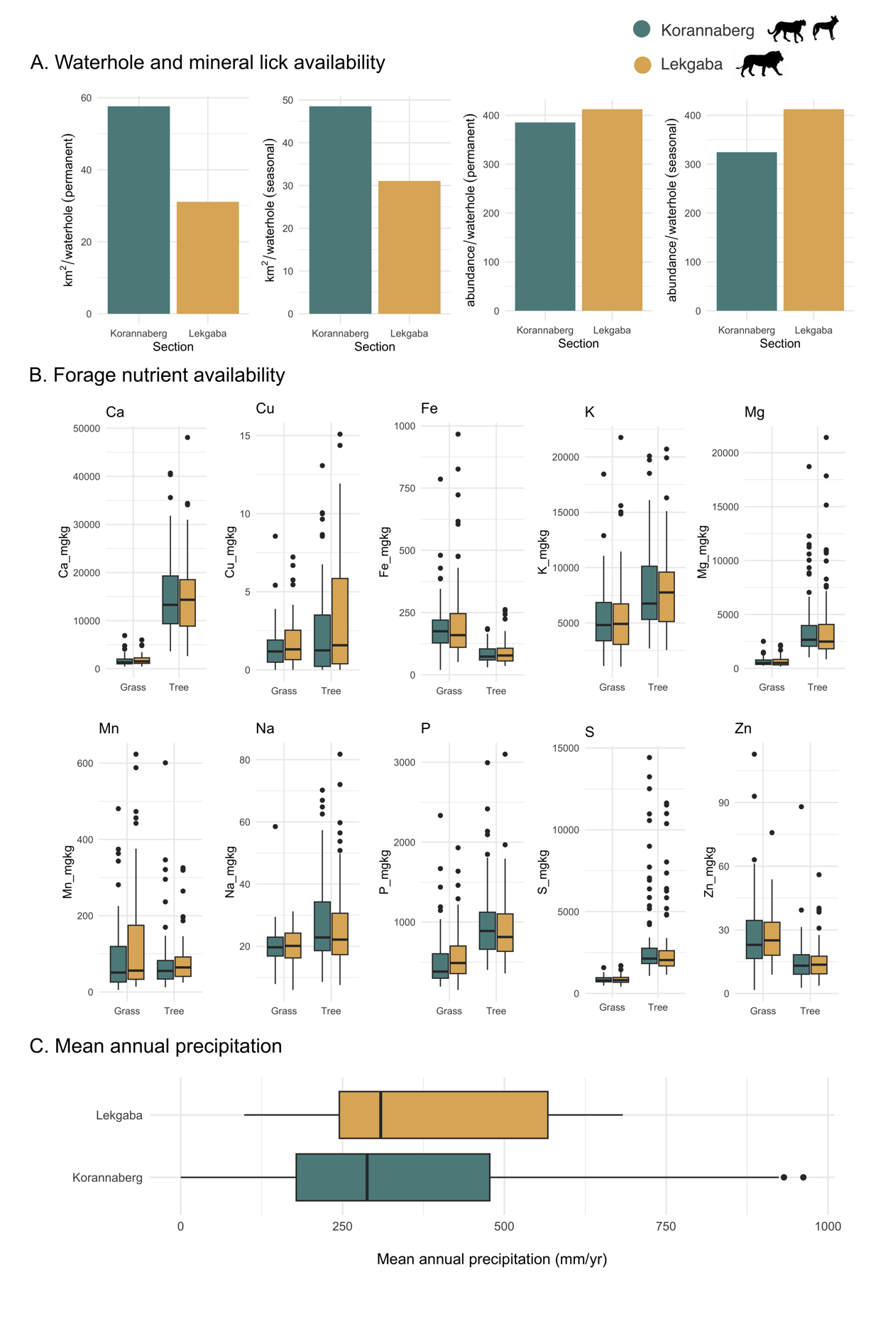
Figure S1. Environmental comparison between the Korannaberg and Lekgaba sections of Tswalu Kalahari Reserve. (A) Per unit area there are more permanent waterhole sites (and thus artificial mineral lick locations) in Lekgaba. However, per ungulate individual, water/mineral lick availability is remarkably similar. (B) Wilcox-tests reveal no statistically significant (p<0.05) differences in forage nutrient quality across 10 elements associated with ungulate health, except for Mn in C₃ plants (trees). (C) Wilcox-tests also reveal no statistical difference in mean annual rainfall between sections.
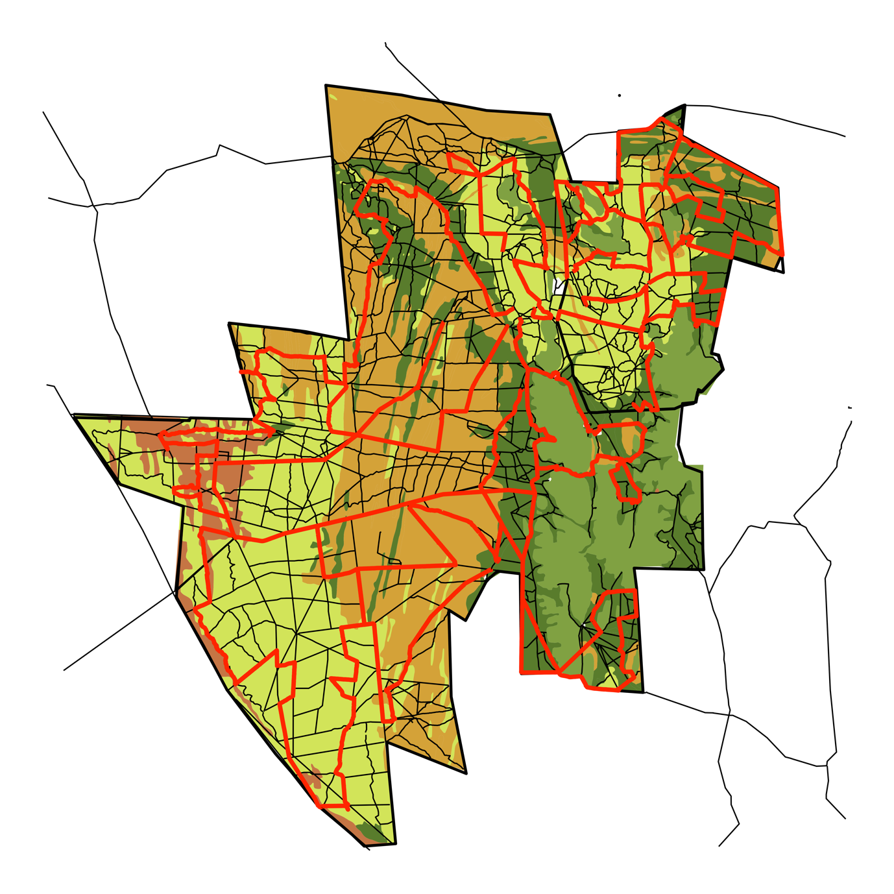
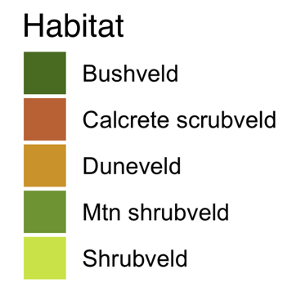

Figure S2. Routes driven during ungulate demographic assessments at Tswalu Kalahari Reserve Black lines display the road network across Tswalu. Routes taken (8 in the Greater Korannaberg section and 4 in the Lekgaba section) are highlighted in red. Effort was made to proportionally cover different habitat types across the reserve. No roads travel over the Korannaberg mountains (habitat: Mtn shrubveld) and thus routes were chosen to travel along the bottom of mountain edges.

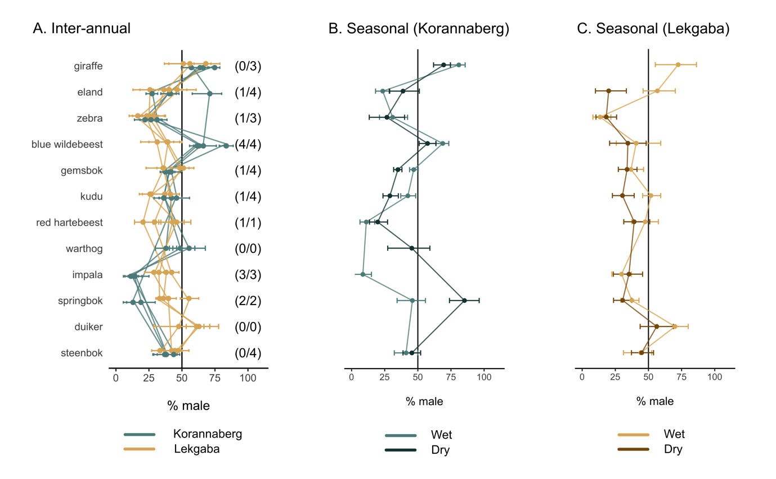
Figure S3. (a) Inter-annual comparison of adult sex ratio (ASR) – represented as percentage of males within each population – of large herbivore species resident within the Korannaberg and Lekgaba sections of Tswalu between 2021-2024. Error bars represent 95% confidence intervals generated from 100-fold bootstrapping procedure. Only results where >20 individuals were observed in both sections are reported. For each species, the number of years ASR was significantly different (p<0.05) based on chi-squared (𝜒²) tests are highlighted. Springbok, impala and blue wildebeest are consistently different across years. Giraffe were not found statistically different in any individual year, although males account for a greater proportion in each field survey and are thus statistically significant when years are combined (see Figure 1). Seasonal comparison of ASR in (b) Korannaberg and (c) Lekgaba for the year 2024, where two field surveys were undertaken at the end of the wet season (February) and end of the dry season (September). In general, results are similar between seasons, although notable discrepancies occur for springbok, impala and eland. We note, however, that these species tend to form large herds segregated by sex. It is therefore possible that observed differences were driven by low sample size rather than actual changes in ungulate ASR throughout the season.

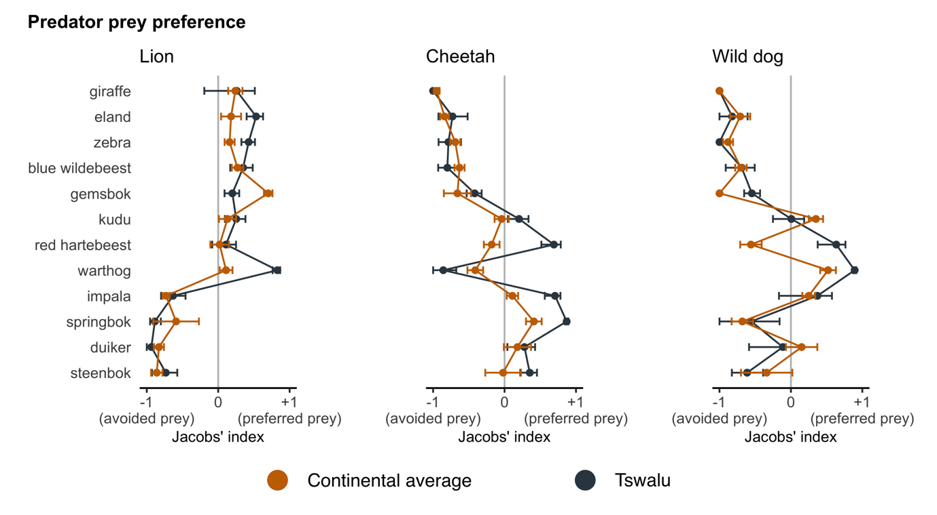
Figure S4. Comparison of predator prey preference at Tswalu Kalahari Reserve and continental averages for lion (Panthera leo), cheetah (Acinonyx jubatus) and wild dog (Lycaon pictus). Continental averages taken from Hayward et al. (2005), Hayward et al. (2006a) and Hayward et al. (2006b).

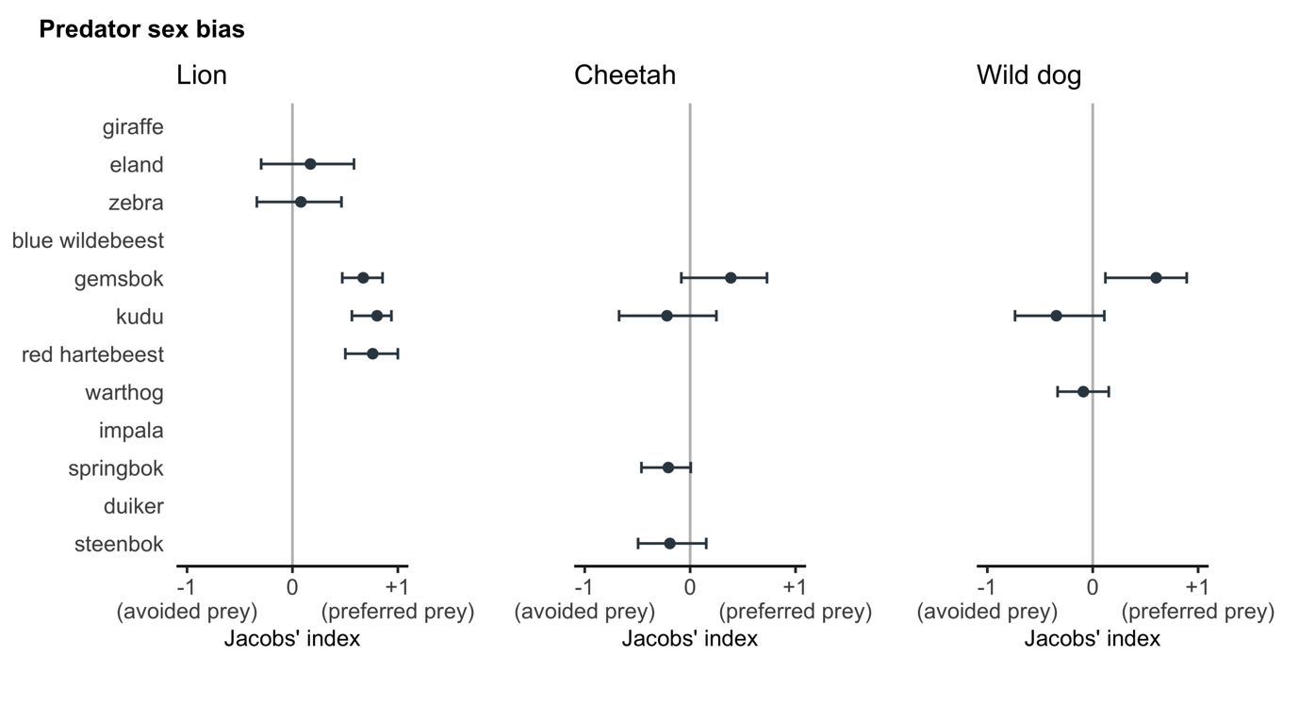
Figure S5: Sex bias in prey kills for lion, cheetah and wild dog, calculated using Jacob’s preference index. Values closer to +1 indicate male bias, while values closer to -1 show female bias. Prey species shown have >20 observations with associated sex information from guide reported predator-prey kill database.

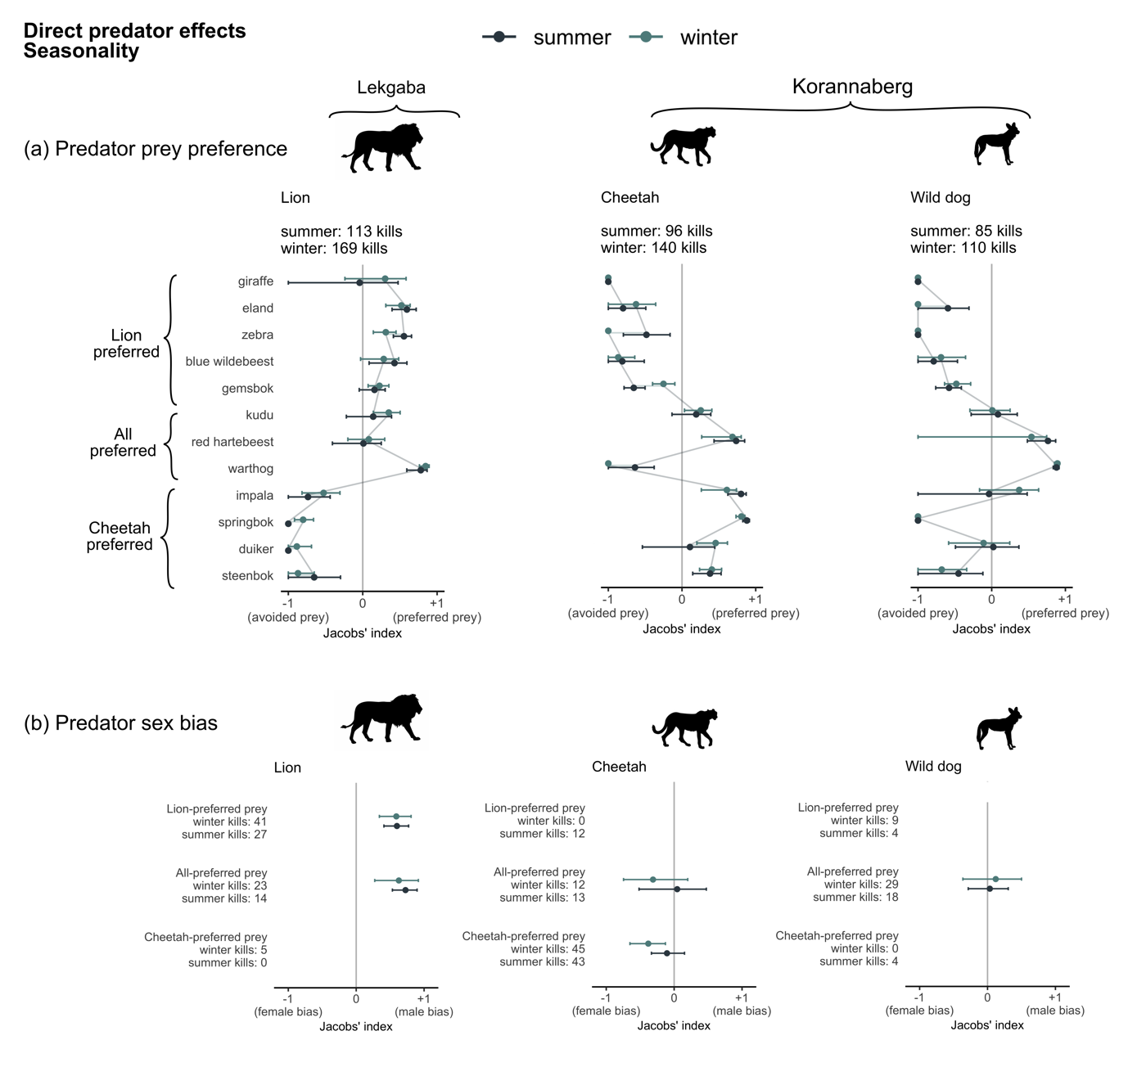
Figure S6. Seasonal predator consumptive effects on herbivore adult sex ratio at Tswalu. (a) Prey preference of large herbivore species (>10kg) for lion (Panthera leo), cheetah (Acinonyx jubatus) and African wild dog (Lycaon pictus), calculated using Jacob’s preference index by season. Values closer to 1 indicate preferred-prey, while values closer to -1 are avoided prey. Summer (wet season) and winter (dry season) seasons are defined by November-April and May-October, respectively. Species are grouped into lion-preferred, all-preferred and cheetah-preferred groups. (b) Seasonal sex bias in prey kills for each prey group by lion, cheetah and wild dog, calculated using Jacob’s preference index. Values closer to +1 indicate male bias, while values closer to -1 show female bias. Only groups with n > 10 are shown. Overall, there is remarkably little seasonal variation in either prey preference or sex bias across large carnivore species, except for cheetah preferring female prey during the dry season, but displaying no sex preference during the wet season.

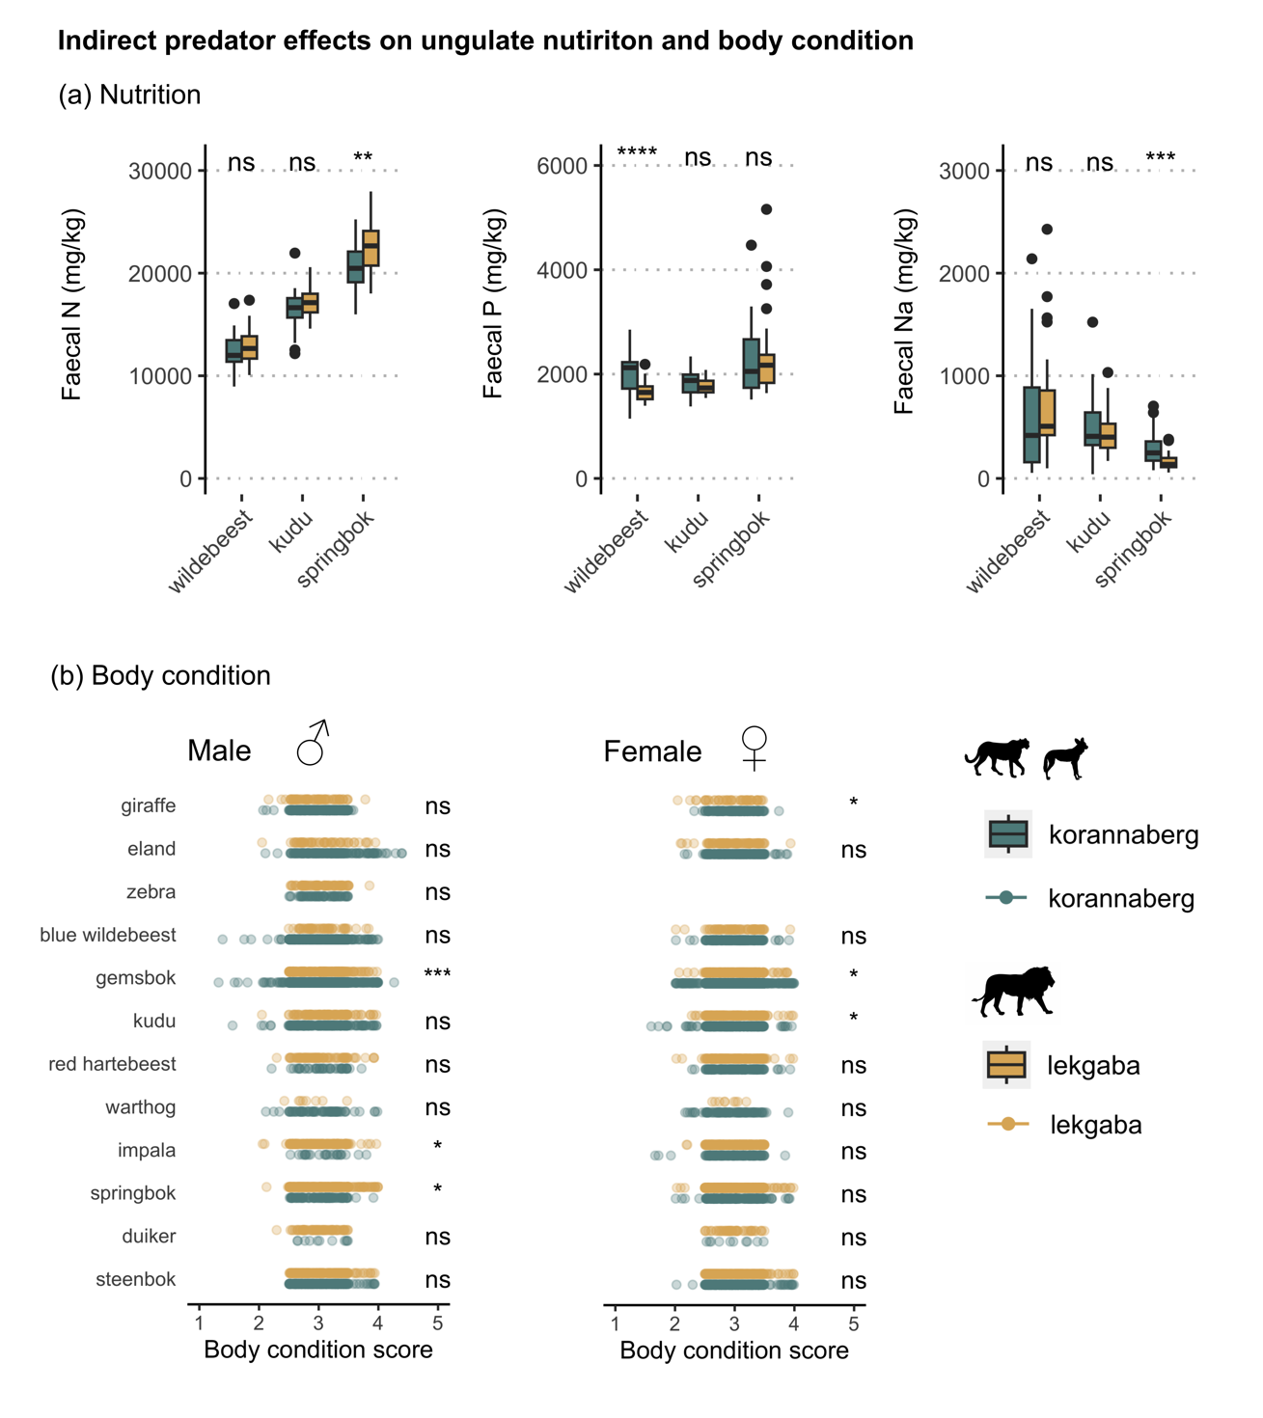
Figure S7. Predator non-consumptive effects on herbivore adult sex ratio at Tswalu Kalahari Reserve (TKR). (A) Comparison of herbivore nutrition, based on concentration of faecal nitrogen (N), phosphorus (P) and sodium (Na), between sections of TKR for a lion-preferred prey (blue wildebeest; Connochaetes taurinus), all-preferred prey species (kudu; Tragelaphus strepsiceros) and cheetah-preferred species (springbok; Antidorcas marsupialis). (B) Comparison of herbivore body condition between sections of TKR for male and female individuals of large herbivore species. Note: body condition scores have been jittered from 0.5 scoring increments for visual effect. Significant differences between sections for both faecal and body condition scores are denoted, where not significant (ns), p<0.05 (*), p<0.01 (**) and p<0.001 (***). Across both faecal and body condition metrics, predators appear to have little effect on herbivore nutrition and body condition.
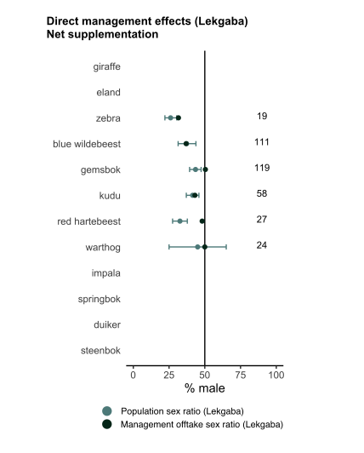
Figure S8. Sex ratio of large herbivores supplemented into the Lekgaba section of Tswalu Kalahari Reserve during the period 2010-2024, compared to the adult sex ratio of large herbivores surveyed in Lekgaba during the period 2021-2024. Numbers to the right highlight the total number of animals supplemented in Lekgaba during 2010-2024.

References
Abraham, A.J., Duvall, E.S., le Roux, E., Ganswindt, A., Clauss, M., Doughty, C.E., Webster, A.B., 2023. Anthropogenic supply of nutrients in a wildlife reserve may compromise conservation success. Biological Conservation 284, 110149. https://doi.org/10.1016/j.biocon.2023.110149

Abraham, A.J., Webster, A.B., Prys-Jones, T.O., le Roux, E., Smith, D., McFayden, D., de Jager, P.C., Clauss, M., Doughty, C.E., 2021. Large predators can mitigate nutrient losses associated with off-site removal of animals from a wildlife reserve. Journal of Applied Ecology 58, 1360–1369. https://doi.org/10.1111/1365-2664.13878

Buckland, S.T., Rexstad, E.A., Marques, T.A., Oedekoven, C.S., 2015. Distance Sampling: Methods and Applications, Methods in Statistical Ecology. Springer International Publishing, Cham. https://doi.org/10.1007/978-3-319-19219-2

Conradt, L., 1998. Measuring the degree of sexual segregation in group-living animals. Journal of Animal Ecology 67, 217–226. https://doi.org/10.1046/j.1365-2656.1998.00183.x

Cowlishaw, G. (1994). Vulnerability To Predation in Baboon Populations. Behaviour, 131(3), 293–304. doi:10.1163/156853994x00488

Davies-Mostert, H. T., Mills, M. G. L., and Macdonald, D. W. (2013). Hard boundaries influence African wild dogs’ diet and prey selection. Journal of Applied Ecology, 50(6), 1358–1366. doi:10.1111/1365-2664.12129

Estes, R. D., and Goddard, J. (1967). Prey Selection and Hunting Behaviour of the African Wild Dog. The Journal of Wildlife Management, 31(1), 52 - 70. doi:10.2307/3798360

Ezenwa, V.O., Jolles, A.E., O’Brien, M.P., 2009. A reliable body condition scoring technique for estimating condition in African buffalo. African Journal of Ecology 47, 476–481. https://doi.org/10.1111/j.1365-2028.2008.00960.x

Fitzgibbon, C. D., and Fanshawe, J. H. (1989). The condition and age of Thomson’s gazelles killed by cheetahs and wild dogs. Journal of Zoology, 218(1), 99–107. doi:10.1111/j.1469-7998.1989.tb02528.x

Fitzgibbon, C. D. (1990). Why do hunting cheetahs prefer male gazelles? Animal Behaviour, 40(5), 837–845. doi:10.1016/s0003-3472(05)80984-4

Fuller, T. K., and Kat, P. W. (1990). Movements, activity, and prey relationships of African wild dogs (Lycaon pictus) near Aitong, southwestern Kenya. African Journal of Ecology, 28(4), 330–350. doi: 10.1111/j.1365-2028.1990.tb01168.x

Fuller, T.K., Nicholls, T.H., and Kat P.W. (1995). Prey and estimated food consumption of African wild dogs in Kenya. South African Journal of Wildlife Research, 25(3), 106-110. doi: 10.10520/EJC116973

Grant, C.C., Peel, M.J.S., van Ryssen, J.B.J., 2000. Nitrogen and phosphorus concentration in faeces: an indicator of range quality as a practical adjunct to existing range evaluation methods. African Journal of Range & Forage Science 17, 81–92. https://doi.org/10.2989/10220110009485743

Hayward, M. W., & Kerley, G. I. (2005). Prey preferences of the lion (Panthera leo). Journal of zoology, 267(3), 309-322.

Hayward, M. W., Hofmeyr, M., O'brien, J., & Kerley, G. I. (2006). Prey preferences of the cheetah (Acinonyx jubatus)(Felidae: Carnivora): morphological limitations or the need to capture rapidly consumable prey before kleptoparasites arrive?. Journal of Zoology, 270(4), 615-627.

Hayward, M. W., O'Brien, J., Hofmeyr, M., & Kerley, G. I. (2006). Prey preferences of the African wild dog Lycaon pictus (Canidae: Carnivora): ecological requirements for conservation. Journal of Mammalogy, 87(6), 1122-1131.

Kruger, S. C., Lawes, M. J., and Maddock, A. H. (1999). Diet choice and capture success of wild dog (Lycaon pictus) in Hluhluwe-Umfolozi Park, South Africa. Journal of Zoology, 248(4), 543–551. doi:10.1111/j.1469-7998.1999.tb01054.x

Kruuk, H., (1972). The Spotted Hyena. Univ. of Chicago Press, Chicago.

Louw et al. (2019). Sex-specific predation patterns on kudu and impala. African Journal of Wildlife Research, 49(1), 77-83. doi: 10.3957/056.049.0077

Makin, D. F., and Kerley, G. I. (2016). Selective predation and prey class behaviour as possible mechanisms explaining cheetah impacts on kudu demographics. African Zoology, 51(4), 217–219. doi:10.1080/15627020.2016.1266913

Malcolm, J. R., and van Lawick, B. H. (1975). Notes on wild dogs (Lycaon pictus) hunting zebras. Mammalia, 39(2), 231-240. doi:10.1515/mamm.1975.39.2.231

Mills, M. G. L. (1984). Prey selection and feeding habits of the large carnivores in the Southern Kalahari. Koedoe, 27(2). doi:10.4102/koedoe.v27i2.586

Mills, M. G. L., & Shenk, T. M. (1992). Predator--Prey Relationships: The Impact of Lion Predation on Wildebeest and Zebra Populations. The Journal of Animal Ecology, 61(3), 693-702. doi:10.2307/5624

Mills, M. G. L., Broomhall, L. S., and du Toit, J. T. (2004). Cheetah Acinonyx jubatus feeding ecology in the Kruger National Park and a comparison across African savanna habitats: is the cheetah only a successful hunter on open grassland plains? Wildlife Biology, 10(1), 177–186. doi:10.2981/wlb.2004.024

O’Kane, C.A.J., Macdonald, D.W., 2017. An experimental demonstration of the impact of predation on sexual segregation and primary sex ratios among ungulates. Austral Ecology 42, 414–421. https://doi.org/10.1111/aec.12458

Owen-Smith, N., 1993. Comparative Mortality Rates of Male and Female Kudus: The Costs of Sexual Size Dimorphism. Journal of Animal Ecology 62, 428–440. https://doi.org/10.2307/5192

Owen-Smith, N. (2008). Changing vulnerability to predation related to season and sex in an African ungulate assemblage. Oikos, 117(4), 602–610. doi:10.1111/j.0030-1299.2008.16309.x

Pole, A., Gordon, I. J., Gorman, M. L., and Mac Askill, M. (2004). Prey selection by African wild dogs (Lycaon pictus) in southern Zimbabwe. Journal of Zoology, 262(2), 207–215. doi:10.1017/s0952836903004576

Prins, H. H. T., and Lason, G. R. (1989). Dangerous Lions and Nonchalant Buffalo. Behaviour, 108(3), 262–296. doi:10.1163/156853989x00330

Rudnai, J. (1974). The pattern of lion predation in Nairobi Park. African Journal of Ecology, 12(3), 213–225. doi:10.1111/j.1365-2028.1974.tb00114.x

Schaller, G. B. (1968). Hunting behaviour of the cheetah in Serengeti National Park, Tanzania. African Journal of Ecology, 6(1), 95–100. doi:10.1111/j.1365-2028.1968.tb00906.x

Schaller, G. B. 1972. The Serengeti lion: a study of predator-prey relations.
ISBN 10: 0226736393 / ISBN 13: 9780226736396

Stapelberg, F.H., Van, R.M.W., Bothma, J. du P., 2008. Spatial and temporal variation in nitrogen and phosphorus concentrations in faeces from springbok in the Kalahari : short communication. South African Journal of Wildlife Research 38, 82–87. https://doi.org/10.10520/EJC117276

Thomas, L., Buckland, S.T., Rexstad, E.A., Laake, J.L., Strindberg, S., Hedley, S.L., Bishop, J.R.B., Marques, T.A., Burnham, K.P., 2010. Distance software: design and analysis of distance sampling surveys for estimating population size. Journal of Applied Ecology 47, 5–14. https://doi.org/10.1111/j.1365-2664.2009.01737.x

Tilson, R., von Blottnitz, F., and Henschel, J. (1980). Prey selection by spotted hyaena (Crocuta crocuta) in the Namib Desert. Madoqua, 1(1), 41 – 49. doi: 10.10520/AJA10115498_227

Toïgo, C., Gaillard, J.-M., 2003. Causes of sex-biased adult survival in ungulates: sexual size dimorphism, mating tactic or environment harshness? Oikos 101, 376–384. https://doi.org/10.1034/j.1600-0706.2003.12073.x

Wanzie, C. (1986). Mortality factors of Buffon’s kob Kobus kob kob (Erxleben) in Waza National Park, Cameroon. Mammalia, 50(3). doi:10.1515/mamm.1986.50.3.3

Van der Meer, E., Fritz, H., and Pays, O. (2015). Anti-predator behaviour of kudu and impala in response to mimicked African wild dog presence: do age and sex matter? Behaviour, 152(9), 1209–1228. doi:10.1163/1568539x-00003275

Van der Meer, E., et al. (2019). Dangerous game: preferential predation on baboons by African wild dogs in Mana Pools National Park, Zimbabwe. Behaviour, 156(1), 37–58. doi:10.1163/1568539x-00003529

Van Dyk, G., and Slotow, R. (2003). The effects of fences and lions on the ecology of African wild dogs reintroduced to Pilanesberg National Park, South Africa. African Zoology, 38(1), 79–94. doi:10.1080/15627020.2003.11657196

Van Rooyen, N. and van Rooyen, G. (2022) Veld condition assessment of Tswalu Kalahari Reserve: Herbaceous layer.
Webster, A.B., and Abraham, A.J. (2021) An assessment of large herbivore dynamics at Tswalu Kalahari Reserve 2008-2021.

Yu, K., Saha, M. V., & D’Odorico, P. (2017). The effects of interannual rainfall variability on tree–grass composition along Kalahari rainfall gradient. Ecosystems, 20, 975-988.

