Supplementary materials

PM_{2.5} chemical composition and geographic origin of air masses in Mabopane, South Africa

Mandla Bhuda, Peter Molnár, Johan Boman, Joyce Shirinde, Janine Wichmann

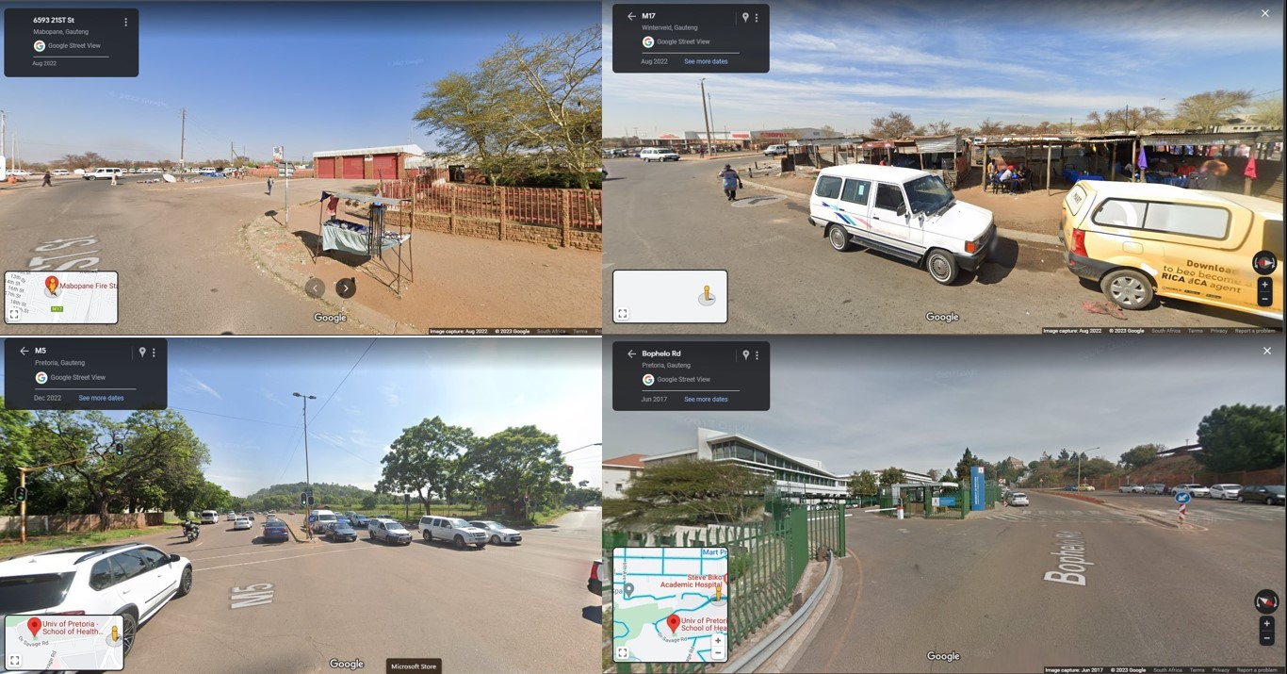
Figure S1: Comparison of type of streets at the Mabopane (top) and SHSPH (bottom) PM_{2.5} sampling sites.
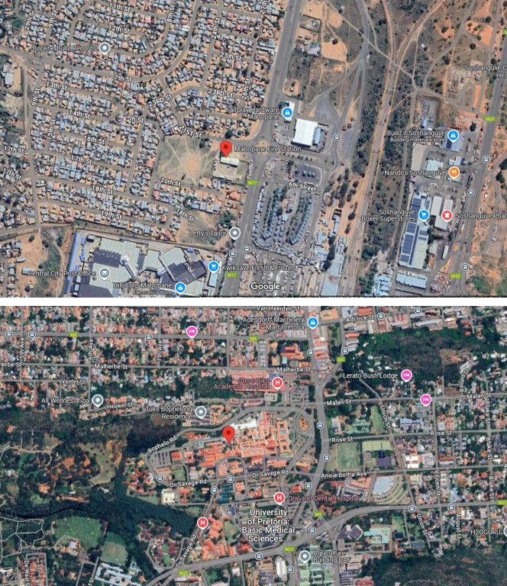
Figure S2: Areal views of the Mabopane (top) and SHSPH (bottom) PM_{2.5} sampling sites

Table S1: Descriptive statistics of 24-hour PM_{2.5}, soot, black carbon, organic carbon, and trace elements levels by season at Mabopane, South Africa from 15 June 2022 to 28 February 2023.
Variable | Winter |  | Spring |  | Summer |  | Weekdays |  | Weekend
Variable | Mean (obs) | Range | Mean (obs) | Range | Mean (obs) | Range | Mean (obs) | Range | Mean (obs) | Range
PM_{2.5} | 9.4 (16) | 3.7 - 20 | 13 (12) | 4.7 - 26 | 8.9 (12) | 1.1 - 29 | 12 (29) | 1.1 - 29 | 6.6 (11) | 3.7 - 15
Soot | 1.0 (16) | 0.3- 2.9 | 1.1 (12) | 0.3 - 1.8 | 0.7 (12) | 0.1 - 2.7 | 1.0(29) | 0.1 - 2.9 | 0.6 (11) | 0.2 - 0.8
BC | 0.9 (16) | 0.0 - 2.4 | 1.0 (12) | 0.0 - 2.3 | 0.6 (12) | 0.2 - 1.5 | 1.0 (29) | 0.0 - 2.4 | 0.6 (11) | 0.0 - 1.2
OC | 1.1 (16) | 0.1- 2.4 | 1.1 (12) | 0.2 - 2.2 | 0.8 (12) | 0.2 - 1.8 | 1.1 (29) | 0.2 - 2.4 | 0.7 (11) | 0.1 - 1.6
Ag | 7.3 (14) | 0.6 -14 | 6.1 (12) | 0.1 - 15 | 5.1 (11) | 0.4 - 14 | 6.6 (27) | 0.1 - 15 | 5.5 (10) | 0.7 - 14
Ba | 12 (16) | 0.7- 37 | 16 (12) | 3.1 - 38 | 9.6 (12) | 1.7 - 29 | 13(29) | 1.3 - 38 | 10 (11) | 0.7 - 34
Br | 4.0 (12) | 1.6 - 7.1 | 6.0 (9) | 1.9 - 10 | 5.1 (6) | 1.2 - 10 | 5.8 (20) | 1.9 - 10 | 2.2 (7) | 1.2 - 3.2
Ca | 105 (16) | 2.4-316 | 153 (12) | 51 - 360 | 64 (12) | 21 - 129 | 122 (29) | 21 - 360 | 69 (11) | 2.4 - 201
Cl | 4.6 (16) | 0.1 - 19 | 10 (12) | 0.0 - 65 | 2.3 (12) | 0.2 - 4.6 | 6.9 (29) | 0.0 - 65 | 2.3 (11) | 0.0 - 4.4
Cu | 2.5 (10) | 0.4 - 5.2 | 2.4 (6) | 0.0 - 5.0 | 1.8 (5) | 0.3 - 3.3 | 2.5 (18) | 0.0 - 5.2 | 0.9 (3) | 0.4 - 1.6
Fe | 230 (16) | 150 - 530 | 282 (12) | 150 - 670 | 221 (12) | 130 - 350 | 263 (29) | 130 - 670 | 191 (11) | 140 - 280
K | 83(16) | 3.8 - 360 | 130 (12) | 16 - 420 | 39 (12) | 1.8 - 99 | 96 (29) | 1.8 - 420 | 54 (11) | 6.6 - 180
Mn | 5.0 (6) | 1.4 - 8.2 | 7.6 (6) | 4.5 - 14 | 6.6 (8) | 0.5 - 170 | 6.8 (13) | 0.5 - 17 | 5.7 (7) | 1.4 - 10
Ni | 4.9 (16) | 1.4 - 18 | 4.6 (12) | 0.5 - 11 | 5.7 (12) | 0.8 - 15 | 4.6 (29) | 0.5 - 15 | 6.3 (11) | 1.7 - 18
P | 11 (16) | 1.1 - 24 | 13 (12) | 0.0 - 41 | 6.4 (12) | 1.5 - 17 | 11 (29) | 0.0 - 41 | 8.3 (11) | 0.0 - 2.8
S | 67(16) | 16 - 221 | 303 (12) | 10 - 2100 | 134 (12) | 9.1 - 640 | 189 (29) | 9.1 - 2100 | 75 (11) | 17 - 190
Sb | 21 (12) | 1.5- 55 | 14 (7) | 4.6 - 29 | 15.3 (5) | 5.4 - 30 | 15 (17) | 1.5 - 29 | 24 (7) | 8.6 - 55
Si | 257 (16) | 7.8 - 1400 | 269 (12) | 20 - 780 | 130 (12) | 12 - 620 | 263 (29) | 7.8 - 1400 | 115 (11) | 9.6 - 400
Sr | 1.2 (16) | 0.1 - 3.7 | 1.7 (12) | 0.2 - 3.5 | 1.4 (12) | 0.5 - 3.1 | 1.6 (29) | 0.16 - 3.7 | 1.0 (11) | 0.1 - 2.7
Ti | 13 (16) | 1.7 - 55 | 19 (12) | 5.6 - 69 | 8.0 (12) | 0.4 - 15 | 16 (29) | 2.0 - 69 | 7.5 (11) | 0.4 - 36
U | 2.1 (16) | 0.1 - 5.2 | 3.1 (12) | 0.3 - 6.0 | 2.9 (12) | 0.1 - 5.2 | 2.7 (29) | 0.1 - 6.0 | 2.6 (11) | 0.3 - 5.2
V | 40 (4) | 5.3 - 77 | 53. (1) | 53 - 53 | 20.1 (3) | 12 - 32 | 30 (2) | 5.3 - 53 | 47 (2) | 16 - 77
Zn | 5 (13) | 0.5 - 14 | 4.6 (9) | 0.8 - 14 | 3.8 (8) | 0.3 - 10 | 5.3 (10) | 0.5 - 14 | 2.6 (10) | 0.3 - 6.3
Units: PM_{2.5} (μg.m⁻³), soot (m⁻¹ x 10⁻⁵), BC (μg.m⁻³), OC (μg.m⁻³), and trace elements (ng.m⁻³).
Obs: Observation (Number of samples)

Table S2: Spearman correlation between 24-hour PM_{2.5}, soot, black carbon, organic carbon, and trace elements levels at Mabopane, South Africa from 15 June 2022 to 28 February 2023
 | Ag | Ba | Br | Ca | Cl | Cu | Fe | K | Mn | Ni | P | S | Sb | Si | Sr | Ti | U | V | Zn
PM_{2.5} | 0.2 | 0.0 | 0.7* | 0.5* | 0.3* | 0.2 | 0.7* | 0.6* | -0.1 | -0.4* | 0.3* | 0.4* | -0.1 | 0.4 | 0.1 | 0.5* | 0.0 | 0.1 | 0.3
Soot | 0.2 | -0.2 | 0.5* | 0.5* | 0.2 | 0.2 | 0.6 | 0.7 | -0.3 | -0.3 | 0.1 | 0.4 | -0.3 | 0.5 | 0.0 | 0.4 | 0.0 | 0.1 | 0.5
BC | 0.2 | 0.0 | 0.4* | 0.0 | 0.2 | -0.1 | 0.3 | 0.2 | -0.1 | -0.2 | 0.2 | 0.1 | -0.3 | 0.2 | 0.2 | 0.1 | 0.0 | -0.5 | 0.0
OC | 0.2 | 0.1 | 0.3 | 0.0 | 0.1 | -0.2 | 0.3 | 0.2 | 0.0 | -0.2 | 0.1 | 0.0 | -0.4 | 0.2 | 0.2 | 0.1 | 0.0 | -0.3 | 0.0
*Significant: (P<0.05)
Units: PM_{2.5} (μg.m⁻³), soot (m⁻¹ x 10⁻⁵), BC (μg.m⁻³), OC (μg.m⁻³) and trace elements (ng.m⁻³)

Table S3: Partial correlation between 24-hour PM_{2.5}, soot, black carbon, organic carbon and climate at Mabopane, South Africa from 15 June 2022 to 28 February 2023
Variable | PM_{2.5} | Soot | Black Carbon | Organic Carbon
Temperature | 0.3 | 0.04 | -0.1 | -0.1
Relative Humidity | -0.5* | -0.6* | -0.4* | -0.4*
Wind Speed | -0.4* | -0.1 | -0.4* | -0.4*
*Significant (P<0.05)
Units: PM_{2.5} (μg.m⁻³), soot (m⁻¹ x 10⁻⁵), BC (μg.m⁻³), OC (μg.m⁻³), temperature (ºC), relative humidity (%) and windspeed (m.s⁻¹)

Table S4: Partial correlation between trace elements levels and climate conditions at Mabopane, South Africa from 15 June 2022 to 28 February 2023
Variable | Ag | Ba | Br | Ca | Cl | Cu | Fe | K | Mn | Ni | P | S | Sb | Si | Sr | Ti | U | V | Zn
Temperature | -0.1 | 0.0 | 0.5* | 0.2 | -0.2 | -0.2 | 0.3* | 0.2 | 0.1 | 0.2 | 0.0 | 0.2 | -0.2 | -0.0 | 0.1 | 0.1 | 0.2 | 0.1 | 0.1
Relative humidity | -0.2 | 0.0 | -0.6* | -0.7* | -0.4* | -0.3 | -0.7* | -0.6* | 0.5 | 0.3 | -0.3 | 0.0 | 0.1 | -0.5* | -0.1 | -0.6* | -0.2 | 0.2 | -0.4*
Windspeed | 0.0 | -0.4* | -0.7* | -0.2 | -0.3 | -0.4 | -0.3 | 0.1 | -0.3 | 0.3 | -0.2 | -0.1 | 0.2 | -0.5* | -0.1 | -0.1 | -0.0 | 0.9* | 0.0
*Significant: (P<0.05)
Units: temperature (ºC), relative humidity (%), windspeed (m.s⁻¹), and trace elements (ng.m⁻³)

Table S5: Frequency of geographical origin of air masses for the entire sampling campaign at Mabopane, South Africa
Cluster | Entire year |  | Winter |  | Spring |  | Summer
Cluster | n | % | n | % | n | % | n | %
Short Southeast Indian Ocean | 7 | 17.5 | 1 | 6.3 | 3 | 25.0 | 3 | 25.0
Northern Limpopo | 10 | 22.5 | 6 | 31.3 | 3 | 25.0 | 1 | 8.3
Northern Cape | 13 | 32.5 | 2 | 12.5 | 5 | 41.7 | 6 | 50.0
Eastern Indian Ocean | 6 | 16.0 | 4 | 25.0 | 1 | 8.3 | 1 | 8.3
Long Southeast Indian Ocean | 4 | 10.0 | 3 | 18.8 | 0 | 0.0 | 1 | 8.3
Total | 40 | 100 | 16 | 100 | 12 | 100 | 12 | 100

Number of contributing days (n)
Percentage (%) of total sampling days

Table S6: Descriptive statistics of 24-hour PM_{2.5}, soot, black carbon, and organic carbon levels by geographical origin of air mass
Variable | S-SEIO |  | N-Limp |  | N-Cape |  | E-IO |  | L-SEIO
Variable | Mean (obs) | Range | Mean (obs) | Range | Mean (obs) | Range | Mean (obs) | Range | Mean (obs) | Range
PM_{2.5} | 9.7 (7) | 1.1 - 25 | 11 (10) | 3.8 - 20 | 10 (13) | 2.2 - 23 | 9.5 (6) | 4.2 - 21 | 13 (4) | 3.7 - 29
Soot | 1.1 (7) | <DL - 2.7 | 1.0 (10) | 0.2 - 2.9 | 0.8 (13) | 0.1 - 1.8 | 0.8 (6) | 0.5 - 1.7 | 0.7 (4) | 0.3 - 0.97
BC | 0.8 (7) | 0.3 - 1.5 | 1.1 (10) | 0.2 - 2.4 | 0.9 (13) | <DL - 2.3 | 0.6 (6) | <DL - 1.2 | 0.5 (4) | 0.3 - 1.1
OC | 0.9 (7) | 0.2 - 1.8 | 1.3 (10) | 0.2 - 2.4 | 1.0 (13) | 0.2 - 2.2 | 0.8 (6) | 0.1 - 1.7 | 0.8 (4) | 0.4 - 1.5
Units: PM_{2.5} (μg.m⁻³), soot (m⁻¹ x 10⁻⁵), BC (μg.m⁻³) and OC (μg.m⁻³)
S-SEIO: Short Southeast Indian Ocean
N-Limp: Northern Limpopo
N-Cape: Northern Cape
E-IO: Eastern Indian Ocean
L-SEIO: Long Southeast Indian Ocean
Obs: Observation (Number of samples)
<DL: Less than the detection limit

