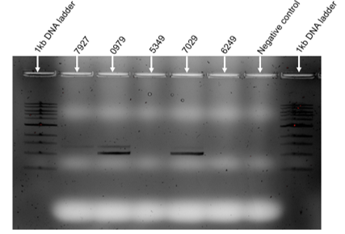
Supplementary figure 3: Agarose gel electrophoretogram showing the performance of the in-house PCR on low viral load samples. PR-RT and IN target fragments were detected in samples 7927, 0979, and 7029 with viral loads (VLs) 534 copies/ml, 960 copies/ml and 1250 copies/ml, respectively. Both target fragments were not detected in samples 5349 and 6249, with VLs 837 copies/ml and 1680 copies/ml, respectively. All these samples were extracted using 0.5 ml input volume, and an input of 10µl was used in the first round of amplification. kb – kilobase; DNA – deoxyribonucleic acid.

