Biosynthesis of Gold Nanoparticles by a Mining- Adapted Bacterial Consortium: Physicochemical Properties and Environmental Applications
Miranda Mpeta*, Job T. Tendenedzai, Shepherd M. Tichapondwa and Evans M.N. Chirwa

SUPPLEMENTARY MATERIAL

EXTRACTS FROM BET REPORT

S1.1 TiO₂/0.5 %wt AuNPs
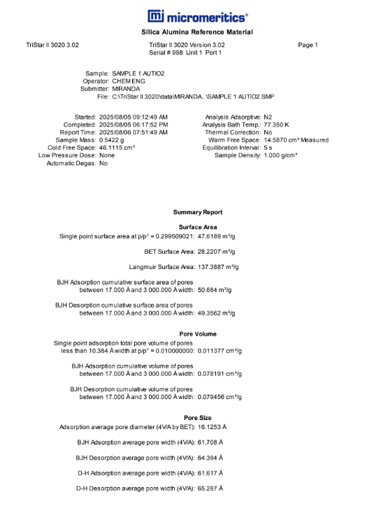
S1.2 TiO₂ Degussa
