Supporting Figure 3: Comparisons of model-fit parameters (mean CSR² values from bacterial ASVs) from across four JSDMs, i.e. across a full model that included all covariates, and the three covariate-specific models.

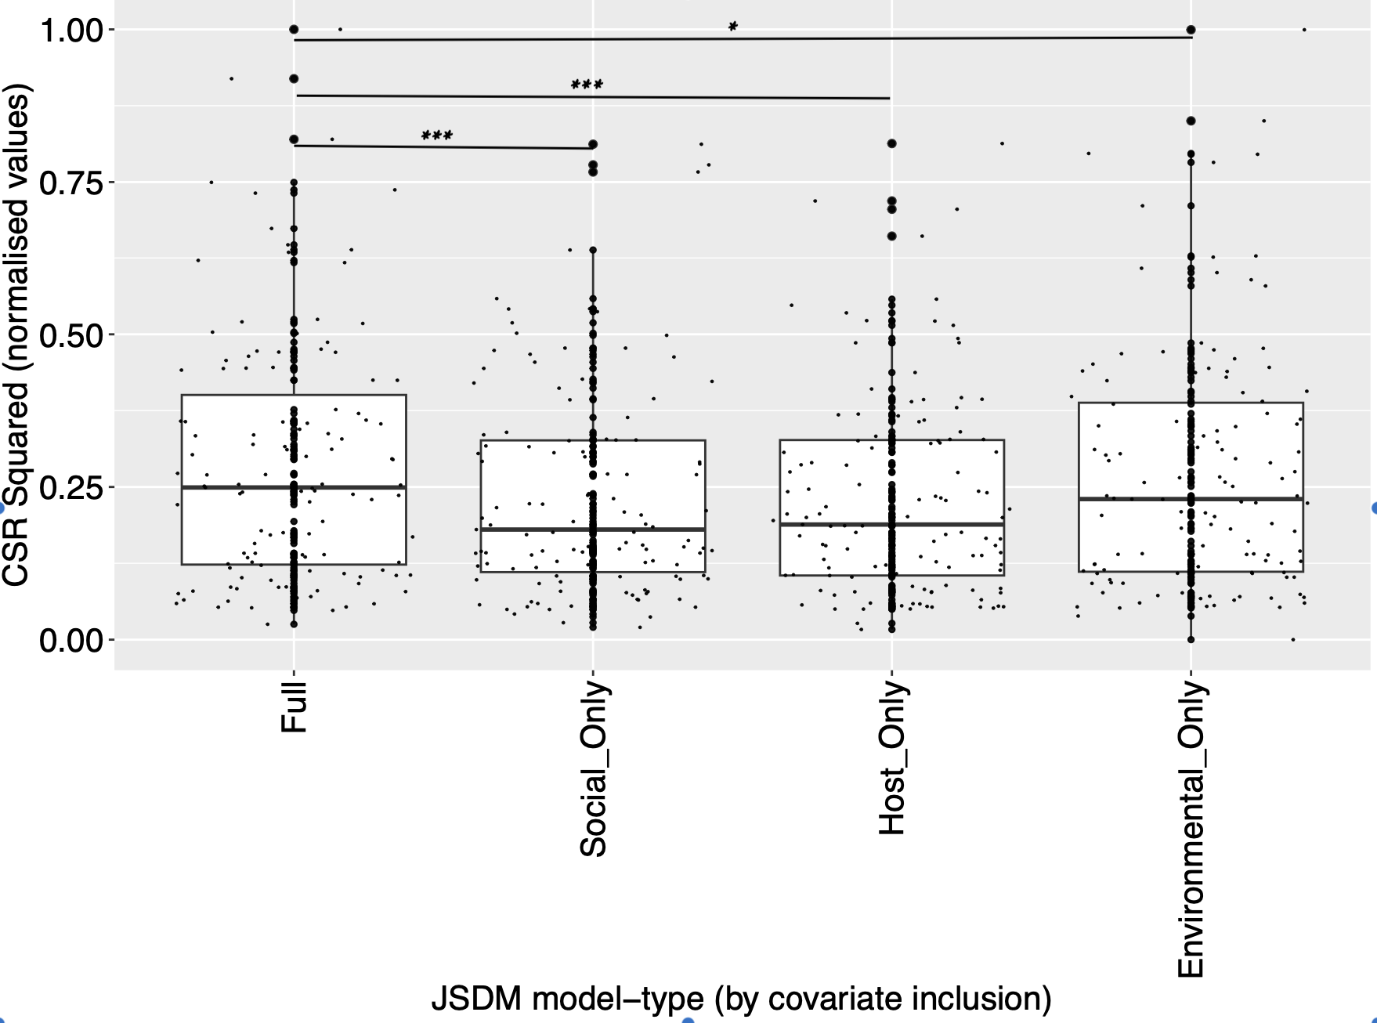

***p < 0.001; *p < 0.05

