Supplementary information
Comparative study of biogenic iron oxide nanoparticles from various extracts of Punica granatum and their efficient application for removal of BTEX
Ngozi Enemuoª, Michael Daramola^{b}, Heidi Richards^{1a}
ª Molecular Sciences Institute, School of Chemistry, University of the Witwatersrand, Private Bag X3, WITS, 2050 Johannesburg, South Africa
^{b} Sustainable Energy and Environment Research Group (SEERG), Department of Chemical Engineering, Faculty of Engineering, Built Environment and Information Technology, University of Pretoria, Hatfield, 0028, Pretoria, South Africa.
¹Heidi Richards Tel: +27-117176773. Email: heidi.richards@wits.ac.za
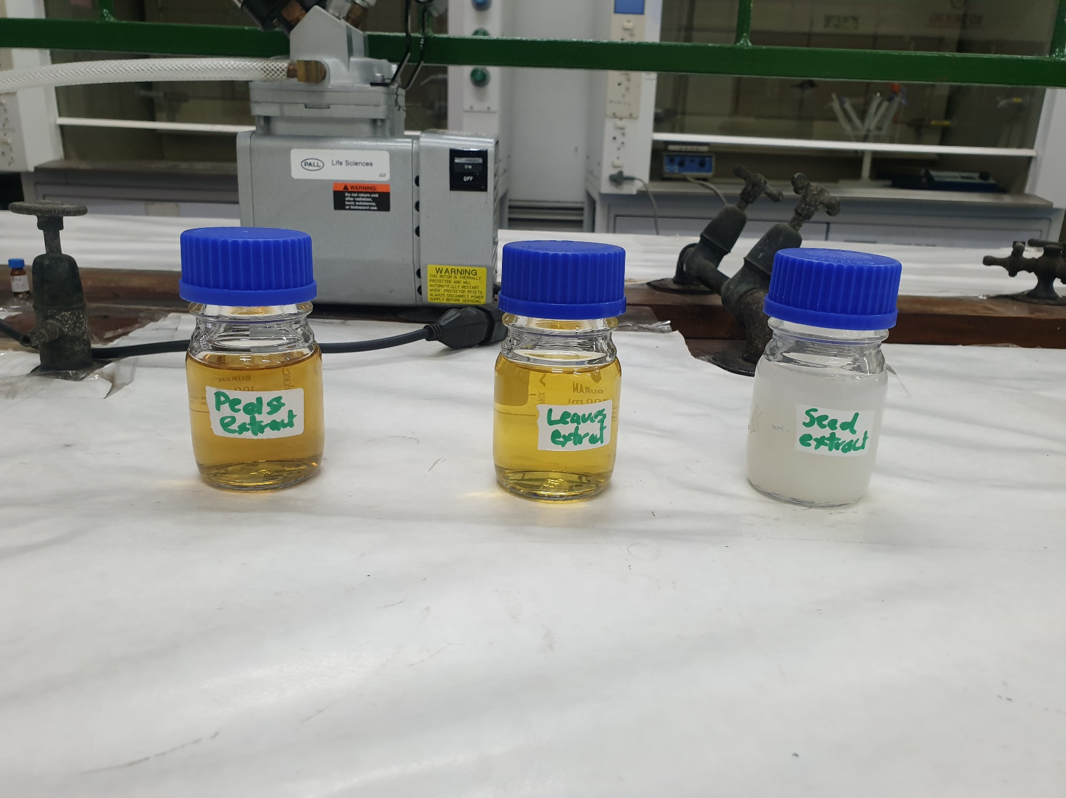



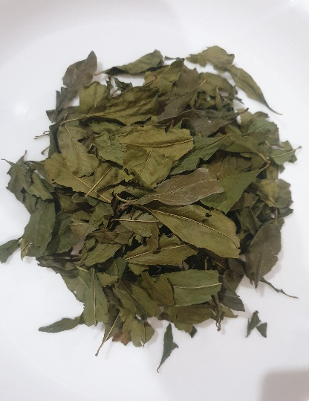
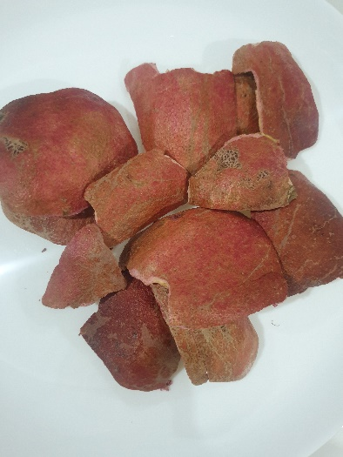
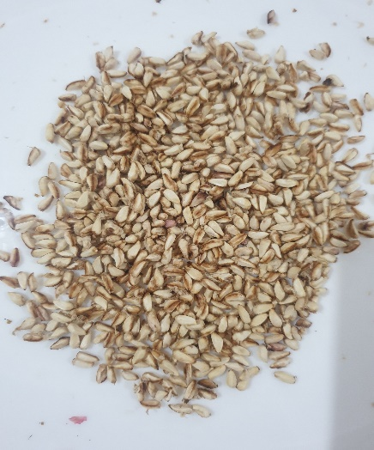



Fig. S1. The various dried parts of the Punica granatum used for the biosynthesis of the FeNPs.

Fig. S2. The various prepared extracts of the Punica granatum used for the biosynthesis of the FeNPs.
Table. S1. Some of the phytochemicals in the leaves extract.
Peak no. | R_{T} value | Compound name | Molecular weight | Formula
13 | 2:44 | Furfural | 96 | C₅H₄O₂
18 | 2:54 | 2-Furanmethanol | 98 | C₅H₆O₂
31 | 3:23 | 2(5H)-Furanone | 84 | C₄H₄O₂
39 | 3:43 | 2,3-Dihydroxy-2-methylpentanoic acid | 148 | C₆H₁₂O₄
41 | 3:51 | 2-Furancarboxaldehyde, 5-methyl- | 110 | C₆H₆O₂
46 | 4:01 | 2,4-Dihydroxy-2,5-dimethyl-3(2H)-furan-3-one | 144 | C₆H₈O₄
65 | 4:35 | Benzyl alcohol | 108 | C₇H₈O
85 | 5:06 | Phenol, 2-methoxy- | 124 | C₇H₈O₂
94 | 5:23 | Pyrimidine-4,6-diol, 5-methyl- | 126 | C₅H₆N₂O₂
109 | 5:44 | Alloxan | 142 | C₄H₂N₂O₄
122 | 6:07 | Benzoic acid, 2-methyl-, 4-benzyloxyphenyl ester | 318 | C₂₁H₁₈O₃
126 | 6:11 | Salicylic acid | 138 | C₇H₆O₃
136 | 6:26 | Silane, trimethoxyphenyl- | 198 | C₉H₁₄O₃Si
139 | 6:32 | 5-Hydroxymethylfurfural | 126 | C₆H₆O₃
163 | 7:02 | 2-Isopropoxyphenol | 152 | C₉H₁₂O₂
170 | 7:18 | 2-Methoxy-4-vinylphenol | 150 | C₉H₁₀O₂
193 | 8:00 | Isosorbide | 146 | C₆H1₀O₄
206 | 8:17 | Rhamnose | 164 | C₆H₁₂O₅
252 | 9:22 | Phenol, 4-nitro- | 134 | C6H₅NO₃
269 | 9:50 | Furan-2(5H)-one, 5-(5-methyl-2-furfurylideno)- | 176 | C1₀H₈O₃
274 | 10:11 | Butanoic acid, 2-methylphenyl ester | 178 | C₁₁H₁₄O₂
286 | 10:37 | 2-Cyclohexen-1-one, 4-(3-hydroxybutyl)-3,5,5-trimethyl- | 210 | C₁₃H₂₂O₂
295 | 10:58 | Ethanone, 1,1'-(1,4-phenylene)bis- | 162 | C1₀H₁₀O₂
302 | 11:06 | Ethanol, 2-(2-ethoxyethoxy)- | 134 | C₆H₁₄O₃
310 | 11:25 | Decanoic acid, octyl ester | 284 | C1₈H₃₆O₂
320 | 11:44 | Adipic acid, 2-isopropoxyphenyl ethyl ester | 308 | C₁₇H₂₄O₅
323 | 11:58 | Benzoic acid, 4-methoxy-, phenyl ester | 228 | C₁₄H₁₂O₃
327 | 12:11 | 2-Propenoic acid, 3-(2-furanyl)- | 138 | C₇H₆O₃
332 | 12:19 | Bicyclo[3.2.1]oct-3-en-2-one, 3,8-dihydroxy-1-methoxy-7-(7-methoxy-1,3-benzodioxol-5-yl)-6-methyl-5-(2-propenyl)-, [1R-(6-endo,7-exo,8-syn)]- | 388 | C₂₁H₂₄O₇
345 | 12:57 | Decanoic acid | 200 | C₁₂H₂₄O₂
357 | 13:20 | Methyl tetradecanoate | 242 | C₁₅H₃₀O₂
363 | 13:38 | Tridecanoic acid | 214 | C1₃H₂₆O₂
393 | 15:28 | Octadecanoic acid, 2-hydroxy-1-(hydroxymethyl)ethyl ester | 358 | C₂₁H₄₂O₄
397 | 15:37 | Hexadecanoic acid, 2-hydroxy-1-(hydroxymethyl)ethyl ester | 330 | C₁₉H₃₈O₄
407 | 17:25 | Glucitol, 6-O-hexyl- | 266 | C₁₂H₂₆O₆
Table. S2. Some of the phytochemicals in the peels extract.

Peak no. | R_{T} value | Compound name | Molecular weight | Formula
13 | 2:34 | Furfural | 96 | C₅H₄O₂
21 | 2:44 | Ethanol, 2-(2-ethoxyethoxy)- | 134 | C₆H₁₄O₃
47 | 3:40 | aS-Triazine-3,5(2H,4H)-dione, 6-(dimethylamino)- | 156 | C₅H₈N₄O₂
51 | 3:46 | Megestrol acetate | 384 | C₂₄H₃₂O₄
56 | 3:51 | 2-Oxopentanedioic acid | 146 | C₅H₆O₅
64 | 4:07 | 2,4-Dihydroxy-2,5-dimethyl-3(2H)-furan-3-one | 144 | C₆H₈O₄
65 | 4:07 | ç-Sitosterol | 414 | C₂₉H₅₀O
66 | 4:08 | 2-Isopropoxyphenol | 152 | C₉H₁₂O₂
72 | 4:15 | 2(5H)-Furanone | 84 | C₄H₄O₂
84 | 4:38 | Butanoic acid, 2,3-dihydroxypropyl ester | 162 | C₇H₁₄O4
98 | 5:02 | 2,5-Furandione, dihydro-3-methylene- | 112 | C₅H₄O₃
102 | 5:18 | Propanoic acid, 3-bromo- | 152 | C₃H₅BrO₂
104 | 5:21 | Maltol | 126 | C₆H₆O₃
112 | 5:42 | 2,5-Furandione, 3-methyl- | 112 | C₅H₄O₃
116 | 6:04 | Cyclic-isopropylidene cyclopropane-1,1-dicarboxylate | 170 | C₈H₁₀O₄
124 | 6:14 | 1-(Phenylmethyl)-1,2,3,6-tetrahydropyridin-3-ol | 189 | C₁₂H₁₅NO
131 | 6:39 | 2-Cyclohexen-1-ol, 1-methyl- | 112 | C₇H₁₂O
148 | 9:09 | á-Methyl xyloside | 164 | C₆H₁₂O₅
152 | 10:02 | D-Glucuronic acid, ç-lactone | 176 | C₆H₈O₆
161 | 12:05 | Undecanoic acid | 186 | C₁₁H₂₂O₂
162 | 12:20 | Spiro[2.3]hexane-1-carboxylic acid, [[5-bromo-3-(1,1-dimethylethyl)-2-hydroxyphenyl]methylidene]hydrazide | 378 | C₁₈H₂₃BrN₂O₂
177 | 15:56 | 2-Furancarboxaldehyde, 5-methyl- | 110 | C₆H₆O₂

Peak no. | R_{T} value | Compound name | Molecular weight | Formula
20 | 3:19 | 4-Ethylbenzoic acid, 2-pentyl ester | 220 | C₁₄H₂₀O₂
31 | 4:02 | 3,4-Pyridinedimethanol, 5-hydroxy-6-methyl- | 169 | C₈H₁₁NO₃
36 | 4:33 | 2-Furanmethanol, tetrahydro- | 103 | C₅H₁₀O₂
37 | 4:41 | 1,2-Benzenediol, 3,5-bis(1,1-dimethylethyl)- | 222 | C₁₄H₂₂O₂
42 | 5:05 | 2-(E)-Pentenoic acid, (4S)-4-[(t-butoxycarbonyl-(R)-alanyl)amino]-, ethyl ester | 314 | C₁₅H₂₆N₂O₅
43 | 5:12 | D-Glucuronic acid, ç-lactone | 176 | C₆H₈O₆
44 | 5:15 | N-(2-Sulfanylethyl)-2-oxopropanamide | 147 | C₅H₉NO₂S
53 | 6:12 | Isosorbide | 146 | C₆H₁₀O₄
57 | 7:05 | 2-Methoxy-4-vinylphenol | 150 | C₉H₁₀O₂
59 | 7:25 | Phenol, 2,6-dimethoxy- | 154 | C₈H₁₀O₃
66 | 9:11 | 4-Methyl-2,5-dimethoxybenzaldehyde | 180 | C₁₀H₁₂O₃
70 | 10:04 | Hexanedioic acid, bis(1-methylpropyl) ester | 258 | C₁₄H₂₆O₄
71 | 10:36 | Phenol, 4-(3-hydroxy-1-propenyl)-2-methoxy- | 180 | C₁₀H₁₂O₃
74 | 10:41 | 2-Heptenoic acid, hexyl ester | 212 | C₁₃H₂₄O₂
80 | 12:06 | Dodecanoic acid | 200 | C₁₂H₂₄O₂
81 | 12:21 | trans-Sinapyl alcohol | 210 | C₁₁H₁₄O₄
83 | 13:06 | Heptanoic acid, methyl ester | 144 | C₈H₁₆O₂
91 | 13:51 | D-glycero-D-manno-Heptitol | 212 | C₇H₁₆O₇
98 | 15:20 | Hexadecanoic acid, 2-hydroxy-1-(hydroxymethyl)ethyl ester | 330 | C₁₉H₃₈O₄
100 | 16:15 | 15-Hydroxypentadecanoic acid | 258 | C₁₅H₃₀O₃
Table. S3. Some of the phytochemicals in the seeds extract.

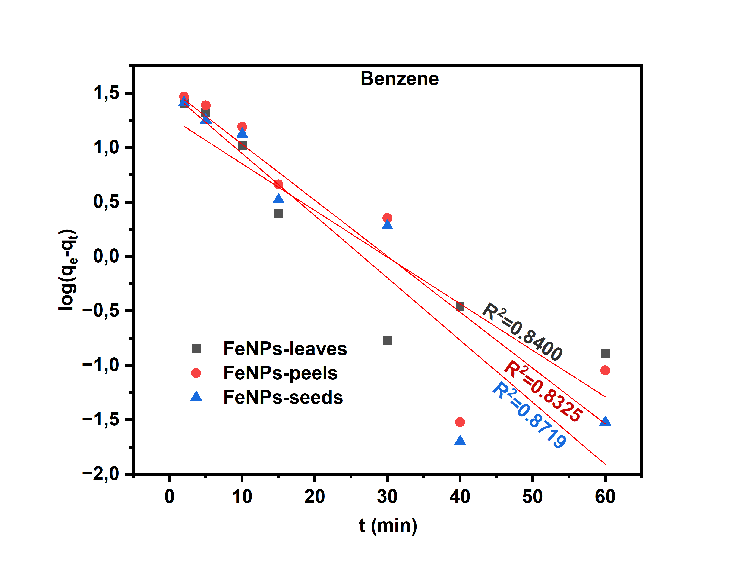
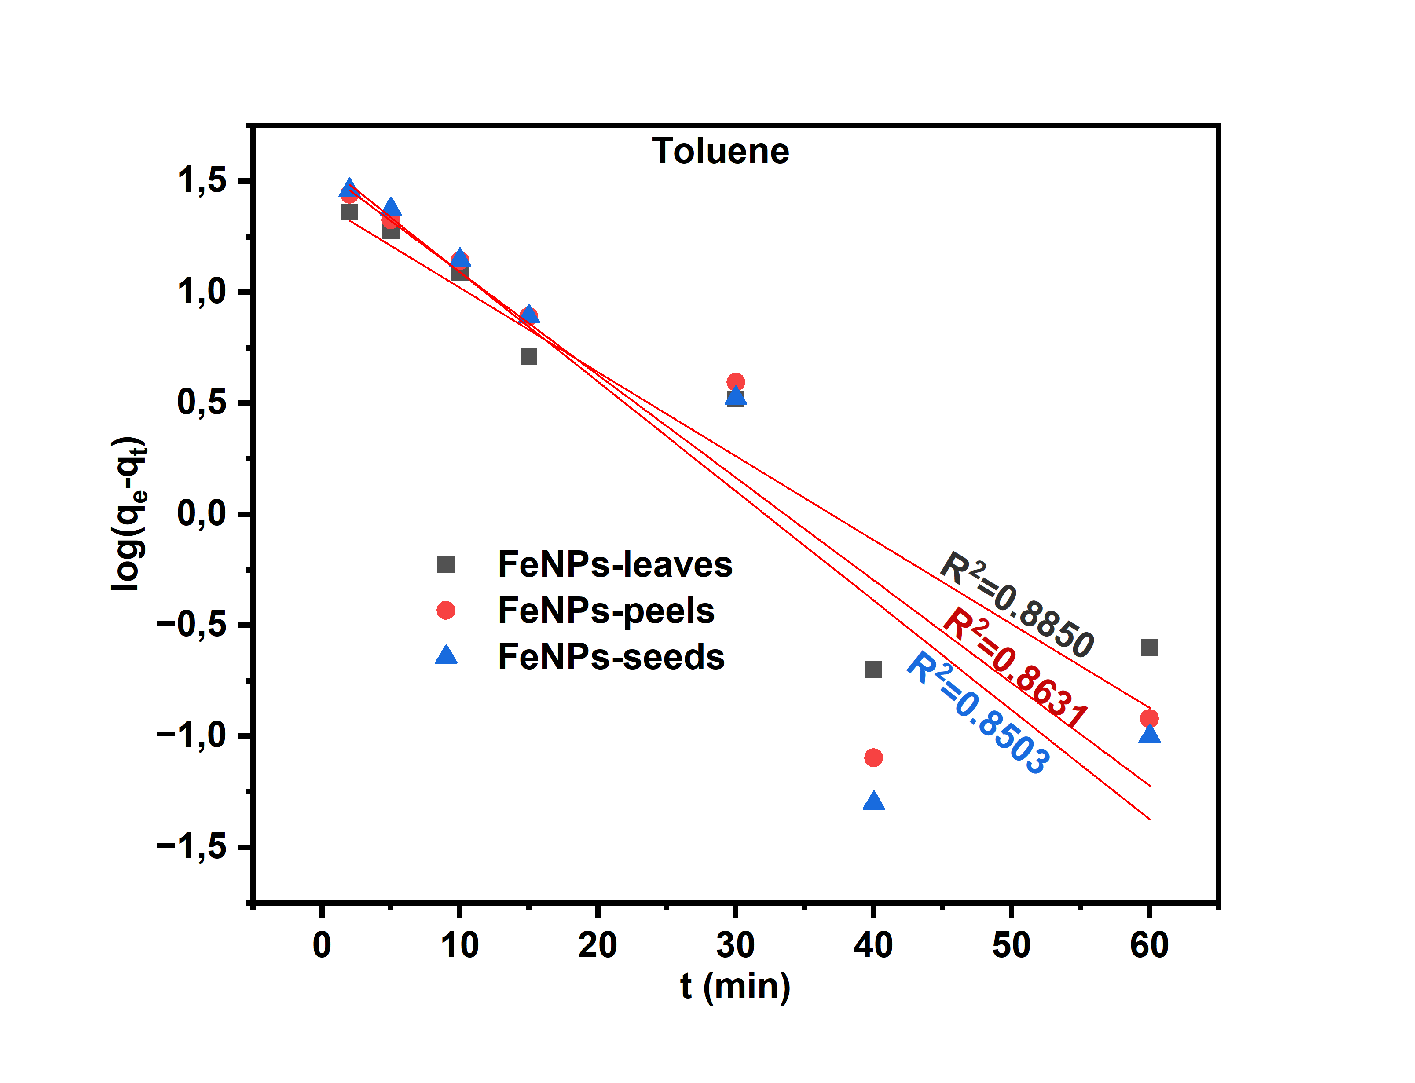
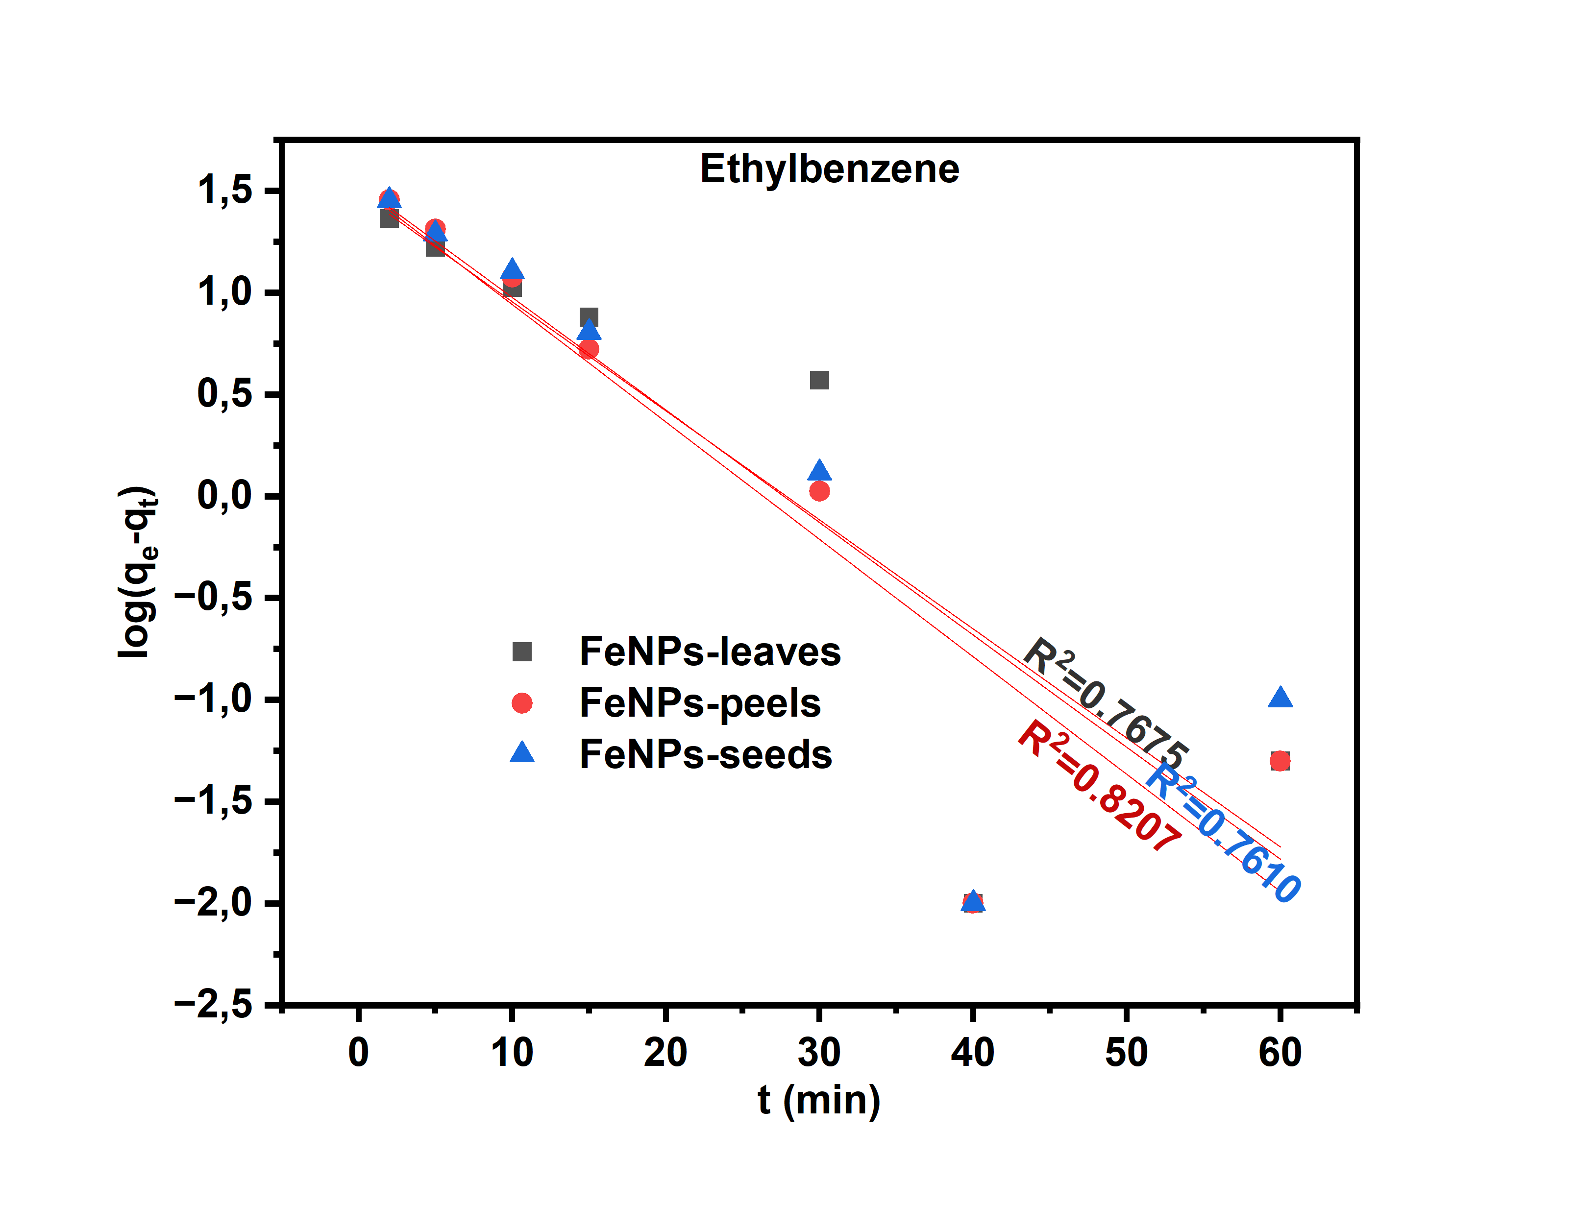
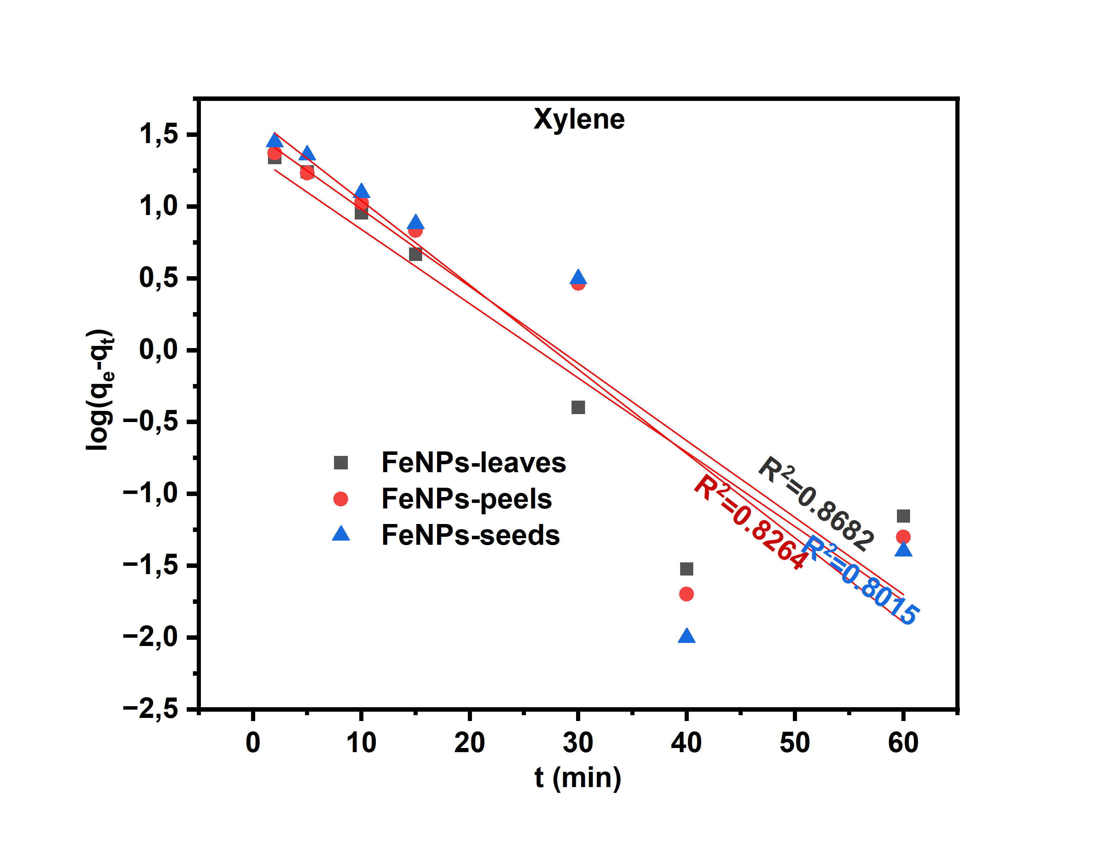
Fig. S3: Linear fit for the pseudo-first-order kinetic model for BTEX adsorption on FeNPs

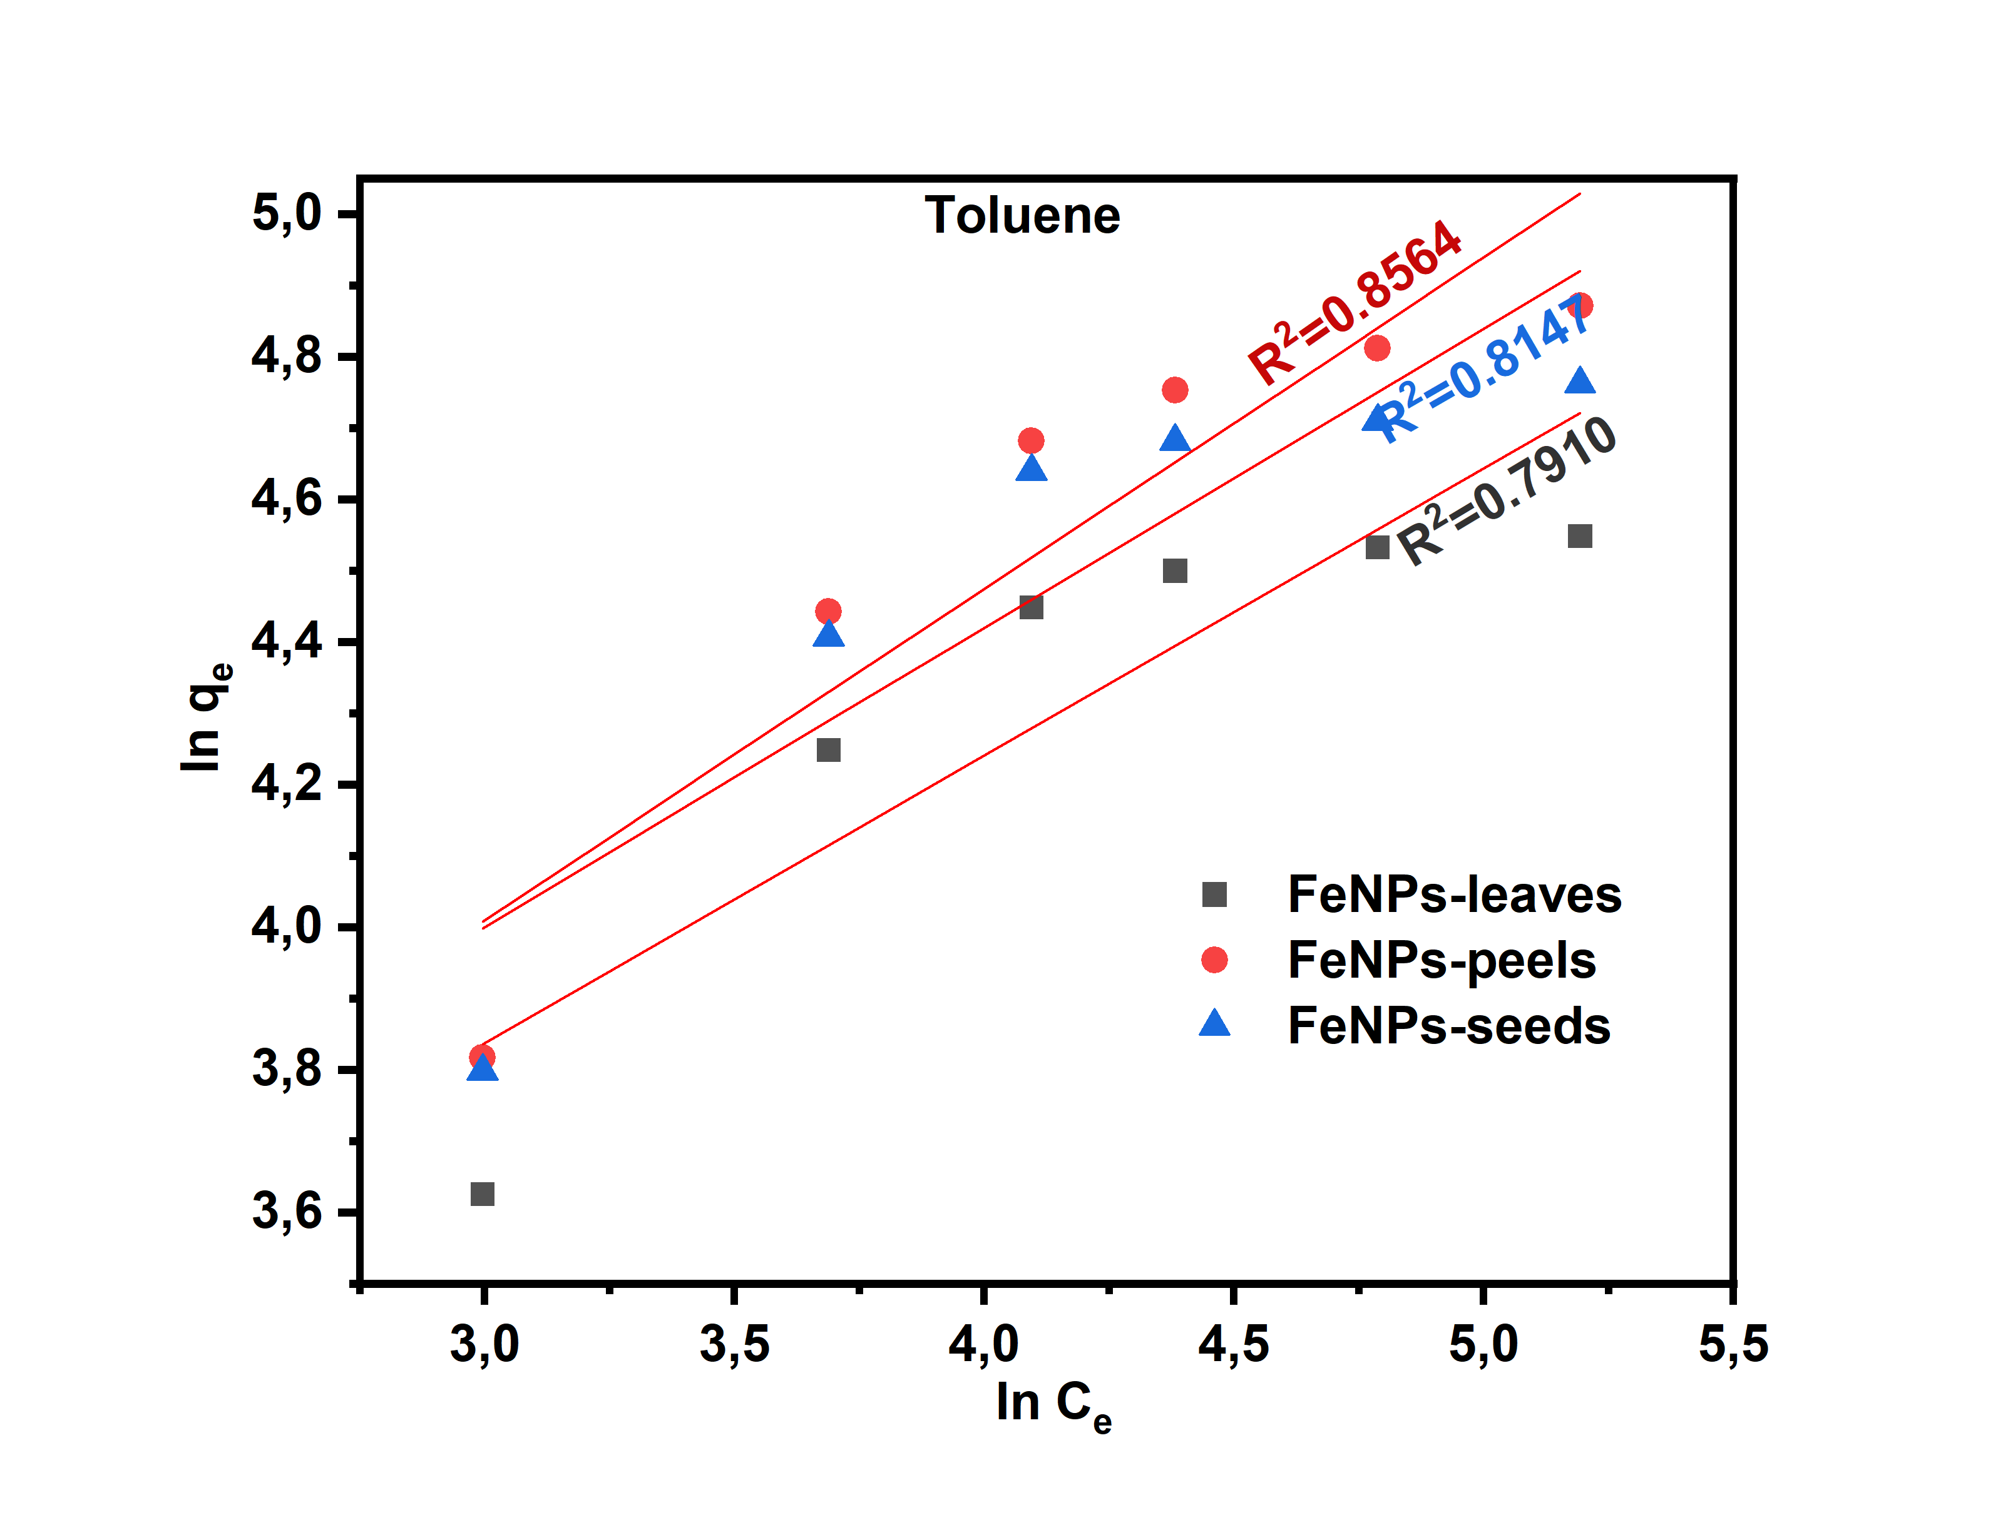
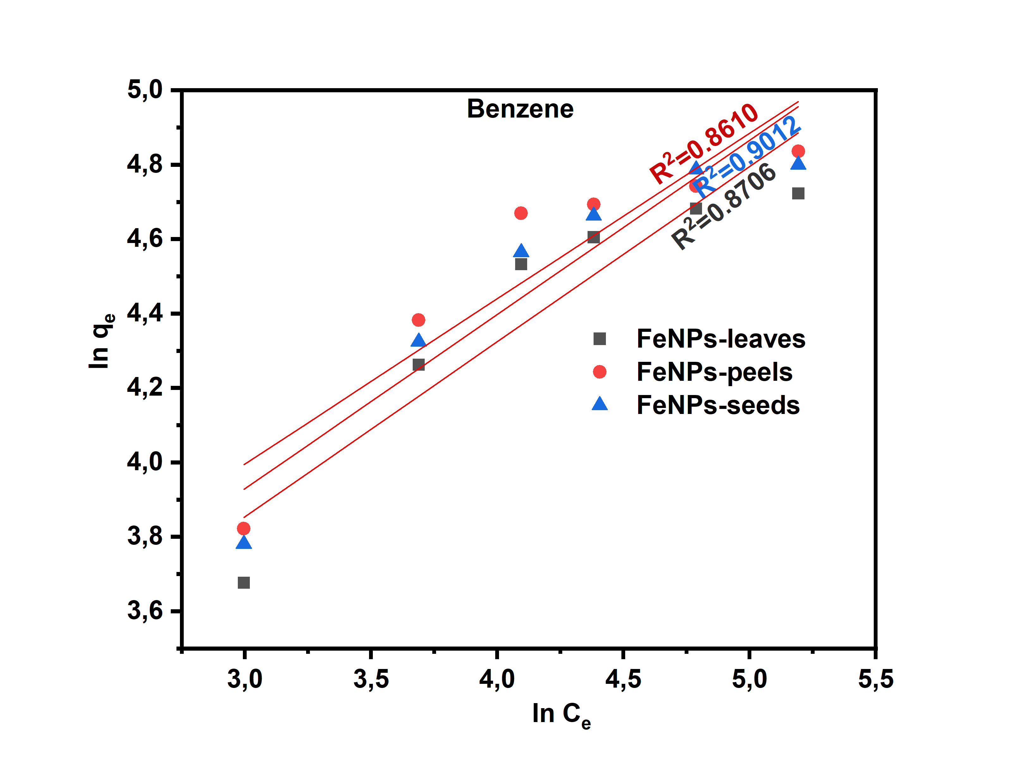
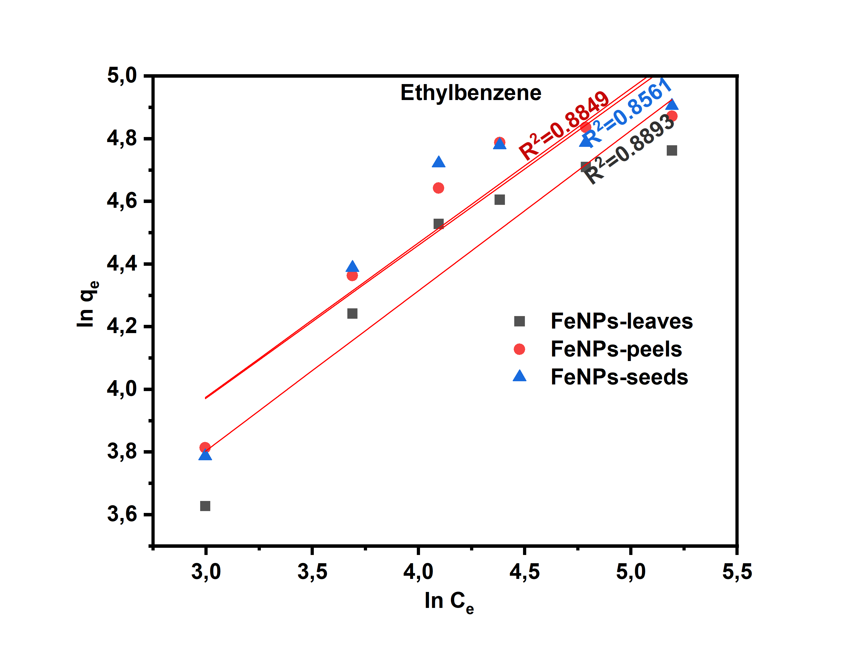
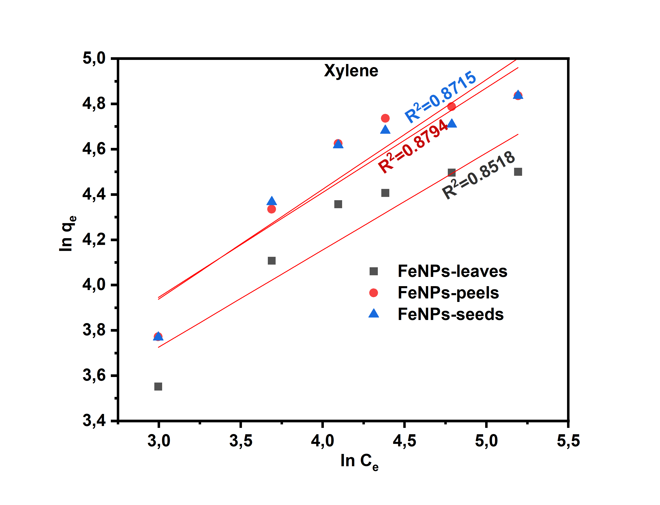
Fig. S4: The linear fit of Freundlich isotherm model for BTEX adsorption on FeNPs.

