Appendix B
The Pre-Operative Sedation Record
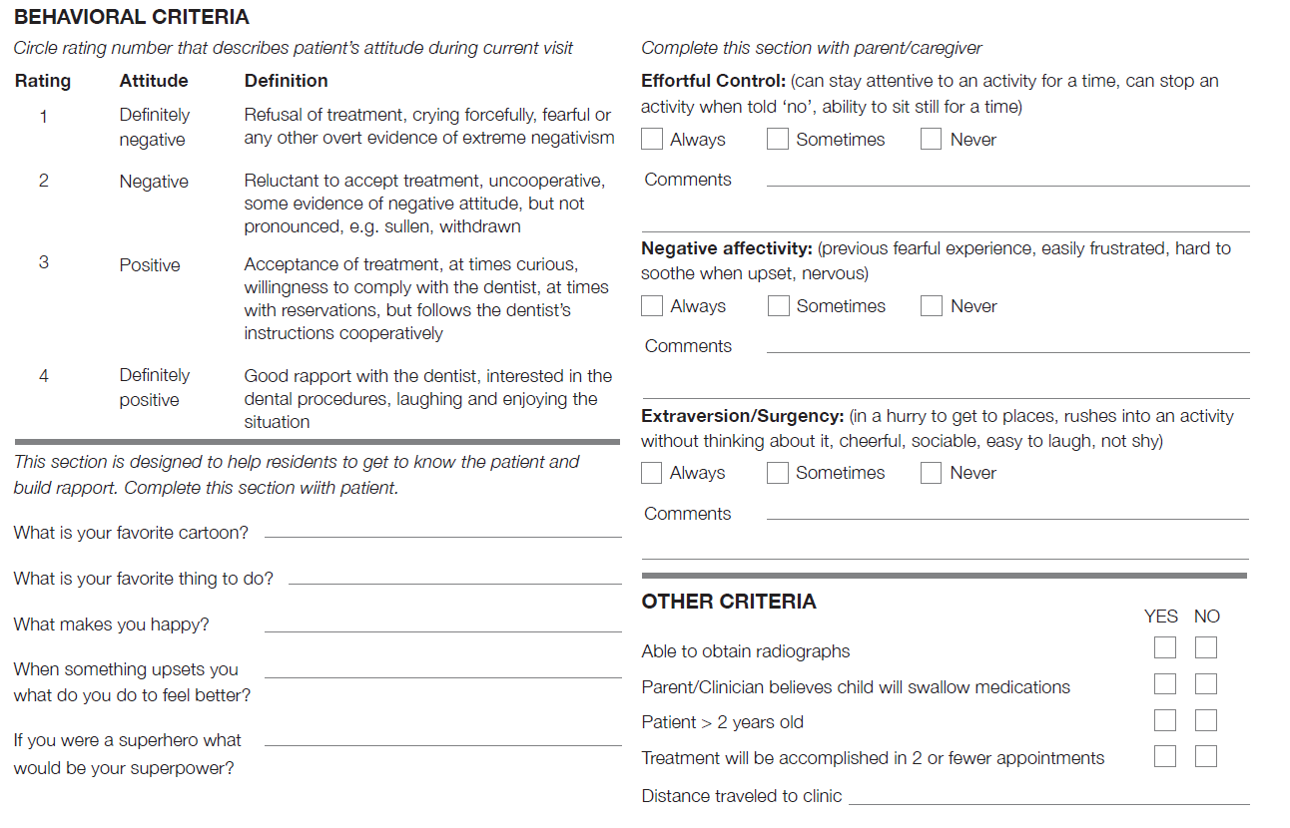
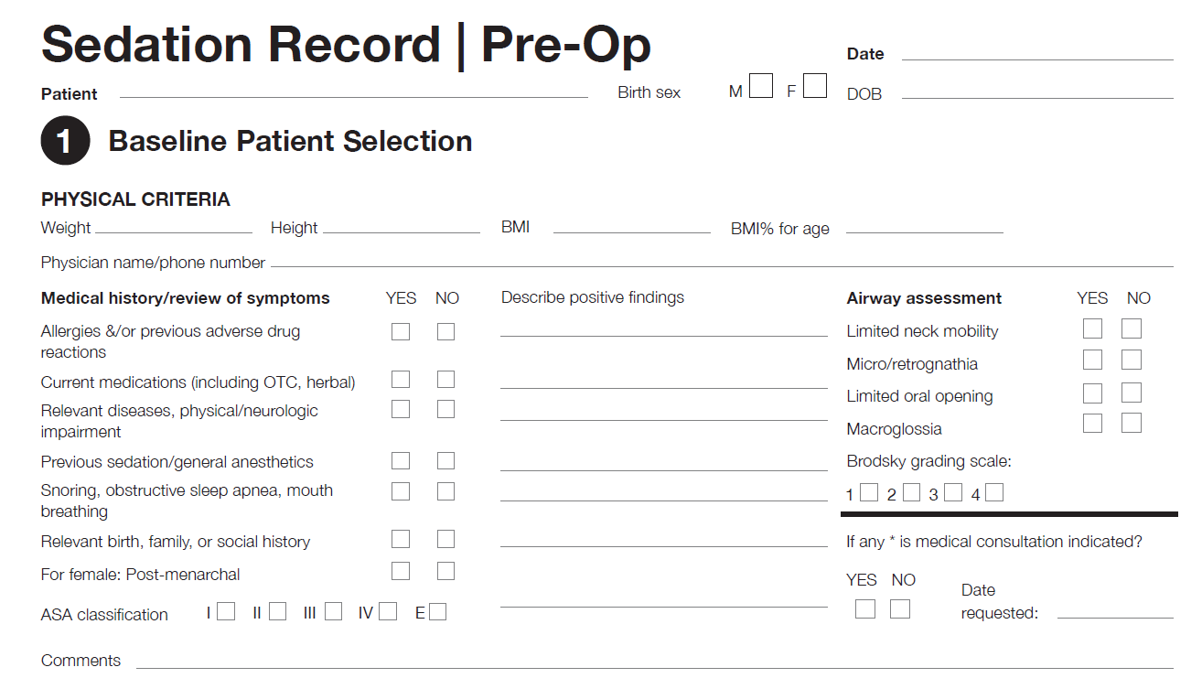
Figure 1: The pre-operative sedation form was enhanced by adding a section to capture the patient’s general temperament and attitudes. It also includes several rapport-building questions to improve communication between the provider, patient, and parents (see highlighted areas).

