Uneven sequencing (coverage) depth can bias microbial intraspecies diversity estimates and how to account for it
Esteban Bustos-Caparros¹*, Tomeu Viver¹, Juan F. Gago¹, Stephanus N. Venter², Rafael Bosch³, Konstantinos T. Konstantinidis⁴, Luis M. Rodriguez-R^{5,6}*, Ramon Rossello-Mora¹*.
¹ Marine Microbiology Group (MMG), Department of Animal and Microbial Biodiversity, Mediterranean Institute for Advanced Studies (IMEDEA, CSIC-UIB), Esporles, Spain.
² Department of Biochemistry, Genetics and Microbiology, and Forestry and Agricultural Biotechnology Institute (FABI), University of Pretoria, Pretoria, South Africa.
³ Microbiologia, Departament de Biologia, Edifici Guillem Colom, Universitat de les Illes Balears, Campus UIB, 07122 Palma de Mallorca, Spain.
⁴ School of Civil and Environmental Engineering and School of Biological Sciences, Georgia Institute of Technology, Atlanta, GA, USA.
⁵ Department of Chemistry and Biosciences, Aalborg University, Aalborg, Denmark.
⁶ Department of Microbiology and Digital Science Center (DiSC), University of Innsbruck, Innsbruck, Austria.
*Corresponding authors: Esteban Bustos-Caparros, Marine Microbiology Group (MMG), Department of Animal and Microbial Biodiversity, Mediterranean Institute for Advanced Studies (IMEDEA, CSIC-UIB), Carrer Miquel Marquès 21, Esporles, Illes Balears, 07190, Spain. Email: ebustos@imedea.uib-csic.es, Luis M. Rodriguez-R, Department of Chemistry and Biosciences, Aalborg University, Frederik Bajers Vej 7H, 9000 Aalborg, Denmark. Email: lmrodriguezr@gmail.com, Ramon Rossello-Mora, Marine Microbiology Group (MMG), Department of Animal and Microbial Biodiversity, Mediterranean Institute for Advanced Studies (IMEDEA, CSIC-UIB), Carrer Miquel Marquès 21, Esporles, Illes Balears, 07190, Spain. Email: ramon@imedea.uib-csic.es
Running title: Sequencing depth can bias microdiversity
Supplementary Figure S1: Schematic representation of the methods used to evaluate the sequencing (coverage) depth bias on microdiversity estimates (pi and ANIr) using both environmental and synthetic metagenomes.

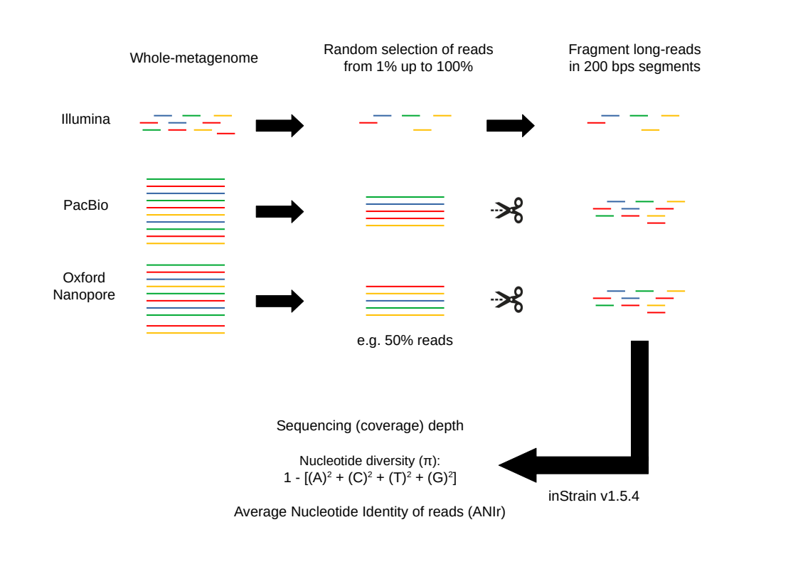

Supplementary Figure S2: Model plot representing the microdiversity estimate (nucleotide diversity or ANIr) trend along an increasing sequencing (coverage) depth. Each line represents the microdiversity estimate (y-axis), represented as Microdiversity ratio, and sequencing (coverage) depth (x-axis) obtained for a single MAG across each metagenome. The Microdiversity ratio was calculated by dividing the nucleotide diversity or ANIr obtained from each fraction of a metagenome by the nucleotide diversity or ANIr obtained from the entire metagenome (100% of reads). Green lines indicate positive correlations (i.e. increasing microdiversity with coverage depth), and red lines indicate negative correlations (i.e. decreasing microdiversity with coverage depth).

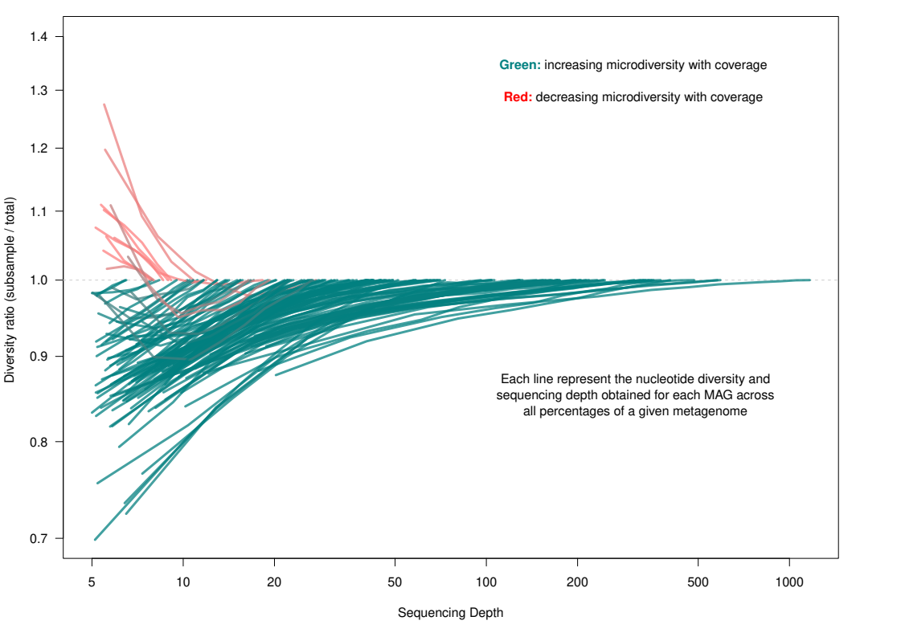
​​

Supplementary Figure S3: Estimation of the impact of sequencing depth from 500X to ~1,400X on the accuracy of nucleotide diversity (π) estimates across hypersaline and marine metagenomes using Illumina sequencing platform. The microdiversity ratio represents the π obtained for each subsample of a metagenome divided by the π of the whole-metagenome, with ratio = 1 meaning that microdiversity in the subsample is equal to microdiversity in the whole-metagenome. Note that each line represents the microdiversity estimate of one MAG in a given metagenome. Green lines indicated larger microdiversity at increasing sequencing depth (i.e. expected trend; microdiversity ratio < 1).

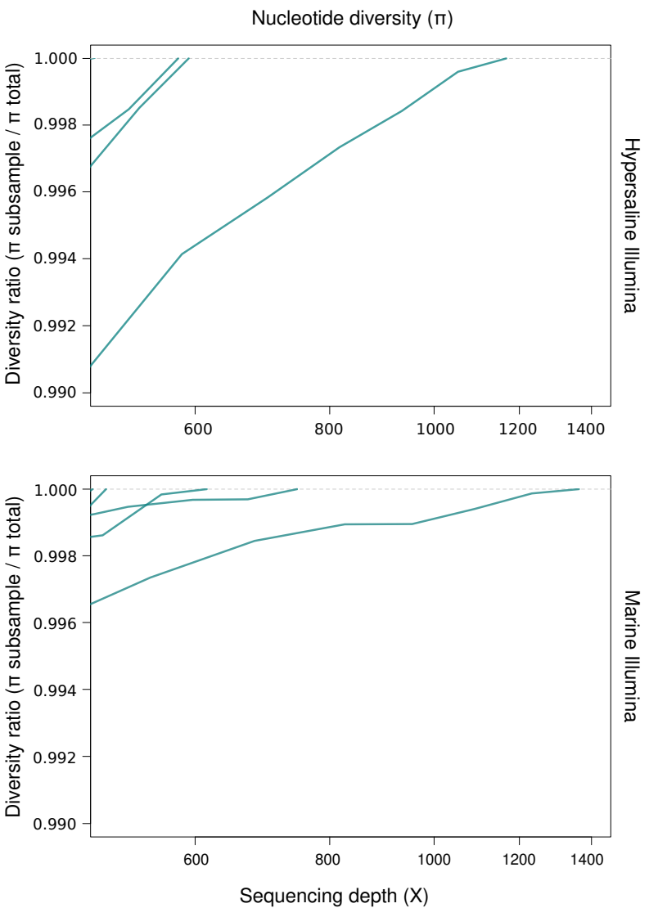
​​

Supplementary Figure S4: Barplots showing nucleotide diversity (π) estimates of each of the ten species analyzed from the hypersaline microbiome using Illumina metagenomes (n = 15). Color gradient represents the sequencing depth values across metagenomes per each species.

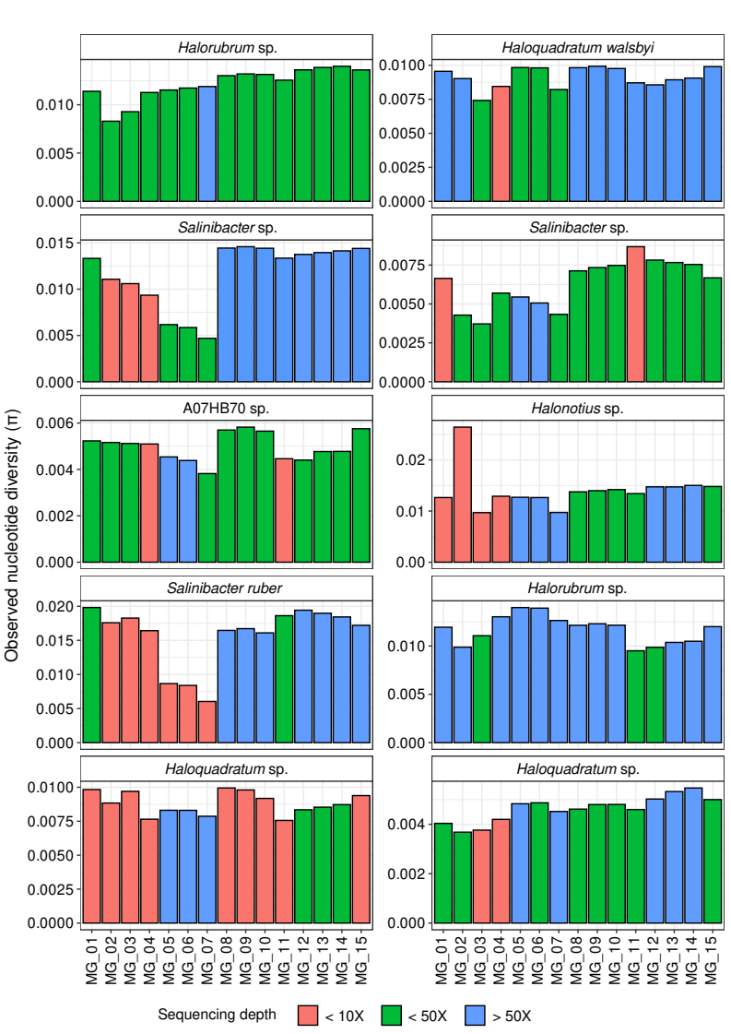

Supplementary Figure S5: Barplots showing nucleotide diversity (π) estimates of each of the ten species analyzed from the marine microbiome using PacBio metagenomes (n = 15). Color gradient represents the sequencing depth values across metagenomes per each species.

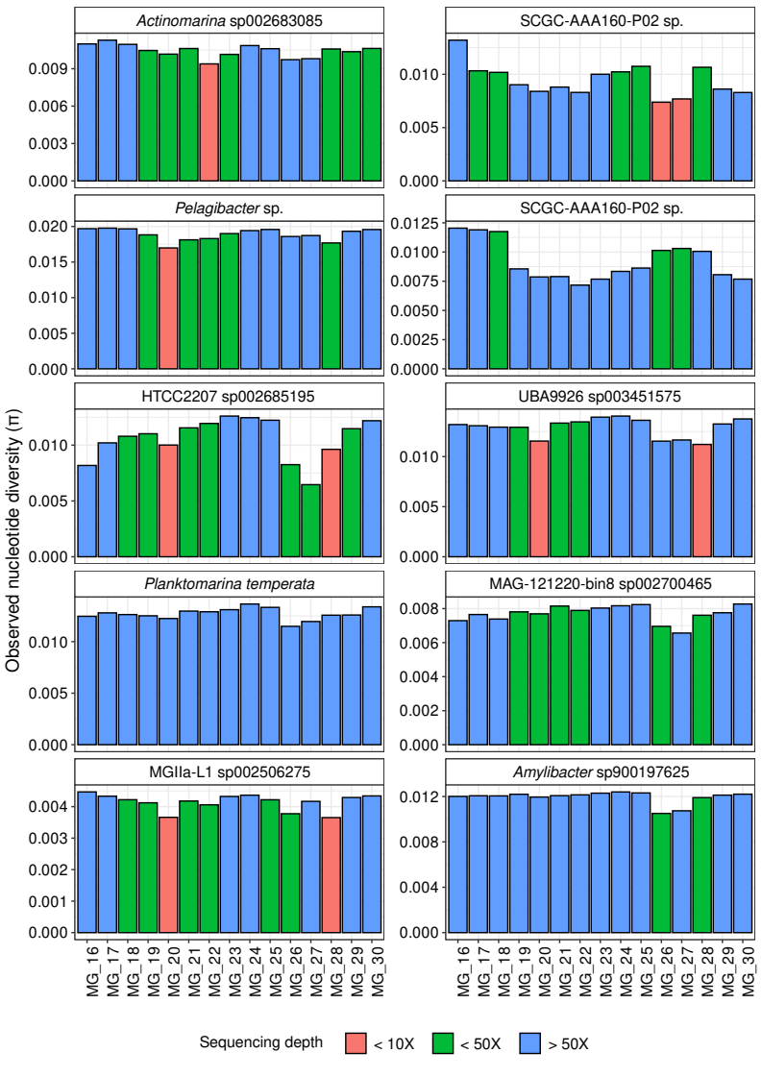

Supplementary Figure S6: Barplots showing nucleotide diversity (π) estimates of each of the ten species analyzed from the marine microbiome using Illumina metagenomes (n = 4). Color gradient represents the sequencing depth values across metagenomes per each species.

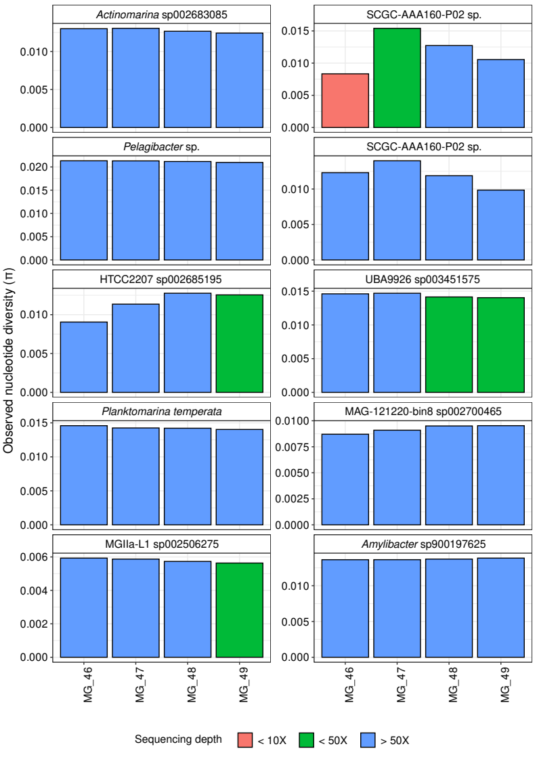

Supplementary Figure S7: Barplots showing nucleotide diversity (π) estimates of each of the ten species analyzed from the human gut microbiome using ONT metagenomes(n = 15). Color gradient represents the sequencing depth values across metagenomes per each species.

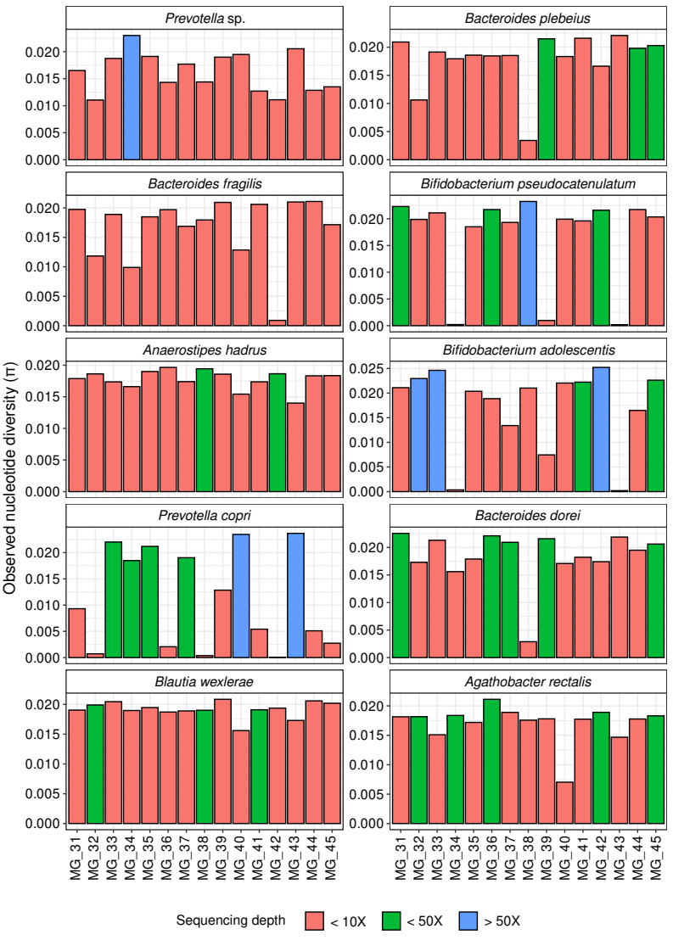

Supplementary Figure S8: Barplots showing nucleotide diversity (π) estimates of each of the ten species analyzed from the human gut microbiome using Illumina metagenomes (n = 4). Color gradient represents the sequencing depth values across metagenomes per each species.

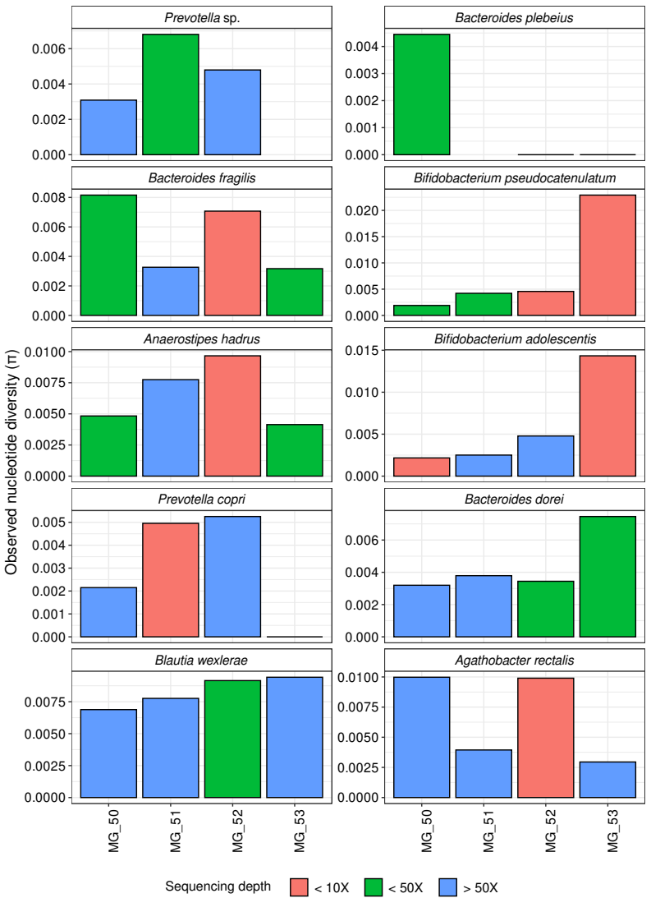

Supplementary Figure S9: Average Nucleotide Identity (ANI) and shared genome fraction (%) comparison among the 100 isolate genomes of Salinibacter ruber.

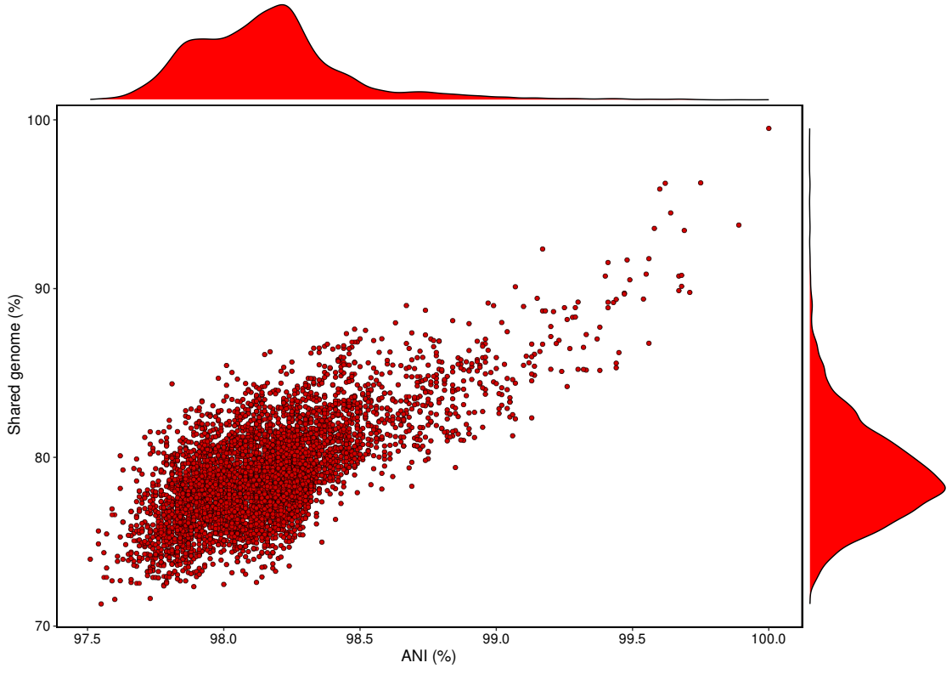

Supplementary Figure S10: Estimation of nucleotide diversity (π) values at increasing sequencing depth and isolate diversity on the 32 distinct in silico metagenomes with variable sequencing error profiles.

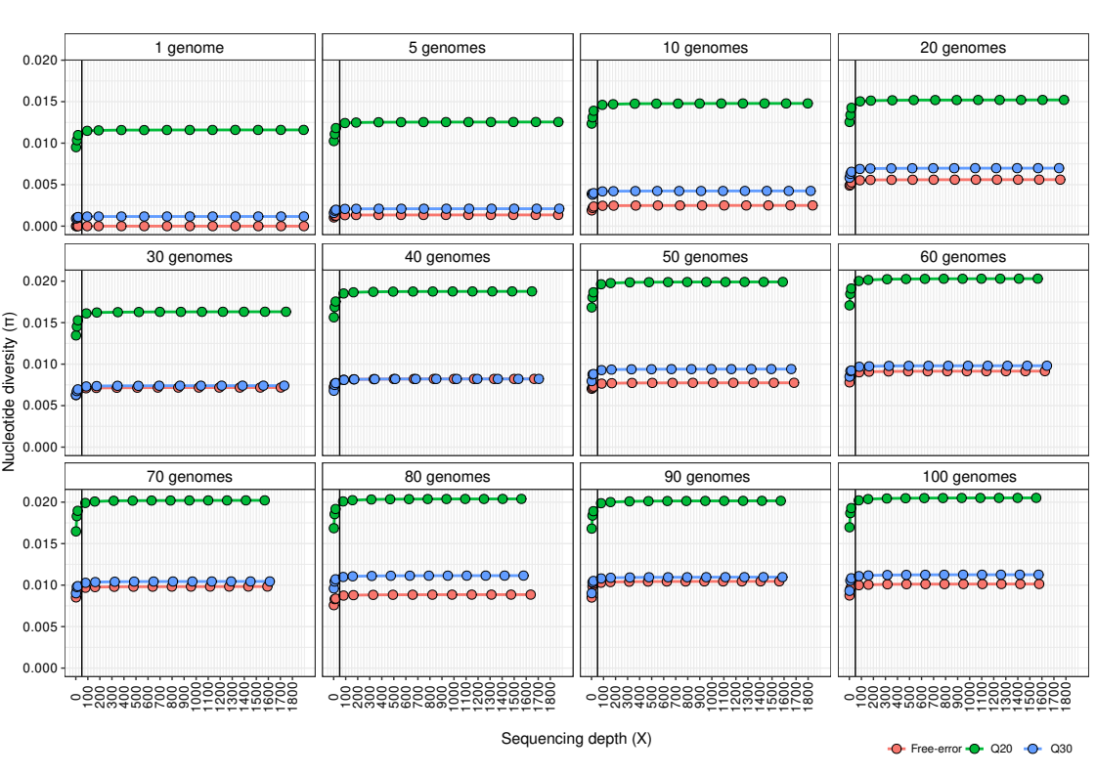
Supplementary Figure S11: Estimation of ANIr values at increasing sequencing depth and isolate diversity on the 32 distinct in silico metagenomes with variable sequencing error profiles.

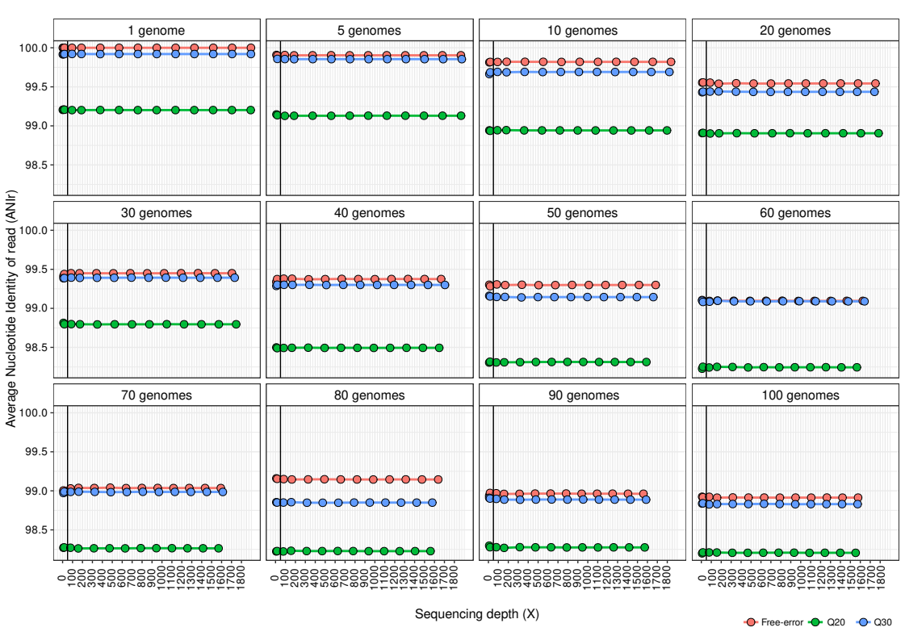
Supplementary Figure S12: Estimation of the effect of increasing sequencing depth on the accuracy of nucleotide diversity (π) across in silico metagenomes with distinct proportions of isolate genomes and sequencing error profiles. The diversity ratio represents the estimated π at each subsample of a metagenome divided by π estimated at the whole-metagenome, with ratio = 1 meaning that π in the subsample is equal to π in the whole-metagenome. Note that we showed the trends up to 400X to better show the effects of sequencing depth on nucleotide diversity (π) estimates. Lines indicate a sequencing depth of 50X and 200X.

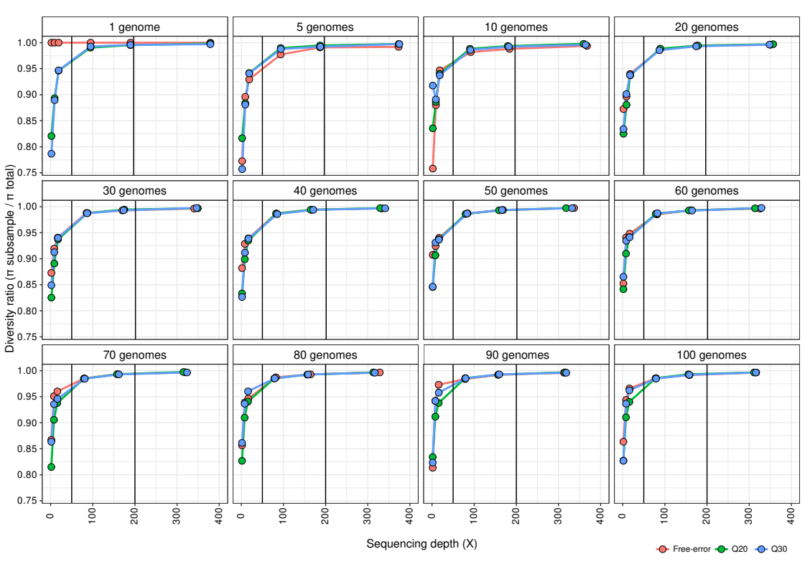

Supplementary Figure S13: Estimation of the effect of increasing sequencing depth on the accuracy of ANIr across in silico metagenomes with distinct proportions of isolate genomes and sequencing error profiles. The diversity ratio represents the estimated ANIr at each subsample of a metagenome divided by ANIr estimated at the whole-metagenome, with ratio = 1 meaning that ANIr in the subsample is equal to ANIr in the whole-metagenome. Note that we showed the trends up to 400X to better show the effects of sequencing depth on ANIr estimates. Lines indicate a sequencing depth of 50X and 200X.

