Supplementary material for
Intra-island variation in wind patterns on sub-Antarctic Marion Island
J Schoombie*¹, KJ Craig¹, K Goddard¹, DW Hedding², W Nel³, PC le Roux⁴

¹ Department of Mechanical and Aeronautical Engineering, University of Pretoria, Pretoria, South Africa
² Department of Geography, University of South Africa, Pretoria, South Africa
³ Department of Chemical and Earth Sciences, University of Fort Hare, Dikeni, South Africa
⁴ Department of Plant and Soil Science, University of Pretoria, Pretoria, South Africa

This supplemental document contains additional wind vector visualisations for eight of the 16 wind directions simulated over Marion Island using computational fluid dynamics (CFD).
Figures are displayed one per page (see below).
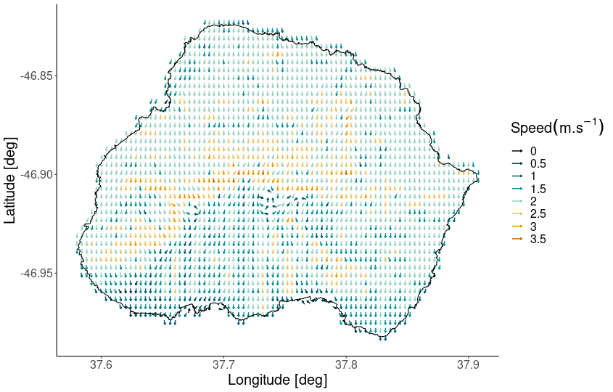
Fig. S1. Fine-scale wind vectors from the CFD simulation with a N inlet condition. Arrows show wind direction, with colours representing wind speed
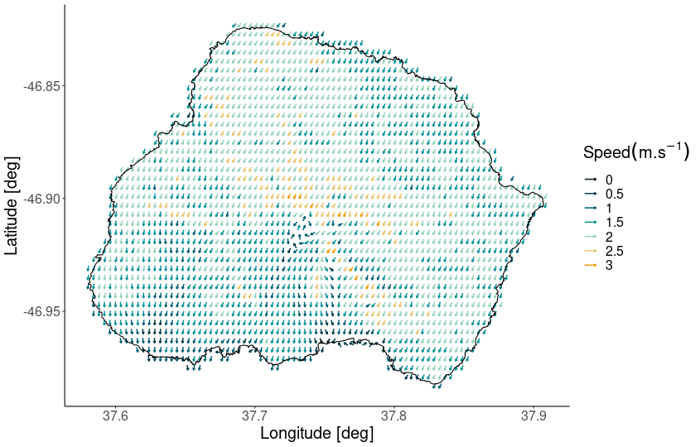
Fig. S2. Fine-scale wind vectors from the CFD simulation with a NE inlet condition. Arrows show wind direction, with colours representing wind speed
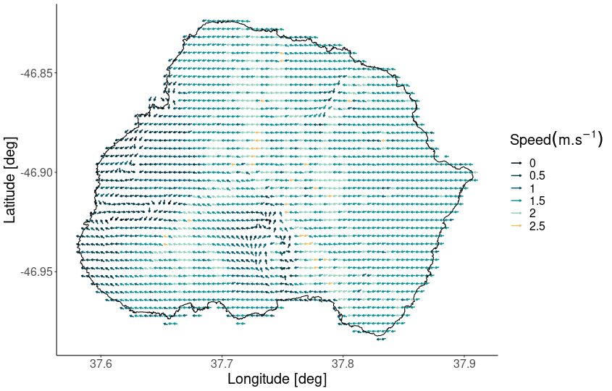
Fig. S3. Fine-scale wind vectors from the CFD simulation with an E inlet condition. Arrows show wind direction, with colours representing wind speed
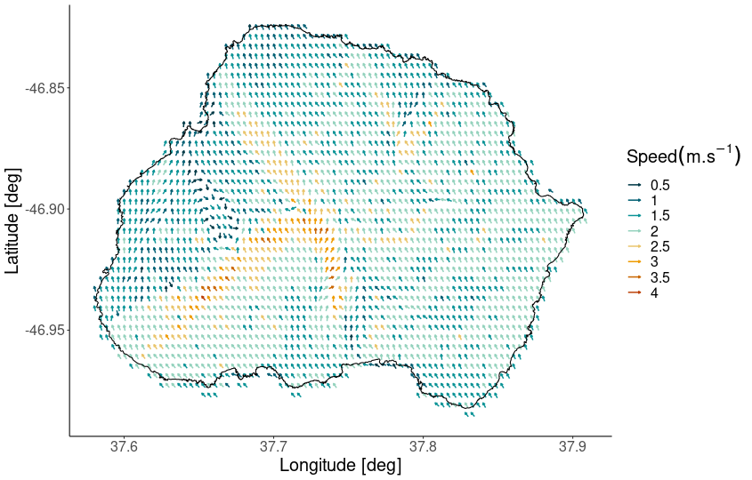
Fig. S4. Fine-scale wind vectors from the CFD simulation with an SE inlet condition. Arrows show wind direction, with colours representing wind speed
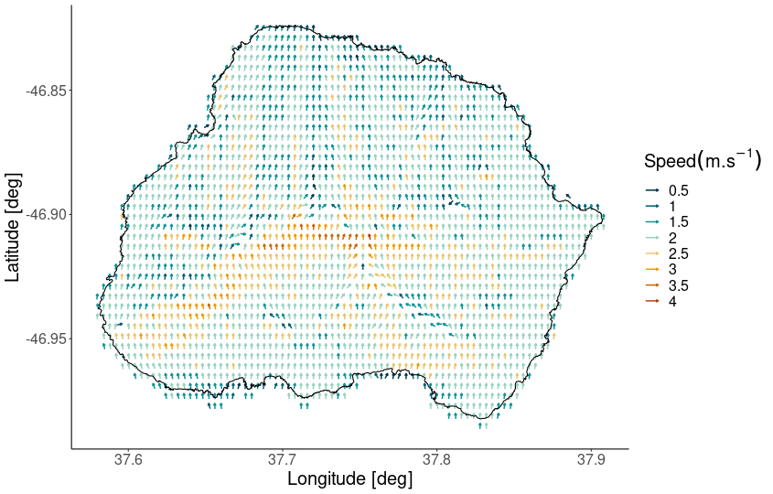
Fig. S5. Fine-scale wind vectors from the CFD simulation with a S inlet condition. Arrows show wind direction, with colours representing wind speed
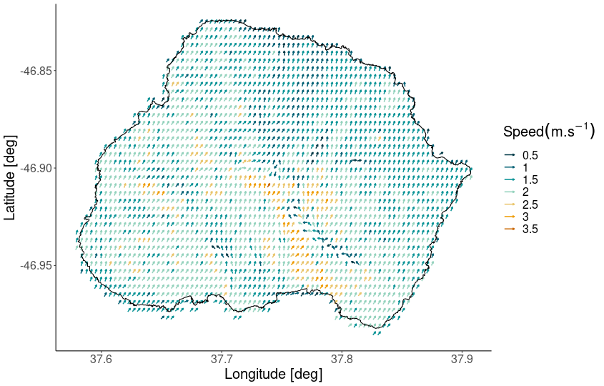
Fig. S6. Fine-scale wind vectors from the CFD simulation with a SW inlet condition. Arrows show wind direction, with colours representing wind speed
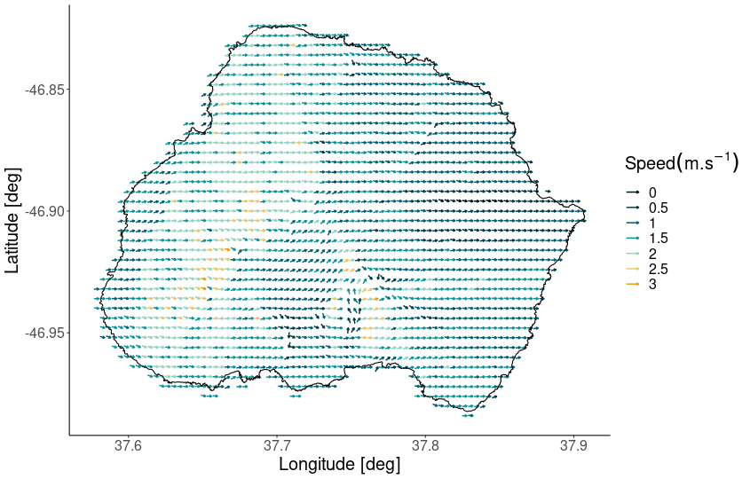
Fig. S7. Fine-scale wind vectors from the CFD simulation with a W inlet condition. Arrows show wind direction, with colours representing wind speed
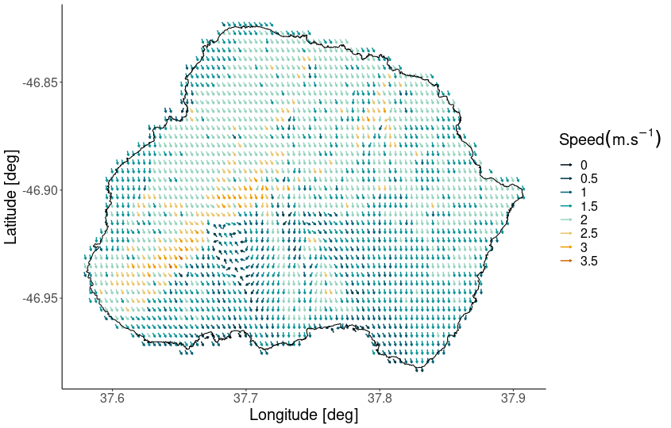
Fig. S8. Fine-scale wind vectors from the CFD simulation with a NW inlet condition. Arrows show wind direction, with colours representing wind speed

