Buffalo City Metropolitan Municipality (East London)
Hexagon | Small area layer | Sub-place
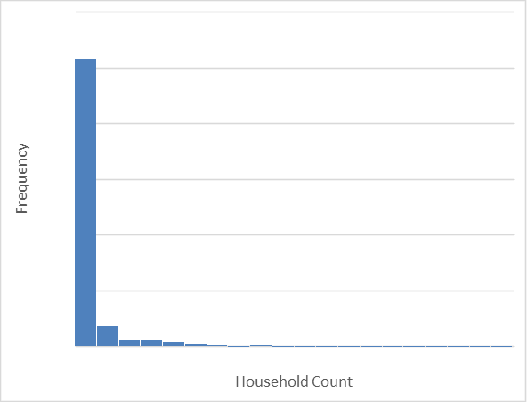 | 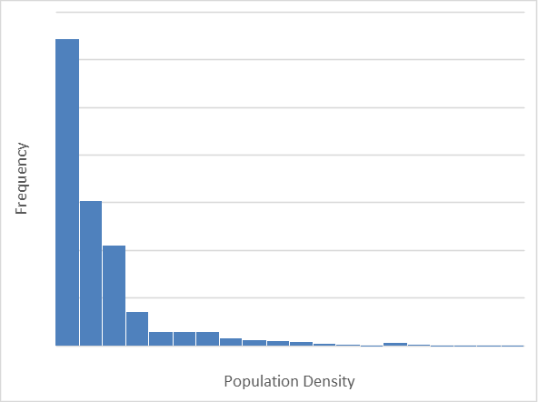 | 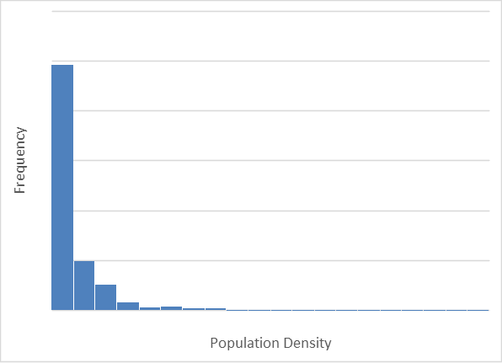
City of Tshwane Metropolitan Municipality
Hexagon | Small area layer | Sub-place
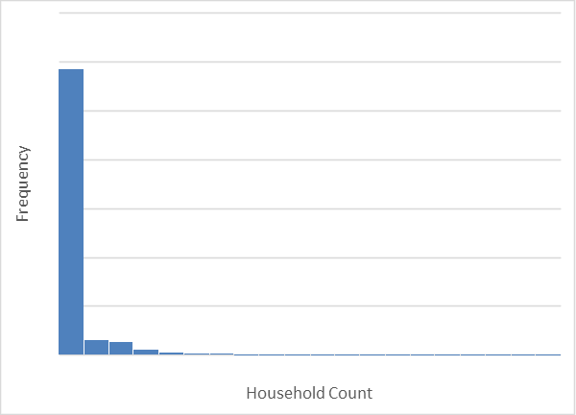 | 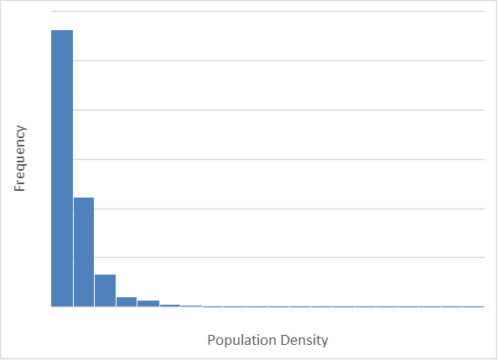 | 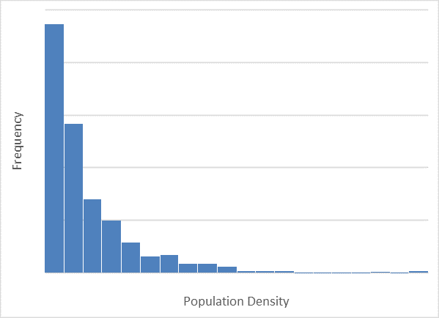
Mangaung Metropolitan Municipality (Bloemfontein)
Hexagon | Small area layer | Sub-place
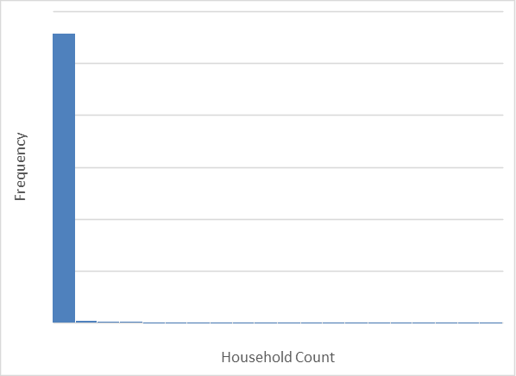 | 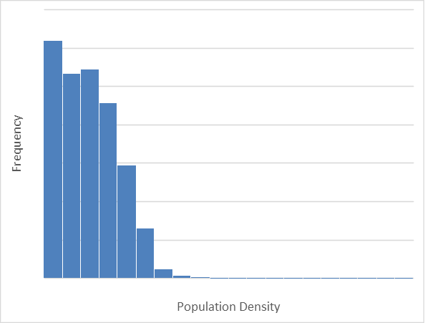 | 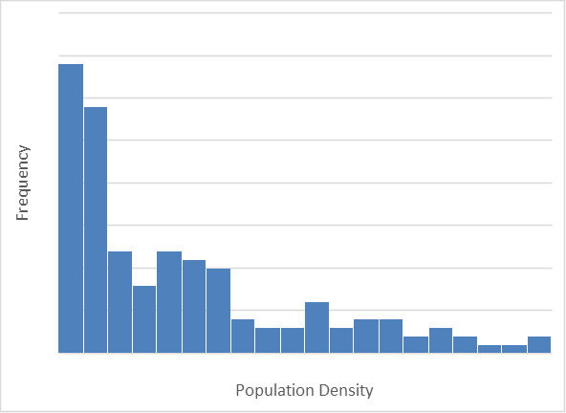
Polokwane Local Municipality
Hexagon | Small area layer | Sub-place
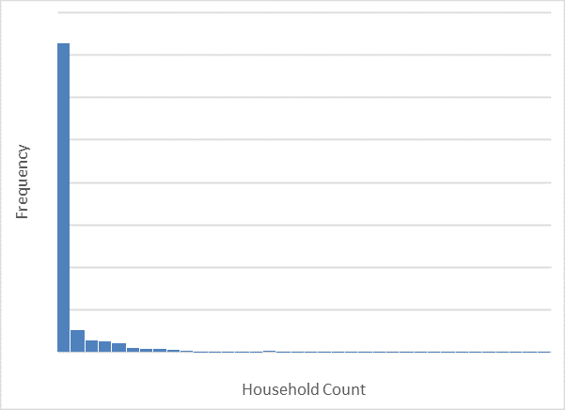 | 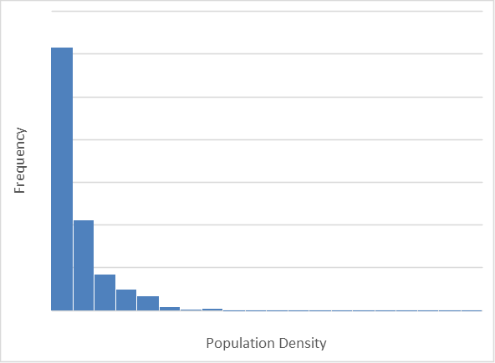 | 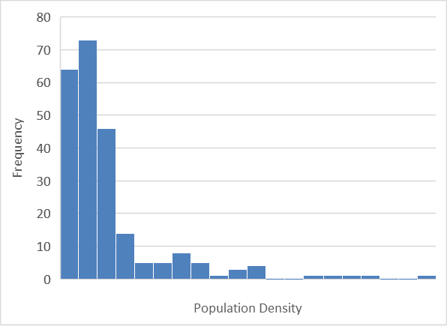
Figure 1: Histograms showing data distribution for each study area per geographic unit

Table 1: Descriptive statistics for Buffalo City Metropolitan Municipality
Buffalo City Metropolitan Municipality (East London) |  | Statistic
Hexagon – Household count | Mean | 162.69
Hexagon – Household count | Median | 20.00
Hexagon – Household count | Std. Deviation | 400.813
Hexagon – Household count | Minimum | 0
Hexagon – Household count | Maximum | 5 192
Hexagon – Household count | N | 1 211
Hexagon – Household count | Skewness | 4.844
Hexagon – Household count | Kurtosis | 33.565
Small area layer – Population density | Mean | 5 270.11
Small area layer – Population density | Median | 3 116.77
Small area layer – Population density | Std. Deviation | 6 715.746
Small area layer – Population density | Minimum | 1
Small area layer – Population density | Maximum | 55 690
Small area layer – Population density | N | 1 386
Small area layer – Population density | Skewness | 2.835
Small area layer – Population density | Kurtosis | 10.311
Sub-place – Population density | Mean | 1 946.80
Sub-place – Population density | Median | 931.28
Sub-place – Population density | Std. Deviation | 3 447.080
Sub-place – Population density | Minimum | 0
Sub-place – Population density | Maximum | 34 544
Sub-place – Population density | N | 347
Sub-place – Population density | Skewness | 5.279
Sub-place – Population density | Kurtosis | 37.045

Table 2: Descriptive statistics for City of Tshwane Metropolitan Municipality
City of Tshwane Metropolitan Municipality |  | Statistic
Hexagon – Household count | Mean | 193.98
Hexagon – Household count | Median | 19.50
Hexagon – Household count | Std. Deviation | 504.134
Hexagon – Household count | Minimum | 0
Hexagon – Household count | Maximum | 6 851
Hexagon – Household count | N | 3 416
Hexagon – Household count | Skewness | 4.765
Hexagon – Household count | Kurtosis | 32.086
Small area layer – Population density | Mean | 7 046.88
Small area layer – Population density | Median | 4 484.17
Small area layer – Population density | Std. Deviation | 8 738.313
Small area layer – Population density | Minimum | 1
Small area layer – Population density | Maximum | 127 262
Small area layer – Population density | N | 594
Small area layer – Population density | Skewness | 4.509
Small area layer – Population density | Kurtosis | 33.953
Sub-place – Population density | Mean | 3 408.64
Sub-place – Population density | Median | 2 195.19
Sub-place – Population density | Std. Deviation | 4 125.388
Sub-place – Population density | Minimum | 0
Sub-place – Population density | Maximum | 31 648
Sub-place – Population density | N | 31 648
Sub-place – Population density | Skewness | 2.491
Sub-place – Population density | Kurtosis | 9.457

Table 3: Descriptive statistics for Mangaung Metropolitan Municipality
Mangaung Metropolitan Municipality (Bloemfontein) |  | Statistic
Hexagon – Household count | Mean | 63.71
Hexagon – Household count | Median | 1.00
Hexagon – Household count | Std. Deviation | 325.762
Hexagon – Household count | Minimum | 0
Hexagon – Household count | Maximum | 4 586
Hexagon – Household count | N | 2 921
Hexagon – Household count | Skewness | 8.020
Hexagon – Household count | Kurtosis | 74.624
Small area layer – Population density | Mean | 5 270.11
Small area layer – Population density | Median | 3 116.77
Small area layer – Population density | Std. Deviation | 6 715.746
Small area layer – Population density | Minimum | 1
Small area layer – Population density | Maximum | 55 690
Small area layer – Population density | N | 1 386
Small area layer – Population density | Skewness | 2.835
Small area layer – Population density | Kurtosis | 10.311
Sub-place – Population density | Mean | 1 946.80
Sub-place – Population density | Median | 931.28
Sub-place – Population density | Std. Deviation | 3 447.080
Sub-place – Population density | Minimum | 0
Sub-place – Population density | Maximum | 34 544
Sub-place – Population density | N | 347
Sub-place – Population density | Skewness | 5.279
Sub-place – Population density | Kurtosis | 37.045

Table 4: Descriptive statistics for Polokwane Local Municipality
Polokwane Local Municipality |  | Statistic
Hexagon – Household count | Mean | 86.99
Hexagon – Household count | Median | 4.00
Hexagon – Household count | Std. Deviation | 237.826
Hexagon – Household count | Minimum | 0
Hexagon – Household count | Maximum | 2 447
Hexagon – Household count | N | 1 853
Hexagon – Household count | Skewness | 4.982
Hexagon – Household count | Kurtosis | 31.772
Small area layer – Population density | Mean | 2 746.80
Small area layer – Population density | Median | 1 585.38
Small area layer – Population density | Std. Deviation | 3 664.407
Small area layer – Population density | Minimum | 0
Small area layer – Population density | Maximum | 41 990
Small area layer – Population density | N | 1 027
Small area layer – Population density | Skewness | 4.967
Small area layer – Population density | Kurtosis | 39.967
Sub-place – Population density | Mean | 1 305.02
Sub-place – Population density | Median | 899.76
Sub-place – Population density | Std. Deviation | 1 528.705
Sub-place – Population density | Minimum | 0
Sub-place – Population density | Maximum | 10 266
Sub-place – Population density | N | 233
Sub-place – Population density | Skewness | 2.742
Sub-place – Population density | Kurtosis | 9.411

