Document Review Process, Coding Framework and Visualisations
Document Analysis Outline: Health Legislation Systematic Review
- Document Identification and Preparation
  - Document Gathering: All listed regulatory documents and relevant grey literature pertaining to medication adherence were sourced.
    - Guidelines and Reporting:
      - South African Department of Statistics Mortality Stats 2017
      - Strategic Plan for Prevention and Control of NCDs
      - World Health Organisation Global Action Plan
      - Large Scale Validation Study of the MARS
      - Adherence Guidelines for HIV, TB and NCDs
      - SA Comparative Risk Assessment Study
    - Legislation:
      - National Health Act
      - NHI Bill 2023
  - Unique Identifiers: Unique identifiers were assigned to each document (e.g., WHO_ActionPlan_1, PharmAct_1) for organizational purposes throughout the analysis.

- Initial Review and Familiarization
  - Preliminary Review: A high-level review of each document was conducted to confirm its relevance to the research question and highlight potential themes.
  - Memos Create initial memos for each document, noting key themes, potential relevance to chronic medication adherence, mortality etc.

- Coding Framework Development
A list of search terms was compiled based on the following core concepts:
- Medication Adherence:
    - Adherence
    - Adhere
    - Non-adherence
    - Non-compliance
    - Proportion of days covered (PDC)
    - Medication possession ratio (MPR)
    - Medication event monitoring system (MEMS)
    - Medication Adherence Risk Score (MARS)
    - Medication adherence
    - Medication adherence strategies
    - Medication adherence risk score
    - Medication compliance

- Mortality:
    - Mortality
    - Death
    - Passed away
    - Passed on
    - Survival

- Mortality Risk:

    - Actual to Expected Ratio (AER)
    - Crude mortality rate
    - Crude rate
    - Underwritten mortality basis
    - Mortality risk
    - Survival rate
    - Survival analysis
    - Survival curve
    - Hazard ratio
    - Odds ratio

- Chronic Disease:
    - Chronic disease
    - Lifestyle disease
    - Non-communicable disease

- In-Depth Document Coding
  - Systematic Coding: Using the coding framework, each document was systematically coded in MAXQDA. This was an iterative process where the coding framework was refined each time.
  - Focused Queries and Analysis: Queries were run in the MAXQDA tool to identify the frequency, co-occurrence and within the documents.

- Coding visualisations
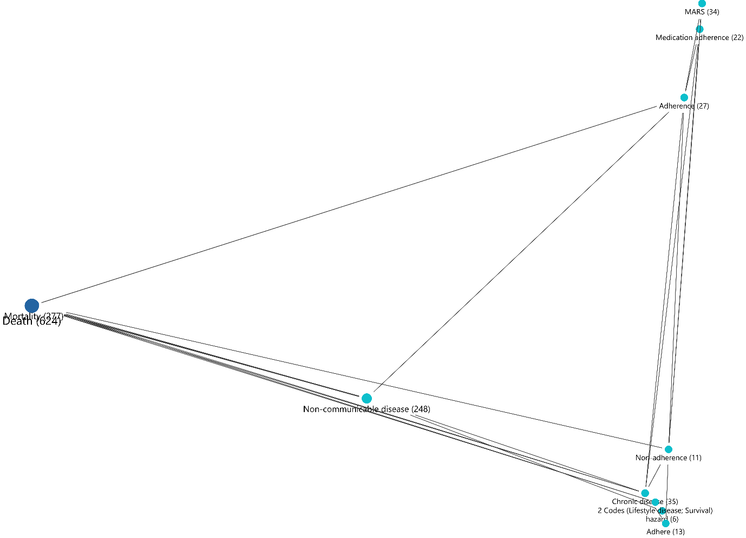
  - Intersection of codes in the same document

  - Occurrence of codes in the same document

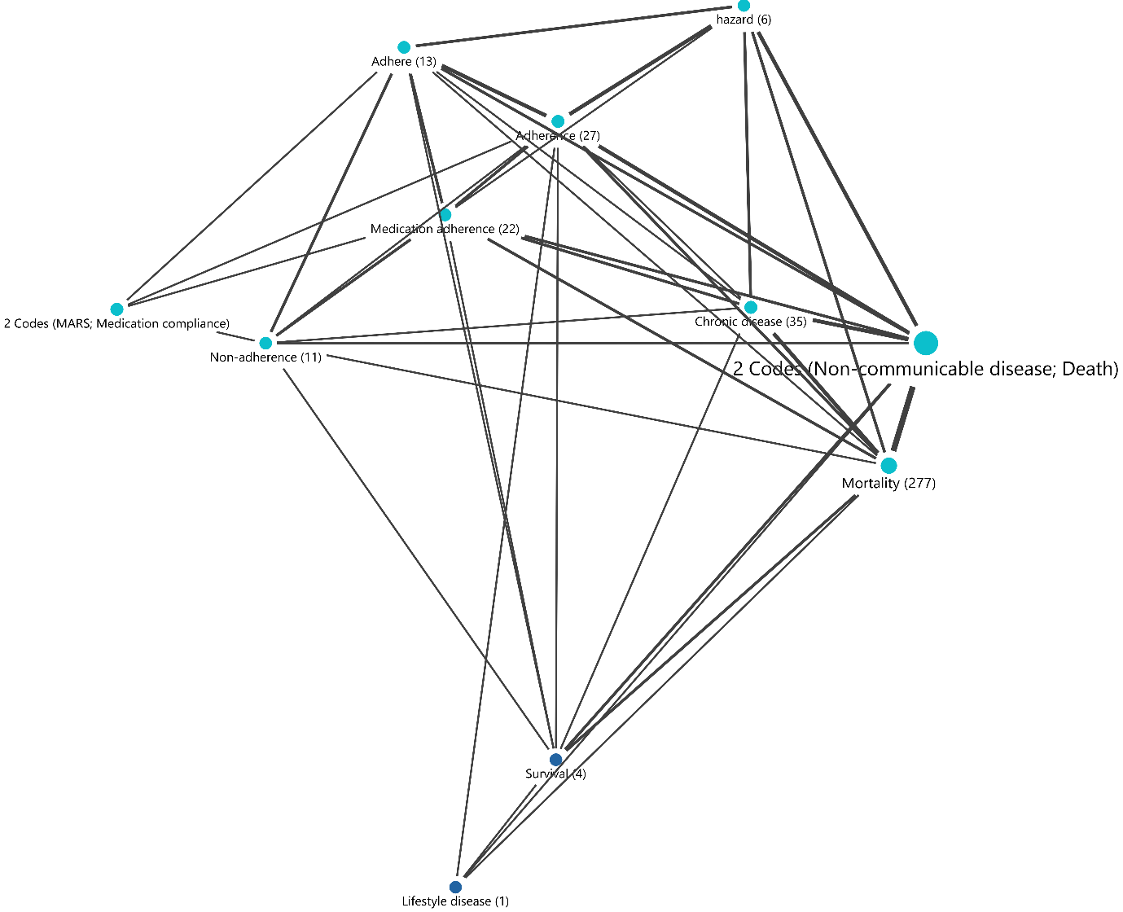

  - Proximity of codes in the same document
